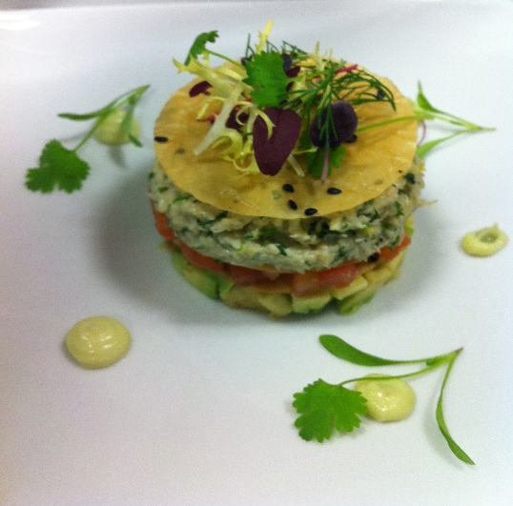
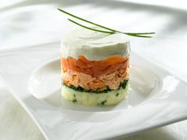
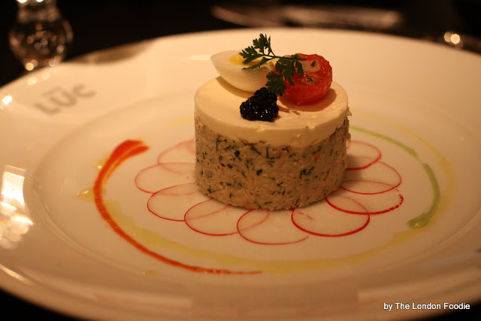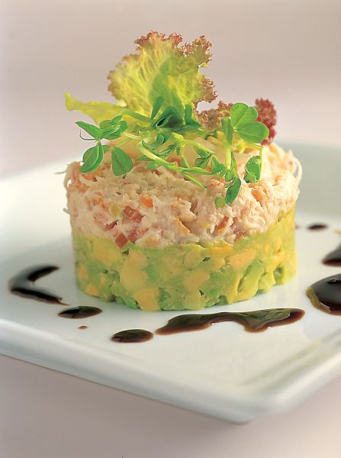
Tian of Whitby Crab, Chilli Tomato Concasse, Fresh Avocado, Parmesan Shard, Radish Carpaccio, Parsley Oil, Coriander Shoots
OR
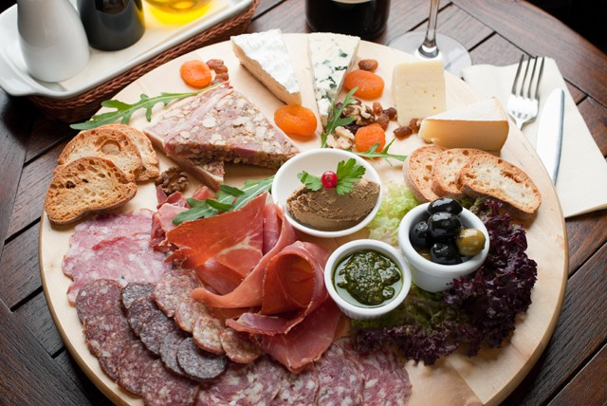
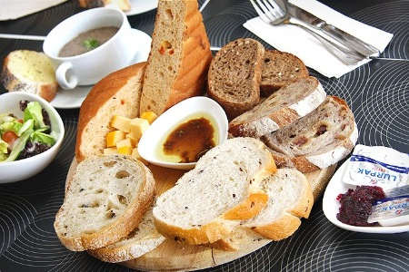
Mediterranean Cured Meat Platter, Chicken Liver Pate, Marinated Olives, Sunblushed Tomatoes, Chutneys x 1 per table
World Cheese Plate, Crostini’s, Caramelised Onion Hummus, Babba Ganoush, Char Grilled Vegetables, Balsamic Syrup x 1 per table
Artisan Bread Selection, Cornish Sea Salted Dairy Butter, Virgin Olive Oil x 2 per table
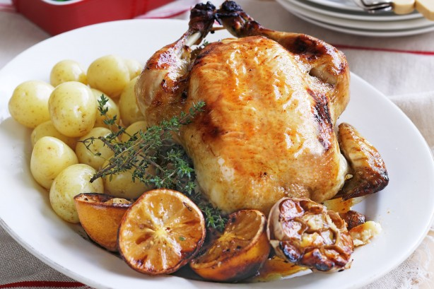
Lemon & Garden Thyme Roast Chicken x 2 per table, carved by designated chef
Goose Fat Roasties, Minted New Potatoes, Medley of Seasonal Market Vegetables, Pickering Watercress, Chicken Jus (served Family Style in White Dishes)
OR
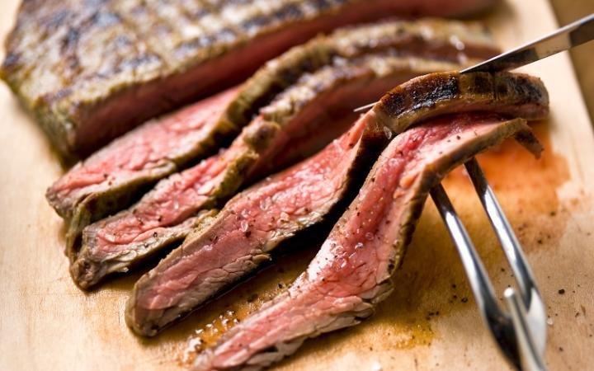

Medium Rare Roast Sirloin of Yorkshire Reared Beef – Carved at the table by the designated chef (Mini Joints)
Served with Homemade Yorkshire Puddings, Thyme Roast Potatoes, Minted New Potatoes & Medley of Seasonal Market Vegetables, Pickering Watercress, Proper Beef Gravy (served Family Style in White Dishes)
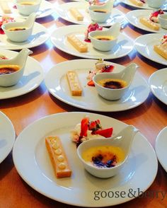
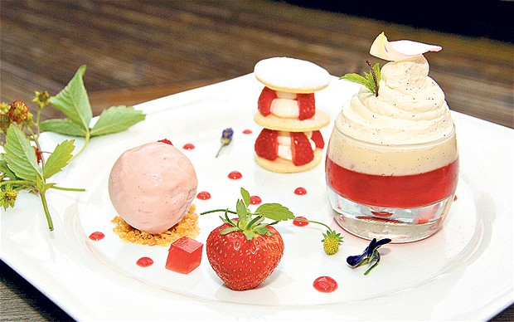
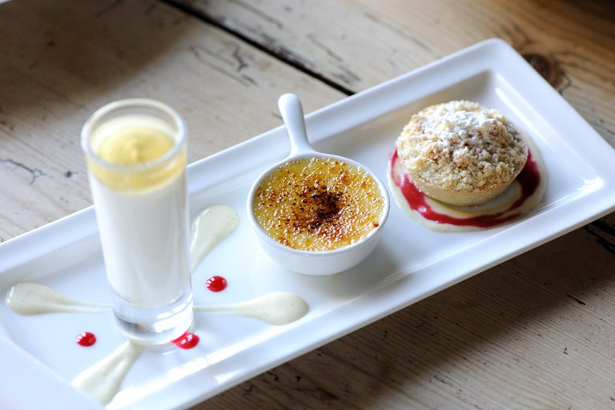

Trio of Seasonal Desserts
Raspberry Crème Brulee, Rich Chocolate Brownie, Limoncello Macerated Strawberries, Crushed Meringue, Vanilla Mascarpone
Glazed Lemon Tart, Strawberries & Cream Tuille, Summer Fruit Milkshake
Valrona Chocolate Tart, White Chocolate & Raspberry Cheesecake, Strawberry Panna Cotta
Sticky Toffee Pudding, Butterscotch Sauce, Lemon Meringue, Strawberry Shot, Citrus Mascarpone
Apple & Blackcurrant Crumble, Elderflower Jelly, Apple Brulee, Granny Smith Sylabub
Canape Suggestions (choose 3 or 4 options)
Bleikers Smoked Salmon Blinis
Beef & Horseradish Mini Yorkies/Roast Lamb & Mint Yorkies
Spiced Lamb & Coriander Kebab
Mini Fish & Chip Cones, Tartare Sauce
Goats Cheese & Red Onion Crostini (v)
Thai Style Chicken Skewers
Boccacini Pesto Bruschetta (v)
Pâté en Croûte, Caramelised Red Onions
Thai Style Pork Meatballs, Chilli Dip
Yorkshire Handmade Glazed Sausage – Choose your own Flavours (3)
Smoked Chicken Caesar Salad
Mini Vegetable Spring Rolls (v)
Smoked Duck & Pomegranate Filo Crown
Panko Coated King Prawns, Sweet Chilli Dip
Wild Mushroom Arancini Rissoles (v)
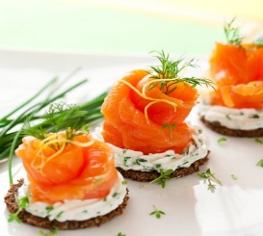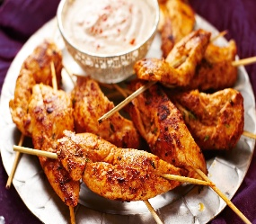
Petit Fours served after meal with coffee (suggest Mini Macaroons)
Vegetarian Options

Starter
Roast Vegetable & Quinoa Tian, Parmesan Crisp, Balsamic Syrup & Parley Oil
OR
Vegetable Sharing Platter

Main
Wild Mushroom, Stilton & Walnut Strudel, Vegi Roast Potatoes, Greens, Red Pepper Coulis
OR
Individual Shepherdess Pie, Root Vegetable Mash, Vegi Roast Potatoes
OR
Baked Aubergine “Slippers” stuffed with Bean Cassoulet & Tomato Ragout, Parmesan Gratin

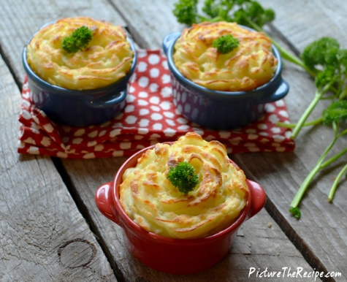
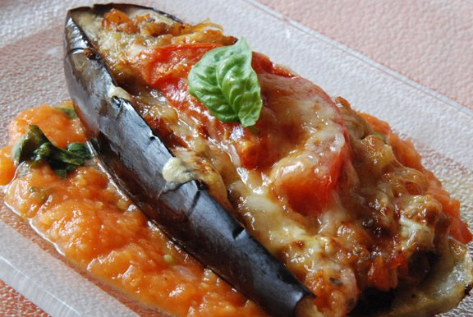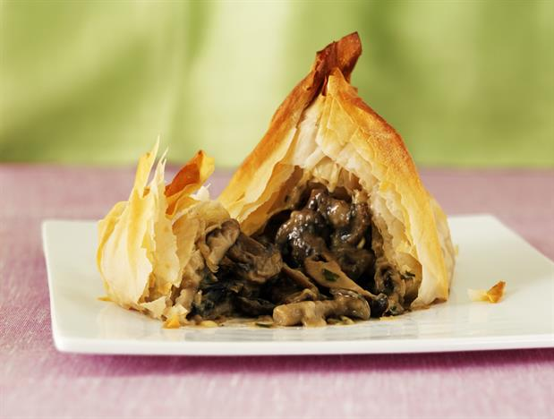

Evening Reception Food
Bowl Food……..
Please choose 2 of the following:- (vegi alternatives available)
- Thai Green Chicken Curry & Rice
- Mini Fish & Chips
- Lamb Tagine & Cous Cous
- Mini Sausage & Mash, Onion Gravy
- Mini Hotdogs, American Mustard, Ketchup
- Pulled Pork Sliders & Fries
- Mini Cheese Burgers, Relish & Gem Lettuce, Fries
- Pork Pie, Peas, Mint Sauce
- Hot Chilli with Rice & Homemade Tortilla Crisps
- Chicken Tikka Massala, Rice, Mini Naan

Hog/Beef Roast served in Soft floured Baps, Seasoned Potato Wedges (Vegi Option Available) – served to your guests around the room

Handmade Cheese Burger Sliders/Mini Hotdogs/BBQ Pulled Pork Ciabatta, Seasoned Potato Wedges (Vegi Option Available) – served to your guests around the room

Traditional cold meat/cheese/salads/nibbles buffet – served from a central buffet table

‘Cake of Cheese’ – a tower of cheeses tiered to look like a wedding cake. Served with oatcakes, celery, grapes, fresh Figs & Chutney’s – guests to help themselves

