

CH Tasmara Golden Highjinxs CD WC AGN AGNJS AGNS

April 16, 1999 - October 20, 2008

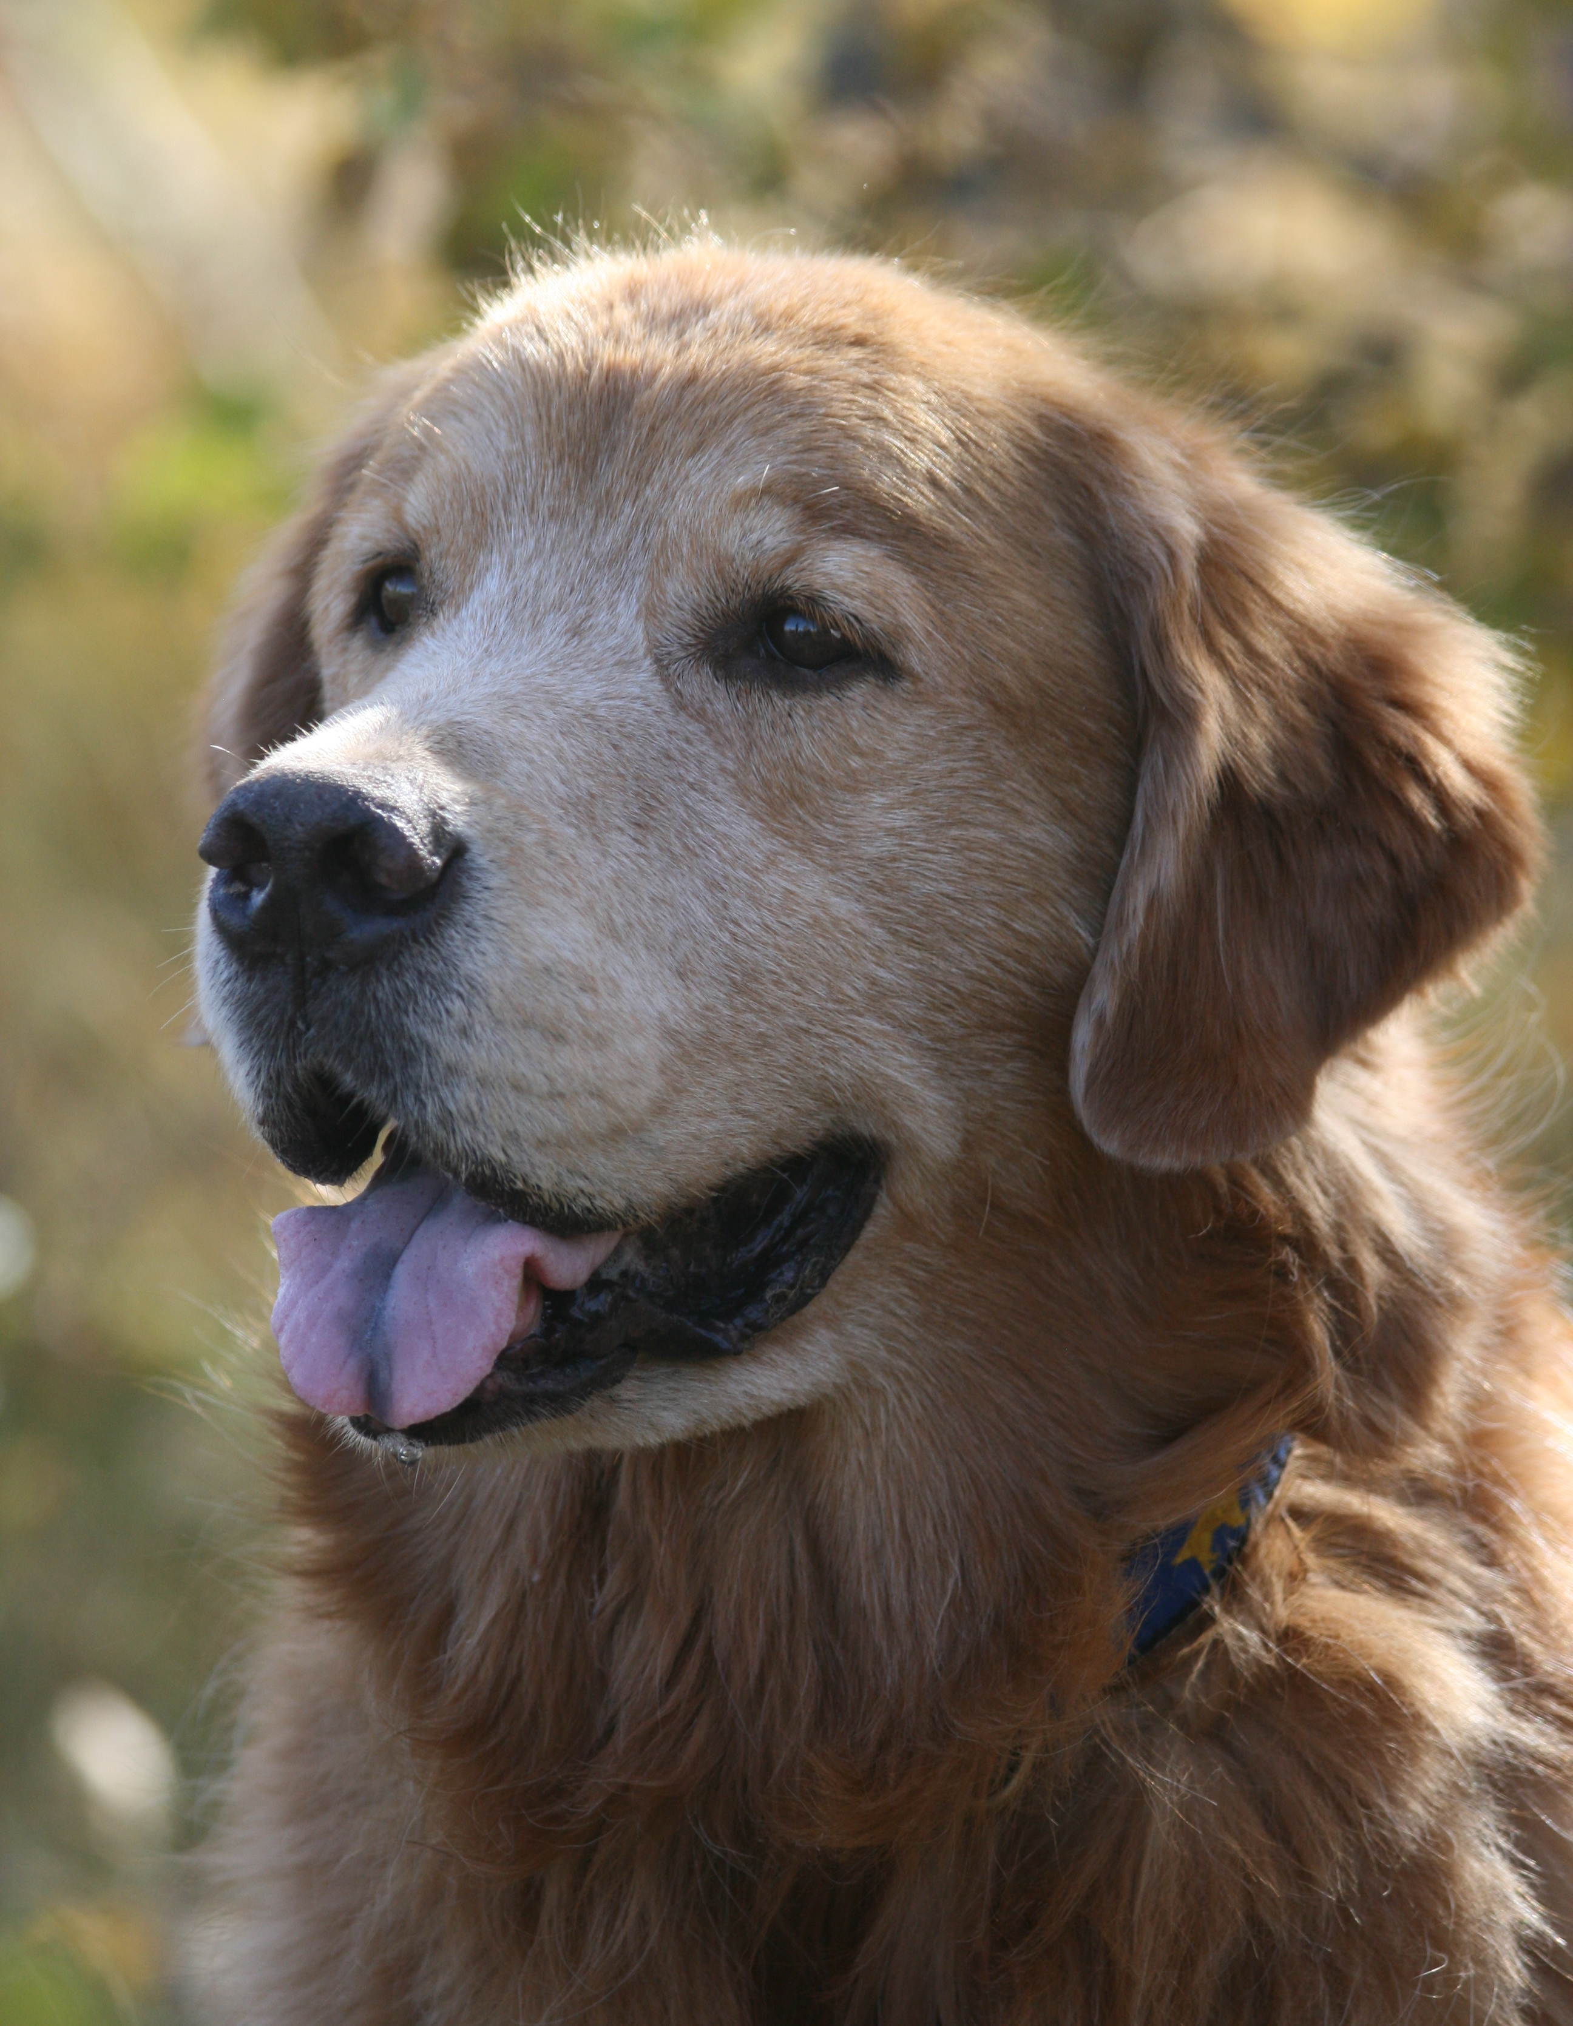

Jinx was not the most titled dog, nor the most well behaved…. but he was beautiful and my dear friend. He taught me patience and humility. He was taken from me far too soon, we were just beginning to enjoy our “golden” years together.

Jinxy, I’m so sorry I couldn’t protect you from the evils of cancer.
Rest well my sweet boy, you were loved immensely and will always be remembered.
Until we meet again……..

Leanne Tucker & Cedar

