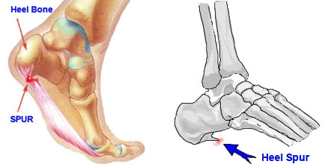

Heel Spurs / Bone Spurs

- Bone Spurs are caused by an imbalance in minerals, and often form on heels, shoulder joints, etc.

- Some people have had success in dissolving them by consistently consuming the following daily …

  - 2 Vita Lea
  - 4 to 6 Super Cal-Mag in Canada / Vita Cal or OsteoMatrix in U.S.
  - 12 to 20 Alfalfa
  - Vitamin C - 4 to 8 daily
  - Note: some people need additional Magnesium & Potassium, in which case, VitalMag would be the ideal answer

Testimonies:
Ruth Marin reports the following: “Because of intense pain, I could no longer lift my arm. I went to the Doctor and he took x-rays, which revealed 5 spurs in my shoulder joint. He began to treat me with 1,600 units of Motrin per day. My sister called and asked, ‘Why don’t you try Shaklee? What do you have to lose?’ I agreed to take 3 Calcium/Magnesium, 1 Vita Lea morning and evening, and 15-20 Alfalfa throughout the day. I added 6 Vita-C (500 mg) and one Herb-Lax. In one week, I noticed a difference, so I cut back on the Motrin. Within 6 weeks, I stopped taking the Motrin. I have very little pain now. Four months later, my doctor’s follow-up x-ray showed the spurs were almost gone. He said, ‘Whatever you’re doing, keep it up.’”

