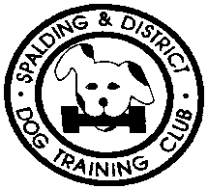
SPALDING & DISTRICT

DOG TRAINING CLUB

SCHEDULE OF 6 CLASS OPEN OBEDIENCE SHOW (CAPPED)

(Held under Kennel Club Rules and Regulations G and licensed by the Kennel Club Limited)
at
THE SNOWDON RECREATIONAL GROUND, CROWLAND, PE6 0LN
on
SUNDAY 18th July 2021
Show Will Open at 9.00am. Judging Will Commence at 10.00am.
PLEASE NOTE – There will be NO ACCESS to the ground before 8.30am

The Show Will Close ½ an hour after all judging has been completed.

ENTRY FEES:
£6.00 Per Dog per Class ~ N.F.C. - Free (ALL details to be recorded)
Dogs may enter two classes for which they are eligible for at this Show, their lowest class plus ONE other
Cheques payable to Spalding & District DTC
Online entries accepted via WYD
www.withyourdog.co.uk

The Officers and Committee members of the society / or the licensee holding the licence are deemed responsible for organising and conducting the show safely and in accordance with the Rules and Regulations of the Kennel Club and agree to abide by and adopt any decision of the Board or any authority to whom the Board may delegate its powers subject to the conditions of Regulation G40. In so doing those appointed as officers and committee members, or the licensee, accept that they are jointly and severally responsible for the organisation of the show and that this is a binding undertaking.

CHIEF STEWARD/COVID OFFICER: Dot Asplen
ENTRIES CLOSE: MONDAY 7th June 2021 (1st Class PM)
Eligibility: In estimating the number of awards won, all wins up to and including
Monday 31st May 2021 shall be counted when entering any class at this show.

PRIZE CARDS AND ROSETTES TO SIXTH PLACE IN ALL CLASSES
No run offs will take place at this show

SHOW SECRETARY: Debbie Back
Telephone: 07979 962230 (not after 10pm.)
Email: spaldingdtc@hotmail.co.uk

RUNNING ORDERS WILL ONLY BE POSTED ON THE S&DDTC WEBSITE AND ON OBUK UNLESS SPECIFICALLY REQUESTED
(www.spaldingdtc.com – www.obedienceuk.net)

CLASSIFICATION AND JUDGES
Judges must be qualified in accordance with the Kennel Club Obedience Show Regulations (G)

CLASS JUDGE RESERVE
- Prebeginners Jan Corr (extra judge sought if needed)
- Beginners Jan Corr Not before 11 am
- Novice Glenys Grimes Kathy Woodgreaves
- Class A Carole Hanney Louise Healey
- Class B Tracy Ansell
- Class C Pat Batchelor

Classes capped at; Prebeginner/Beginner – 35 entries, Novice and A – 100 entries, B 45 entries and C – 40 entries

STAY EXERCISES IN OBEDIENCE COMPETITIONS WILL BE SUSPENDED UNTIL 31 DECEMBER 2021
Beginners start time will be confirmed with running orders

Hon. Veterinary Surgeon On Call
SUTTERTON VETERINARY HOSPITAL
Station Rd, Sutterton, Boston PE20 2LF. Tel: 01205 345345
(All expenses to be paid by owner/handler)

RULES AND REGULATIONS

These Rules and Regulations are to be read in conjunction with The Kennel Club Obedience Show Regulations G under which this show is licensed. It is the responsibility of everyone entering the Show to make themselves familiar with the Kennel Club G Regulations, available from the Kennel Club.

- Dogs entered at Kennel Club Licensed Obedience Shows must be registered at the Kennel Club in accordance with the Kennel Club Regulations for Classification and Registration B.
- All dogs registered and resident outside the UK must be issued with a Kennel Club Authority to Compete number before entry to the show/event can be made. All overseas entries without an Authority to Compete number will be returned to the exhibitor/competitor
- Only dogs of six calendar months of age and over are eligible for competition at Kennel Club licensed Obedience Shows
- A dog must not compete in the same class more than once, including special classes.
- Organisers of Open Obedience shows may set a capping level on the entries to be accepted in any standard or special class, and may decline entries received after the capping level has been reached. Classes capped for each class at; Prebeginner and Beginner – 35 entries (extra judged sourced if required), Novice and A – 100 entries, B - 45 entries and C – 50 entries.
- Not for competition entries will be accepted for dogs aged four calendar months and over. Dogs must be Kennel Club registered with their full details recorded on the entry form.
- Entries may be made on-line via ‘With Your Dog’ (WYD)
- Running orders will only be available on line at www.spaldingdtc.com and www.obedienceuk.com and by email via WYD, unless otherwise requested on entry form.
- The Committee reserves to itself the right to refuse entries.
- In the event that the show is cancelled due to unforeseen circumstances, the society will refund fees, less reasonably incurred expenses. If the show processor has the provisions to do so, competitors will be refunded in the manner in which they had entered the show, but in any event the society will refund fees within 3 months of the show date to all those who had entered and requested a refund within 1 month of the show date.
- In classes without a full running order dogs will be received until one hour after the commencement of judging (11.00) after which no dogs may be received except under unforeseen and exceptional circumstances and by special permission of the Show Management, excluding Beginners. COVID INCLUSION: Classes will have a partial running order drawn with remaining competitors booking in and selecting a time slot to compete.
- Stay exercise in obedience competitions will be suspended until 31 December 2021
- For the duration of the show all dogs, including those in the exercise area must be on a lead except when competing or practising prior to competition.
- The mating of bitches within the precincts of the competition is forbidden.
- The dog should be led into the ring for judging with a smooth collar or half check collar, with lead attached (unless otherwise directed) and should be at the handler’s side.
- Animals allowed in Event No animal other than one officially entered shall be brought into the precincts of the event during its continuance, except any dogs registered to assist the disabled, or dogs required for educational or instructional purposes or by permission of the Board. However, at the discretion of the show society, a dog brought to the show by a spectator may be admitted into the precincts of the dog show, with the proviso that those in charge of the dog sign a declaration confirming the dog is free from disease and that the dog will be kept under proper control at all times.
- Following discussion between the Chief Steward and the show management and/or a veterinary surgeon, a dog shall be prevented from competing and/or removed from the Show if it is:-
a. A bitch which is in season
b. Suffering from any infectious or contagious disease
c. Interfering with the safety or chance of winning of an opponent
d. Of such temperament, or is so much out of control, as to be a danger to the safety of any person or other animal.
e. Likely to cause suffering to the dog if it continues competing
The circumstances of such a removal shall be recorded in the show Incident Book and submitted to the Kennel Club.
- Dogs will be disqualified if proved to have been handled by the scheduled judge’s spouse or immediate family, or resident at the same address as the scheduled judge.
- No person shall carry out punitive correction or harsh handling of a dog at any time within the boundaries of the Show.
- No competitor shall impugn the decision of the Judge or Judges.
- Should a judge be unable to fulfil the appointment to judge the Committee reserves the right to appoint another judge
- Should circumstances so dictate the Society, in consultation with the judges, may alter arrangements as necessary. Such changes and the circumstances surrounding them will be reported to the Kennel Club
- No prize money is on offer
- Dogs entered at this Show will be entirely at the owner’s risk. The Committee will not accept responsibility for loss, damage or injury howsoever caused whilst at the Show. PLEASE NOTE: Parents/Guardians are to be held responsible for any/all damage caused by children in their care.
- Remedial action will be taken in the event of any dog found to be in distress, which has been left in a vehicle.
- Entries close MONDAY 7th June 2021 – 1st Class PM. Wins up to Monday 31st May to be counted towards progression.
- DOGS IN VEHICLES ON HOT DAYS Your dog is vulnerable and AT RISK if left in a vehicle in high temperatures and even on days considered as slightly warm. Please take care of your dog. If your dog is found to be at risk forcible entry to your vehicle may be necessary without liability for any damage caused.
- WELFARE OF DOGS - A competitor whose dog is entered at a Kennel Club licensed event should take all reasonable steps to ensure the needs of their dog(s) are met, and should not knowingly put their dogs’ health and welfare at risk by any action, default, omission or otherwise. A breach of this Regulation may be referred to the General Committee for disciplinary action under Kennel Club Rules and Regulations. The use of pinch collars, electronic shock collars or prong collars is not permitted at any Obedience show licensed by the Kennel Club. This shall apply at the venue and within the precincts of the show.
- Food and/or toys shall not be carried or given to a dog under test except in Introductory Class where silent toy and food rewards may be used between and after exercises and in a Special Class if specified in the class definition. Competitors must not distract other dogs when rewarding their dog with food, toy or play. (Refer to Obedience Code of Conduct)

DOGS IN VEHICLES ON HOT DAYS

** Your dog is vulnerable and at risk during hot weather and the Kennel Club offers the following guidance to help guide you through the do’s and don’ts of travelling to and whilst at KC licensed events.
- When travelling to a show please take a moment to consider whether the route to the show is on a busy holiday route, and leave early to avoid increased time in traffic jams
- Ensure your dog is not sitting in full sunlight. There should be plenty of free-flowing air around the dog
- Keep the dog in the shade – take your own shade for example a large umbrella and always have plenty of water available to drink so your dog stays well hydrated
Remember, if you feel hot your dog is very likely to feel much hotter and dehydrated, and this could lead to dire results. Please look after your dog’s welfare.**

Anyone whose dog is entered at a Kennel Club licensed event should take all reasonable steps to ensure the needs of
their dog(s) are met, and should not put a dog’s health and welfare at risk by any action, default, omission or otherwise. Breach of Kennel Club Regulations in this respect may be referred to the General Committee for disciplinary action
under Kennel Club Rules and Regulations.

DEFINITIONS OF CLASSES

- In the following Definitions of Classes First Prize wins in Limited Show Obedience Classes and Open Shows confined to one breed do not count for entry in Open and Championship Obedience Classes but do count for eligibility at Limited Obedience Shows or Open Shows confined to one breed.
- A dog must be entered in the lowest scheduled class for which it is eligible and may also be entered in another class if desired plus one additional class at the society’s discretion. (No additional class to be entered at this show)
- Societies may schedule classes other than those defined below. The eligibility for ‘special’ classes must be defined by the society and included in the schedule. The word ‘special’ must be included in the title of the class.

PREBEGINNERS: To compete in Pre-Beginners a handler or dog must not have won two 1st Prizes in either Pre-Beginners or Beginners nor gained a third place or above in any other obedience class. (Introductory Class excepted.)
BEGINNERS: To compete in Beginners a handler or dog must not have won a total of two or more 1st prizes in Beginners Class or one 1st prize in any other Obedience Class. (Introductory Class and Pre-beginners excepted.)
NOVICE: For dogs, which have not won two 1st prizes in Obedience Classes (Introductory Class, Pre-beginners & Beginners excepted)
CLASS A: For dogs, which have not won three 1st prizes in Classes A, B and Open C in total
CLASS B: For dogs, which have not won three 1st prizes in Class B and Open Class C in total.
CLASS C: At Open and Premier Shows, and in the Open C Classes held at Championship Shows, open to all dogs

Right to Refuse Entries: Exhibitors/Competitors are reminded that show societies have the right under Kennel Club Regulations to refuse any entry.

COVID INCLUSION: The Society will ensure to the best of its ability that the event is run to Covid Safe guidelines. It is your responsibility to ensure you comply with national and local restrictions including advice given about non-essential travel in and out of locally affected regions (which must not be ignored) -in the interests of the safety of all participants this may give rise to a short notice refusal of entry at the society’s discretion. The Kennel Club will respect the society’s exercise of its discretion. If anyone has Covid-19 related symptoms or has tested positive for Covid-19 they must isolate in line with Government advice. Face masks may be worn at the individual’s discretion including whilst working.
SOCIAL DISTANCING AT ALL TIMES. HANDS - FACE - SPACE

THE SNOWDON RECREATIONAL GROUND,
CROWLAND, PE6 0LN
(Postcode – The Chase; Car Park Entrance)

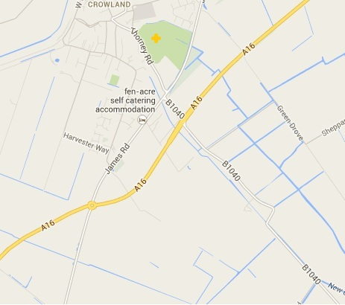
Competitors PE6 0LN

Boston

Judges/Stewards/Helpers
PE6 0EN

Peterborough

Taken from KC specimen schedule – WT07/CAT: November 2020 (Version 25)

ENTRY FEES (Cheques/POs payable to Spalding & District DTC)

______ entries @ £6.00 per dog per class £ _________

______ Not for competition FREE £ FREE
(All details must be stated on entry form)
TOTAL: £ _________
On no account will entries be accepted without fees
Please circle one of the following - if a class has reached its limit

ENTRIES (WITH CORRECT FEES) MUST BE PREPAID AND SENT TO THE SHOW SECRETARY:
c/o, 68 Albert Street, Spalding, Lincs PE11 1LA
Tel: 07979 962230 (not after 10pm)

ENTRIES CLOSE: Monday, 7th June 2021 or when cap is reached
Wins up to and including Monday, 31st May 2021 must be counted when entering any classes.

RUNNING ORDERS WILL BE AVAILABLE ON THE S&DDTC WEBSITE AND ON OBUK UNLESS SPECIFICALLY REQUESTED – WYD WILL SEND OUT TO ALL REGISTERED USERS
(Please send running order by post/email* *delete as appropriate)

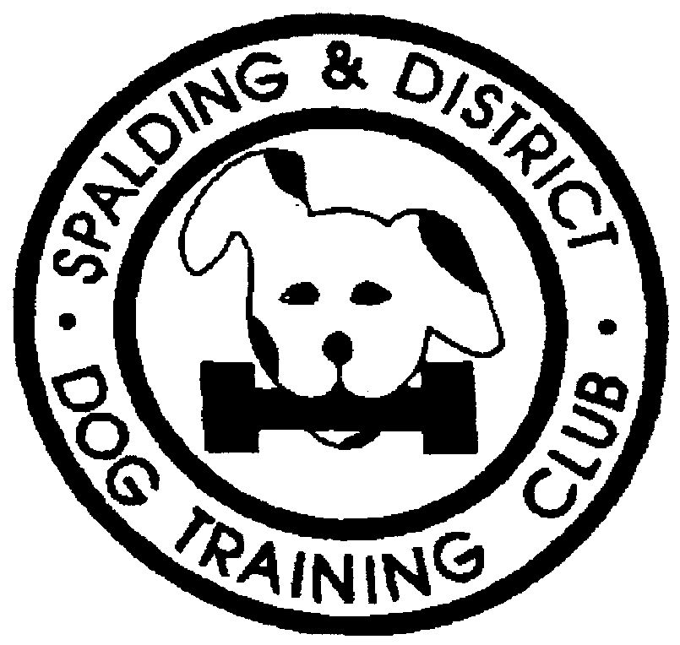

SCHEDULE OF 6 CLASS CAPPED OPEN OBEDIENCE SHOW
(held under Kennel Club Limited rules and regulations G)
at
The Snowdon Recreational Ground, Crowland, PE6 0LN
on
Sunday, 18th July 2021

SPALDING & DISTRICT
DOG TRAINING CLUB

INSTRUCTIONS:
This form must be used by one person only (or partnership). Writing MUST BE IN INK OR INDELIBLE PENCIL. Use one line only for each dog. The name of the dog and all the details as recorded with the Kennel Club must be given on this entry form. If an error is made the dog may be disqualified by the Committee of the Kennel Club. All dogs must be REGISTERED at the Kennel Club and if a registered dog has changed ownership, the TRANSFER must be registered before the date of the Show. Puppies under 6 months of age on the first day of the Show cannot be entered for competition. On no account will entries be accepted without fees. If a dog is in the process of Registration or Transfer at the time entry is made, add the letters NAF or TAF as appropriate after its name. For new registrations, the first choice name on the Registration Application form should be used. Please put classes in numerical order and USE BLOCK CAPITALS throughout when completing this entry form. PLEASE CHECK ALL DETAILS BEFORE POSTING.

REGISTERED NAME OF DOG  Followed by K.C. Reg. No. (or *ATC No.) | BREED | SEX  D/B | FULL DATE OF BIRTH | BREEDER | SIRE | DAM | CLASSES ENTERED  (Class No)
*KC/ATC No.
*KC/ATC No.
*KC/ATC No.
*KC/ATC No.

*The Kennel Club Registration Number or Authority to Compete Number (for dogs resident/registered outside the UK) must be stated or the entry will be returned. *The appropriate number must also be stated for dogs entered Not for Competition.
Your dog is vulnerable and AT RISK if left in a vehicle in high temperatures and even on days considered slightly warm. Please take care of your dog.
In the case of joint registered ownership, the name of every owner must be given here

Name/s: ___________________________________________________

Address: ____________________________________________________

__________________________ Postcode: _________________

Telephone: ________________________________________

E-mail: __________________________________________

Your address will not appear in the catalogue
Please see our privacy notice for how we keep your data safely and compliantly
If your dog is found to be at risk, forcible entry to your vehicle may be necessary WITHOUT liability for any damage caused.

DECLARATION
I/We agree to submit to and be bound by Kennel Club Limited Rules & Regulations in their present form or as they may be amended from time to time in relation to
all canine matters with which the Kennel Club is concerned and that this entry is made upon the basis that all current single or joint registered owners of this
dog(s) have authorised/consented to this entry. I/We also undertake to abide by the Regulations of this Show and not to bring to the Show any dog which has
contracted or been knowingly exposed to any infectious or contagious disease during the 21 days prior to the Show, or which is suffering from a visible condition
which adversely affects its health or welfare.
I/We further declare that, I believe to the best of my knowledge that dogs are not liable to disqualification under Kennel Club Obedience Show Regulations.
.
Usual Signature of Owner(s): _______________________________________________ Date: _____________

ALL registered owners must sign here unless the signatory holds written authority and consent from other joint registered owners to sign on their behalf;
evidence of such authority may be required.
NOTE: Dogs entered in breach of Kennel Club Show Regulations are liable to disqualification, whether or not the owner(s) was/were aware of the breach.
NOTE: Children under the age of 11 are the responsibility of a Parent or Guardian and must be supervised at all times including when competing.

Web

