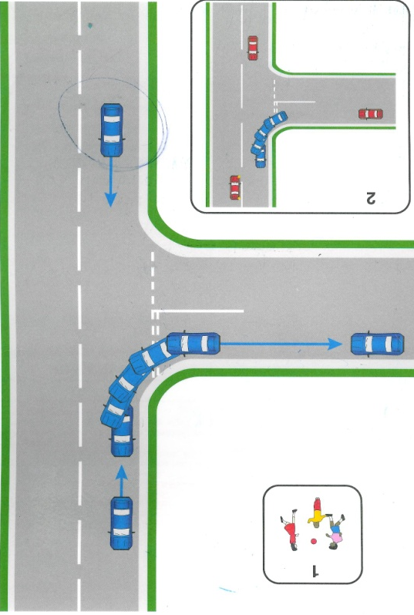
Your aim for this manoeuvre is to reverse round the corner keeping reasonable close to the kerb without touching the kerb
Before you attempt to reverse left round a corner take in some information about the area
- Is the area safe, legal and convenience
- Assess the gradient of the road and how this would affect the control of the car
- Assess the contour of the bend is it Right angled, long or a medium bend.

Pull up to your starting position leaving 2 car lengths from the bend of the corner. (This is so that other vehicles can see when attempting to come out of the junction)

- From the starting position prepare the car by selecting reverse gear
- Observe all round to make sure it is safe to move
- Straight line reverse back at a crawling pace (snail)
- Before you reach your POT observe all round to ensure it is safe to steer round the bend)
- At your POT steer 45min = medium bend, 30 min = long bend and full lock = right angle bend.
- Check passengers exterior mirror to check you are reasonably close to the kerb
- If happy with your position make all round observations
- If the car is coming too close to the kerb take 5 min at a time off (right, towards you) until you are happy with the position
- If the car is going to wide from the kerb add on (left, towards kerb) 5 min at a time until you are happy with the position
- Again if you are happy with the position of the car make all round observations
- Once you are at the peak of the bend allow the car to come round until the kerb meet the middle of the rear wiper or when the kerb looks parallel to the kerb in the mirror.
- Straighten the wheel
- Straight line reverse back making all round observation until the car is 2 car length from the junction
- If the car starts to go wide or too close to the kerbs as you reverse adjust accordingly

If other road users (pedestrians, cyclists or vehicle) you must give way to find out what they will do. If a car wanted to come out of the junction you must stop and pull out to the starting position again. Give way to vehicles as they approach closer to the junction and before you attempt to steer round the junction.
What can go wrong? Pace too fast, leaving little time to correct, lack of observations, missing POT, not identifying distance form kerb, Hitting kerb and crossing over to other side of the road.

