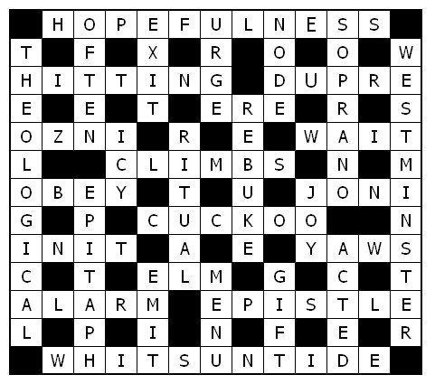

Service times at St Mary’s
Sunday: 10:30am Holy Communion
or Morning Prayer
Normally the first and third Sunday is Holy Communion with Morning on the second and fourth.

Tuesday: 10.00am Holy Communion
12.15pm Lunch-time Service

Wedding, Baptism, Funeral and other services by arrangement with the Rector.

St Mary’s and the Nave Café is open – Tuesday, Thursday, Friday & Saturday from 9.00am – 3.00pm

Readers contributions to the magazine are always welcome. Hard copy (hand written if easier) to the Rectory address or by email: to : st.marysstockport@gmail.com
Editorial discretion with regard to content and space available will apply.

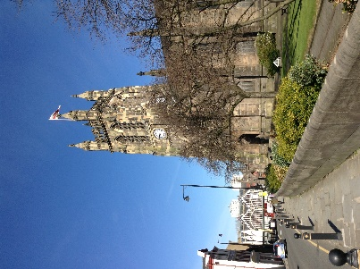
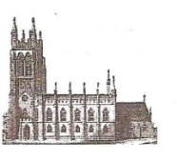
St Mary’s in the Marketplace
St Mary’s Rectory, 24 Gorsey Mount Street,
Stockport, SK1 4DU.
0161 429 6564
www.stmarysinthemarketplace.com.

St Mary’s in the Marketplace
Parish Magazine
November 2014

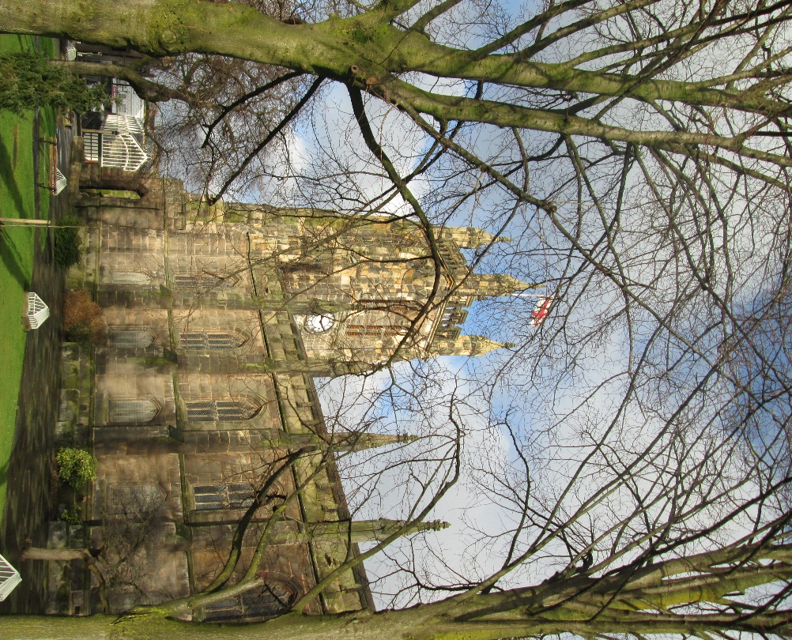

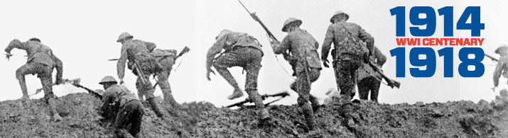
50p
From the Rector’s “ i-Pad”
Dear Reader
Remembrance Sunday this year has an added poignancy, owing to the Centenary Anniversary of the commencement of World War One in 1914.
Stockport, in common with many other northern towns, lost many souls in the four years of that terrible conflict, and their names and the memory of them will be honoured for generations to come, prompted by the multitude of fine War Memorials and Rolls of Honour in St.Mary's and throughout the Borough.
Countless families hereabouts will still recall family members ,their loved ones who paid the ultimate price, as well as those who survived, often dreadfully injured , blinded or traumatised. Shell shock left many men desperately broken and profoundly misunderstood. Today we call it post traumatic stress disorder (P.T.S.D.) and many soldiers of more recent conflicts are being treated quietly and compassionately in this country as we speak ,for this sad affliction . The work of charities like the Royal British Legion and Help for Heroes are providing invaluable on going assistance to those whose lives have been shattered by war and terrorist outrage as terrible in effect as the ravages of World War One.
It was with a mixture of horror and pride then, that I found the copy of a letter which was sent by the Senior Chaplain serving on the Front ( though I'm not sure where as yet) to my Great Grandfather, regarding his son my great uncle Cecil. You can read it for yourself on another page. One can imagine the family's relief at receiving such news.
Imagine the horror of that scene of total devastation that so nearly ended Cecil's life; ghastly, horrific. Poor men. And such sadness for their families. For many, my own family included I'm sure, it was a sadness mixed with pride in their loved ones, some of whom survived the horror of the trenches, and who like Cecil, were spared to live on, and to remember those who had fallen. Cecil, who had followed his brother-in-law George, my
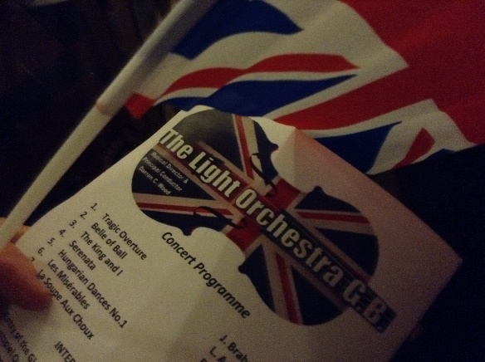
Welcome to The Light Orchestra GB
Flags at the ready as we enjoyed a Last Night of the Proms style concert at St Mary’s. It was a great success for all concerned.
Comments taken off the web:
Last Night of The Proms concert 27.09.2014 the audience loved it - lots of foot stomping, singing, flag waving- and, of course, clapping! they were a fantastic audience!!
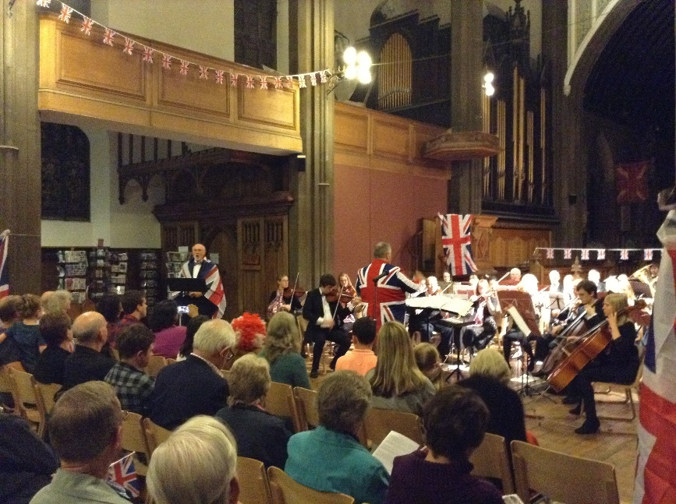
Buzzing after The Light Orchestra's performance of Last Night of the Proms at St. Mary's Church, Stockport this evening. See you all there on December 10th…!
…. My daughter and her friends loved it!

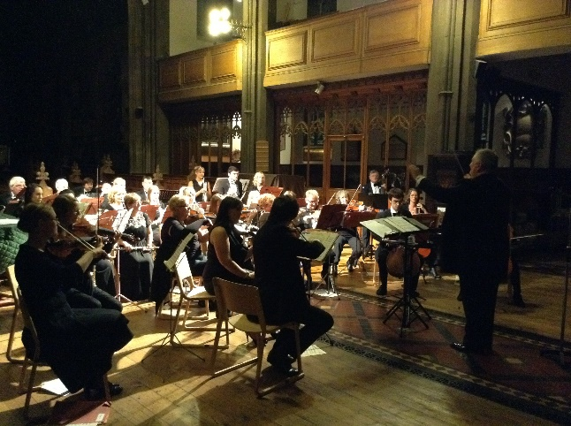
The comments say it all, the orchestra enjoyed playing at St Mary’ for the first time and the audience loved it. It was indeed a very warm welcome to the Light Orchestra GB who will return for their Christmas Spectacular on the 10th December
Tickets are already on sale on-line at . www.tlo.ticketsource.co.uk but will be available at St Mary’s in due course.

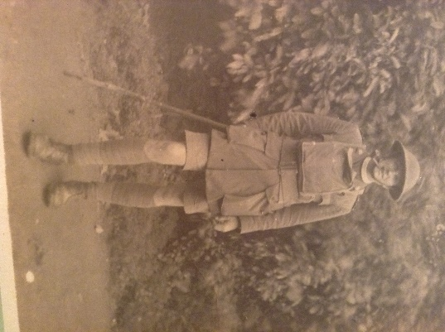
…It was with a mixture of horror and pride then, that I found the copy of a letter which was sent by the Senior Chaplain serving on the Front ( though I'm not sure where as yet) to my Great Grandfather, regarding his son my great uncle …Cecil.

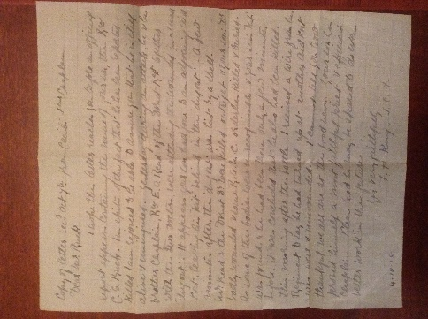
Copy of letter received October 7th from Cecil’s Senior Chaplain

Dear Mr Ruck
I hope this letter reaches you before the official report appears containing the news of your son, the Rev C S Ruck. In spite of the fact that he has been reported killed I am rejoiced to be able to assure you that he is still alive and uninjured. Yesterday during an attack, he and his brother Chaplain, Rev E O Read of the Dorset Regt together with the two doctors were attending the wounded in a small dugout”. It appears your son had gone to an adjourning Aid Post, leaving his “kit” behind in the dugout. A few minutes after the dugout was hit by a shell. Mr Read and the Dorset doctors were killed outright and your sons badly wounded and some R.A.M.C. orderlies killed and buried. As some of their bodies were unrecognisable and your son’s kit was found and he had been there only a few minutes before, it was concluded that he also had been killed.
The morning after the battle, I received a wire from his Regiment to say he had turned up at another Aid Post and was well and unwounded. I cannot tell you how thankful we all are at the good news. Your son has proved himself a most faithful priest and efficient Chaplain. Please God he may be spared to do even better work in the future.
Yours very faithfully
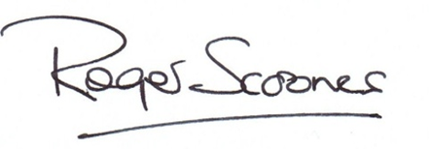
F H King
4.10.18

grandfather into the ordained ministry of the Church of England before the Great War, went on to serve God in East Africa, retiring to Canterbury after a lifetime of work the Mission known as U.S.P.G. , only to die of cancer shorty after his arrival home. As his Senior Chaplain said of Cecil, he had indeed been "spared", to do even better work in the future.
There are countless stories to be told about our family members ,who lived through those dark days of war at the beginning of the last century, the 20th Century. Like other churches and community groups I hope that we at St. Mary's may be able to find a suitably dynamic expression of this "remembering" in the coming months and years, bringing to life the memory of the men and women of Stockport and around the country, and even overseas ,those who served in the Great War, those who lived and those who died. WE WILL REMEMBER THEM!
On a more cheerful note I am glad to be able say how much we are looking forward to welcoming The Community in all its many forms , schools, charities, the business community, choirs, bands and musical groups, young and old, locals and friends from far away, to join in our 2014 Christmas Programme, which begins on Advent Sunday with a beautiful Choral Celebration with Candlelight led by the inspirational choir ,the much loved Maia Singers .
I have already heard a number of adverse comments about shops preparing " too early" for Christmas, and it might well be said of churches like ours, filling Advent with Carol Services and Concerts!
Personally speaking and from 18 years experience of offering this programme to The Community, I cannot think of a better or more appropriate way of preparing for Christmas than by attending one of these lovely events in our beautiful Parish Church. I look forward to welcoming YOU, DEAR READER, and your family and friends, to St.Mary's in the coming weeks. Thank you for your continuing support.
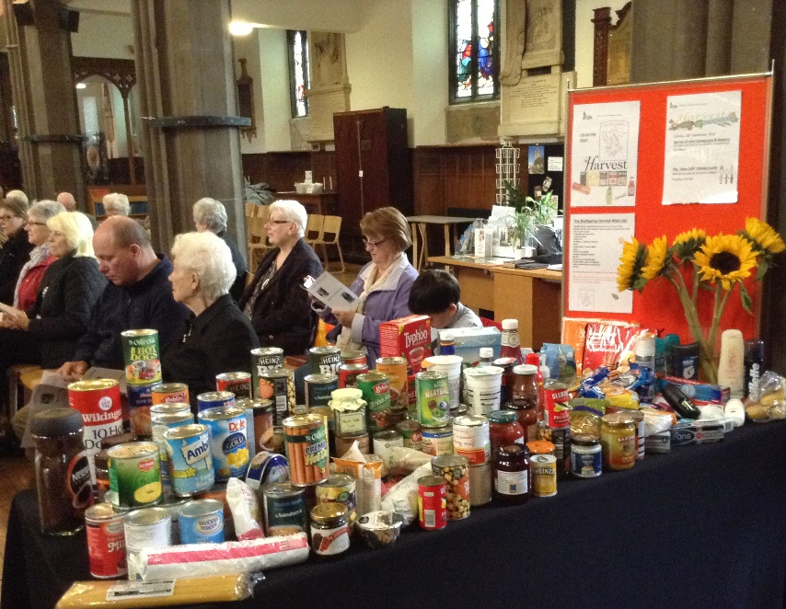
Harvest at St Mary’s – a fantastic contribution
- without doubt a year of plenty!
Once again many thanks to everyone who contributed to the “Harvest Collection for The Wellspring”. It was indeed a bumper crop of tins and toiletries which will be much appreciated by those in need of our support at this time of their lives.

Also…..
Thank you to those who attended our “Harvest Lunch”. Our numbers were relatively small this year, however the event offered the opportunity for talking and sharing a meal with friends and the added bonus of raising £112 towards church funds.
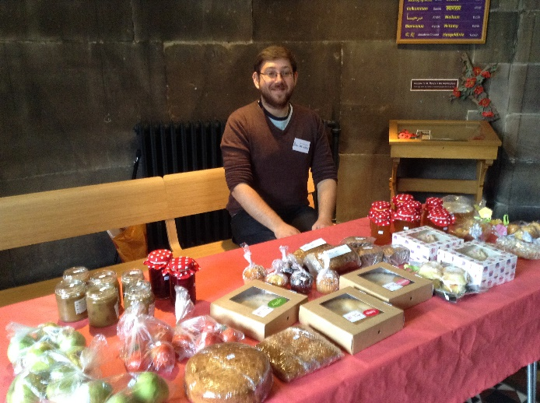
And then there was the “The Tower Produce Stall”…
Again many thanks to all those who contributed home grown produce, cakes, jams and pickles etc. We had a lovely display and generated £52.00 towards church funds.
Shown here is Adam, holding the fort, thanks to all our other volunteers who took a turn on the stall and to everyone who support the event.

MacMillian Coffee Morning
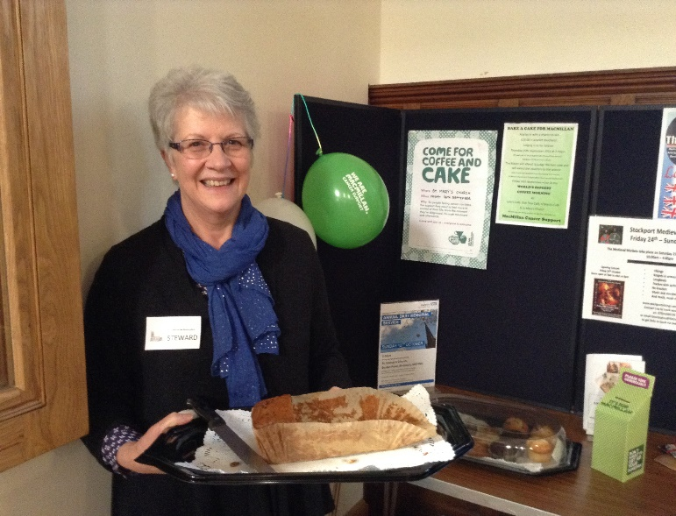
The magnificent sum of £186.22 was raised at the joint coffee morning sessions held at Lynn’s Café, Oak Tree Café, O’Mara Café and St Mary’s Nave Café. Our donation to the cause being £67.00. Thanks to everyone who made cakes and supported the event.
Shown here is Cartriona with her own cake – well what’s left of it!
Down but not beaten - In the last edition of this magazine we wished Roger “all the best” following his unfortunate trip and slip. He had of course suffered the indignity of flying through the air when slipping on the train of a wedding dress at the conclusion of a marriage service at St Mary’s - breaking his hand in the process. Somehow the incident was transmitted rapidly across the media and reported in much of the local and national press. For a moment Roger was down but not beaten, his injured hand recovering well . David Andrews has penned this poem to record the event.
A Vicar we know called Scoones,
Had a forte for starting hymn tunes,
At a wedding one day, to the brides dismay,
The vicar did slip on her train,
He flew through the air,
And gasped in despair,
But the bones are setting OK!
Calling all ladies and gentlemen (with a voice for singing Christmas carols & songs) to join the “St Mary’s Singers” for their performance at our special Christmas lunch-time service on the 23rd December. Rehearsals to be held each Tuesday (after the lunch-time service) – all welcome.
Lovingly Restored – these two Rolls of Honour – Stockport Parish Church Day School Old Boys & Stockport Parish Church Sunday School
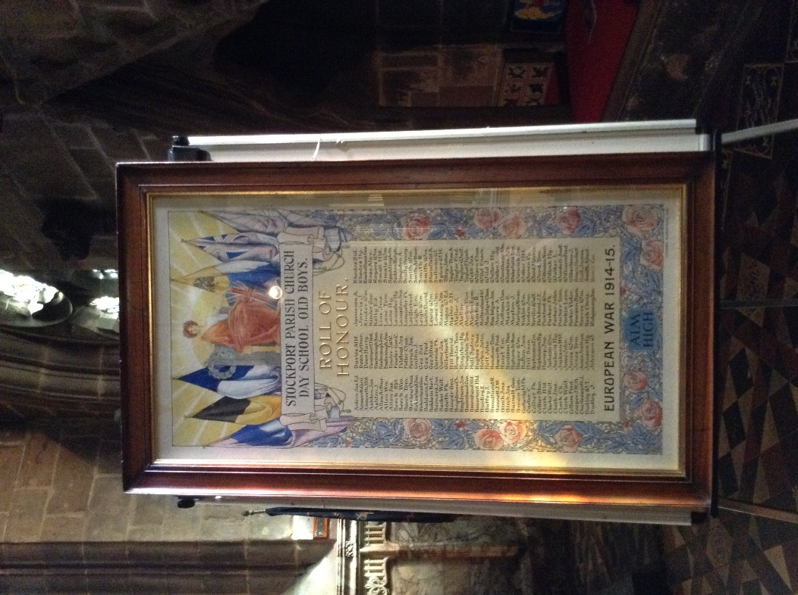
The sun shines through the stained glass window at St Mary’s on these two recently restored Rolls of Honour.
The two Rolls of Honour, which were once on display in Church have been partly restored, remounted and reframed by Mr Graeme Storey of Britton and Storey, Art Conservation of Shropshire, as a personal gift to St Mary’s in this Anniversary Year 2014.
The quality of the art work and calligraphy, and the significance of the two framed Rolls of Honour deserved and have the best professional care available. Graeme Storey who has done significant art conservation work with The National Trust, The Council for the Care of Churches, The University of Manchester and the Tate Gallery, to name but a few eminent institutions, has made this most generous gift to St Mary’s to make this historic anniversary to the lasting benefit of our Church and Community, for which we thank him most sincerely.
www.brittonandstorey.co.uk
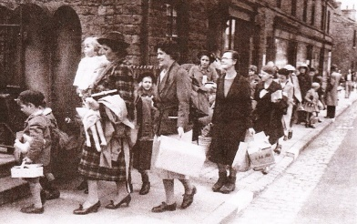
Saturday, 8th November 10.00am – 1.00pm We’ll Meet Again
Gillian Mawson .
Discover how 17,000 Guernsey children, teachers and parents adjusted to life in northern England during the Second World War.
- See their wartime documents and photographs and look inside a real evacuee’s suitcase which still contains some of the original contents.
- Read their Red Cross messages and write your own, and view our wartime displays.
- Enjoy listening to The George Formby Experience ‘live’.
- Share your own memories with Stockport Heritage Trust.
Something for all ages, ideal for school projects, refreshments available, 1940s dress optional.
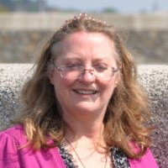
In 2008 Gillian Mawson set out to examine the experiences of evacuated Guernsey civilians. She interviewed people in Guernsey as well as many of the former evacuees who remained in England at the end of the war. As you would expect, some had passed away by the time the research began, and numbers decline year on year. BUT… there were/are stories to be told, many extremely emotional.
Little did Gillian know six years ago just how much her work would actually change her life, especially since 2010 - when she was involved in the organisation of a number of events which marked the seventieth anniversary of the evacuation. Her work has continued from strength to strength, including having written and published “Guernsey Evacuees – The Forgotten Evacuees of the Second World War”(2012). She has become an established award winning freelance researcher, writer and broadcaster - speaking on BBC Radio in both Manchester and Guernsey as well as making television appearances. Gillian gives talks, provides workshops for schools, has created a documentary film. She is without doubt a busy lady heavily involved in community engagement etc. We are delighted to welcome her to St Mary’s and to host this event – do come it will be a wonderful experience for all ages. We also look forward to her return next year (2015) with some of the surviving evacuees for a special 75th Anniversary Service.
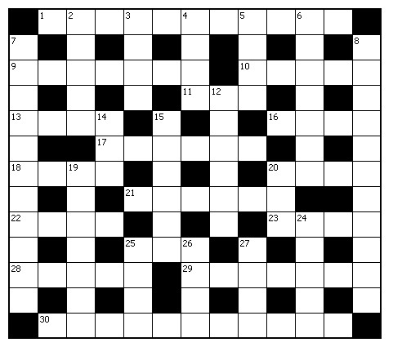
cross:
1 and 20 Down ‘Lord of all — , Lord of all — , whose trust, ever child-like, no cares could destroy’ (11,3)
9 Moses’ question to a fighting Hebrew labourer: ‘Why are you — your fellow Hebrew?’ (Exodus 2:13) (7)
10 Acclaimed cellist who contracted multiple sclerosis at the height of her fame, Jacqueline — (2,3)
11 ‘At even — the sun was set, the sick, O Lord, around thee lay’ (3)
13 A descendant of Gad (Numbers 26:16) (4)
16 ‘Do not leave Jerusalem, but — for the gift my Father promised’ (Acts 1:4) (4)
17 Clambers (Jeremiah 48:44) (6)
18 Peter’s response to questioning by the Sanhedrin: ‘We must — God rather than men!’ (Acts 5:29) (4)
20 Christian paraplegic author, artist and campaigner, — Eareckson Tada (4)
21 Bird partial to the nests of other birds (6)
22 ‘Such large crowds gathered round him that he got into a boat and sat — — ’ (Matthew 13:2) (2,2)
23 Infectious tropical disease (4)
St Mary’s “Knit & Natter”
(with Stockport Crafters Group)
Thursday mornings at St Mary’s is now a fun place to be – lots of laughing, talking, drinking coffee and of course “crafting”.
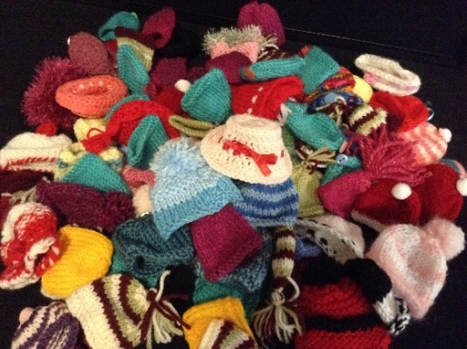
A big “thank you” to everyone who has knitted the little hats for our “Innocent Smoothie” appeal. At last count we had 87 hats in the box ready to be given to Age UK Stockport. Others are still on knitting needles or waiting to be brought into Church.
Moving on, our next knitting challenge is for child/young-adult size scarfs to put in the shoe-box presents and of course (very important) items that can be sold at the St Mary’s Christmas Fayre on the 6th December.
All welcome (boys and girls) to come and join the group, catch up with friends and make some new ones.
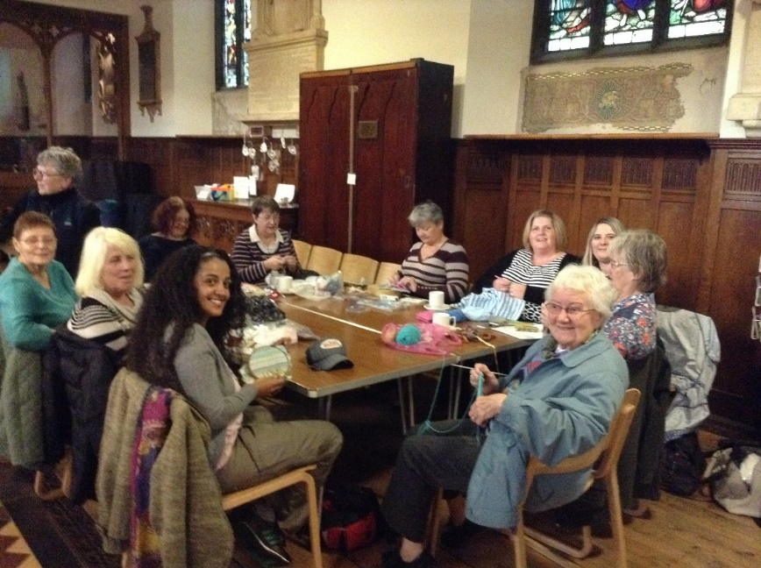

Lest We Forget - One of the most amazing sights in London this year has been the art installation 'Blood Swept Lands and Seas of Red' at the Tower of London. The dry moat has been filled with 888,246 ceramic poppies, each representing a British or Colonial soldier killed in the First World War and commemorated in this centenary year.
‘In Flanders fields, the poppies grow between the crosses, row on row, that mark our places; and in the sky the larks, still bravely singing, fly scarce heard amongst the guns below.’ - This is the first stanza of John McCrae’s poem, first published in Punch magazine in 1915. Within months, it came to symbolise the sacrifices of all who were fighting in the First World War. Today, the poppy remains a tangible symbol of all those who have sacrificed their lives in war. But why do we remember? ‘They will beat their swords into ploughshares and their spears into pruning hooks. Nation will not take up sword against nation, nor will they train for war anymore.’ (Micah 4:3). Writing about 700 years before Christ, Micah’s words have to be seen against a background of violence with the fall of Samaria and the instability created by the aggression of Assyria. However, he prophesied a future of hope, a world where nations come together in peace instead of war. His vision saw a time when the arms of war would be turned into farming tools and people would live in peaceful community.
Our understanding of peace is more than the avoidance of war or the absence of conflict. It’s about building relationships between people, communities and nations, which positively creates a love and care for others founded on justice for all. As we remember the sacrifice of those who died in the First World War, our response must be to look practically at how we can build relationships of peace and justice in our world, starting with our own families, colleagues and neighbourhoods. As Micah says, ‘we will walk in the name of the Lord our God for ever and ever.’ (4:5). We always need God’s presence and power to change us into the people who have a passion for peace and justice, and compassion for everyone.
‘They shall grow not old as we that are left grow old: Age shall not weary them, nor the years condemn. At the going down of the sun and in the morning we will remember them.’
25 Tree (3)
28 ‘No fear of me should — you, nor should my hand be heavy upon you’ (Job 33:7) (5)
29 For example, to Titus, Timothy or Philemon (7)
30 Week beginning with Pentecost Sunday, according to the Church’s calendar (11)
Down:
2 ‘O Jerusalem… how — I have longed to gather your children together’ (Matthew 23:37) (5)
3 Way out (4)
4 Exhort (Romans 12:1) (4)
5 Done (anag.) (4)
6 Highest of the four voice-parts in a choir (7)
7 Concerning the study of God (11)
8 Uniquely, it has Abbey, Cathedral and Chapel (11)
12 Admonish (Matthew 16:22) (6)
14 Frozen (3)
15 Established form of religious ceremony (6)
19 Inscription often found on gravestones (7)
20 See 1 Across
24 Behaved (Joshua 7:1) (5)
25 Time (anag.) (4)
26 Lists choice of meals (4)
27 ‘For the wages of sin is death, but the — of God is eternal life in Christ Jesus our Lord’ (Romans 6:23) (4)

“Oh yes it is” – a great afternoon out!
A booking has been made for our St Mary’s annual trip to the Plaza Panto
on Friday, 2nd January 2015 (2.30pm).

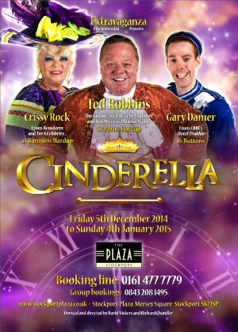
Tickets:- Adults £16.50 / Concession £14.50 and under 16 years of age £10.50.
Please book early (list available at Church) leaving us a deposit of £5.00 per ticket (balance to be paid by the 1st December).

Roger warmly invites
the “panto goers”
to a traditional seasonal
after Christmas/New Year Afternoon Tea
at
St Mary’s Rector
amidst the Christmas decorations

Further to “Looking at the Language that Jesus spoke” – by Rev. Bernard Elsdon, in September’s church magazine Chris Knight writes:
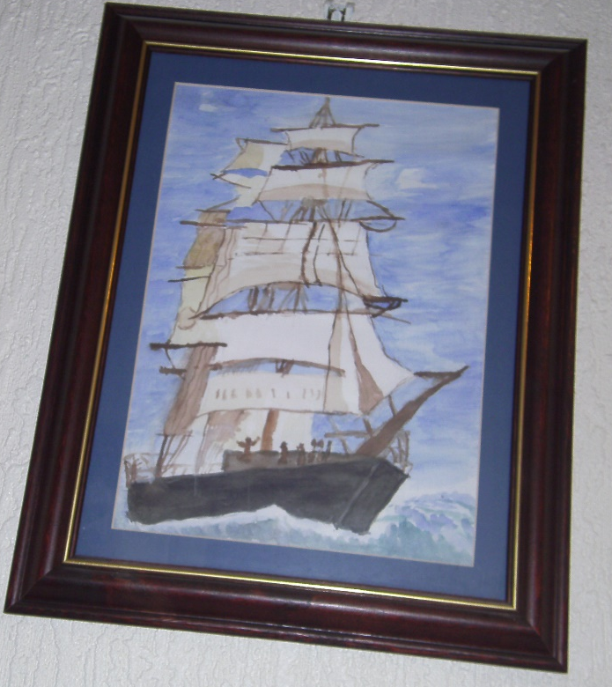
“This article reminded me of when I was being taught about the Church of England by Dr Noel Fletcher; she spoke to me about the Ancient Christians. As she saw it, they were special, because to her they were the first Christians.
Then I remembered the story of my great-great-uncle who was a sea captain. His ship (a barque) was called the Salopian. He spoke seven languages of which the last was Arabic – but alas, not Aramaic! In September /October 1880, his ship was on a voyage from Lisbon to Liverpool, and my grandfather and his sister (a great aunt who I never knew) were on board, possibly working their passage. As the ship was in a dangerous condition and the weather rough, I am glad to say they were put ashore by a pilot at Crookhaven, ending up in lodgings with a Mrs Whitten in Patrick Quay, Cork. I believe the house is now a dress shop! My great-great-uncle wanted to continue his voyage but was forced to abandon his ship a few days later and sadly died shortly after that from exhaustion”.
Does anyone else have intriguing family history tales to tell? .
[Stories will be published only as space permits]

GLO Church
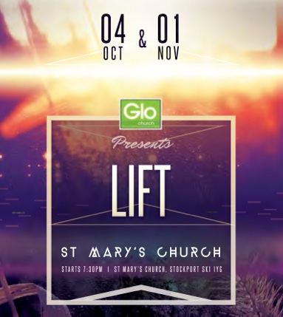
Another new experience for St Mary’s when we opened the doors to GLO Church, enabling them to hold a different style of worship experience for the young people of Stockport (and those of us slightly older but “young at heart”).
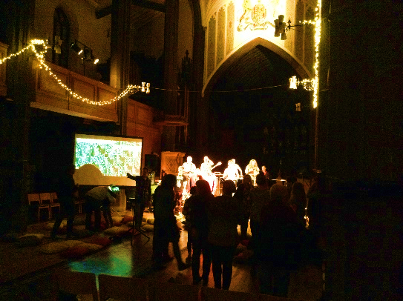
The GLO Team greeted those entering St Mary’s by taking a “selfie” with them and posting this immediately to “twitter”. Yes, the St Mary’s Team were “tweeted” or whatever the express is!
The church was dressed in an informal style, of scatter cushions (for those wishing to sit on the floor - seating available for those of us who preferred to sit on chairs - having no chance whatsoever of being able to get up again if ever getting down there) and lit only by the stage lighting and “fairy” lights strung from the gallery. Indeed, a new experience.
Congratulations to Gareth and his GLO team for a wonderful and very moving experience.

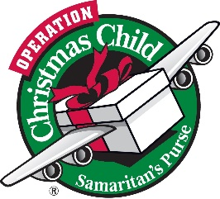
Last Reminder:
Operation Christmas Child
Remember, remember … that we need your shoebox gifts between the 1st and 23rd November.
Leaflets and empty boxes are available in Church (Hospitality Area) together with a box for gifts to be included in boxes if you are unable to make-up a complete box yourself. Donations (cash) also appreciated which may be given to Margaret Forster or Irene Hamnett
Blessing of the shoebox gifts will be incorporated into the morning service on Sunday, 23rd November .
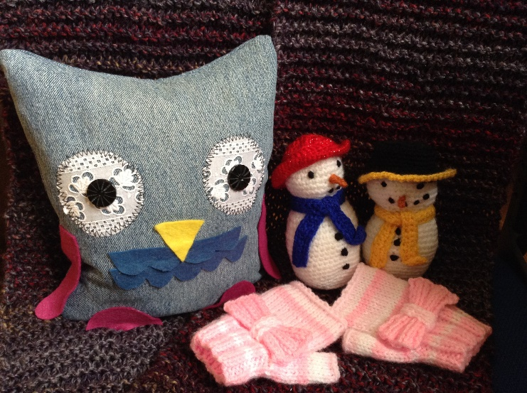
St Mary’s
Christmas Fayre 2014
10.30am Saturday
6th December
Our collection box is open for items to sell at the Christmas Fayre.

All donations most welcome and if you can join us on a Thursday at the “knit and natter”, even better! There is naturally a lot of “nattering” at the expense of “knitting” so homework may be required to build up our stocks!
As well as “home made” craft items we will of course accept unused and unopened “gifts” etc. – providing they are of good quality and sellable. No books please or “second hand” items. Cakes, preserves, pickles etc. gratefully received just before the event.
Tables available (as appropriate and as space allows ) for a fixed table fee or percentage of takings.
St Mary’s Christmas Programme 2014 (subject to amendment)
Day | Date | Event | Time
Saturday | 29th November | Gorton Community Voice Choir | 7.30PM
Sunday | 30th November | First Sunday in Advent:  “A Choral Celebration” in words and music by candlelight with the Maia Singers in preparation for Advent and Christmas | 6.30PM
Monday | 1st December | CLOSED
Tuesday | 2nd December | HOLY COMMUNION  LUNCHTIME SERVICE | 10.00AM  12.15PM
Wednesday | 3rd December | CLOSED | 7.00 PM
Thursday | 4th December | Stockport Secondary Schools Carol Festival | 7.00PM
Friday | 5th December | OPEN AS USUAL
Saturday | 6th December | St Mary’s Christmas Fayre  Ladybrook Singers Christmas Concert | 10.30AM  7.30PM
Sunday | 7th December | Ex-Services Associations Carol Service | 3PM
Monday | 8th December | Stockport MENCAP Christmas Celebration with Stockport Special Schools | 1PM
Tuesday | 9th December | HOLY COMMUNION  LUNCHTIME SERVICE | 10.00AM  12.15PM
Wednesday | 10th December | The Light Orchestra GB Christmas Concert | 7.30PM
Thursday | 11th December | “Marketing Stockport” Carol Service | 6.00PM
Friday | 12th December | AGE UK Stockport Carol Service with Warren Wood Primary School & Cheadle Hulme Singing Group | 1.30PM
Saturday | 13th December | Affinity Show Choir Christmas Concert | 7.30PM
Sunday | 14th December | Advent Morning Prayer “Toy Service” | 10.30AM
Monday | 15th December | Beechwood Cancer Care “Tree of Light” Service/Dedication | 7.00PM
Tuesday  Tuesday | 16th December  16th December | HOLY COMMUNION  LUNCHTIME CAROL SERVICE  Banks Lane Junior School Carol Service | 10.00AM  12.15PM  7.00PM
Wednesday | 17th December | Mayor’s Carol Service with Warren Wood Primary School | 12.30PM
Thursday | 18th December | Vernon Park Primary School Carol Service | 2.00PM
Friday  Friday | 19th December  19th December | Shopmobility Stockport Christmas Celebration with Offerton Methodist Choir  Silent Night Carol Service with the Sapphire Blue Choir | 1.00PM  7.30PM
Saturday | 20th December | “Sing Christmas” Concert with the Maia Singers | 7.30PM
Sunday | 21st December | “Remembering Christmas in the absence of a loved one” | 3.00PM
Monday | 22nd December | Wellspring Christmas | 1.30PM
Tuesday | 23rd December | HOLY COMMUNION  LUNCHTIME CAROL SERVICE AT ST MARYS | 10.00AM  12.15PM
Wednesday | 24th December  CHRISTMAS EVE | CAROLS FOR ALL  FAMILY CAROL SERVICE  HOLY COMMUNION WITH CAROLS | 12.00 noon  6.00PM  11.00PM
Thursday | 25th December  CHRISTMAS DAY | FESTIVAL OF CHRISTMAS | 10.00AM
Friday | 26th December | Closed
Saturday | 27th December | Closed
Sunday | 28th December | HOLY COMMUNION | 10.30AM
Monday | 29th December | Closed
Tuesday | 30th December | Closed (No services)
Wednesday | 31st December  NEW YEARS EVE | Watch Night Service | 11.30PM
Thursday | 1st January 2015 | Closed
Friday | 2nd January 2015 | Closed
Saturday | 3rd January 2015 | Closed
Sunday | 4th January 2015 | HOLY COMMUNION | 10.30AM
Monday | 5th January 2015 | Closed
Tuesday | 6th January 2015 | HOLY COMMUNION  LUNCHTIME SERVICE | 10.00AM  12.15PM

