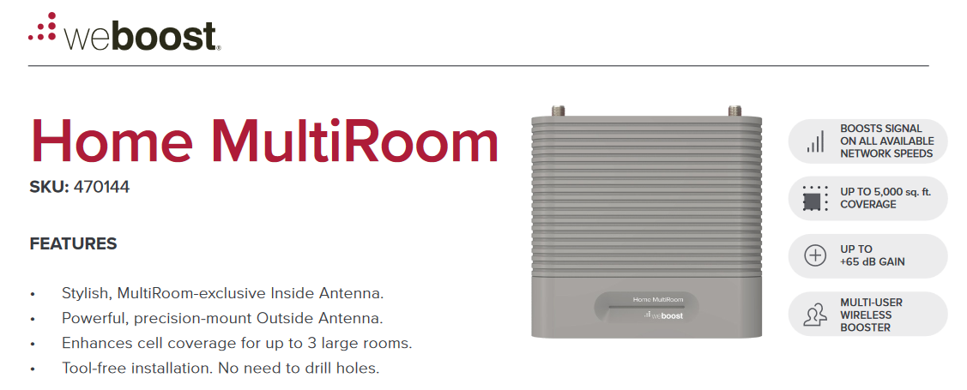
No more annoying dropped calls or poor call quality!

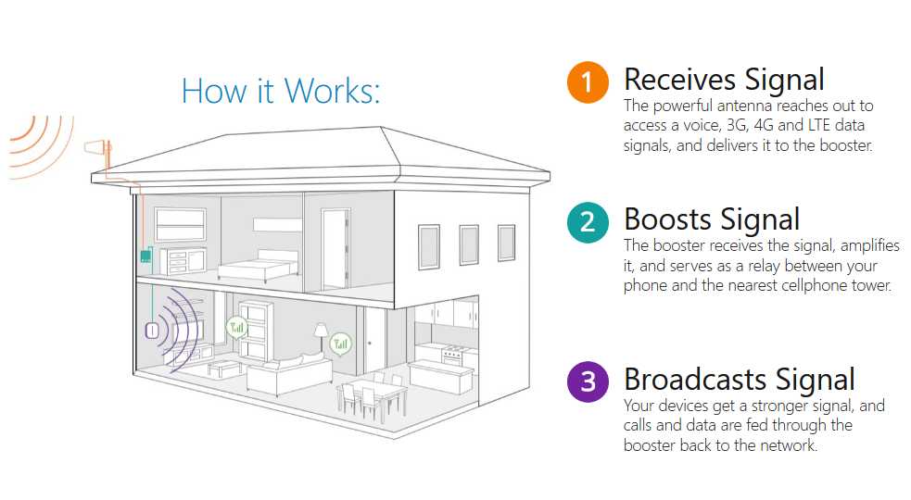

*One-time Fee of $1,100.00 for System & Professional Installation

