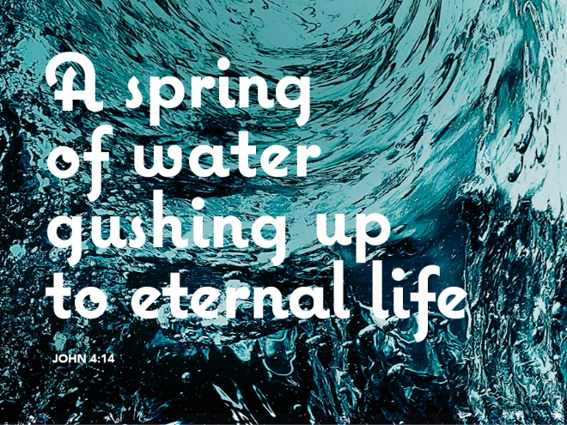

Come and Drink – Go and Tell
March 19, 2017
John 4:5-42

Grace and peace to you from God Our Father and from the one who breaks down barriers of prejudice and hatred, Jesu Christ our Lord, amen.
For me to preach on today’s Gospel lesson is difficult, if not altogether wrong. This is a woman’s text. As a man I cannot possibly understand her feelings as an outcast. If anything, I represent most of which puts her on the outside, all of the stereotypes under which she suffers. She is a woman, dependent on a man for her identity as a human being. She is a woman who has suffered the end of five relationships with men and is tentative about the one she has now. She is a Samaritan in a world where Jews are supreme. And so, she is alone.
She knows the life of an outcast to the point where she goes to a well far distant from the city at a time of day when no one else will be there. For her, the well was not a place to gather with other women to share the news, a time of camaraderie to be lifted above the drudgery of everyday life. This woman knew that she would have likely been the subject of that conversation and gossip so she stayed away, losing the only human contact that might give her life significance.
I stand here as a benefactor of most of those stereotypes which continue to have power today, stereotypes which make it difficult for a man to taste her isolation and thirst. I guess you could say I’m the beneficiary of not just white privilege, but white man’s privilege. Most of us have been subjected to interpretations of this passage either softened so as not to offend anyone and or poor biblical interpretation. We know she has been married five times and is living with another. We do not know how the others ended, whether by death or divorce. She likely made some choices she regretted, but Jesus is not interested, as we might be, in the sordid details. Jesus sees a woman desperately thirsty for something more, for love and relationship. Jesus sees a woman subjected to condemnation, from all those around her and, likely self-loathing as well.
Jesus accepts her as a person loved by God, and he gives her the living water she craves, love, relationship and acceptance. Jesus acknowledges her life as it is. Yes, there may have been poor choices with the likely consequences, but he loves her without condition.
I’ve had the honor and privilege of walking with several families who are in the process of losing a loved one. Sometimes it comes suddenly, others after long drawn out illness and suffering. In all cases, people long to put our trust in the promises of Jesus for peace and eternal life. We long for answers about heaven, hell, and our eternal fate. Most people can’t even express the deep desires of their souls. Instead we remain in the superficial level. In his discussion with the woman at the well, Jesus refused to remain in the superficial level. He kept drilling to the heart of what mattered with this Samaritan woman. I don’t know if she ever really made the connection to all of what Jesus is and was, but she certainly recognized a far deeper level than just a Jewish rabbi needing a drink in the heat of the day. Jesus was the living water that the woman at the well needed. To be accepted and loved for who she was.
For those of you who heard my story of Joe Williams’ last communion at his funeral I apologize for telling it again, but Joe’s thirst for the living water of Jesus affected me at a deep level and this story needs to be shared. Dean and I met at Wayne and made our way to the 4th floor Hospice unit where Joe had been transferred. He wasn’t able to do much and could hardly talk. In fact he really should have stayed on the CPAP machine, but the nurse was kind enough to take it off and replace it with an oxygen tube for the few minutes we were there. As he had done every time I visited him, he teared up and indicated how much he loved and missed “His” church. He didn’t just want to take communion, he needed it. He needed one more time to be reunited with his church family in sacrament and with Jesus Christ in that great promise of eternal life. Keep in mind, Joe couldn’t swallow any more, but he stuck our his tongue to touch the bread of life and his lips to drink in the cup of salvation. I know the feeling Joe felt at that moment, I’m sure you all do as well. That feeling of being set free from all that oppresses you and holds you down. That feeling of knowing, at least for that one instant, that the promises Jesus made about our forgiveness and about our place in heaven are really real and for me. Not just for everyone, but for me. He died with the living water gushing up like a spring that carried him all the way to heaven.
We all know the living water in the words of a funeral service assuring us that nothing is able to separate us from the love of God in Christ Jesus our lord. We taste it in the assurance when a son or daughter is baptized into Christ and know we too are also baptized into his death and resurrection. We taste it as we recite Psalm 23, “even though I walk through the valley of the shadow of death, I will fear no evil.”
Just as Jesus went out of his way to speak to the woman, Jesus takes the time to speak to each one of us. When our thirst secretly seeks to dry up each one of us. Jesus comes to us with the living water that can satisfy the thirst that lies deep within us and cries out for quenching. Jesus seeks to lift us above whatever our sin is or the devil’s tempting that tries to keep us thirsty, to keep us isolated from life and those around us. Jesus knows the poor decisions each of us have made in life, accepts us for who we are, and loves us still.
Jesus invites us to be like the woman at the well, who goes into her city and tells others of what she has discovered, one who knows her for who she is and loves her anyway. We are thirsty people, we know the living water, drink deep and find a way to invite others who thirst to drink deep as well. We can know the freedom from the secret sins that bind us. Our words of invitation can be, “He told me everything I had even done, and still loved me” and these are words of freedom, words to quench whatever thirst eats at us.
May you hear the words of Jesus today. Come to Jesus and receive the living water in the forgiveness of all your sin. Come to Jesus today and drink deeply from the cup of salvation and eat your fill of the bread of life. Come and eat and drink, then go and tell and share, amen.
Thanks be to God.

