Table of Contents
Table of Contents 1
1 INTEGRATED INSTRUMENT INDEX DATA BROWSER 2
1.1 Copy Selected Data to Instrument Index Data Table 2
1.2 Selected Specification Form Data Subset 2
1.3 Browse Specification Form Data and Status 3
1.4 Extended Manual Data Entry Instrument Index Fields 4
1.5 Comparing Safety Design Conditions 5
1.5 Instrument Index Custom Reports for Deliverables 5
ANNEX B INSTRUMENT INDEX DATA LIST 5
TABLE 1 - Specification Form Integrated Data 5
TABLE 2 - Manual Data Entry Properties of Instrument Index Data Table 7
TABLE 3 - Manual Entry Instrument Index Property Dropdown List 8
TABLE 4 - Custom Views of Instrument Index Data Table 10

1 INTEGRATED INSTRUMENT INDEX DATA BROWSER

1.1 Copy Selected Data to Instrument Index Data Table
About 80 fields from each specification form are automatically copied to the Excel Instrument Index Data table, whenever a specification document is saved. The Instrument Index Data table has one record for each specification document number and that record will be updated with the latest data at each saving of the document. This tabular data presentation can be instrumental in review for inconsistencies between multiple forms, partial status of the form’s data entry or as an index to identify data related to a tag or functional identification.

- Notes: See Quick Start Tour document, paragraph 8.6 Integrated Instrument Index Data Browser for step-by- step usage.

- Note: Data changes made in the Instrument Index Data table are NOT propagated to the Specification Form documents. Therefore, any changes identified by review of the index table must be corrected on the individual document, which when saved will update the Instrument Index Data file.

1.2 Selected Specification Form Data Subset

While specification forms are created as individual files, they generally are reviewed, approved, and packaged together for multiple different information exchanges. Our integrated Instrument Index Data browser is automatically populated when document files are saved, with over 80 fields of data, which only adds 1-2 seconds to the saving time.

- Note: See Annex B Instrument Index Data List

To browse the Instrument Index Data for any file folder, use the Form Loader Dashboard by double clicking the Desktop shortcut to activate the interface. When the integrated interface opens, scroll through the list of Instrument Index Data files, and click the window row for the Excel® spreadsheet of interests. The selected file will be highlighted while it is loading.

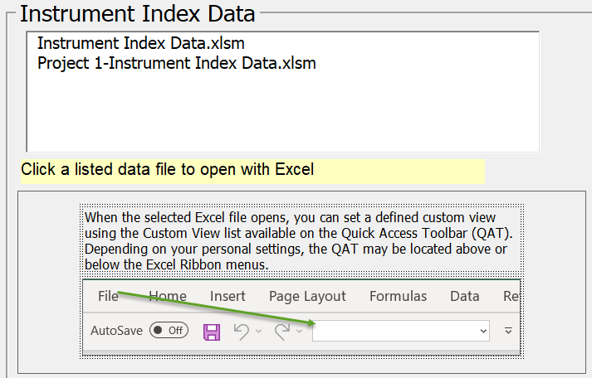

- Note: The Form Loader Dashboard interface includes a reminder that several Custom Views are available if the user opens the spreadsheet dropdown list of configured views, or uses the View tab and Custom view tab, as shown below.

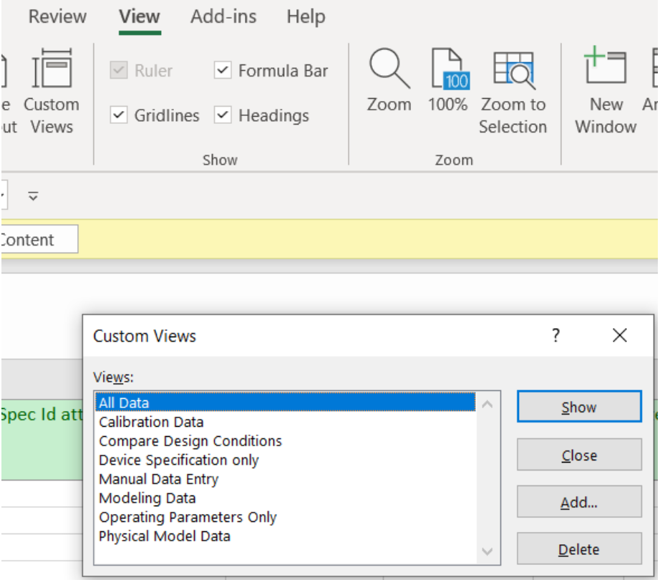

1.3 Browse Specification Form Data and Status

The spreadsheet opens with the last saved Custom View as its default. The data is automatically ordered by the Tag no/Functional ID (keywords) and indicates a calculated % complete for each field.

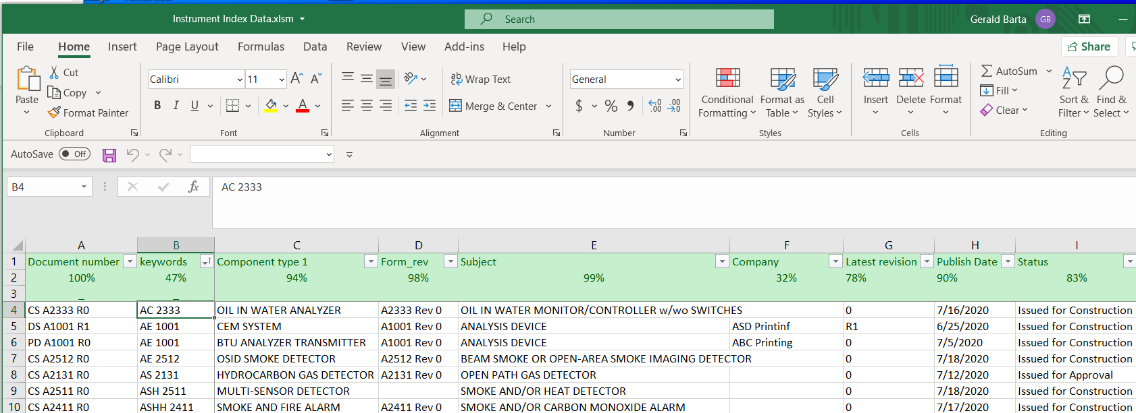

Each field has a dropdown sort & filter list for convenience in reviewing the list of unique values and limiting the view for review.
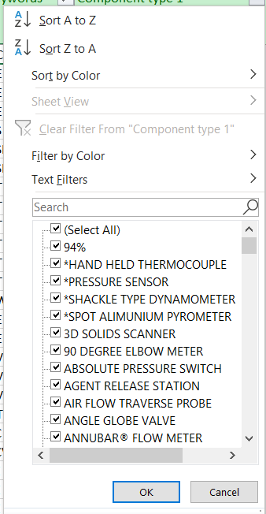

1.4 Extended Manual Data Entry Instrument Index Fields

Over 25 additional typical Instrument Index Fields, related to the specification form’s tagged device, are provided, and can be expanded if desired. They can be easily accessed by selecting the “Manual Data Entry” custom view. This data will NOT be overwritten when specification documents are revised and saved.

Several of these fields include dropdown list to assist in maintaining consistency, as identified on the third row of the header and defined below:

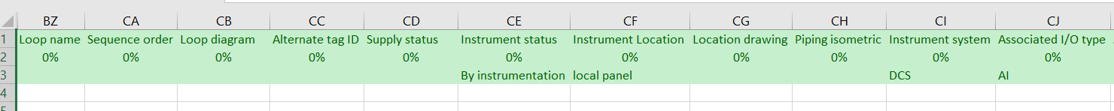

- See Annex B Instrument Index Data List

1.5 Comparing Safety Design Conditions
OSHA design requirements specifically document requiring that Device Specification design conditions exceed the Operating Parameters design conditions. The Instrument Index table (browser) allows viewing Operating Parameter data typically from page one with Device Specification design data typically from page two, in adjacent columns. This can assist in ensuring that the design criteria are appropriate for the intended process use.
To facilitate comparing such form data that generally occur pages apart, the Comparing Design Conditions custom view is available. The field names with the ‘PC” prefix are those of the device’s Performance Characteristics section.

1.5 Instrument Index Custom Reports for Deliverables
Although no custom reports are presently included, such reports can be designed to produce special listings of data, such as:
- Calibration data report
- Safety instrument report
- Document status report
- Reports filtered by Physical Model properties such as Unit number
- etc.

ANNEX B INSTRUMENT INDEX DATA LIST

TABLE 1 - Specification Form Integrated Data

About 82 default fields are automatically copied to an Excel Instrument Index Data table, whenever a specification document is saved.
Content Control Property Title | Data Description
Document number | Specification Document number (must be unique)
Keywords (Tag no/Functional ID) | Document master Tag no/Functional identification
Component type 1 | Primary Component type name
Form_rev | Specification form number and revision
Subject | Specification form title (document Subject description)
Company | Responsible Organization company identification
Latest revision | Document latest revision
Publish Date | Document publish date
Status | Document issue status
Spec Id attri1value | Specification Identifications section definable field name
Spec id attribute 1 value | Specification Identifications section definable field value
Project number | Project number
Sub project no | Sub project number
Project | Project title
Enterprise | Enterprise identification
Site | Site name
Area | Area identification acronym
Unit | Unit identification acronym
Admin Def attribute 1 name | Administrative Identifications section definable field bane
Admin Def attribute 1 value | Administrative Identifications section definable field value
Comments | Word/SharePoint document comment
Related equipment | Related equipment identification
Service | Service description
P_ID_Reference dwg number | P&ID or Reference drawing number
Upstr line_nozzle number | Upstream line or nozzle number
Upstr line pipe spec | Upstream line pipe spec
Upstr line nom rating | Upstream line nominal rating
Upstr line conn type | Upstream line connection type
Upstr line termn style | Upstream line termination style
Upstr line material type | Upstream line material type
Primary construction material | Material of pressure containing shell component
Inline hazardous area cl | Inline or Local Hazardous Area Class
Inline hazardous Div_Zone | Inline or Local Hazardous Area Division or Zone
Inline hazardous gr | Inline or Local Hazardous Area Group
Inline T Code | Inline or Local Hazardous Area Temperature Code
Criticality classification | Criticality classification
Signal loss failure mode | Signal loss failure mode
Supply loss failure mode | Supply loss failure mode
Design Inlet press max | Design Inlet pressure maximum value
Design inlet press units | Design Inlet pressure maximum value units
PC Max press at design temp | Performance Characteristics Max pressure at design temp
PC Max press at design temp units | Performance Characteristics Max pressure at design temp units
Design Inlet temp max | Design Inlet temperature maximum value
Design inlet temp units | Design Inlet temperature maximum value units
PC Max design temp | Performance Characteristics Max design temp
PC Max design temp units | Performance Characteristics Max design temp units
Inlet temp min cond | Inlet temperature minimum flow condition
Inlet temp max cond | Inlet temperature max flow condition
Inlet temperature units | Inlet temperature units
PC Min working temp | Performance Characteristics Min working temperature
PC Min working temp units | Performance Characteristics Min working temperature units
PC Max working temp | Performance Characteristics Max working temperature
PC Max working temp units | Performance Characteristics Max working temperature units
Minimum ambient temp | Minimum ambient working temperature
Minimum ambient temp units | Minimum ambient working temperature units
PC Min ambient working temp | Performance Characteristics Min ambient working temperature
PC Min ambient working temp units | Performance Characteristics Min ambient working temperature units
Maximum ambient temp | Maximum ambient working temperature
Maximum ambient temp units | Maximum ambient working temperature units
PC Max ambient working temp | Performance Characteristics Max ambient working temperature
PC Max ambient working temp units | Performance Characteristics Max ambient working temperature units
Material name | Process Material name
GHS health hazard | GHS Health Hazard
Signal power source | Identification of the signal power range required for the device
Digital communication std | Identification of the primary digital communication standard
Compliance standard | Compliance standard
Component Manufacturer 1 | Primary Component Manufacturer name
Component Model number 1 | Primary Component Model number
Estimated weight | Estimated weight
Estimated weight units | Estimated weight units
Prim Tag no Input_Output | Tag number or functional identification of the primary input or output signal
Prim_CAL_Input_Output Desc | Primary Calibration Input-Output Description
Prim_CAL_Input_LRV | Primary Calibration Input LRV
Prim_CAL_Input_LRV units | Primary Calibration Input LRV units
Prim_CAL_Action | Primary Calibration Action
Prim_CAL_Output LRV | Primary Calibration Output LRV
Prim_CAL_Output LRV units | Primary Calibration Output LRV units
Prim_CAL_Output URV | Primary Calibration Output URV
Prim_CAL_Output URV units | Primary Calibration Output URV units
Test pressure Input URV | Test pressure value
Test pressure Input URV units | Test pressure units
File Name | Document full path or file name

- Note: Any additional Content Control property titles can be added to the Excel file columns and subsequent document savings will copy such additional data to the modified Instrument Index Data table.

TABLE 2 - Manual Data Entry Properties of Instrument Index Data Table

About 28 additional manual data entry properties can be managed in the Instrument Index Data table:

Extended Index Property Title | Data Description
Loop name | Identifying parent name common to all members of the loop
Sequence order | Loop sequence order of individual member of a loop
Loop diagram | Loop diagram drawing
Alternate tag ID | Alternate identification of a device such as assigned by package equipment manufacturer, electrical interface equipment number or of a renamed device
Supply status | Identify organization responsible to supply of device such as instrumentation. piping, electrical, packaged equipment, etc.
Instrument status | Identification of the device status such as existing, new, spare, abandoned in place, to-be-removed, etc.
Instrument location | Relative location such as field, local panel, remote panel, I/O building, etc.
Location drawing | Drawing number showing the device relative location
Piping isometric | Drawing number showing the device location within a piping isometric
Instrument system | Abbreviation for the digital system which the device signal is connected to, such as DCS, PLC, ANALYZER, ESD, etc.
Associated I/O type | Associated digital system I/O component such as AI. AO, DI. DO, HART®, etc.
Associated I/O location | Location of associated I/O component such as building number, cabinet/rack number, panel number, etc.
Interlock Logic number | Name/number common to all members of the interlock
Process data owner | Organization responsible for providing process data such as Process, Mechanical, Vessel, Electrical or packaged equipment
Specification package | Specification package ID
Turnover System | Identification of the data packaging for transfer to the owner
Process data required | Required date for process data specifications
Requisition required | Required date for issuing specification requisition
Required on site | Required date for receiving device on site
Air/Purge connection | Air/Purge connection detail drawing
Electrical/Signal connection | Electrical/Signal connection detail drawing
Environmental protection | Environmental protection detail drawing
Junction Box | Junction Box detail drawing
Process connection | Process connection detail drawing
Support/Mounting | Support/Mounting detail drawing
Requires power supply | Identifies devices that require power independent of their signal wiring.
P&ID status | Identification of P&ID activity such as future work, work on hold, pending deletion or pending scope change
P&ID Checked By | Initials of individual who checked the P&ID and Index data for completeness and consistency

- Note: Any additional manual entry property titles can be added to the Excel file columns.

TABLE 3 - Manual Entry Instrument Index Property Dropdown List

Supply status
By electrical | Furnished by electrical discipline
By instrument | Furnished by instrument discipline
By mechanical | Furnished by instrument discipline
By vessel | Furnished by vessel discipline
By others | Furnished by vessel discipline
NA | Not applicable
Instrument status
By instrumentation | New instrument by instrumentation
By others | Furnished by others
NA | Not applicable
Relocate | Existing device to be relocated
Reuse in place | Existing device to be reused in place
Vendor package | New instrument in packed equipment
Instrument location
Actuator | Mounted on actuator
External mount | Mounted external to a vessel (bridle)
Main panel | Located on the front of a panel
Sec panel | Mounted front of secondary panel
Close coupled | Close coupled element or gauge
Non-process | Field located without process connections
Equipment | Directly inserted in or on equipment
In line | Directly inserted inline
In vessel | Located in vessel/connection
Shelter | Located in a local instrument shelter
Local panel | Visible on front of panel
MCC | Motor control center
NA | Not applicable
On line | Mounted on line (non-intrusive)
Rear panel | Mounted rear of main panel
Rear sec panel | Mounted rear of secondary panel
Remote | Remote transmitter from primary element
SIS | Safety Instrumented System
Shared control | Integral to instrument system shared control
Video display | Integral to instrument system shared display
Instrument system
ACS | Analyzer Control System
AS | Alarm System (panel)
BMS | Burner Management System
BPCS | Basic Process Control System
CCS | Computer Control System
CEMS | Continuous Emissions Monitoring System
DCS | Distributed Control System
ECS | Electronic Control System
FGS | Fire & Gas System
LOCAL | Self-contained instrument or loop
MCS | Machinery Control System
NA | Not applicable
PLC | Programmable Logic System
Associated I/O type
AI | Analog input
AO | Analog output
DI | Discrete input
DO | Discrete output
FF | FOUNDATION fieldbus
Profibus-DP | Profibus-DP fieldbus
Profibus-PA | Profibus-PA fieldbus
FI | Frequency input
FO | Frequency output
HART AI | HART AI
HART AO | Hart AO
NA | Not applicable
RTD | RTD element
SERIAL | Serial communication
TC | Thermocouple element
Process data owner
Instrumentation | Instrumentation department
Line list | Line classification list
Mechanical | Mechanical engineering department
NA | Not applicable
Package vendor | Packaged equipment vendor
Process data sheet | Process design department
Vessel | Vessel design department
P&ID status
Approved | Drawing revision approved
Future work | Drawing revision future work
Hold work | Drawing revision work on hold
NA | Not applicable
Pending change | Drawing revision pending change
Pending deletion | Drawing revision pending deletion
Pending scope change | Drawing revision pending scope change

TABLE 4 - Custom Views of Instrument Index Data Table

Seven basic custom views of the Instrument Index Data are provided and can be added to and configured:
All Data Entry
Calibration Data
Compare Design Conditions
Device Specification only
Manual Data Entry
Operating Parameters Only
Physical Model Data

- Note: Any additional Custom View can be added to the Excel file columns.

