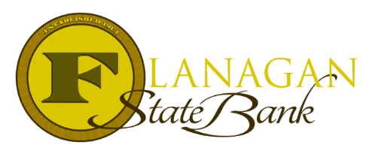
Mortgage Tidbits

Keeping you informed and in the know….

Community Property States
If you are completing a Mortgage Loan in one of the 9 Community Property states, there are things you need to know. The Community Property states are: Arizona, California, Idaho, Louisiana, Nevada, New Mexico, Texas, Washington and Wisconsin. Here are the basics that will be needed for a mortgage:

- My Debt Is Your Debt – when using an FHA, VA or USDA loan, all debts must be included in the debt ratio. This means the Lender will require a credit report on both the borrower and the non-borrowing spouse. Conventional loans do not require this. Any debt that is open and in repayment must be included on the 1003 for calculation in the DTI. Credit reports should be pulled separately to keep the AUS decision from picking up the credit scores of the non-borrowing spouse.
- Charge-offs and Collections – for the Spouse that is not on the loan, this will play a factor when analyzing the debt ratio. If the charge-offs or collections have a payment plan in place or may affect the lien on the property, they will need to be included in the ratios or be paid in full.
- Judgements & Liens – if the Spouse has open judgements or liens, these will need to be satisfied prior to closing to allow the Lender to have 1st lien position.

At this point, most who read this information wonder what the point is in not applying for a joint loan. The silver lining here is if the spouse’s credit score and derogatory credit cannot be used as a reason for denial if they are not on the loan. The debts will need to be used in the ratios, but the Lender cannot base a denial on a credit report if the person is not on the loan application.

Need more information on Community Property State Mortgage Lending?

Give us a call!

~ Provided to you by ~
Insert photo here or delete box when ready to use
Name: Phone:
Title: Email:
Address: City, State, Zip
Apply Now Link:

