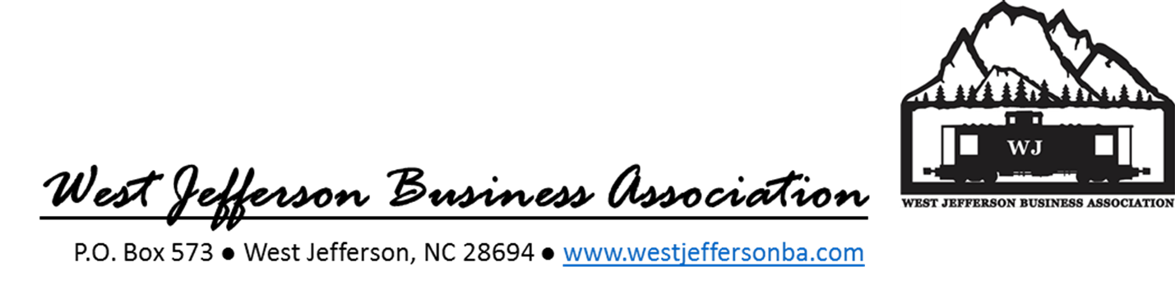
Dear Business Owner,
As we begin planning for a successful 2019, we invite you to become a member of the West Jefferson Business Association for a reduced fee of $75. Add your voice in the planning and execution process to continue to fulfill our mission: to promote a positive and prosperous economic environment for West Jefferson.
Our goals for 2019 are to build on our past accomplishments and build our membership to get many more West Jefferson businesses engaged and represented on the map. Your membership puts you on the map: our Business Guide / Walking Map brochure distributed to visitor/welcome centers across the state, and our map posters displayed across downtown.
Your membership also provides you with an invitation to our monthly meetings where we discuss new ideas to grow our businesses, plan activities and events and share information coordinated with the WJ Community Partnership and the town of West Jefferson. Below is sample of the activities we have planned for 2019:
- Design, print and distribute Business Guide / Walking Map brochures and posters exclusive to WJBA members
- Sponsor a Backstreet Summer Concert that brings folks into town
- Provide financial support for marketing the monthly Gallery Crawls where folks wander the downtown streets and support our local businesses
- Support Light up the Town
- Promote Small Business Saturday and the Shop Small Business movement and provide customers with an opportunity to win a Gift Basket filled with goodies from our local businesses
- Represent members at the monthly West Jefferson Community Partnership meetings
To join the WJBA and learn more go to our website www.westjeffersonba.com
Follow the WJBA on Facebook: West Jefferson Business Association
We look forward to you becoming a member of the WJBA and supporting a prospering West Jefferson!
Sincerely,
WJBA Board of Directors
Crystal Miller, WJBA President

