Grace Episcopal Church
Casanova, Virginia 20139

e-mail: gracechurchcasanova@gmail.com website: www.gracechurchcasanova.org

James

This month’s epistles are from the Book of James. Below are some interesting perspectives paraphrased from the writings of others in Forward Day By Day:

James 4:4. Adulterers! Do you not know that friendship with the world is enmity with God? Therefore, whoever wishes to be a friend of the world becomes an enemy of God._{NRSV}

We don’t know for sure who the author of James was, though there is an ample supply of academic conjecture. It doesn’t seem that he was a pleasure to be around. This soul was a brilliant authority of what was superlative for the expanding Christian community but probably a bit too righteous and preachy in day-to-day communications to have been the star of coffee hour.
Like many voices we hear in the Bible, from the prophets to John the Baptist, the author of James has some hard things to say to us and provides us with a moral, if difficult, spiritual standard.
Thank God for the Jameses of the world. They act as speedbumps for the rest of us who lack their restraint, who are quite comfy with the world and sidle up to temptation with one toe in the fountain of life.

James 3:8-9. But no one can tame the tongue – a restless evil, full of deadly poison. With it, we bless the Lord and Father, and with it we curse those who are made in the likeness of God._{NRSV}

The word gossip sounds weird: It invokes something prude and shameful, or a meddlesome sitcom neighbor who activates the town rumor mill. It is doubtful that any of us thinks of ourselves as a gossip, especially when gossip has become a 24-hour, multimedia component of the entertainment business.
We are drowning in gossip and have been for longer than we can recollect. It’s a regrettable side effect of our native inquisitiveness about other people. The author of the Epistle of James reminds us that gossip isn’t a sin that we conceived. It’s something that beset the early Church, too.
Think about the people you know who steer clear of gossip. These souls of discretion demonstrate for us the circumstance that idle talk, while entertaining, can injure others. What if we tried to control our tongues and guard each other’s tender selves?

SENIOR WARDEN’S REPORT – SEPTEMBER 2021
Dear Grace Family,
Since the Vestry meetings have been suspended this Summer, there isn’t a lot to report. In September 2021, we should be returning to our regularly scheduled Vestry meetings on the third Wednesday of each month at 3PM in the Parish Hall. You are all welcome to attend.
Bishop Ted and I have both been on vacation for the month of August. I cannot report on his trip, but I can tell you about mine. I returned to one of my favorite vacation spots: Cape May, New Jersey. It is a lovely little town with Victorian Bed and Breakfasts throughout. Cape May has a shopping street, horse and carriage rides, a pristine beach, as well as many other attractions. I attended their Episcopal Church and found them to be very welcoming. We all wore masks and only received the bread at communion, but I felt very at home and able to worship God. I encourage you to check out Cape May sometime if you haven’t.
We are most grateful to those who filled Bishop Ted’s position this month; I know the Grace folks made them feel right at home!
Please continue to pray for Grace Church as the on-going search for a minister continues. We need your prayers no matter the occasion and sincerely appreciate your loving care and support.
Blessings and love on behalf of the Vestry,
Mary

TREASURER’S REPORT – JULY 2021
Income for the month of July was $3,930.99 (budget $6,267.00); expenditures totaled $5,272.23 (budget $4,543.00) resulting in a deficit for the month of $1,341.24.

The book value of our endowment fund is $60,073.49; market value as of 06/30/21 - $70,177.53.

Please continue to pray for Grace Church that it will grow spiritually, financially and numerically. If you have any questions about this report or any financial matter, please contact me.

Judy Ball, Treasurer

FEED MY SHEEP (FMS)
Psalm 113 KJV vs.3&4. From the rising of the sun to the going down of the same, the Lord’s name is to be praised.

The “dog days” are almost over and our kids are returning to school. That means easy, healthy snacks will be needed for breakfast and after school snacks (not everyone qualifies for free meals.) Some of our kids are ‘ latchkey kids, so we like to make sure they have “grab and eat” foods. A significant number of our clients are elderly and on fixed incomes. Most have no transportation and are dependent on others to shop. And we are all aware of rising grocery prices with no end in sight. FMS helps to fill that gap. The groceries are delivered directly to our clients . Every effort is made to accommodate dietary needs. It is small volunteer groups like FMS that provide for the underserved in our communities. Your continued support is vital to keep this ministry going. Checks may be made out to Grace Episcopal Church and mailed directly to the church. Please make a notation on your check that reads: FMS. Cash is always welcome and can be put in an envelope (labeled for FMS) and left in the collection plate. Thank you for your continued support.
Carol Grove

SEPTEMBER BIRTHDAYS & ANNIVERSARIES
Shelly Shipe 2-Sep
Amy Fields 5-Sep
Jimmy & Karen Walton 11-Sep
Diane Gulick Fahy 13-Sep
Bennett Warren 16-Sep
Nathan Moline 17-Sep
Melanie Lemmel McKee 18-Sep
Michael Calhoun 19-Sep
Jimmy Walton 20-Sep
Andy Butler 26-Sep

SEPTEMBER SERVING SCHEDULE
SEPTEMBER | Readings | Altar/Flowers | Reader/Acolyte | Ushers | Coffee Hosts
5  Fifteenth Sunday after Pentecost | Proverbs 22:1-2, 8-9, 22-23  Psalm 125  James 2:1-10, [11-13], 14-17  Mark 7:24-37 | Mary Neal | Judy Ball | Marilyn Ottevaere/Sharon Sweeney | Penny Depompa-Davis/Mary Neal
12  Sixteenth Sunday after Pentecost | Proverbs 1:20-33  Psalm 19  James 3:1-12  Mark 8:27-38 | Pam Ruffner | Mary Neal | Mignonne Spellmeyer/Diane Gulick | Sue Ballentine
19  Seventeenth Sunday after Pentecost | Proverbs 31:10-31  Psalm 1  James 3:13-4:3, 7-8a  Mark 9:30-37 | Sharon Sweeney | Barbara Gulick | Sue Ballentine/Mary Neal | Mignonne Spellmeyer/Dee Garrett
26  Eighteenth Sunday after Pentecost | Esther 7:1-6, 9-10; 9:20-22  Psalm 124  James 5:13-20  Mark 9:38-50 | Barbara Jacobs/Diane Gulick | Betsy Anderson | The Jacobs | Judy Ball/Barbara Eanes
https://lectionary.library.vanderbilt.edu

If any of the above scheduled duties is a hardship for you, please arrange to trade with someone. If you would like to be added to the serving schedule, please contact Barbara Jacobs or Mary Neal. (easternviewdesigns@gmail.com or maryneal2112@gmail.com )

This month’s entry – Do you know why these children were posing? Give yourself an extra point if you know who they are!
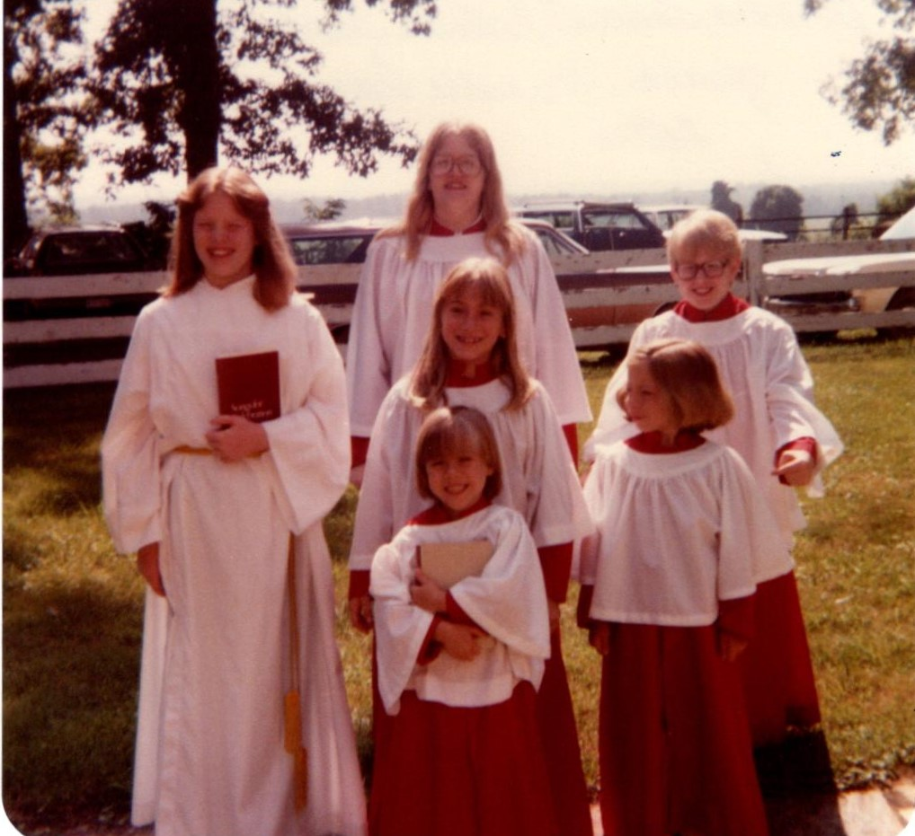

From the Grace Archives

† † † † † † † † † † † † † † † †

Last month’s photo: How accurate was your guess for the cuties in the picture? This is Pete Butler and Stacey Walton-Lewis, 1984. We were attempting to incorporate the children a bit more in the service at that time.
This Photo by Unknown Author is licensed under CC BY-SA-NC

Just so you know that we are not wasting funds, we found this colored paper in the Church office and decided to use it for the newsletter. Otherwise, it will just sit on the shelf and fade.

AMAZON SMILE
FOR GRACE CHURCH
Don’t forget to sign up with Amazon Smile to have 0.5% of the purchase price of eligible items given to Grace Church at no cost to you! You can also go to the Grace Church website home page and click on the link there.

*******AmazonSmile Shopping App for Android Users Now Available******
You can now support Grace in the Amazon shopping app on your Android device! Simply follow these instructions to turn on AmazonSmile and start generating donations to Grace from your Android device.
- If you have the latest version of the Amazon Shopping App, open the App on your Android device.
- View Settings and select AmazonSmile.
- Follow the in-App instructions to complete the process.
AmazonSmile is not currently available for IOS users – we’ll let you know when it becomes available.

