In May 1664, Benoîte Rencurel, a 17-year-old shepherdess in southeastern France, saw an apparition of St Maurice, a third-century martyr greatly revered in her home region. He warned her that locals eyed her flock and counseled that she should go to a nearby valley, where she would see the Virgin Mary.
In a grotto in the Valley of Kilns, she discovered Mary, holding baby Jesus. The Virgin directed Benoîte to go to the village of Laus, where she was instructed to build a chapel where sinners would be converted and the Virgin promised to appear often.
Some of the pilgrims to Laus have themselves become saints, including Eugene de Mazenod, founder of the Oblates of Mary Immaculate. The Marian apparitions at Laus lasted until 1718. Despite their antiquity, the apparitions of Our Lady of Laus were recognized by the Holy See only in 2008.
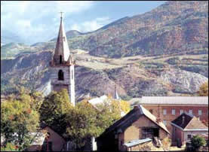

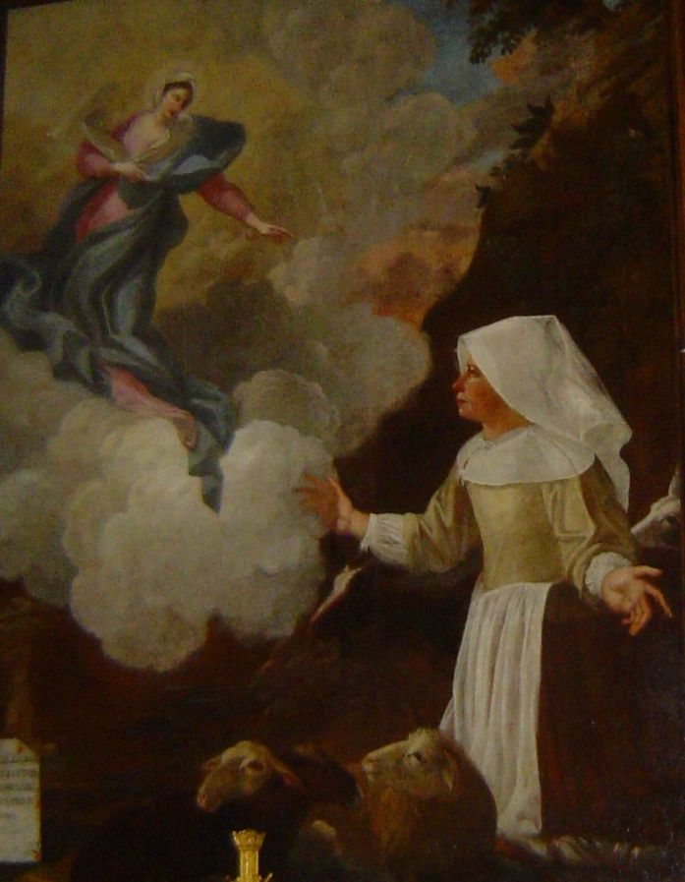

Laus Chapel

The Virgin appears to Benoîte. Image: AntonyB, CC BY-SA 3.0

