SAVE THE DATE!
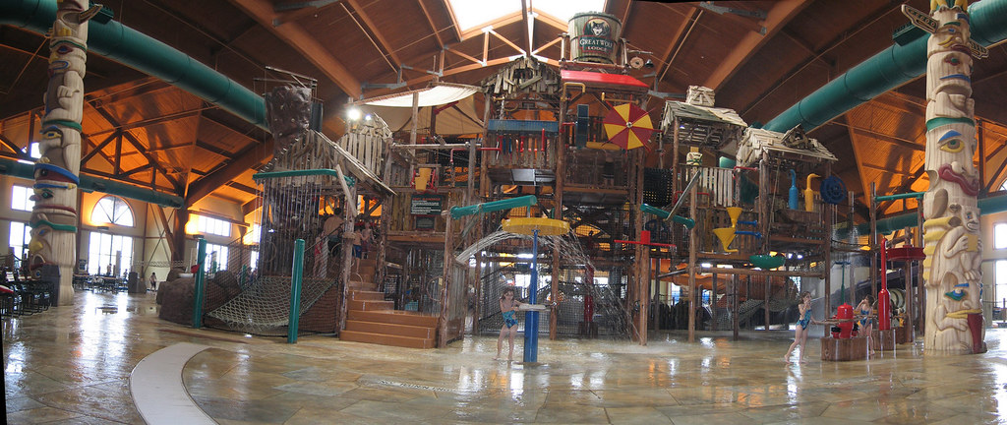

Virginia Association of Community Psychiatric Nurses
“Spectrums of Care”
December 1–3, 2023

Great Wolf Lodge
549 East Rochambeau Drive
Williamsburg, VA

Bring friends and family to play and stay at the Great Wolf Lodge! All rooms sleep 6 people and include waterpark admission for all.

Registration and costs will be posted on our website. Please check out our website periodically to register for this conference at www.vacpn.net

Let’s make some tracks!
This Photo by Unknown Author is licensed under CC BY-SA

