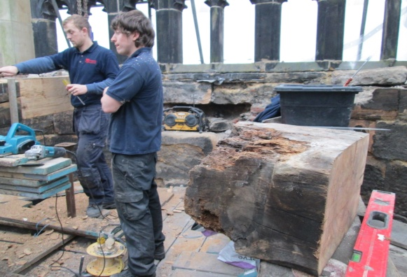
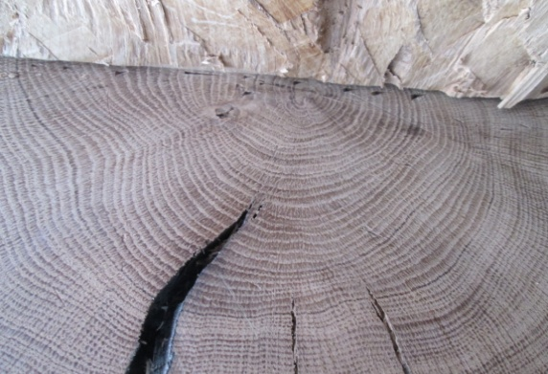
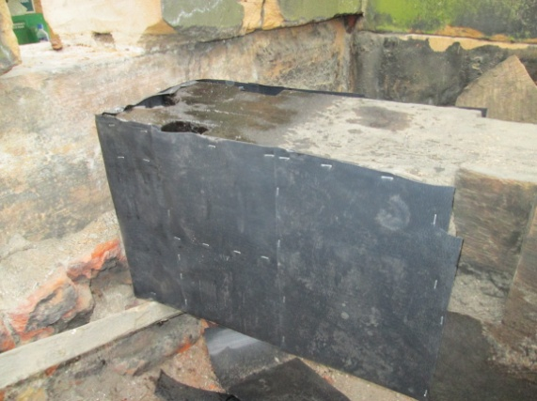
There is however plenty of activity up on the tower roof with repair work on the original timbers (thought to be approx 350 years old) - and quite a complex process it seems to be. The rotten ends are expertly removed (just look at the size of them and think of the weight those ends must be). The newly created ends are then protected in a damp-proof cover before being placed into position.

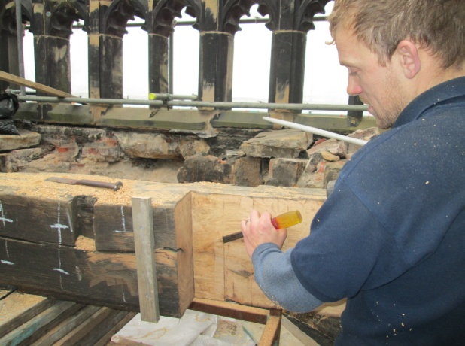

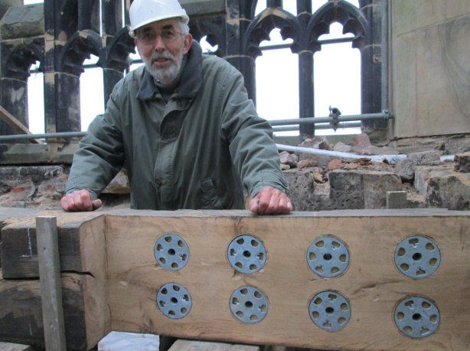
The gaps in the middle are (for want of a better word) spliced with new wood and joined together with special (well they probably have a technical name) “bolts” (as shown here being inspected by our Steeple-keeper) – which somehow or other reduce the stress on the timbers. Fortunately we have experts on the job – Robinsons – and we are very pleased to have them with us.
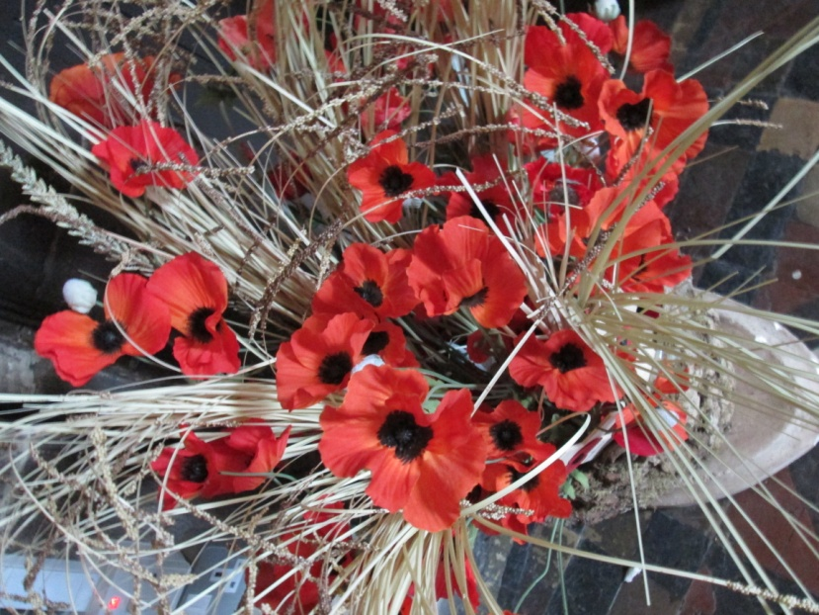
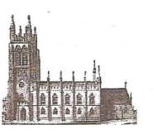
St Mary’s in the Marketplace.
Issue No 17 (11th November 2012)

“Securing the future for the next 100 years”
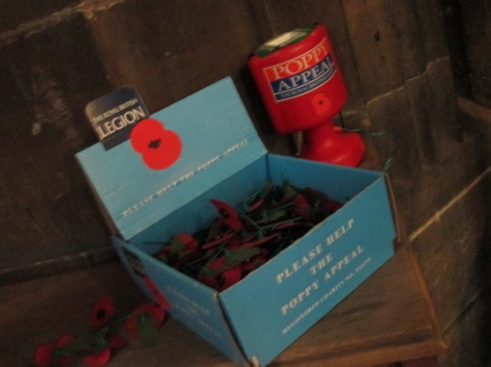
For those of you reading this on Sunday, 11th November please support the Royal British Legion Poppy Appeal -
our collection box is located near the inner
west doors next to the book of Remembrance.
Our thanks to Rita Waters for taking our service
of Morning Worship and act of Remembrance
(as Roger takes part in the civic service on the
steps of the Art Gallery/War Memorial).

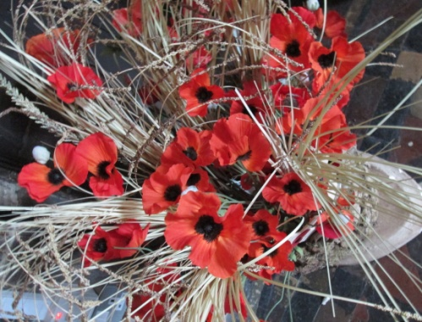
Thank you to Marion for our special Remembrance poppy display – which can be seen near the door to the Tower steps.

“We will remember them”
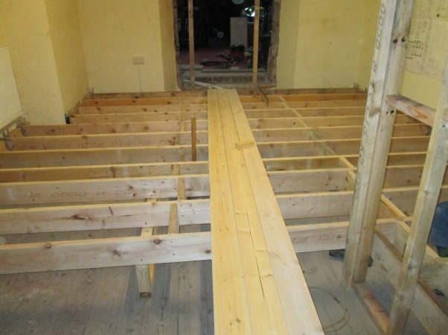
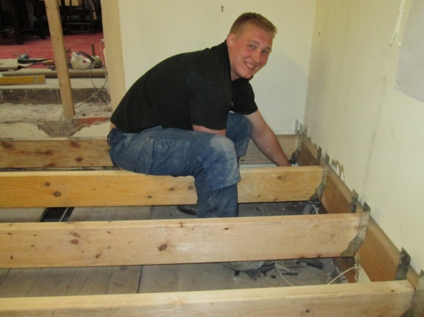

Interesting this week to return to old Church Office and the newly created entrance to the “Choir Vestry” to see that work has started to put in the new floor.
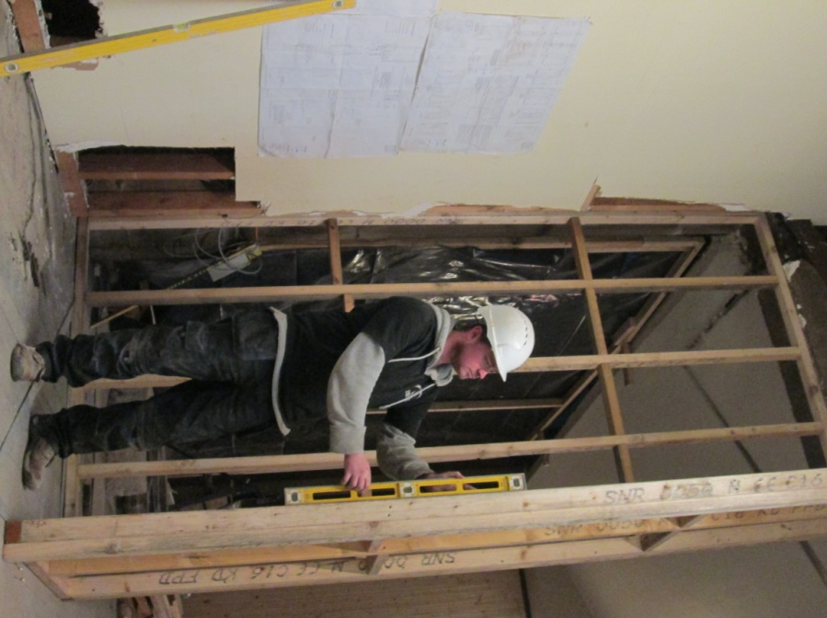
Also being created another new partition – with care and attention to ensure the positioning is correct. In fact a spirit-level has been the order of the day as work progresses indoors.
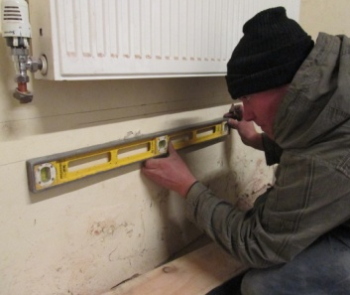

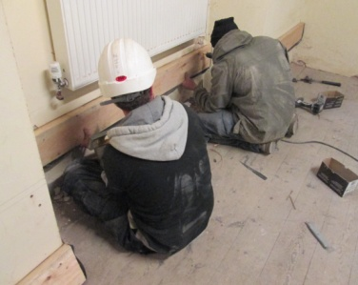

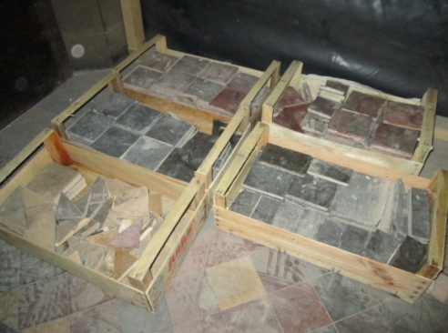
If you were wondering what has happened
to the tiles presently “going-spare” as it were
they have been carefully collected and are
being sorted out ready to be re-used in other
areas where essential repairs will be under-
taken later on.

Visiting St Mary’s this week to view work on the tower – and have a look at the bells at the same time – Clive Carlton – our “Steeple-keeper”.

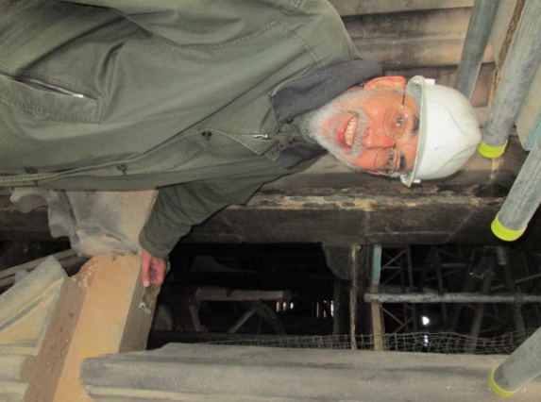
It’s been quite awhile now since the bells last
rang-out at St Mary’s – Clive is as excited as
we are to see the work finished and approval
given by our Structural Engineer for us to peel
the bells.
