FAMILY HEALTH NEEDS ASSESSMENT FORM

Many areas of daily life can affect the health of you and your family. This assessment will enable our service to identify any areas where you and your family could benefit from additional help and support. Some subjects explored may be sensitive and you may not want to discuss them now. However, you can discuss them at a later time if you want to. The information given for this assessment will be kept confidentially within the service unless an identified need makes professionals concerned that either you or your children or others are not safe. The information would then be shared with other appropriate services to support you and your family.

Name of Family: : ........………………………………………………........................................ | …………...…… Date: | ........………………………………………………………
Parental Consent/Signature: …………………………......…………………………………… | Name of Practitioner: | ........………………………………………………………………
1

 |  |  | ABBREVIATIONS & ACRONYMS |  |  | NO | NUMBER
A | ANALYSIS |  |  |  |  | NNU | NEONATAL UNIT
AABR | AUTOMATED AUDITORY BRAINSTEM RESPONSE | FHP |  | FAMILY HEALTH PARTNERSHIP |  | NDDH | NORTH DEVON DISTRICT HOSPITAL
A&E | ACCIDENT AND EMERGENCY DEPT | FRS |  | FURTHER RESPONSE SERVICE |  | OAE | OTOACOUSTIC EMISSION
AM | MORNING | FOC |  | FATHER OF CHILD |  | OPD | OUT PATIENTS DEPARTMENT
AN | ANTENATAL | FSS |  | FAMILY SUPPORT SERVICE |  | P | PLAN
APPT | APPOINTMENT | FSW |  | FAMILY SUPPORT WORKER |  | PGM | PATERNAL GRANDMOTHER
BF | BREAST FEEDING | GMS |  | GRAMS |  | PHNHST | PLYMOUTH HOSPITAL NHS TRUST
BFI | BABY FRIENDLY INITIATIVE | GP |  | GENERAL PRACTITIONER |  | PLS | PERSONALISED LEARNING SERVICE
CAF | COMMON ASSESSMENT FRAMEWORK | HC |  | HEAD CIRCUMFERENCE |  | PM | AFTERNOON
CAMHS | CHILD & ADOLESCENT MENTAL HEALTH SERVICES | HT |  | HEIGHT |  | PAED | PAEDIATRICIAN
CHW | COMMUNITY HEALTH WORKER | HV |  | HEALTH VISITOR |  | PHN | PUBLIC HEALTH NURSE
CIC | CHILD IN CARE | ICS |  | INTEGRATED CHILDREN’S SERVICES |  | PND | POSTNATAL DEPRESSION
CIN | CHILD IN NEED | IMMS |  | IMMUNISATIONS |  | PMHW | PRIMARY MENTAL HEALTH WORKER
CM | CENTIMETRES | INFO |  | INFORMATION |  | POS | POSITIVE
CP | CHILD PROTECTION | JACAT |  | JOINT AGENCY CHILD ABUSE TEAM |  | RD&E | ROYAL DEVON AND EXETER HOSPITAL
CPN | COMMUNITY PSYCHIATRIC NURSE | KG |  | KILOGRAMS |  | SALT | SPEECH AND LANGUAGE THERAPIST
CPS | CHILD PROTECTION SUPERVISOR | LP |  | LEAD PROFESSIONAL |  | SCH | SCHOOL
CPP | CHILD PROTECTION PLAN | MARAC |  | MULTI AGENCY RISK ASSESSMENT COMMITTEE |  | SDHC | SOUTH DEVON HEALTHCARE
CSN | COMMUNITY STAFF NURSE | MASH |  | MULTI AGENCY SAFEGUARDING HUB |  | SCPHN | SPECIALIST COMMUNITY PUBLIC HEALTH NURSE
CYPS | CHILDREN AND YOUNG PEOPLE’S SERVICES | MMH |  | MATERNAL MENTAL HEALTH ASSESSMENT |  | SEND | SPECIAL EDUCATIONAL NEEDS & DISABILITY
D&V | DIARRHOEA AND VOMITING | MIU |  | MINOR INJURY UNIT |  | SHEF | SAFEGUARDING HUB ENQUIRY FORM
DNA | DID NOT ATTEND | MW |  | MIDWIFE |  | SN | SCHOOL NURSE
DOB | DATE OF BIRTH | MOC |  | MOTHER OF CHILD |  | SW | SOCIAL WORKER
DA | DOMESTIC ABUSE | NBV |  | NEWBIRTH VISIT |  | TAC | TEAM AROUND THE CHILD
EBM | EXPRESSED BREAST MILK | NCMP |  | NATIONAL CHILD MEASURING PROGRAMME |  | TB | TUBERCULOSIS
EDD | EXPECTED DATE OF DELIVERY | N/A |  | NOT APPLICABLE |  | TH | TORBAY HOSPITAL
EHWBS | EMOTIONAL HEALTH AND WELL BEING SERVICE | NAD |  | NOTHING ABNORMAL DETECTED |  | TSDHCT | TORBAY & SOUTHERN DEVON HEALTH & CARE TRUST
EPDS | EDINBURGH POSTNATAL DEPRESSION SCORE | NR |  | NO RESPONSE |  | WIC | WALK IN CENTRE
ERS | EARLY RESPONSE SERVICE | NEG |  | NEGATIVE |  | # | FRACTURE
EWO | EDUCATION WELFARE OFFICER | NHSP |  | NEWBORN HEARING SCREENING PROGRAMME

FILE NAME ……………………………………………......…..... Page 2

YOUR FAMILY AND HOUSEHOLD MEMBERS

File Name:
*Parental Responsibility*
 |  | Surname |  |  | Forename |  |  | M F |  |  | DoB | Relationship |  |  | *PR* |  |  |  | Next of |  |  | Occupation |  |  |  |  | Disability |  |  | Ethnicity |  |  |  |  | Religion |  |  |  | Pre School / |  |  | Address
 |  |  |  |  |  |  |  |  |  |  |  |  |  |  | Y/N |  |  |  | Kin Y/N |  |  |  |  |  |  |  | (Y/N) |  |  | See codes |  |  |  |  |  |  |  |  | School |  |  | BOX NO.
 |  |  |  |  |  |  |  |  |  |  |  |  |  |  |  |  |  |  | Kin Y/N |  |  |  |  |  |  |  |  |  |  | below
 |  | PROMPT: Who else lives with you? Does anyone stay over regularly? Does anyone in the household have Carer responsibility?
 |  | Applicable codes: |  |  | LANGUAGE: |  |  |  |  |  |  |  |  |  |  |  |  |  |  |  |  |  |  |  | INTERPRETER REQUIRED: |  |  |  |  |  |  |  |  |  |  |  |  | YES / NO
 |  | White British | WB |  | Black African |  | BA |  |  | Mixed White & Black African |  |  |  | WBA |  |  | Asian -Indian |  |  |  |  |  | AI |  | Mixed White & Asian |  |  |  |  |  |  | MWA |  |  |  | Other Ethnic Group |  |  |  |  |  |  | OG
 |  | White Irish | WI |  | Black Caribbean |  | BC |  |  | Mixed White & Black Caribbean |  |  |  | WBC |  |  | Asian-Pakistani |  |  |  |  |  | AP |  | Asian - Other |  |  |  |  |  |  | AO |  |  |  | None Given |  |  |  |  |  |  | NO
 |  | White Other | WO |  | Black Other |  | BO |  |  | Mixed Other |  |  |  | MO |  |  | Asian-Bangladeshi |  |  |  |  |  | AB |  | Chinese

FILE NAME ……………………………………………......…..... Page 3

 |  | Surname |  |  |  | Forename |  |  |  | M F |  |  |  | DoB |  |  | Relationship |  |  | *PR* |  |  |  | Next of |  |  | Occupation |  |  |  |  | Disability |  |  | Ethnicity |  |  |  | Religion |  |  |  | Pre School / |  |  | Address
 |  |  |  |  |  |  |  |  |  |  |  |  |  |  |  |  |  |  |  | Y/N |  |  |  | Kin Y/N |  |  |  |  |  |  |  | (Y/N) |  |  | See codes |  |  |  |  |  |  |  | School |  |  | BOX NO.
 |  |  |  |  |  |  |  |  |  |  |  |  |  |  |  |  |  |  |  |  |  |  |  | Kin Y/N |  |  |  |  |  |  |  |  |  |  | below
 |  | Applicable codes: |  | LANGUAGE: |  |  |  |  |  |  |  |  |  |  |  |  |  |  |  |  |  |  |  |  |  |  |  |  | INTERPRETER REQUIRED: |  |  |  |  |  |  |  |  |  |  | YES / NO
 |  | White British | WB | Black African |  |  | BA |  |  |  | Mixed White & Black African |  |  |  |  |  |  | WBA |  |  | Asian -Indian |  |  |  |  |  |  | AI | Mixed White & Asian |  |  |  |  |  |  | MWA |  |  |  | Other Ethnic Group |  |  |  |  |  |  | OG
 |  | White Irish | WI | Black Caribbean |  |  | BC |  |  |  | Mixed White & Black Caribbean |  |  |  |  |  |  | WBC |  |  | Asian-Pakistani |  |  |  |  |  |  | AP | Asian - Other |  |  |  |  |  |  | AO |  |  |  | None Given |  |  |  |  |  |  | NO
 |  | White Other | WO | Black Other |  |  | BO |  |  |  | Mixed Other |  |  |  |  |  |  | MO |  |  | Asian-Bangladeshi |  |  |  |  |  |  | AB | Chinese

FILE NAME ……………………………………………......…..... Page 4

FAMILY TREE
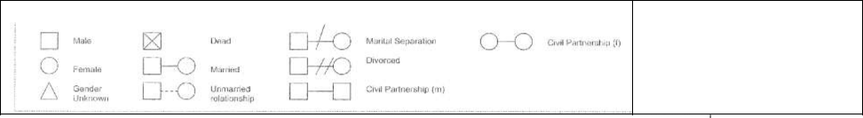

Keep each generation on the same horizontal line. Use own key if necessary. | Please circle household | Completed by:

………………………………………………………….
Date:

………………………………………………………….

FILE NAME ……………………………………………......…..... Page 5

ADDRESS HISTORY

HOW MANY TIMES HAVE YOU MOVED HOME IN THE LAST 12 MONTHS?
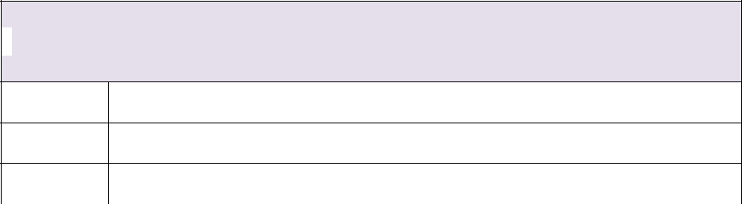

DATE:

DATE:

DATE:

_{BOX 1} CONTACT DETAILS

Name:

DATE: Address:

_{BOX 2} CONTACT DETAILS

Name::

_{BOX 3} CONTACT DETAILS

Name:

DATE: Address:

DATE: Address:

_{BOX 4} CONTACT DETAILS
Name:

_{BOX 5} CONTACT DETAILS

Name:

DATE: | Address: | DATE: | Address:

FILE NAME ……………………………………………......…..... Page 6

 |  | ADDRESS HISTORY (contd.)
BOX 6 | CONTACT DETAILS |  |  |  | BOX 7 |  | CONTACT DETAILS
 | Name: |  |  |  |  |  | Name:

DATE: Address:

DATE: Address:

_{BOX 8} CONTACT DETAILS
Name:

DATE: Address:

BOX 10 | CONTACT DETAILS
 | Name:
DATE: | Address:

_{BOX 9} CONTACT DETAILS
Name:

DATE: Address:

BOX 11 | CONTACT DETAILS
 | Name:
DATE: | Address:

FILE NAME ……………………………………………......…..... Page 7

PROFESSIONALS / AGENCIES / VOLUNTEERS INVOLVED WITH FAMILY

Professionals Involved - Name | Agency | Address | Telephone / email | Date

FILE NAME ……………………………………………......…..... Page 8

SCPHN TEAM SIGNATORY SHEET

NAME (print) | PROFESSION | USUAL SIGNATURE | INITIALS

FILE NAME ……………………………………………......…..... Page 9

PROTECTIVE FACTORS TO CONSIDER WHEN WORKING WITH A FAMILY
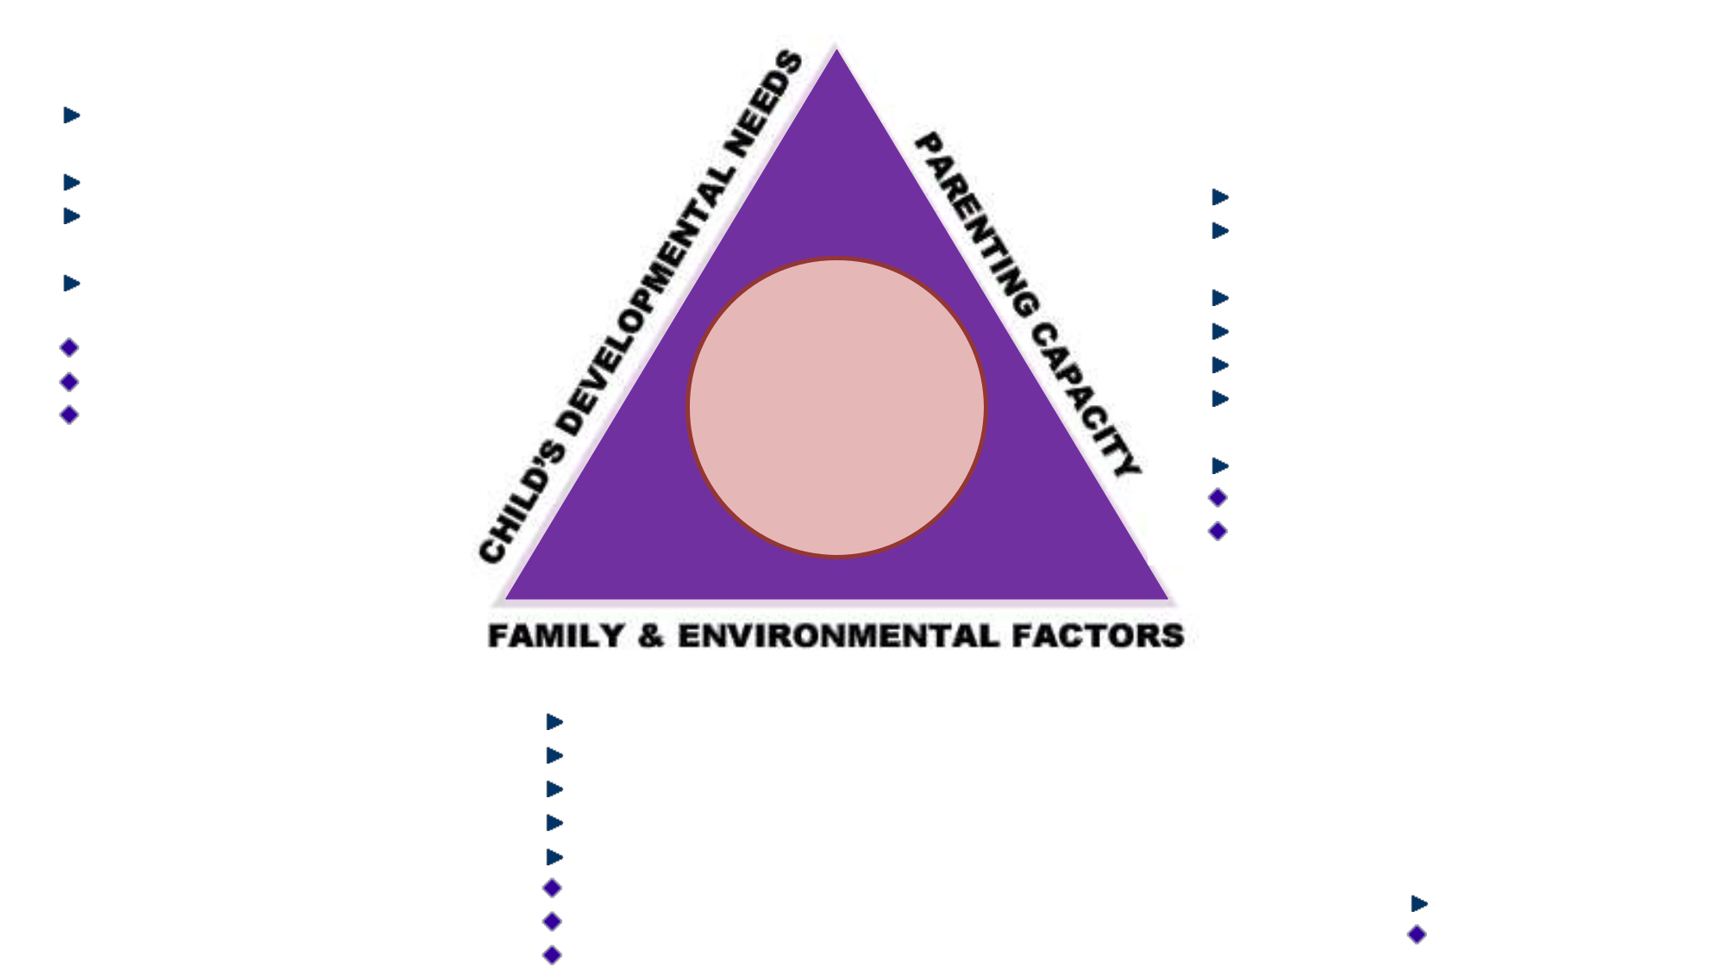

CHILD’S DEVELOPMENTAL NEEDS:

Able-bodied child with good health and positive development

Calm child with positive attachments Good school attendance / attainment

Child has secure relationships and is able to express self verbally Good communication skills Calm and accepting child

Acceptance of loss processes

CHILD

SAFEGUARDING

- PROMOTING WELFARE

PARENTING CAPACITY:
‘Older’ mother

Parent with good physical and mental health

Controlled use of substances or alcohol
Positive attitude to education
Family support

Good attendance at health checks and other appointments
Shared parental responsibility
Parent with no additional needs
Parental acceptance of loss processes

FAMILY & ENVIRONMENTAL FACTORS:
Stable relationships
Positive contact with absent parent
Stable and well managed income
Employed

Stable neighbourhood and community links
Secure tenancy or owner occupier
Positive acceptance of child
Housing meets decent housing standards

KEY:

High evidence Medium evidence

FILE NAME ……………………………………………......…..... Page 10

RISK FACTORS TO CONSIDER WHEN WORKING WITH A FAMILY
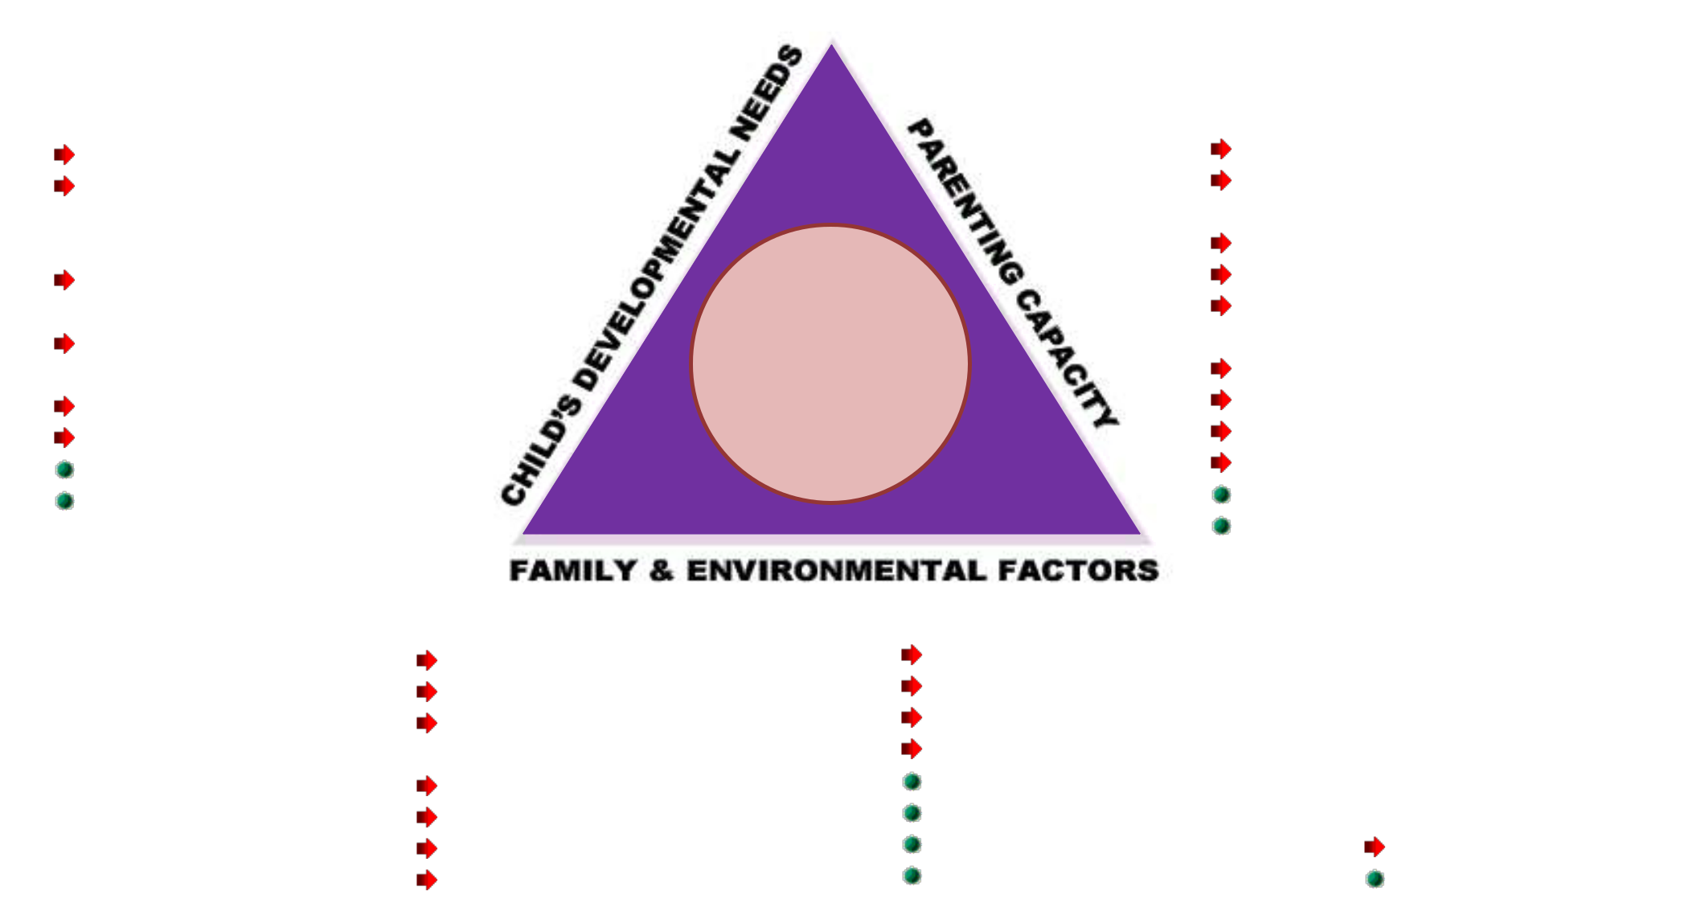

CHILD’S DEVELOPMENTAL NEEDS:
Irritable, sleepless child
Child with additional needs or
specific learning difficulties,
including ASD, Asperger’s, ADHD
Child with communication
difficulties

Poor school attendance / attainment
Child missing from education
Low self-esteem or self-harming
Defiant / angry child
Child affected by bereavement

CHILD

SAFEGUARDING

- PROMOTING WELFARE

PARENTING CAPACITY:

Mother under 20 years at first pregnancy Parent with history of poor school attendance and attainment Parent formerly in Care

Parent misuses substances or alcohol Poor attendance at health appointments

- GP, health visitor, clinics Domestic abuse

Parent with learning difficulties Child in Care

Child previously fostered Parent with physical disability Parent affected by bereavement

FAMILY & ENVIRONMENTAL FACTORS:
Single parent
Serial relationships
Reconstructed family
(parent or children)
Low income or debt
Out of work

Frequent moves
Crime

Trafficking
Female genital mutilation
Forced marriage
Honour based violence
Homeless or insecure housing
Poor quality housing KEY:
Number of house/school moves
Uncertain immigration

High evidence risk Medium evidence risk

FILE NAME ……………………………………………......…..... Page 11

ASSESSMENT FRAMEWORK

 | “THE CHILD’S VOICE” |  |  |  |  |  | NOTE TO ASSESSOR:
 |  |  |  |  | CHILD |  | COMPLETE SEPARATE ASSESSMENT FOR EACH CHILD
Place yourself in the child’s shoes and consider
 |  |  |  |  | SAFEGUARDING |  | Child’s Name
each issue from the child’s perspective, |  |  |  |  | & PROMOTING
OR record child’s comments |  |  |  |  | WELFARE
 |  |  |  |  |  |  | DoB ..........................................................................
 |  |  |  | FAMILY & ENVIRONMENTAL FACTORS
Community Resources |  | Family’s Social Integration |  |  |  | Income |  |  | Employment
 |  |  |  |  |  | ................................................................... |  |  | ...................................................................
................................................................... |  | ...................................................................
................................................................... |  | ................................................................... |  |  |  | ................................................................... |  |  | ...................................................................
................................................................... |  | ................................................................... |  |  |  | ................................................................... |  |  | ...................................................................
................................................................... |  | ................................................................... |  |  |  | ................................................................... |  |  | ...................................................................
................................................................... |  | ................................................................... |  |  |  | ................................................................... |  |  | ...................................................................
................................................................... |  | ................................................................... |  |  |  | ................................................................... |  |  | ...................................................................
................................................................... |  | ................................................................... |  |  |  | ................................................................... |  |  | ...................................................................
Housing |  |  |  |  | Wider Family |  |  |  | Family History and Functioning
 |  |  |  |  |  |  | .........................................................................................
......................................................................................... |  |  | .........................................................................................
......................................................................................... |  |  | ......................................................................................... |  |  |  | .........................................................................................
........................................................................................ |  |  | ........................................................................................ |  |  |  | ........................................................................................
.......................................................................................... |  |  | .......................................................................................... |  |  |  | ..........................................................................................
.......................................................................................... |  |  | .......................................................................................... |  |  |  | ..........................................................................................
.......................................................................................... |  |  | .......................................................................................... |  |  |  | ..........................................................................................
.......................................................................................... |  |  | .......................................................................................... |  |  |  | ..........................................................................................

FILE NAME ……………………………………………......…..... Page 12

FAMILY & ENVIRONMENTAL FACTORS

- Do you or your partner have any family history of health problems? Previous depression / mental health issues?

- Any recent major changes in your family’s situation e.g. bereavement, separation, moving house / job, accident, burglary?
- Employment / return to work

- Diet, weight, exercise, healthy lifestyle (alcohol, smoking, drug use), daily routine, socialisation / social networking

- Do you like where you live – housing / neighbourhood? Who lives there?

- Are you currently in temporary accommodation, Local Authority, Housing Association, Bed & Breakfast?

- Are you currently on a short term lease in private sector only?

- Small rental debt?

- Eviction imminent and/or homeless and/or large rental debt / Bed & Breakfast?

- Advice and support with childcare / Benefits entitlement (smoke detector), Healthy Start leaflet

- Access to transport, how do you get about?

- Do you or your family members have support from any other professionals?

- Do you or the father of the child have any medical or health concerns that may affect the child, e.g. epilepsy, asthma, eczema, diabetes, hearing or sight loss?

- What are your daily family routines /does your family have routines e.g. meals, sleep, work?

- When working directly with a school aged child / young person, points to consider:

How is school – attendance, bullying (mobile phone / internet), breakfast, packed lunches?

Are there any recent changes in your family?

Record of Assessment : date, time, persons present, contact codes

………………………………………………………………………………………………………………………………………………………………………………………….....

………………………………………………………………………………………………………………………………………………………………………………………….....

………………………………………………………………………………………………………………………………………………………………………………………….....

………………………………………………………………………………………………………………………………………………………………………………………….....

………………………………………………………………………………………………………………………………………………………………………………………….....

………………………………………………………………………………………………………………………………………………………………………………………….....

………………………………………………………………………………………………………………………………………………………………………………………….....

………………………………………………………………………………………………………………………………………………………………………………………….....

………………………………………………………………………………………………………………………………………………………………………………………….....

………………………………………………………………………………………………………………………………………………………………………………………….....

………………………………………………………………………………………………………………………………………………………………………………………….....

………………………………………………………………………………………………………………………………………………………………………………………….....

………………………………………………………………………………………………………………………………………………………………………………………….....

………………………………………………………………………………………………………………………………………………………………………………………….....

………………………………………………………………………………………………………………………………………………………………………………………….....

………………………………………………………………………………………………………………………………………………………………………………………….....

Date………………….…………………..…………. Time……..………………….……… Sign……………................………………………

Contact | WHERE: | H = HOME VISIT | C = CLINIC | S = SCHOOL | T = TELEPHONE
codes | TYPE OF CONTACT: | AN = ANTENATAL | NBV = NEW BIRTH VISIT PN = POSTNATAL PERIOD 2-6 WEEKS 1YR = 1YEAR REVIEW 2.5YR = 2 ½ YEAR REVIEW SE = SCHOOL ENTRY TI = TRANSFER IN

FILE NAME ……………………………………………......…..... Page 13

ASSESSMENT FRAMEWORK

“THE CHILD’S VOICE”
Place yourself in the child’s shoes and consider
each issue from the child’s perspective,
OR record child’s comments | CHILD

NOTE TO ASSESSOR:
COMPLETE SEPARATE ASSESSMENT FOR EACH CHILD

Child’s Name ..........................................................................

DoB ........................................................................................

SAFEGUARDING
& PROMOTING
WELFARE

Basic Care |  | Ensuring Safety |  | Emotional Warmth
......................................................................................... |  | ......................................................................................... |  | .........................................................................................
......................................................................................... |  | ......................................................................................... |  | .........................................................................................
........................................................................................ |  | ........................................................................................ |  | ........................................................................................
.......................................................................................... |  | .......................................................................................... |  | ..........................................................................................
.......................................................................................... |  | .......................................................................................... |  | ..........................................................................................
.......................................................................................... |  | .......................................................................................... |  | ..........................................................................................
.......................................................................................... |  | .......................................................................................... |  | ..........................................................................................
Stimulation |  | Guidance and Boundaries |  | Stability
......................................................................................... |  | ......................................................................................... |  | .........................................................................................
......................................................................................... |  | ......................................................................................... |  | .........................................................................................
........................................................................................ |  | ........................................................................................ |  | ........................................................................................
.......................................................................................... |  | .......................................................................................... |  | ..........................................................................................
.......................................................................................... |  | .......................................................................................... |  | ..........................................................................................
.......................................................................................... |  | .......................................................................................... |  | ..........................................................................................
.......................................................................................... |  | .......................................................................................... |  | ..........................................................................................
 |  |  |  | FILE NAME ……………………………………………......…..... Page 14

PARENTING CAPACITY / Parents and Carers | Record of Assessment : date, time, persons present, contact codes
• How do you feel about your pregnancy / | ………………………………………………………………………………………………………………………………………………………………………………………………………….…….
parenthood? | ……………………………………………………………………………………………………………………………………………………………………………………………………………….
• Have you had experience of babies / young | ………………………………………………………………………………………………………………………………………………………………………………………………………………
children?
children? | ……………………………………………………………………………………………………………………………………………………………………………………………………………….
• What was your childhood experience like? /
Would you make any changes when parenting | ………………………………………………………………………………………………………………………………………………………………………………………………………………
your own children?
your own children? | ……………………………………………………………………………………………………………………………………………………………………………………………………………….
• Are you and your partner still in close contact
with your parents / extended family? Do they | ……………………………………………………………………………………………………………………………………………………………………………………………………………….
live nearby?
live nearby? | ………………………………………………………………………………………………………………………………………………………………………………………………………………..
• How is your partner adapting to parenthood?
• Does anyone in your family consider | ………………………………………………………………………………………………………………………………………………………………………………………………………………..
themselves to be a carer? | ………………………………………………………………………………………………………………………………………………………………………………………………………………
• Has anyone in your household needed and/or
received extra support in school? | ……………………………………………………………………………………………………………………………………………………………………………………………………………….
• Have you ever had support from Children and | ………………………………………………………………………………………………………………………………………………………………………………………………………………..
Young People’s Services?
- Ιφ ψου φεελ ιτ ισ σαφε το δο σο, εξπλαιν ανδ μακε ………………………………………………………………………………………………………………………………………………………………………………………………………………..
 | a routine enquiry about domestic abuse: |  |  | ……………………………………………………………………………………………………………………………………………………………………………………………………………….
 | DIRECT QUESTION: Are you in a relationship
 | with someone who hurts or threatens you ‘or |  |  | ………………………………………………………………………………………………………………………………………………………………………………………………………………..
 | if evident’ did someone cause these injuries to |  |  | ……………………………………………………………………………………………………………………………………………………………………………………………………………….
 | you?’
• | When working directly with a school aged |  |  | ………………………………………………………………………………………………………………………………………………………………………………………………………………..
 | child / young person, points to consider: |  |  | ………………………………………………………………………………………………………………………………………………………………………………………………………………..
 | Who do you talk to if you have any concerns?
• | Have you ever had support from Children and |  |  | ………………………………………………………………………………………………………………………………………………………………………………………………………………...
 | Young People’s Services? |  |  | …………………………………………………………………………………………………………………………………………………………………………………………………………………
 |  |  |  | Date………………….…………………..…………. Time……..……………….........….……… Sign………………………………………………….……………….…………………..
Contact | WHERE: | H = HOME VISIT | C = CLINIC S = SCHOOL T = TELEPHONE
codes | TYPE OF CONTACT: | AN = ANTENATAL | NBV = NEW BIRTH VISIT PN = POSTNATAL PERIOD 2-6 WEEKS 1YR = 1YEAR REVIEW 2.5YR = 2 ½ YEAR REVIEW SE = SCHOOL ENTRY TI = TRANSFER IN
FILE NAME ……………………………………………......…..... Page 15
ASSESSMENT FRAMEWORK

“THE CHILD’S VOICE” |  | NOTE TO ASSESSOR:
“THE CHILD’S VOICE” |  | COMPLETE SEPARATE ASSESSMENT FOR EACH CHILD
Place yourself in the child’s shoes and consider |  | Child’s Name ..........................................................................
each issue from the child’s perspective,
each issue from the child’s perspective, | CHILD
OR record child’s comments | CHILD | DoB ........................................................................................
SAFEGUARDING
& PROMOTING
WELFARE

Health | Education | Emotional & Behavioural Development
......................................................................................... | ......................................................................................... | .........................................................................................
......................................................................................... | ......................................................................................... | .........................................................................................
........................................................................................ | ........................................................................................ | ........................................................................................
.......................................................................................... | .......................................................................................... | ..........................................................................................
.......................................................................................... | .......................................................................................... | ..........................................................................................
.......................................................................................... | .......................................................................................... | ..........................................................................................
.......................................................................................... | .......................................................................................... | ..........................................................................................

Identity | Family & Social Relationships | Social Presentation |  | Selfcare Skills
................................................................... | ................................................................... | ................................................................... |  | ...................................................................
................................................................... | ................................................................... | ................................................................... |  | ...................................................................
................................................................... | ................................................................... | ................................................................... |  | ...................................................................
................................................................... | ................................................................... | ................................................................... |  | ...................................................................
................................................................... | ................................................................... | ................................................................... |  | ...................................................................
................................................................... | ................................................................... | ................................................................... |  | ...................................................................
................................................................... | ................................................................... | ................................................................... |  | ...................................................................
 |  |  | FILE NAME ……………………………………………......…..... Page 16

CHILD’S DEVELOPMENTAL NEEDS | Record of Assessment : date, time, persons present, contact codes
- ΤΒ ρισκ
 | • Exposure to drugs, alcohol, smoking |  |  |  |  |  | ………………………………………………………………………………………………………………………………………………………………………….………………………..................
 | • Known or family history of asthma / eczema / |  |  |  |  |  | ………………………………………………………………………………………………………………………………………………………….……………………………….…..………………….
 |  | hay fever / allergies
 | • Consider parental mental health and well-being |  |  |  |  |  | ………………………………………………………………………………………………………………………………………………………….……………………………….……………………….
 |  | (Whooley questions) |  |  |  |  | …………………………………………………………………………………………………………………………………………………………………………………….……………………………..
 | Whooley Questions:
 | (i) During the past month, have you often been bothered by |  |  |  |  |  | ……………………………………………………………………………………………………………………………………………………………………………………….…………………………..
 | feeling down, depressed or hopeless? |  |  |  |  |  | ………………………………………………………………………………………………………………………………………………………………………………………..………………………….
 | (ii) During the past month, have you often been bothered by
 | having little interest or pleasure in doing things? |  |  |  |  |  | ………………………………………………………………………………………………………………………………………………………………….………………………….…………………….
 | Consider a Third Question: |  |  |  |  |  | ………………………………………………………………………………………………………………………………………………………….………………………………….…………………….
 | Is this something you feel you need or want help with?
 | • Family history of childhood deafness/fits/eye |  |  |  |  |  | ………………………………………………………………………………………………………………………………………………….………………………………………….…………………….
 |  | problems/reading and spelling difficulties/other
 |  |  |  |  |  |  | ……………………………………………………………………………………………………………………………………………………………………………………………..……..................
 | • When working directly with a school aged child /
 |  | young person points to consider: |  |  |  |  | ………………………………………………………………………………………………………………………………………………………….…………………………………….………………….
 |  | Do you have any worries about your health:
 |  |  |  |  |  |  | ………………………………………………………………………………………………………………………………………………………….……………………………………….……………….
 |  | hearing problems; dentist; orthodontist;
 |  | optician; sleep habits; smoking / alcohol / illegal |  |  |  |  | ………………………………………………………………………………………………………………………………………………………….……………………………………….……………….
 |  | substances; identity / self-esteem? Do you feel
 |  |  |  |  |  |  | ………………………………………………………………………………………………………………………………………………………………………………………………….………………..
 |  | good about who you are?
 |  | Do you know where to get advice / help about |  |  |  |  | ………………………………………………………………………………………………………………………………………………………………………………………………….………………..
 |  | sexual health?
 |  |  |  |  |  |  | ……………………………………………………………………………………………………………………………………………………………………………….………………………………….
 | If specific needs identified commence individualised care
 | plan / or early support information required - commence |  |  |  |  |  | ………………………………………………………………………………………………………………………………………………………………….……………………………………………….
 | BLUE FAMILY FILE
 |  |  |  |  |  |  | ………………………………………………………………………………………………………………………………………………………….……………………………………………………….
 | Please follow SOP No 4 : The Perinatal Infant Mental
 | Health Contact by SCPHN HV |  |  |  |  |  | Date………………….…………………..….……….……. Time……..…………………….……… Sign………………………………….……………………………….………….………..
 | Contact |  | WHERE: | H = HOME VISIT | C = CLINIC |  | S = SCHOOL T = TELEPHONE
 | codes |  | TYPE OF CONTACT: | AN = ANTENATAL | NBV = NEW BIRTH VISIT PN = POSTNATAL PERIOD 2-6 WEEKS 1YR = 1YEAR REVIEW 2.5YR = 2 ½ YEAR REVIEW SE = SCHOOL ENTRY TI = TRANSFER IN

FILE NAME ……………………………………………......…..... Page 17

SUMMARY SHEET


ANALYSIS & NEEDS IDENTIFIED

………………………………………………………………………………………………………………………………………………………………………...................

………………………………………………………………………………………………………………………………………………………………………...................

………………………………………………………………………………………………………………………………………………………………………...................

………………………………………………………………………………………………………………………………………………………………………...................

………………………………………………………………………………………………………………………………………………………………………...................

………………………………………………………………………………………………………………………………………………………………………...................

………………………………………………………………………………………………………………………………………………………………………...................

………………………………………………………………………………………………………………………………………………………………………...................

………………………………………………………………………………………………………………………………………………………………………...................

………………………………………………………………………………………………………………………………………………………………………...................

………………………………………………………………………………………………………………………………………………………………………...................

………………………………………………………………………………………………………………………………………………………………………...................

………………………………………………………………………………………………………………………………………………………………………...................

………………………………………………………………………………………………………………………………………………………………………...................

………………………………………………………………………………………………………………………………………………………………………...................

………………………………………………………………………………………………………………………………………………………………………...................

………………………………………………………………………………………………………………………………………………………………………...................

.………………………………………………………………………………………………………………………………………………………………………...................

………………………………………………………………………………………………………………………………………………………………………...................

………………………………………………………………………………………………………………………………………………………………………...................

………………………………………………………………………………………………………………………………………………………………………...................

...................................................................................Signature ................................................................................... | Date .......................................................
 | FILE NAME ……………………………………………......…..... Page 18

Date | ACTION PLAN

………………………………………………………………………………………………………………………………………………………………………...................

………………………………………………………………………………………………………………………………………………………………………...................

………………………………………………………………………………………………………………………………………………………………………...................

………………………………………………………………………………………………………………………………………………………………………...................

………………………………………………………………………………………………………………………………………………………………………...................

………………………………………………………………………………………………………………………………………………………………………...................

………………………………………………………………………………………………………………………………………………………………………...................

………………………………………………………………………………………………………………………………………………………………………...................

………………………………………………………………………………………………………………………………………………………………………...................

………………………………………………………………………………………………………………………………………………………………………...................

………………………………………………………………………………………………………………………………………………………………………...................

………………………………………………………………………………………………………………………………………………………………………...................

………………………………………………………………………………………………………………………………………………………………………...................

………………………………………………………………………………………………………………………………………………………………………...................

………………………………………………………………………………………………………………………………………………………………………...................

………………………………………………………………………………………………………………………………………………………………………...................

………………………………………………………………………………………………………………………………………………………………………...................

…………………………………………………………………………………………………………………………………………………………………………………….

……………………………………………………………………………………………………………………………………………………………………………………..

............................................................................................................... | Signature .......................................................... | Date .................................................
UNIVERSAL (U) | UNIVERSAL PLUS (UP) | UNIVERSAL PARTNERSHIP PLUS (UPP) / Safeguarding

FILE NAME ……………………………………………......…..... Page 19

 | REVIEW SHEET
REVIEW DATE |  | PRACTITIONER SIGNATURE

Action Plan:

………………………………………………………………………………………………………………………………………………………………………...................

………………………………………………………………………………………………………………………………………………………………………...................

………………………………………………………………………………………………………………………………………………………………………...................

………………………………………………………………………………………………………………………………………………………………………...................

…………………………………………………………………………………………………………………………………………………………………………………….

……………………………………………………………………………………………………………………………………………………………………………………..

……………………………………………………………………………………………………………………………………………………………………………………..

……………………………………………………………………………………………………………………………………………………………………………………..

REVIEW DATE | PRACTITIONER SIGNATURE
Action Plan:

………………………………………………………………………………………………………………………………………………………………………...................

………………………………………………………………………………………………………………………………………………………………………...................

………………………………………………………………………………………………………………………………………………………………………...................

………………………………………………………………………………………………………………………………………………………………………...................

…………………………………………………………………………………………………………………………………………………………………………………….

……………………………………………………………………………………………………………………………………………………………………………………..

……………………………………………………………………………………………………………………………………………………………………………………..

……………………………………………………………………………………………………………………………………………………………………………………..

FILE NAME ……………………………………………......…..... Page 20

Review Sheets (contd.)

 | REVIEW DATE | PRACTITIONER SIGNATURE
Action Plan:

………………………………………………………………………………………………………………………………………………………………………...................

………………………………………………………………………………………………………………………………………………………………………...................

………………………………………………………………………………………………………………………………………………………………………...................

………………………………………………………………………………………………………………………………………………………………………...................

…………………………………………………………………………………………………………………………………………………………………………………….

……………………………………………………………………………………………………………………………………………………………………………………..

……………………………………………………………………………………………………………………………………………………………………………………..

……………………………………………………………………………………………………………………………………………………………………………………..

 | REVIEW DATE | PRACTITIONER SIGNATURE
Action Plan:

………………………………………………………………………………………………………………………………………………………………………...................

………………………………………………………………………………………………………………………………………………………………………...................

………………………………………………………………………………………………………………………………………………………………………...................

………………………………………………………………………………………………………………………………………………………………………...................

…………………………………………………………………………………………………………………………………………………………………………………….

……………………………………………………………………………………………………………………………………………………………………………………..

……………………………………………………………………………………………………………………………………………………………………………………..

……………………………………………………………………………………………………………………………………………………………………………………..

FILE NAME ……………………………………………......…..... Page 21

 |  | LONE WORKING AND HOME VISITING COMMUNITY RISK ASSESSMENT
 | Name of Client: | Client DoB:
 | Client Address: | GP:
 |  | Team:
 | Telephone: | Date form commenced:
 |  | Form commenced by:

 |  | RISK AREA |  |  | ADDITIONAL INFORMATION
 | House Location |  | YES | NO
 | 1. | Is the house/flat number or name visible from the road? | O | O
 | 2. | Are there any specific landmarks? | O | O
 | 3. | Are specific directions required? | O | O
 | 4. | Are there other houses close by? | O | O
 | Entry System |  | YES | NO
 | 5. | Is there an intercom system? | O | O
 | 6. | Does the doorbell work? | O | O
 | 7. | Is it front door entry? | O | O
 | 8. | Is it back door entry? | O | O
 | 9. | Is there a key safe/other entry system? | O | O
 | Parking |  | YES | NO
 | 10. | Can you park outside on the road? | O | O
 | 11. | Can you park close by < 5 minutes? | O | O
 | Lighting and Footpaths |  | YES | NO
 | 12. | Is the area well lit? (state if a torch is required) | O | O
 | 13. | Are there outside lights for the house? | O | O
 | 14. | Are there any environmental risks/hazards? | O | O
 |  | (e.g. steps, alley way, uneven paths, debris etc.)
 | Family Members and Associated Persons |  | YES | NO
 | 15. | Are there concerns about other individuals in the household? (e.g. inappropriate behaviour/drugs/alcohol etc.) | O | O
 | 16. | Are there any concerns about the neighbours? | O | O
 | Premises |  | YES | NO
 | 17. | Does the property have mobile telephone network coverage? | O | O
FILE NAME ……………………………………………......…..... Page 22

 | 18. | Does the house have a land line telephone? | O | O
 | 19. | Are there any slip, trip, fall hazards? | O | O
 | 20. | Are doors locked whilst staff are in the house? | O | O
 | 21. | Are there concerns about electrical equipment you may be required to use? | O | O
 | 22. | Are there any pets present which need to be restrained prior to the visit? | O | O
 | 23. | Are there any alternative means of exiting the premises in the event of an emergency (e.g. fire, violence etc.)? | O | O
 | 24. | Are there any other internal risks or hazards which cause you concern? | O | O

 | Individual |  | YES | NO
 | 25. | Does the client/patient have any sensory impairment? | O | O
 | 26. | Does the client/patient use drugs/alcohol and does this pose a risk to staff? | O | O
 | 27. | Has the client/patient been diagnosed with mental health disorders/ personality disorder/learning disability, or are | O | O
 |  | there any adult protection concerns?
 | 28. | Does the client/patient have any history of violence/abuse/bullying/domestic violence? | O | O
 | 29. | Does this client/patient require an individual risk assessment? (if so, please attach) | O | O
 | Drug and Alcohol Related Risks |  | YES | NO
 | 30. | Does the client/patient use drugs? | O | O
 | 31. | Does the client/patient use alcohol? | O | O
 | 32. | Is anyone else in the household a drug or alcohol user? | O | O
 | 33. | Are drug/alcohol users known to visit the property to use drugs or alcohol? Do they have keys to the property? | O | O
 | 34. | Do any injecting drug users live in the home, or does anyone visit the home to inject drugs? (consider occasional | O | O
 |  | and regular injecting patterns)
 | 35. | Is there a known risk of uncapped sharps or blood spills in the home? | O | O
 | 36. | Is there a risk of the worker being exposed to drug dealing or other offences (e.g. handling stolen goods, sex work) in | O | O
 |  | the home?
 | 37. | Does the client/patient have a known risk of violence or hostility to staff? | O | O
 | 38. | Is the client/patient at risk of violence from others? | O | O
 | 39. | Are there any concerns of weapons (e.g. blades or firearms) being held at the property? | O | O
 | 40. | Does the client/patient have a diagnosed mental illness? | O | O
 |  | Is there any deterioration in their condition which might pose a risk to home visiting staff?
 | 41. | Is the home visit likely to involve the relaying of ‘bad news’ or difficult conversations which could provoke a hostile | O | O
 |  | reaction in the client/patient? (e.g. cessation of treatment, child protection, welfare issues)
 | 42. | Is the client/patient likely to be in a state of drug or alcohol withdrawal? | O | O
 | 43. | Are there any other substance-specific issues that may pose a risk to a worker undertaking a home visit? | O | O
 | 44. | Does the client/patient smoke? | O | O
 | 45. | Is the client/patient on oxygen? | O | O
 |  |  | FILE NAME ……………………………………………......…..... Page 23


Additional Notes

FILE NAME ……………………………………………......…..... Page 24 of 24

