C20 in Sheffield
The Annual General Meeting Tour
26th & 27th May 2012
Ian McInnes & Sid Fletcher

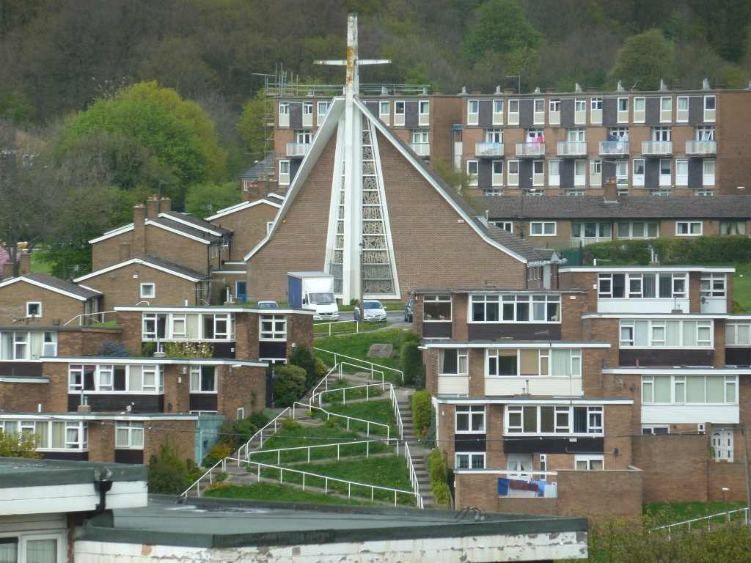
Holy Cross Church and Spotswood Drive Housing
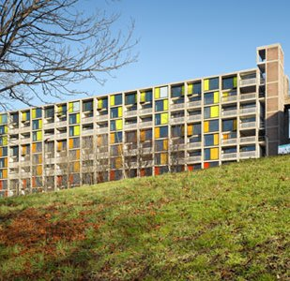

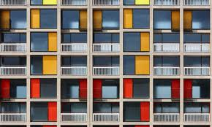The new Park Hill
Itinerary:

Saturday:

11:00 Meet at SITE Gallery,
11:30 AGM (allow 1.5 hours)
13:00 Lunch at SITE Gallery till 13:30
13:30 Coach picks up & drives to Park Hill
13.45 Visit Park Hill & exhibition
15:00 Coach leaves & drives to the University
15.15 Visit University Arts Tower
15.45 Coach leaves & drives to Trinity United Reform Church
16.00 Visit Trinity United Reform Church
16.20 Coach leaves & drives to Hathersage
16:45 Tour of David Mellor Factory and Museum, Hathersage
18:00 Coach drives to end of lane leading to
Fiona's MacCarthy’s house
18:15 Drinks at Fiona McCarthy’s house
20:00 Coach returns to city centre and does brief
tour around city to see Moor Street Sub-station etc
20:30 Dinner on your own

Sunday:

08:30 Check out of hotel
08:45 Coach picks up baggage
09:00 City Walk - Cathedral, City Hall, Castle Market, Co-op, Millennium Galleries etc led by Sid Fletcher
10:30 Coach leaves from city centre &
Drives to Gleadless Valley
11:00 Visit Gleadless Valley housing
Holy Cross Church
Derby Terrace
11:45 Coach leaves Gleadless Valley & drives to Greenhill
12:00 Visit Low Edges Estate
Greenhill Library
St Peters Greenhill
12:45 Coach leaves & drives to
Richmond Road
13.00 Visit St Catherine of Sienna
Lunch stop & tea/coffee/toilets.
13.45 Coach leaves & drives to
Woodhouse
14.00 Visit Vic Hallam Houses
14.15 Coach leaves & drives to
Wordsworth Avenue
14.30 Visit St Pauls Wordsworth Avenue
15:00 Coach leaves & drives to Park Lane (if time permits) via Regent Court Flats, Houses in Endcliffe Hall Avenue etc
15:45 Arrive at 1 Park Lane & visit
16:45 Leave Park Lane and drive to station
17:10 Arrive at Sheffield Station

Introduction:

Nikolaus Pevsner was almost ecstatic about Sheffield and its ‘massive achievement’ in the post war era. “No other English city except London can show so impressive an architectural record” he wrote in 1959, praising the exceptional contribution of city architect Lewis Womersley while expressing some doubts about the long-term viability of the modern heritage. Of the ‘sensational’ Park Hill Pevsner wrote “there can be no doubt that such a vast scheme of closely set high blocks of flats will be a slum in half a century or less”.

Ian Nairn, writing in the Listener was equally positive “without any doubt, the buildings put up in the last ten years, and projected for the next twenty, are as interesting and exciting as all the older buildings in the city put together; and this, for Britain, is quite an achievement”. He thought Sheffield’s pre c20 buildings something of a joke but was clearly affected by the optimism of the city in the 50s and 60s.

Park Hill was, in his view, undoubtedly a success – but he also wondered whether it would wear well. He thought the new market complex to be even better with its multi-level format perhaps offering a clue to the future development of the whole of the central area – luckily that never happened.

A large amount of the social housing built in the 50s and 60s, has been either knocked down or extensively refurbished - there is a continuing city wide programme of upgrading and replacement, and Park Hill is only the latest example.

Park Hill’s sister estate, Hyde Park, was beset with problems from the start and was part demolished and part refurbished in 1991, to serve initially as accommodation for the World Student games.

Sheffield was always looking at more imaginative ways of house building and undertook a large programme of prefabrication, many of the houses remain and we will see some later in the tour.

While some estates did not work architecturally and sociologically, that is not true of them all, and the Gleadless Valley, build during the late 1950s is one of the better examples which is substantially original.
The main 1950s/60s housing developments were as follows:

Greenhill 1952-59
Bush Meadow 1955-57
Gleadless 1955-61
Netherthorpe 1956-60
Park Hill 1957-60
Birklands Avenue 1957-60
Woodside 1960-63
Burngreave 1960-63
Hyde Park 1962-65
Middlewood 1962-65
Stannington 1962-65
Norfolk Park 1962-66

Saturday:

Park Hill Refurbishment, 2007-12 (architect – Hawkins Brown & Studio Egret West)

The first phase of the £140m redevelopment by architects Hawkins brown and Studio Egret West is now complete and the new flats are on the market. The project included the refurbishment of the thirteen storey north block into 321 new flats with the lower floors set to become retail, restaurant, bar and/or café spaces. There will be extensive hard landscaping works to create outdoor spaces for residents and visitors and to improve connections through the Estate and to the city beyond.

The most radical aspect of the project has been the replacement of the original façade of brick panels and timber windows with brightly coloured anodized aluminium panels and large fixed sections of glazing. The new window ‘cassettes’ contrast with the previous façade and are designed to introduce a shimmering effect with colours ranging from a dark aubergine at the lowest level, to a lime green at the top of the building. In addition the concrete frame has been cleaned and repaired, with larger balconies and new concrete balustrades added.

An article in the Observer raised the critical point. “The question is whether whatever is important about Park Hill will remain after its doing-up, which is both drastic and pernickety. On the one hand, everything has been removed except the concrete frame. On the other, that concrete was restored in 5,500 places, following debates between English Heritage and Urban Splash. Pursuing principles once proposed by William Morris for the repair of ancient stone churches, the mends are made such that you can see them, but not too easily.

In order to sell flats to people who might not like the idea of council estates, the developers wanted what the architects call "shimmer". So the brick infill panels of the old building, in shades of plum and ochre, were not afforded the same respect as the precious concrete, but were replaced by shiny aluminium panels (guaranteed against fading) in red, orange and yellow.
The cleverly planned, well-dimensioned flats have been reinstated, but with bigger windows and greater openness than before. The streets in the sky are back and now overlooked with windows from the flats, to make them more sociable. Access is controlled and there will be concierges: it will be gated, to put it negatively, or, if you prefer, have the degree of security you would find in a Parisian apartment block.”
Ivor Smith, one of the original architects, is still alive and was reported as being positive about the work, saying "The care taken to repair a derelict structure is impressive". He apparently liked the new glass lifts and thought the new scheme "represents a new beginning, a new vitality". He also noted that "the whole design is free of gimmicks and there is a consistency and inevitability to each part".
The Observer article continued “And so, mostly, it's refreshing. If Urban Splash can be too flash for their own good, the seriousness of Park Hill, and the difficulties of restoring it, have focused the mind. The original building was never supposed to be frozen, but open to accident and circumstance, and it now registers both its original intentions and its recent changes. Those aluminium panels are, as Ivor Smith says, "a bit bright", uncomfortably out-staring the original work, and could perhaps be modified in later phases, when the developers are less nervous about the estate's image. They might even find that the original brick is not so bad, with its ability to weather and age.
The decision to list the building now looks brave and right. Had it gone, nothing would now be there but the nothing housing you see all over the country, with meaner dimensions, shoddier building and an absence of spirit. Nor is the rescue of Park Hill a grotesque extravagance: demolition and rebuilding would not necessarily have been more cost-effective and it would have been environmentally profligate.
There is one – large – detail. Two-thirds of the original 1,000 council flats will, with the help of public subsidy to the development, now be for private sale. The council says that it's better to have a mixture of tenures than to remake a "ghetto" of council tenants. This follows the current orthodoxy and might be entirely reasonable if the homes were being replaced elsewhere in the city. Instead, there has been a demolition derby of council flats, leaving cleared sites which "haven't been built on as fast as we would like". This problem is not the size of Park Hill, it's the size of Sheffield.”
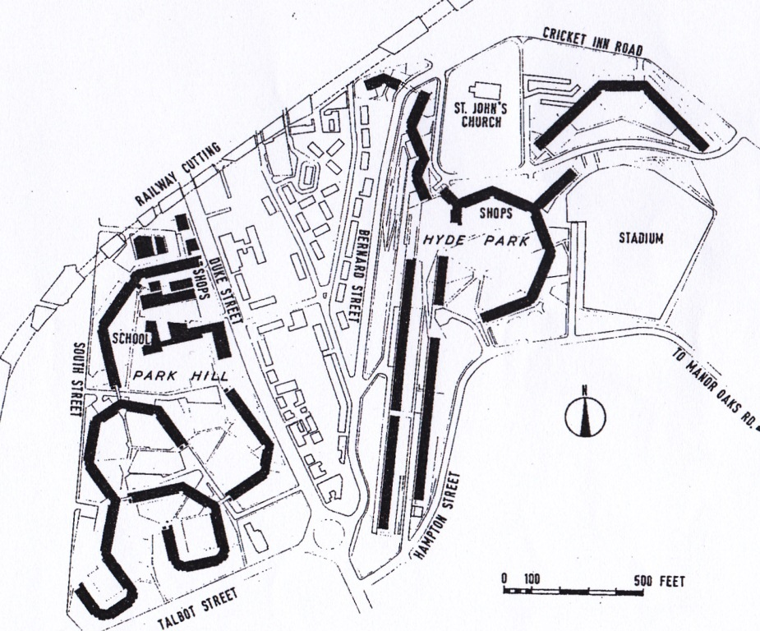Park Hill & Hyde Park Site Plan
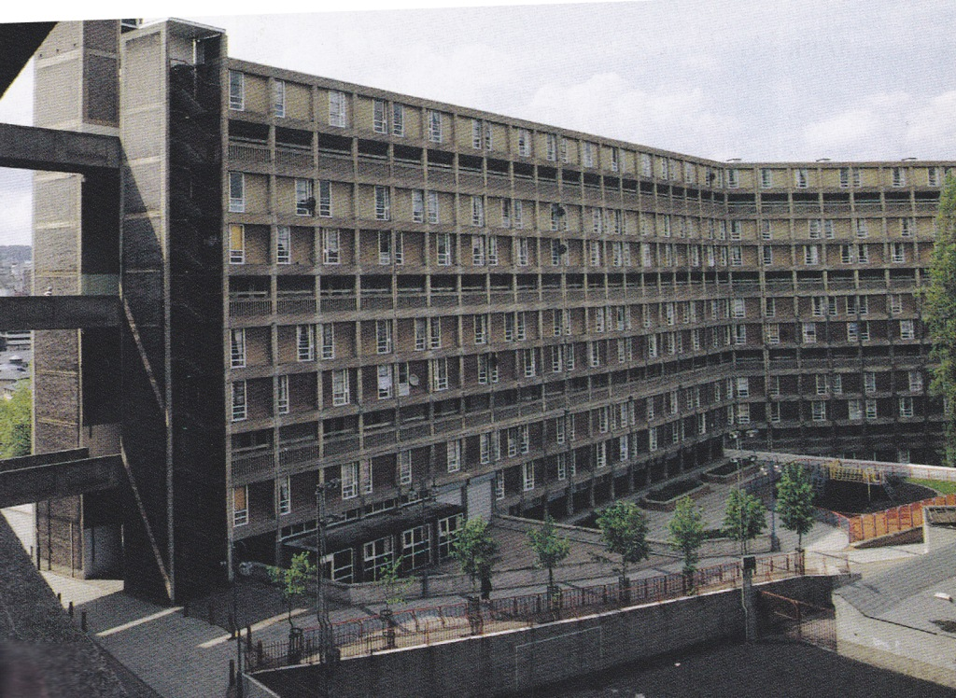Park Hill general view
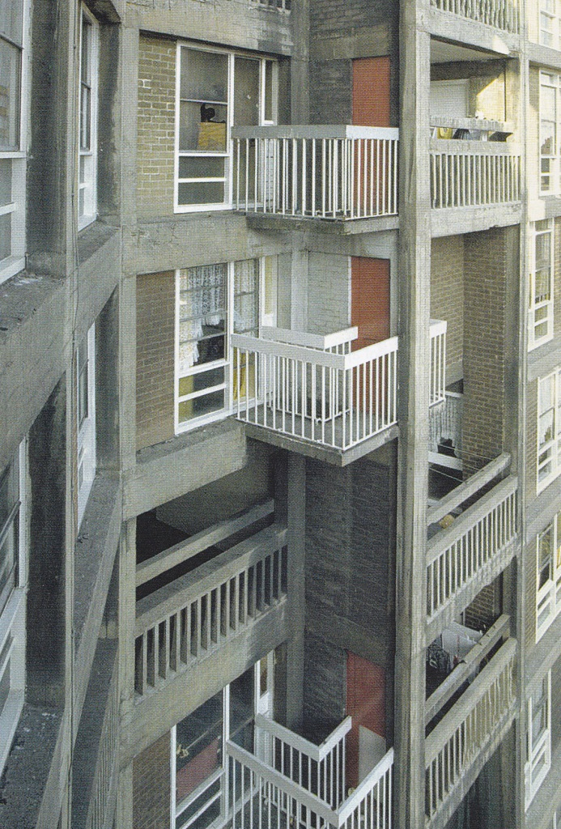
Park Hill – original façade detail
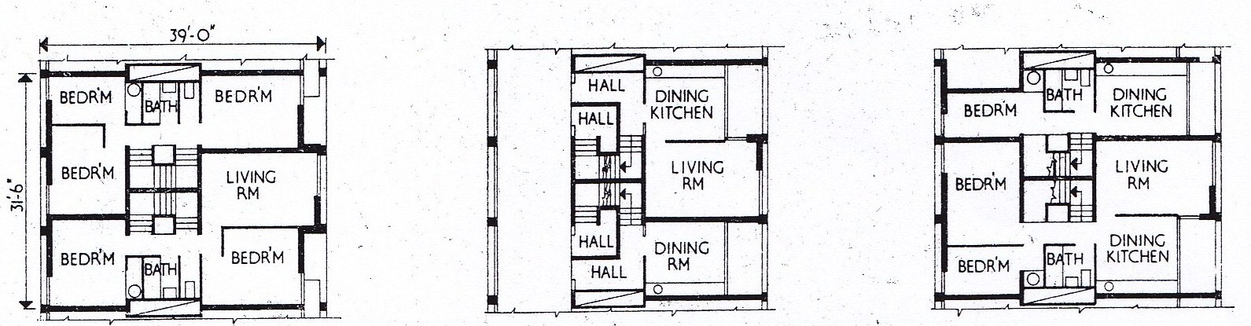
Original Floor Plans
Park Hill,1957-61 (architect - Sheffield City Architect's Department (City Architect - J L Womersley, project architects - Jack Lynn and Ivor Smith with F E Nicklin and John Forrester (artist); Ronald Jenkins of Ove Arup and Partners, engineer)
Park Hill was previously the site of back-to-back housing, a mixture of 2-3 storey tenement buildings, waste ground, quarries and steep alleways. Facilities were poor with one standpipe supporting up to 100 people. It was colloquially known as "Little Chicago" in the 1930s, due to the incidence of violent crime there. Clearance of the area began during the 1930s but was halted due to World War II.
More was written about the original Park Hill development than perhaps any other in the country and it has long been considered to be of international importance. It is the first built manifestation of a widespread theoretical interest, in the early and mid-1950s, in external access decks as a way of building high without the problems of isolation and expense encountered with point blocks. Sheffield and the London County Council had had the only major local authority departments designing imaginative and successful public housing in the 1950s, and this was Sheffield's flagship. The decks were conceived as a way of recreating the community spirit of traditional slum streets, with the benefit of vehicular segregation; The deck system was uniquely appropriate here because the steeply sloping site allowed all but the uppermost deck to reach ground level, and the impact of the long, flat-topped structure rising above the city centre made for one of Sheffield's most impressive landmarks. The result was Britain's first completed scheme of post-war slum clearance and the most ambitious inner-city development of its time. It was formally opened in 1961 by Hugh Gaitskell, the leader of the Labour Party.
The early residents were thrilled more by the plumbing than the bold concrete exterior and by the walkways, which meant they could get from one end to the other without getting wet. People now remember the community spirit of Park Hill's first two decades, before the devastation of the steel industry and council housing policies that turned it into a sink estate. The Park Hill enthusiasts like to quote a woman who said: "You think I live in council housing. I've got a penthouse."
Park Hill was formed of four ranges linked by bridges across the upper decks, all cranked at obtuse angles (between 112 and 135 degrees) to maximise the site aspect and panoramic views. Lifts (mainly in pairs), stairs, pubs and laundry were set at nodal points. The boiler house and former garchey station were set on the lowest point of the site - to the north-west.

The blocks were designed to keep a constant roof level - the height of the blocks range from four to thirteen storeys. Access decks at every third floor served maisonettes on and above the deck and one-storey flats set below it. The innovatory width of these four 'street decks' was a key feature of the architects' concept; all save the uppermost (Norwich Row) debouches on to ground level at some part of the scheme, and are served by 13 lifts and two large goods' lifts which gave milk floats and other services direct access to the decks, enhancing the image of 'streets in the sky'.

The main unit of construction was a standard three-bay unit, with central staircases, set in pairs, within an H-shaped frame. Each contained a one-bedroom and a two-bedroom flat, and a two-bedroom and three-bedroom maisonette, all with balconies. The rigid grid of flats and maisonettes ensured that kitchens and bathrooms were stacked in pairs to facilitate servicing.

Elevations were treated as a regular exposed grid of the board-marked concrete frame. Balconies on those elevations not served by decks provide a rhythmic 2:1 pattern in both directions across facades, varied only at corners. Balconies and decks had vertical concrete balustrading, with a similar pattern of slender steel balustrading to bedroom balconies. The original windows were timber, with aluminium horizontal opening sections. Doors were flush timber.

Sheffield University Competition

The 1953 competition for the expansion of the University caught the public’s attention as an indication of a new architectural image for a modern university. Assessed by F R S Yorke and Percy Thomas it attracted over 100 entries including a radical scheme from the Smithsons.

Gollins Melvin and Ward were the winners with a scheme that disregarded the closed quadrangle form set by the original buildings on the site and adopted an ‘elementarist’ approach of separate buildings which were to be seen as elements in an abstract composition set against a blank canvas of neutral

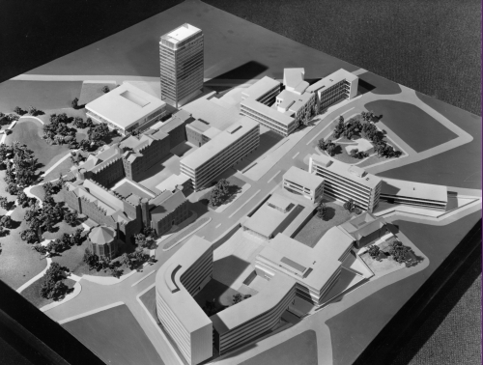
Site Model 1960

open space. The upside of this allowed for growth and the identification of individual buildings whose form and style could vary according to function and location. The down side was that little or no thought was given to the spaces between the buildings or the relationship between them – the windswept forecourt to the Arts Tower was one of the results
On the right:
Dainton Building, 1950-53 (architect – J W Beamont & Sons) Institutional sripped classicism with later extensions. The west block was built 1960-64 (architect – Gollins Melvin Ward and Partners) and the east is 1955-63 by the same architect, but remodelled in 2002-04 (architect –CPMG Architects)

Sheffield University Arts Tower, 1961-65 (architect – Gollins Melvin Ward and Partners (Robert Smith)) Listed Grade II*
At first this building was intended to be a 13 storey high slab block, at right angles to its present site and some way from the library. It then went through various design stages, including a cylindrical one, until finally achieving its present form as a 20 storey tower. The university authorities are said to have wanted a landmark focus for the extended campus.
Changes in the design brought its appearance closer to that of SOM’s Lever House and to Mies van de Rohe’s Seagram Tower but the project architect has denied their influence, saying that the form of the building came from the surrounding context.
The original design of the curtain walling would have been similar to that on the Hicks building ie a more rectangular proportion, without its current vertical emphasis.
Entry to the building was originally made by a wide 'bridge' between fountains over a shallow pool area in front of the building. This pool was eventually drained and covered over when it was found that strong down drafts of wind hitting the building on gusty days caused the fountain to soak people entering and exiting the building. An alternative design for a rotunda style cylindrical building was thrown out when suitable curved furnishings were costed.
The building was refurbished and reclad in 2007-11 (architect - HLM architects). The original intention had been to retain the curtain walling but this
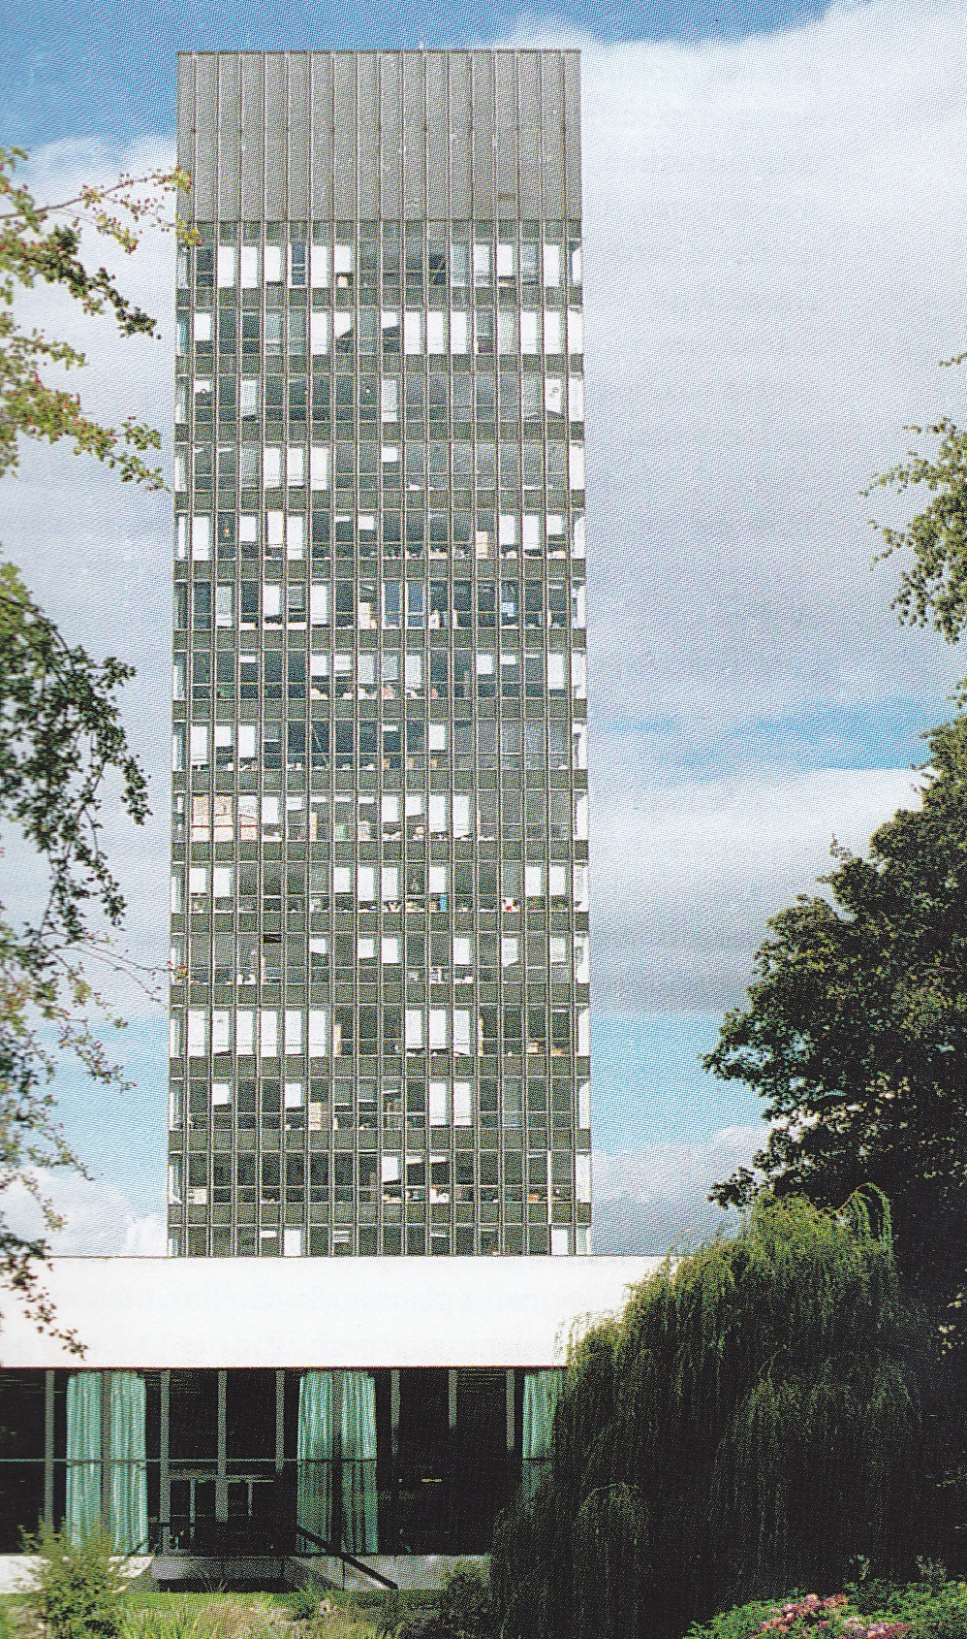Sheffield Universty Arts Tower
proved to be impractical once a detailed survey had confirmed its actual condition. The new double glazed units and insulated spandrels match the original in appearance. The paternoster lift, which has been retained and upgraded, is the largest of the few still working in Britain. The opportunity was also taken to improve the provision for the ever-expanding student numbers with a complete retrofit for the departments of architecture and landscape architecture, who now between them occupy floors 9 to 19.
Sheffield University Library, 1955 -59 (architect – Gollins Melvin Ward and Partners) Listed Grade II*
The library has a superb location in relation to the finely landscaped and historic Western park to the west. The best views of the Library are from that western side, with the Arts Tower rising behind. Pevsner considered that it “deserved the prize for the best individual 20th century building in Sheffield”.

The plan is square, with three floors above ground (and a fourth at certain mezzanine locations) and two floors below ground. – apparently the bridge link to the Arts Tower was an afterthought.

The materials are blue brick and Portland stone. The window wall of the reading room originally had steel mullions faced with black painted aluminium; other windows were box section steel. The reading room roof is supported on 8 foot steel beams spanning 80 feet.

The building was refurbished and upgraded in 2007-10 (architect – Avanti Architects)
Alfred Denny Building, 1971 (architect – Gollins Melvin Ward and Partners) This was shown as a curtain wall design in their 1953 scheme but was clad in brickwork to compliment Firth Court and with the ground floor recessed behind rectangular pilotis. The numerous identical square windows punched out of the walls, with recessed frames, suggested to Pevsner thought it was “ reminiscent of Alvar Aalto’s Baker House at MIT (1947-48) but, without its sinuous curves, the effect of seven floors is overpowering.
Firth Court, 1903-05 (architect – E M Gibb)
Old University Library, 1909 (architect – E M Gibb)
On the left:
Information Commons, 2004-07 (architect – RMJM)
Hicks Building, 1962-64 (architect – Gollins Melvin Ward and Partners) This was reclad in brick with a pseudo classical cornice added.
Graves Building, 1935-36 (architect – Stephen Welsh)
University House extension, 1996 (architect –Ward McHugh Associates)
University House, 1962-63 (architect – Gollins Melvin Ward and Partners)
The Octagon, 1982 (architect – Gollins Melvin Ward and Partners)

Trinity United Reform Church, 1970-71 (architect – John Mark Mansell Jenkinson)

This church replaced a brick church hall designed by the architect’s father John Mansell Jenkinson in 1934.

Notes on the church provided by Clyde Binfield, a Society member, suggests that the architect was influenced by Le Corbusier and Frank Lloyd Wright in terms of plan form and materials, and more locally, by Park Hill and Lasdun’s National Theatre. He also implies that Derek Evans, the designer’s partner would apparently have preferred brick softened by greenery, more in the organic modernism style of Alvar Aalto.

The site is small and geologically challenging and the main road is very close. Externally this is an uncompromising early 1970s ‘Neo-brutalist’ building, arguably totally appropriate in its cliff face setting.

The main church is hexagonal in plan, lit from glazing in the sides and the roof. The insitu fair face concrete walls (originally a bright white) are faced internally within golden brown stone and the seating is tiered.

A steel cross designed by architect Ian Donaldson was added in 1989. The brown brick tower providing disabled access into the church is by architect Andrew Shepherd.

The gold cross above the pulpit was designed by David Mellor.

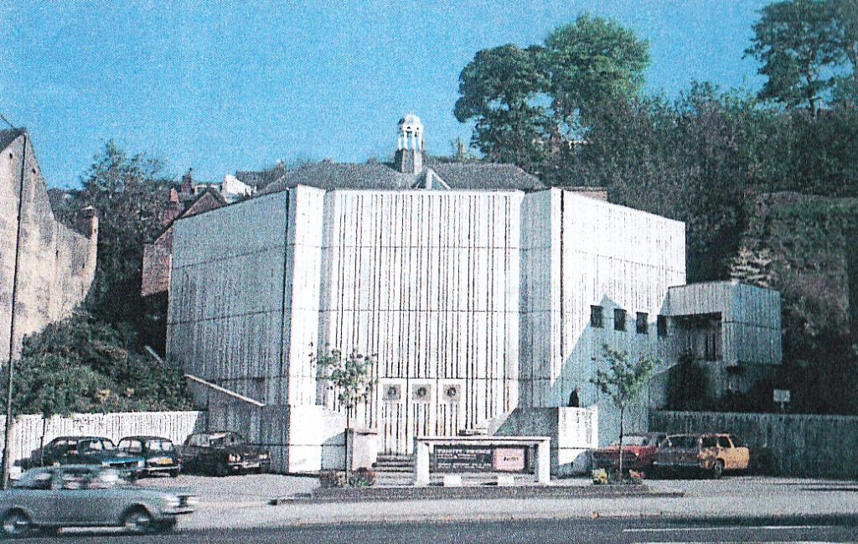
Trinity United Reform Church

David Mellor Design Museum & Cutlery Factory, Hathersage

The Round Building, 1990 (architect Sir Michael Hopkins) The David Mellor Factory and Mueaum site was formerly the Hathersage Gas Works. It was built in 1906-07 and had become redundant folloing the arrival of North Sea Gas in the 1970s. The gas holder was demolished in 1986 but the substantial stone ancillary buildings, the retort House, the offices and workshop were left standing. David Mellor bought the site in 1988 and secured planning permission for its re-use on a restricted occupancy basis.

The Hope Valley area of Derbyshire round Hathersag has its own strong vernacular tradition of building. Hopkin’s aim was to combine traditional materials with the most modern structural techniques, developed in collaboration with the specialist
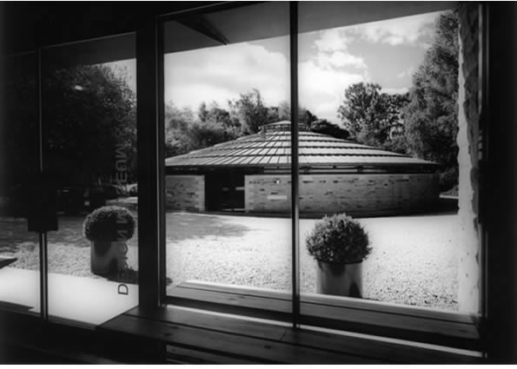
The Round Building

structural engineers Whitby and Bird. The Round Building reuses the gas holder foundation and is constructed in natural gritstone and steel. A thick stone rim runs round the perimeter of the building, and from this rim the giant steel bicycle-wheel sructure of the roof rises twoards its central hub. A steel perimter tie bar holds the whole structure together.

The roof itself is built up of a series of double- skinned sectional panels in Finish pine plywood hooking on to the circular purlins. This allows the building to be ventilated by the more or less traditional method of passage of air thorugh the panels. The roof is leaded externally. David Mellor worked very closely with the architects in the development of the design, supervising the construction and manufacturing of many of the components, He and his own workforce laid the large circular concrete floor over the original gasometer slab. They cast the concrete quoins and padstones used in the walls, and constructed the Finnish plywood roof panels.

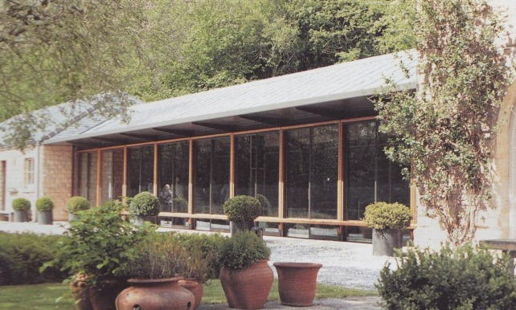
Design Museum and Café

David Mellor Design Museum, 2004 (architect Sir Michael Hopkins) The Museum is sited opposite the Round Building and also contains the café. The majority of the construction was carried out by the on-site staff.

Lane End, Hathersage, 2007-12 (architects- Sir Michael and Lady Hopkins)

The building was designed personally by for Fiona MacCarthy (Mrs. Mellor) an old friend. The house was completed in January 2012.

Lane End occupies the site of a cottage built in 1910 and now demolished, reusing the original stone. Externally the house appears relatively traditional, in accordance with strict guidelines set by the Peak National Park. The structure is random stone walling with cut local gritstone lintels, sills and mullions. The glazing is set behind the mullions. The roof is slate, as is common in the locality.
The interior of the building has a much more contemporary feel. The roof structure consists of a series of triangular ash trusses and hand-turned beams. The roof and many other internal details and specially designed fittings, both wood and metal, were made in the David Mellor workshops and the construction was undertaken by the workshop team.
SUNDAY:
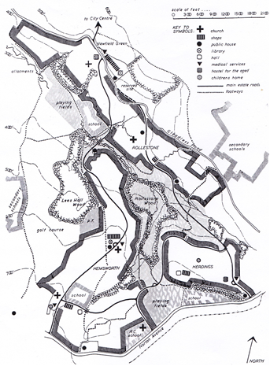 Site plan of Gleadless Valley development 1955
Gleadless Valley, 1955-61 ((architect – Sheffield City Council Architect’s Department (City Architect – J L Womersley, project architects – D R Paxton, A N Tunley. G M D Elson, J Gray, GA Butcher, R A Shaw, R T Simpson))
The 300 acre site is located some 2 to 3 miles from the city centre and had been rejected before WW2 as unsuitable for building because of the hilly terrain. However, the demand for homes, and changes in architectural approach, made a housing scheme more feasible and work began in 1955. An initial slope analysis revealed that nearly 50% of the proposed net residential areas had a slope steeper than one in eight.
The area is divided naturally into three parts by a large triangular wedge of woodland and this has influenced the pattern of development. The brief was to provide housing for 17,000 people in three distinct neighbourhoods, Hemsworth, Herdings, and Rollestone (apparently the names were taken from the area’s farms and hamlets for continuity), each having a shopping centre and a primary school. When completed, Hemsworth contained just over 2000 dwellings, Herdings about 750 and Rollestone 1600.
The valley bottom with the Meersbrook stream separated the north and south-facing slopes on either side, the former having fine views of the city, the latter the Yorkshire/Derbyshire border moorland. The valley itself and adjoining woodland formed the basis of a pedestrian footpath system linking the neighbourhoods, shops and schools, with two underpasses under principal traffic routes built to further this aim.
The natural characteristics of each area formed the basis for the house design and layout. A good deal of research work was apparently carried out in designing the house types suitable for steep slopes, leading to some unconventional (for the time) solutions. The general pattern was a ‘mixed’ development of two storey houses, three storey flats, four and six storey maisonettes and 13 and 15 storey point blocks, at a net average density of about 70 persons to the acre.
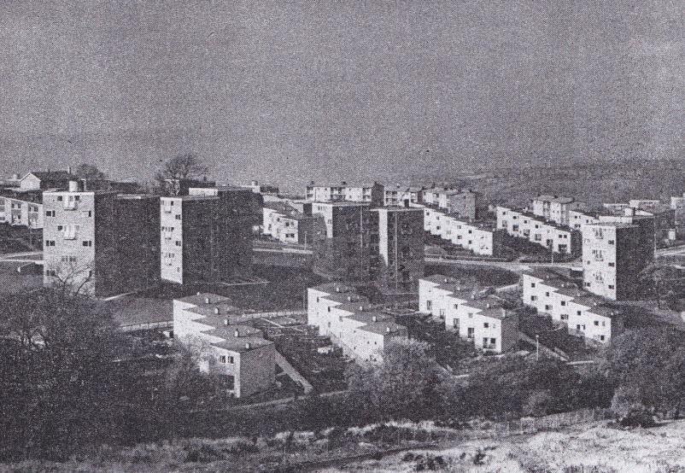View of Herdings Estate - 1
The houses were designed to cope with the various slope conditions and fell into three broad categories – ‘along the contours’, ‘across the contours’ and ‘irregular contours’ types.’ The contemporary press reported that the experience gained from these designs, and subsequent Ministry of Housing and Local Government sociological surveys, would be invaluable in the development of future sites over similar terrain within the city.

‘Along the contours’ dwellings, used where the contours were roughly parallel for a horizontal distance of 80 feet or more, were generally terraced units. Steeper sloped led to the development of the ‘reverse plan’, with the living rooms at the upper entrance level and bedrooms below.
‘Across the contours’ dwellings were generally narrow fronted in order to present the minimum dimension to the slope. Footpath access was employed and, where this became too steep for convenience, the terraces were staggered, allowing footpaths to run diagonally across the contours.
‘Irregular contour’ houses were used on sites where irregular slopes and curves made the use of terraced dwellings difficult.

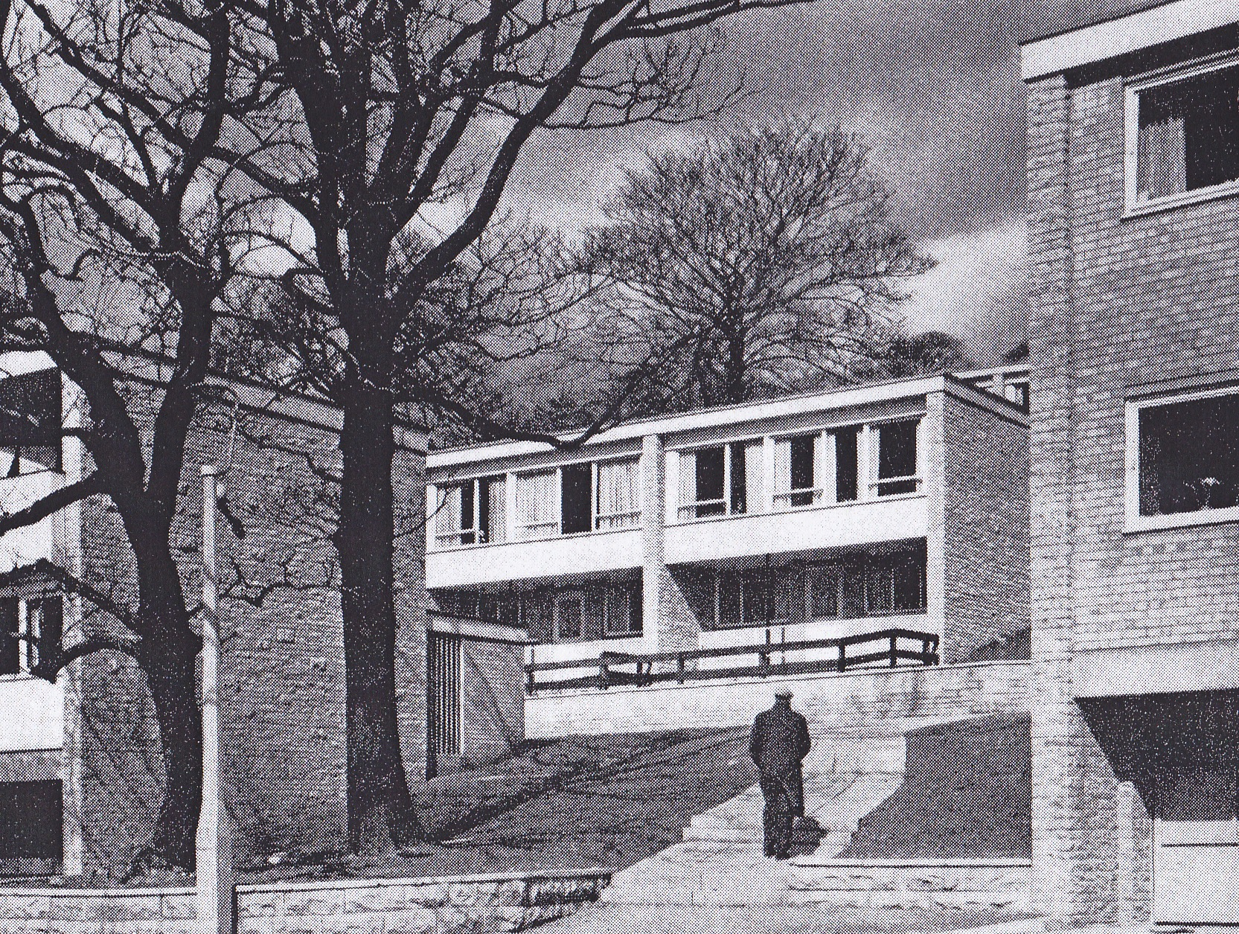’Reverse plan’ houses, elevations
The team also developed a three storey cruciform block, with segments, which could be set at different levels to avoid excessive underbuilding.
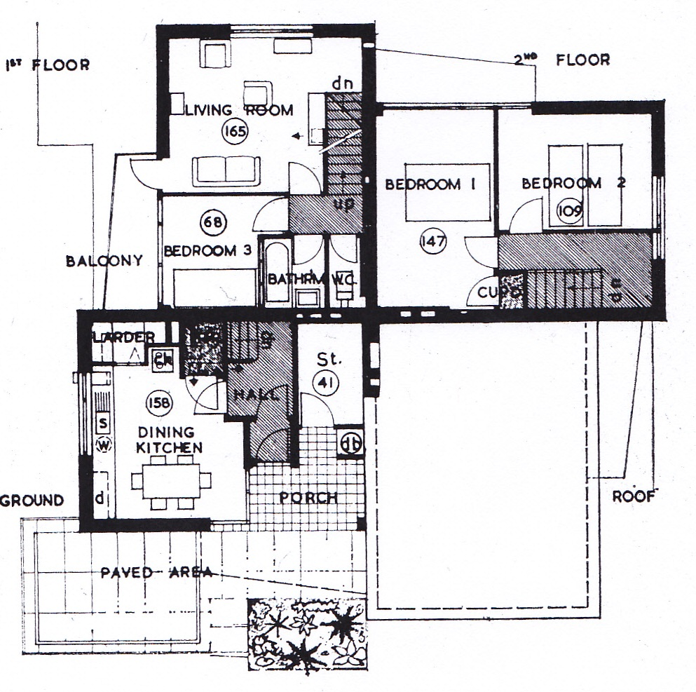Plan of cruciform block
The recent Pevsner suggests that Gleadless Valley vies with Park Hill as Sheffield’s greatest contribution to the post war public housing in Britain. It was described at the time by the Council as being “Mediterranean in appearance”, perhaps because of the way the buildings caught the sun as it moved across the valley. It is a highly successful fusion of two, apparently opposing, ideals; high density housing types on small plots and the garden city.
Spotswood Mount Housing

These striking two storey patio houses are built on a 1: 5 slope with an enclosed patio garden between each house and living rooms on the first floor. These look over the roof of the house below and providing unobstructed views across the valley. Access to the lower houses is by steps and ramps

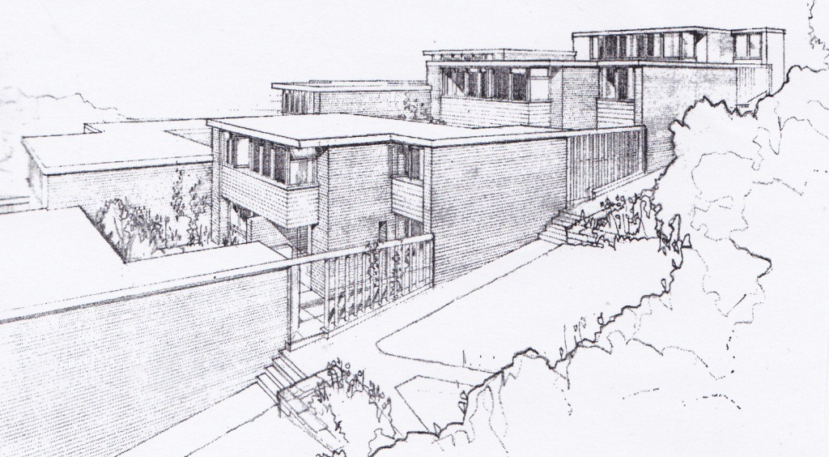
Perspective view of Spotswood Mount houses

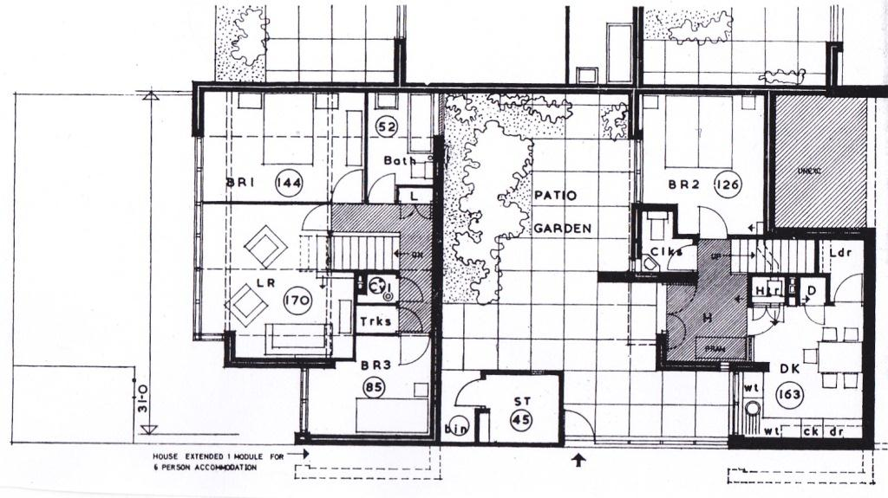
Floor plans of Spotswood Mount houses
Holy Cross Church, Spotswood Mount, 1964-65 (architect – Braddock & Martin Smith)

Dramatically sited, the church has a canted east front, broadly triangular in shape with a concrete central column rising to form a cross. The interior is lit by rooflights and is plain white. It is dominated by a very striking full height stained glass window by John Baker, made at the Whitefriars Studio - with immensely tall figures of the Virgin Mary and St John with their traditional symbols, and a crown of thorns above them. There is a chunky rough-hewn font on one side of the alter balanced by a wood pulpit on the other. The silver cross is by David Mellor.

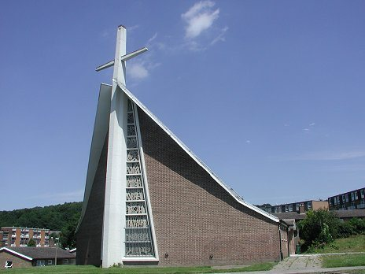
Holy Cross Church

Derby Place. 1978-80 (architect - Sheffield City Council, Planning & Design (John Taylor & Peter Jackson)

These three-storey stepped profile blocks were built further up the south facing slope long after the main
estate was finished. They were the second iteration of this type of development, the first being in Netherthorpe a couple of years earlier. Designed to house elderly people live on the top two floors, the ground floor was reserved for families who could enjoy private gardens.

The flats are deck access and have extensively glazed facades articulated by projecting greenhouse porches and rain spouts carried on slim timber brackets. The ‘organic’ feel of the buildings is enhanced by the massive baulks of timber used to support the ends of the decks, by the planters of rough creosoted timber used to line them, and by the low-pitched roofs.

These blocks are different form their predecessors in ensuring that each level has its own access by means of bridges – to give the impression perhaps that the residents are not living in a block of flats but in bungalows that happen to be on top of one another.

There are similar blocks in Stannington and they were some of the last deck access flats to be built, at last achieving at last the humane approach to housing that the Smithsons, amongst many others, believed such planning could provide.

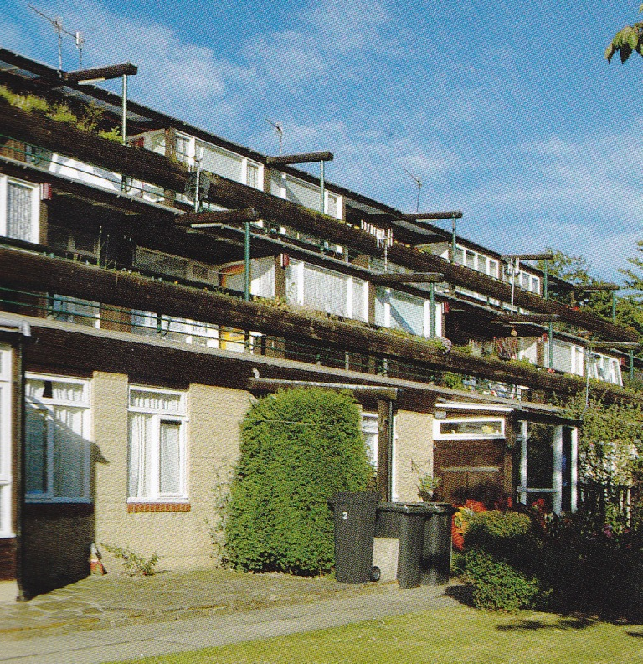
Derby Place from below

Low Edges Estate, Greenhill, 1952-59 (architect – Sheffield City Council Architect’s Department (City Architect – J L Womersley))

The site was 220 acres in area and faced south. The original plan was to build an estate of 3000 houses and work began in 1953. Most of the houses were complete by 1955 but the three 13 story point blocks were not finished until 1959. The comprehensive plan included a junior and infant school, two shopping centres, a health centre (combining a maternity and child welfare clinic and surgeries for 3 doctors), two churches, two public houses, a branch library, a community centre and youth club, and an old persons residential home. There was a wide diversity of building types, from bed sitting room flats for single persons to four bedroom 6 person houses. The Council’s 1962 report ‘Ten years of housing in Sheffield’ noted that the estate had Sheffield’s first four storey maisonettes built in cross-wall brick construction on a 14ft frontage (providing accommodation for families up to 4 persons) and was very positive over the “two storey ‘corner’ flats linking terraces of houses at right angles to each other to provide smaller dwellings very economically, in addition to hiding back gardens from public view and giving architectural emphasis at street corners where it is wanted”. Unlike the LCC who were not making sufficient provision for the car, Sheffield architects were including “Brick garages built in carefully planned groups distributed throughout the Estate for letting to tenants at economic rentals”.

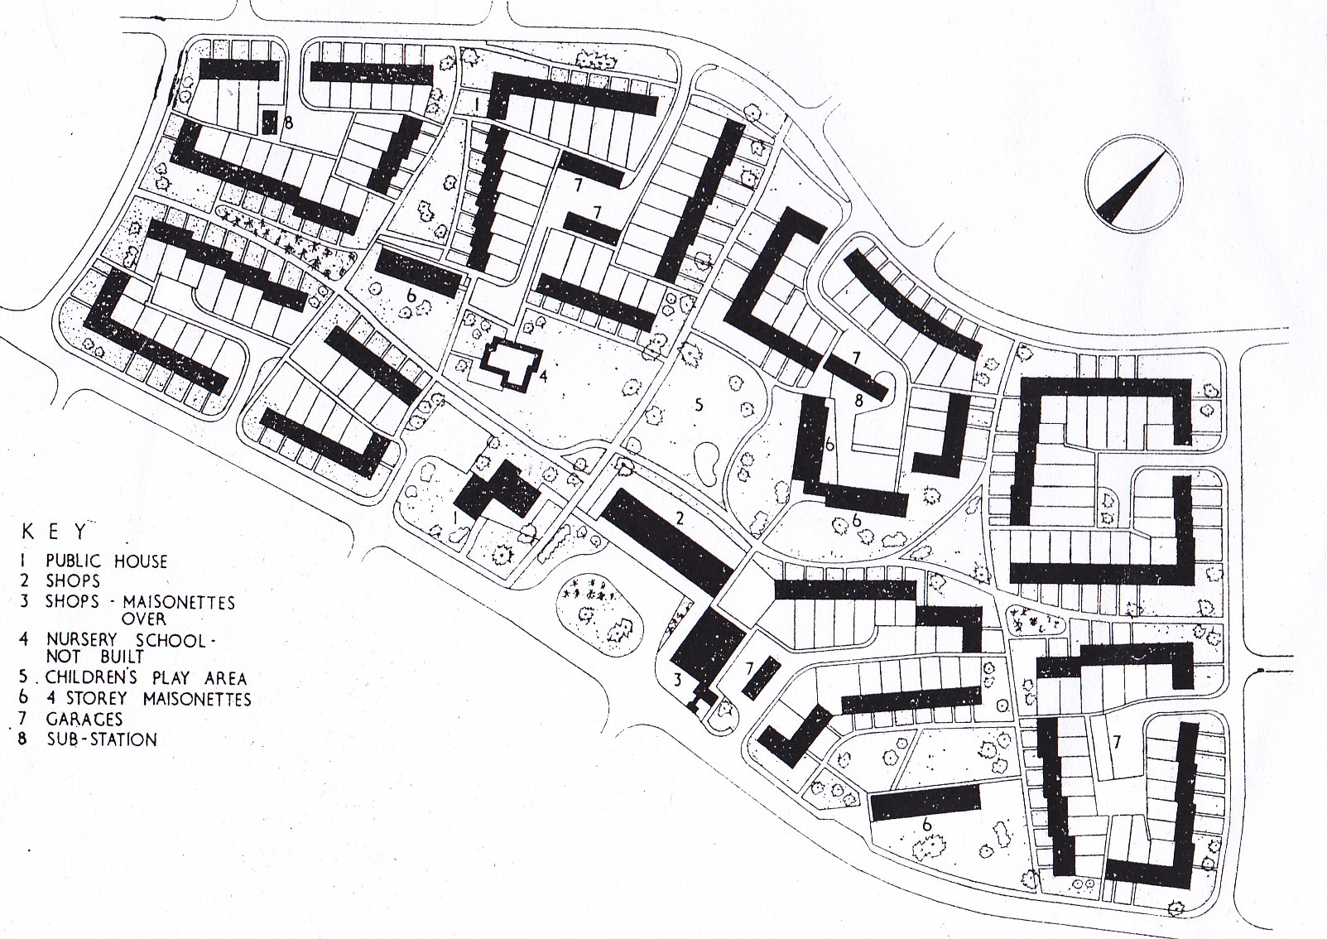

Plan of Greenhill – Bradley, the ‘super block’ on the Low Edges Estate
The appreciation of the potential increase in car ownership led to the use of Radburn planning in the later phases, separating vehicles and pedestrians, and this culiminated in the final phase being designed as a ‘superblock’ where all the houses overlooked a park-like space. As the book said, “In an age of ever increasing motor traffic this form of development points the way to increased safety and amenity”.

GreenhIll Library, 1960-62 (architect – Sheffield City Council Architect’s department (City Architect – J L Womersley, project architect – D R Boothroyd)

The library was located next to one of the shopping centres and the old person flats - the old people were originally provided with sitting out areas next to the library to give opportunities for contact with the rest of the community.

The main lending library has a butterfly roof supported by a welded steel frame. The clerestory

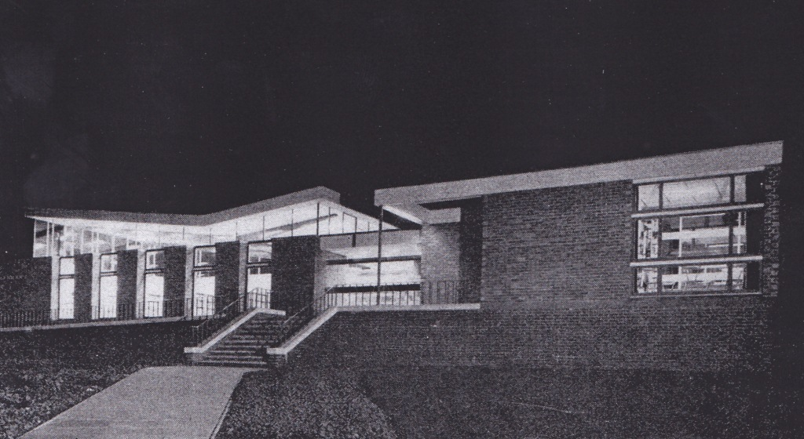
Greenhill Library at night
of the main library is aluminium framed and was designed with a slip joint at the head to allow for differential movement between the roof structure and the more sold walls. It still looks in good condition.

The adjacent children’s library and administration block main has load bearing brickwork with steel beams supporting a flat roof. It was built by the Sheffield Public Works Department.

St Peter, Greenhill, 1963 – 66 (architect - Oxley & Bussey (architect - Peter Sargent) Listed Grade II.

The church was listed in 1999 with English Heritage describing it as “an early example of the influence of the Liturgical Movement, bringing the celebrant closer to the people and ensuring the whole congregation have a clear view of the altar. The success of the design is demonstrated by the almost complete preservation of the original arrangements. It is a most handsome and lavish church of its date, with fixtures and fittings of exceptional quality and completeness.”

The circular shape of St. Peter’s, along with its 93ft Westmorland green slate clad spire make it a local landmark. The main framework of the building is supported by four laminated timber columns/beams which rise from around the altar forming the square spire with clear glass clerestory windows. The walls, inside and out are constructed of Brindle facing bricks and the floor is muhuhu wooden blocks and the pews are afromosia.
The circular plan has advanced and recessed sections joined by flat glass walls. The Day chapel has a completely glazed west wall of colourful abstract design – it shows features associated with St. Peter. Bottom left is the cockerel; the crossed keys of the Kingdom of Heaven are diagonally across the window; and on the right is the Cross of Christ. Behind the cross, the Light of Christ is rising to dispel the darkness of the world. The Day chapel was formerly known as the Blessed Sacrament Chapel and contained the altar and reredos from the original Hall-Church that stood on the site. In the mid 1980’s the Sacrament was moved to its new position in the main church and the Chapel was re-designed. It is now known as the Chapel of Healing and Reconciliation.
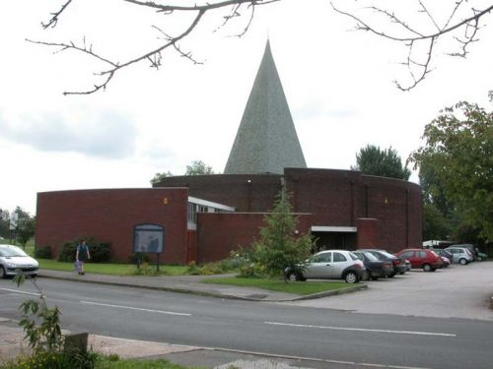
St Peters Greenhill

Internally there is a raised circular altar space. The altar is made of Old Derbyshire Marble, carved with five crosses and was donated by scholars of the Old Greenhill Village Sunday School. Above the altar hangs the stainless steel cross which measures 8ft long and 4ft across, suspended by high tensile wire. It is designed to catch the light from the windows during the day and from the spotlights at night. Around the altar, the altar rails are made of afromosia and stainless steel. The font is made from Old English Marble quarried in Matlock. Next to the font is the Jerusalem Stone – sent to St. Peter’s by the Archbishop of Jerusalem.
The present organ was installed in 1971. It came from the United Methodist Church, Old Basford, Nottingham where it had been installed as a memorial to those who died in the 1914-18 war. It was built in 1922 by Sweetland of Bath.
All around the inside walls of the church hang fourteen banners – the Stations of the Cross – which tell the story of Jesus’ last journey to Calvary. They depict his condemnation by Pontius Pilate through to his death on the cross and being laid to rest in the tomb. The banners were designed and made by members of the congregation.
Vic Hallam Houses, Woodhouse & other areas, 1960 onwards (architect – Sheffield City Architects’ Department)
The current Sheffield Pevsner describes the prefabricated 5M houses designed by the MOHLG houses in Gloucester Crescent near the University Sheffield but only pauses briefly to mention the other system built designs developed in association with Vic Hallam Ltd, a based at Langley Mill in Derbyshire (the firm is perhaps better known for their system built schools). Substantial numbers were built in the Sheffield area and, although many seem now to be being demolished under the Government’s ‘Decent Home Standards’ programme, there are still many left.
Lewis Womersley outlined the case for this type of system built housing development in a paper presented to the 1963 RIBA Conference (held in Sheffield) and published in the Builder on 12/07/63 “It has been made abundantly clear in recent months that a substantial increase in building productivity is essential if slum areas are to be cleared and redeveloped, aging and outdated town centres renewed and universities expanded whilst at the same time industrial and commercial buildings continue to be erected and more building of a cultural and recreational nature be sponsored in order to meet the needs of a nation which is enjoying increasing hours of leisure.
The can be little doubt that we are on the verge of a vast upsurge in our production of dwellings because of the greatly increased use of mechanisation and of factory-made building components. The critical pint, so far as housing is concerned, is simply whether this upsurge of activity is to produce larger, warmer, better finished dwellings than we have had in the past or whether, for the sake of cheapness we are to produce dwelling and residential environments which will be outdated almost by the time they are built.
In Sheffield therefore, we have recently set out to prove that by intelligent collaboration, between architect, manufacturer and builder, factory-made houses can be produced which fulfil the Parker Morris standards, have superior equipment and finishes, and are erected three times more quickly than traditional houses and at no greater cost. These are the ‘Hallamshire’ houses at Woodhouse. This is only one solution – many others must be possible and another example is that of the 5M (5 module) houses at Gloucester Street, a constructional system designed by architects in the Ministry of Housing & Local Government.
In each of these examples the houses have been designed both to be good dwellings in themselves and also to be capable of being grouped in a variety of ways to give layouts of interest – a satisfactory living environment. The types of layout developed are also influenced by our recent researches into density, privacy and ratios of numbers of high flat to maisonettes and houses for any given density.
The major change brought about by these considerations and evident in these new layouts is the realisation of a reasonably high density by the use of low buildings only and by putting families of five persons and over in two storey houses. This can be achieved, of course by placing the houses closer together and it is here where the integration of house plan and layout is vital. The houses are so designed and so laid out as to give adequate privacy within the dwelling and at least on one side of the house outside the dwelling. Thus the layout shows houses closely grouped on either side of a footpath onto which the entrance and kitchen windows face whereas sitting and dining rooms overlook the wider spaces at the rear. Here, small, patio sized screened gardens abut onto play areas for small children which are accessible only to the houses in one individual house group.
Fears are frequently expressed that the growth of scientific and technological influences upon building will eventually bring about the demise of Architecture. This need never occur so long as architects are true to their profession and believe that architecture is the art of building beautifully. For whilst it must require a different architectural approach to create beauty under the strict discipline imposed by factory production and standardisation, a wonderful new beauty in simplicity of form and machine-like grace – a form of beauty which will have real meaning for our present day and - is possible if we strive hard enough to achieve it.
The new approach to house planning and design therefore can, if they are properly guided, herald the dawn of a new and virile architecture – an architecture of enlightened democracy.”
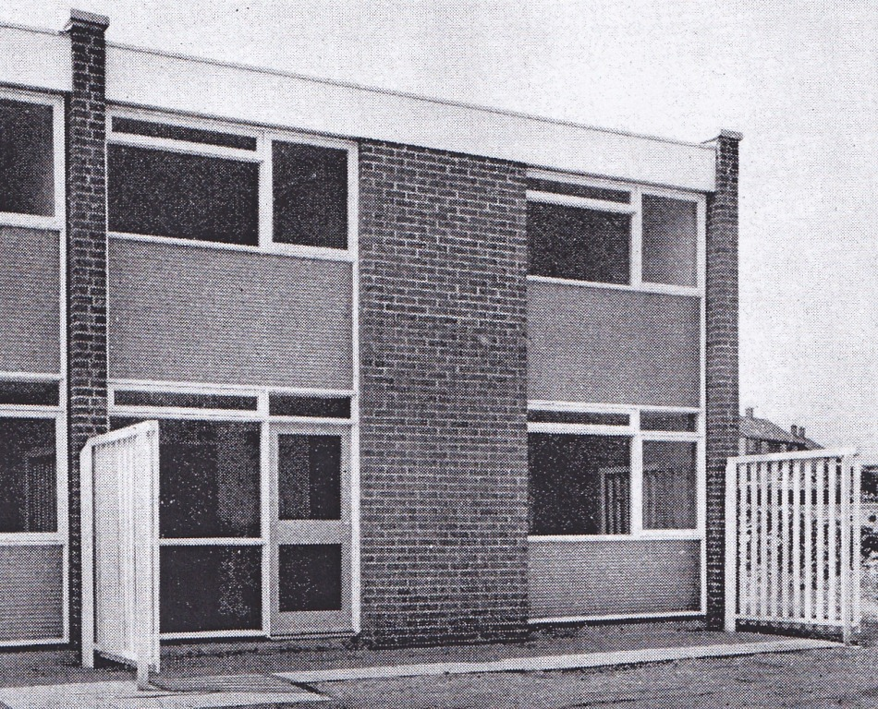
Typical Vic Hallam House
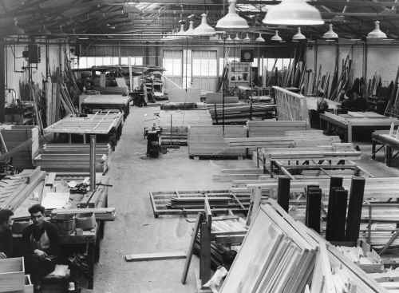
Vic Hallam work shop in 1963

St Catherine of Sienna, Richmond Road, 1958-62 (architect - Basil Spence) Listed Grade II

This is the second of Spence’s two parish churches in Sheffield and is a strongly sculptural design with a powerful presence. It was funded by the War Damages Commission, in compensation for a bombed city church, who insisted on a plain church for 500 worshippers. A folding screen means that the adjoining church can be opened into the nave for major festivals and provide the full complement of seating. The unusually rich fittings testify to the church’s relatively generous funding.

The main external walls are in brown brick with a copper clad roof. The nave is rectangular and it sweeps around into a semicircular apsed sanctuary. The slate hung entrance is to the south- west and has an incised inscription, "The Church of St Catherine", by Ralph Beyer, who was then carving the inscriptions for Coventry Cathedral.

The 23 metre bell tower is formed of two convex slabs of brickwork forming a sacristy at ground level and linked by concrete beams above. On plan it looks like an eye. A later addition, a patinated bronze sculptural group with crucified Christ, is affixed to its east side.

The interior plan is aisleless with vertical slit windows to the north and south walls and the roof sloping upwards towards chancel. The roof structure consists of laminated timber beams, and slopes gently upwards towards the chancel so that the roof deck is separated from the walls by a narrow glazed strip. Light is thrown onto the east wall by a concealed window at the east end of the nave.

Spence’s simple architecture achieves its effect through the directed clerestory lighting and white plastered walls, the last forming a theatrical cyclorama in the apse behind the liturgical fittings. The sanctuary is carefully staged. It was raised two shallow steps, and the altar was originally raised on two further steps against the east wall. It has now been moved forward. The alter, pulpit and the fossil limestone font stand in a line, and thus attain equal prominence. The altar is a black painted metal framed table with a varnished timber top. The font is still in its original position and has a timber lid with a schematic metal dove. There is a large timber cross behind the altar, comprising two pairs of overlapping beams, penetrated symbolically by large nails. Timber sedilia are on metal supports. The pews are made from laminated timber.

Since the building was listed the porch has been extended, and the hall has been modified.

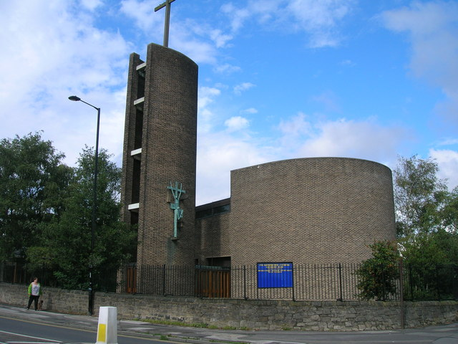
St Catherine of Siena

St Pauls, Wordsworth Avenue, 1958-59 (architect - Basil Spence) Listed Grade II*
The church is a most striking composition and perhaps Spence's best small church. It comprises a single volume under a barrel vaulted roof with a glazed east wall, a gallery set against the west wall, and a free standing bell tower.

Basil Spence won the competition for the rebuilding of Coventry Cathedral in 1951. He was not part of the ecclesiastical ‘establishment’ of the time and seemed to have worked quite hard to establish his credibility with study tours and lectures to the RIBA setting out his philosophical basis of church design. He designed some twelve churches in addition to Coventry cathedral, not all of which were built. It would probably be fair to say that the three churches built in the Coventry suburbs in 1958 and the two churches in Sheffield are probably the best known along with St Andrews Clermiston in Edinburgh.

There is a generic plan firm to these churches with a simple rectangular worship space, with attached vestry or ancillary accommodation, and with a freestanding bell tower of some variety. Light was important and was generally allowed to cascade through side wall openings in a similar fashion to the cathedral. Generally both alter and nave were within a single space. Contemporary commentaries suggest that a very tight budget of £50,000 for the complete assembly of Church, Church hall and Parsonage, necessitated a standardised ‘kit of parts’ approach which Spence put together as the site dictated.

The main structure is two red brick diaphragm walls (with the brick exposed internally). The internal face has a shallow zig-zag profile in plan, presumably to create a suitable acoustic. The copper clad segmental barrel roof is formed of triangulated truss segments with tubular supports set diagonally. These are supported on a steel structure which is in turn supported off the concrete capping to the side walls.

The vestry is a rectangular box attached to the liturgical south side. There is a covered walkway to the campanile at the west end of the church.

Internally the sanctuary is raised by a step and the altar is placed against a background of a vertical slatted screen added later.
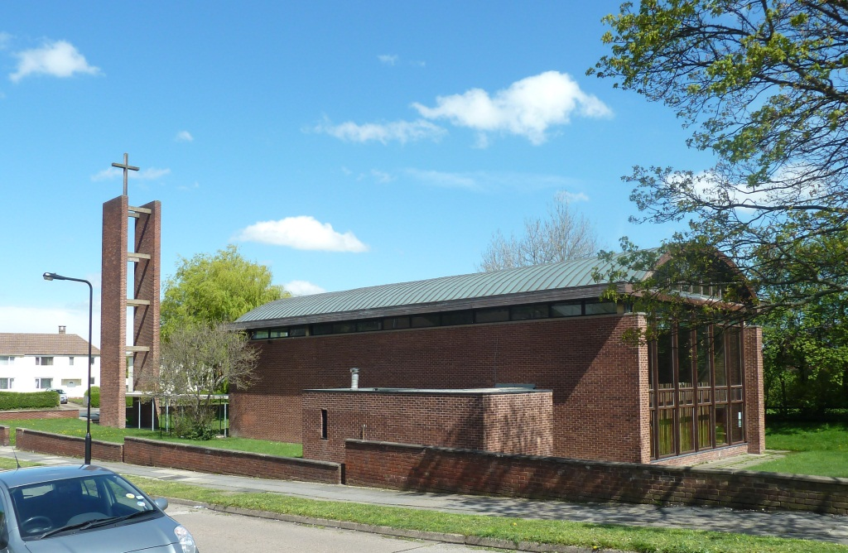
St Pauls

The altar rail and sanctuary seating is by Spence. The mezzanine gallery to the west end is reached by the original staircase with an open balustrade and thick timber handrail and contains the organ and choir stalls. The balcony front comprises two thick horizontal bands of timber, linked at wide intervals by light, painted metal supports. The font is placed in the central aisle, beneath the gallery. It is of textured concrete and flares outwards both above and below a narrow point just under half way down. The applique altar frontal is by Beryl Dene. The pair of candlesticks on altar is by Basil Spence as are the laminated timber pews.

There have been some minor changes to the internal fittings over time and the Crown of Thorns on the Cross to the alter is formed from the copper salvaged when the original roof covering was replaced.

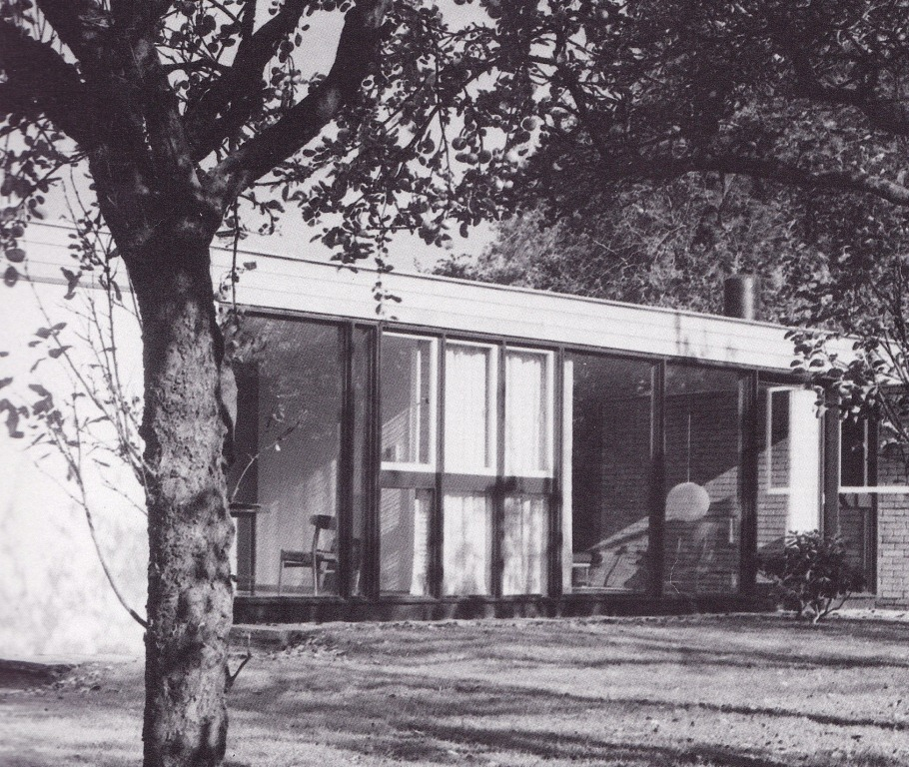1 Park Lane, part of garden elevation
House and studio at 1 Park Lane, 1959-60 (architect - Patric Guest) Listed Grade II.
The house was built for David Mellor, It has a single storey built on a gently sloping site. Two bedrooms were added to the main house on Mellor's marriage in 1965 but the original plan can still be readily determined.
The construction is loadbearing fair-faced light-brown facing brick crosswalls. The roof is flat with timber joists and a deep timber fascia. There were large glazed doors and double-glazed sliding windows in thick varnished and stained cedar frames.
The interior still reflects the combination of house and studio for which it was designed. The walls are of painted brick, with the entrance hall and adjoining corridor area divided only by large glass panels, that to the ‘L’ shaped lounge with blinds and that between the corridor and the former drawing office (now kitchen) tiled on the rear. The floors to the living areas and corridor are teak strip, with marble inset slab in front of living room stove (renewed) and mosaic bathroom floor. Ceilings are softwood timber. The doors are solid teak the full height of the rooms, hung on pivots. Five steps lead down to the larger workshop - the continuous roofline makes this space the tallest in the building. The plan and design of the space also reflects the heavy machinery and industrial plant required for a metalware designer and producer, compared with the facilities required, for example, an artist.
The house is not only a fine modern design, early in its use of naturally finished, overscaled timber, but is important as a landmark in Mellor's career. There was space here for Mellor to work with four or five assistants, and here he produced all his designs, limited editions and prototypes between 1960 and 1972, the years in which he established his international reputation.
The house featured in House and garden, November 1963. The review said “Although David Mellor was trained as a craftsman in silver and gold, he takes as much delight and care in the design of a new litter bin or tele-printer case as in the shaping of the most delicate silver candlestick. He has recently designed a new range of silver cutlery and hollow-ware for the new British Embassy at Warsaw and a new stamp machine for the GPO.
To provide a suitable background for his diverse activities and to accommodate his four assistants,
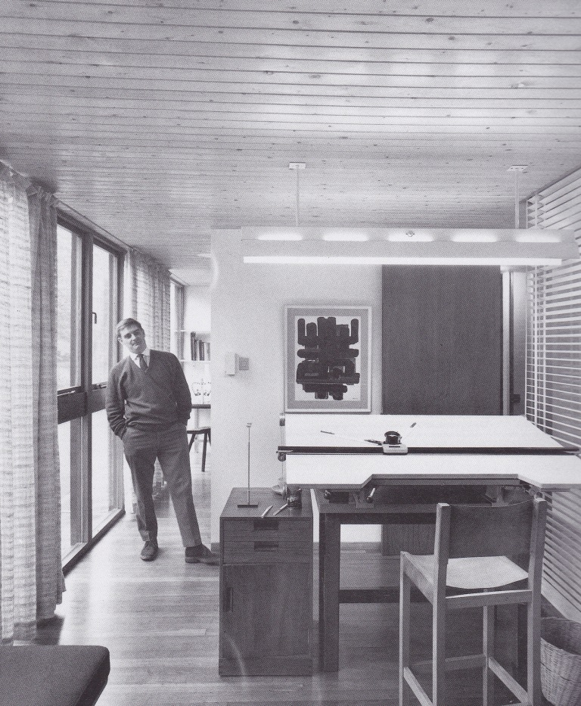 David Mellor photographed in the drawing office
David Mellor needed a large working studio. As his is not the kind of work that can be put out of sight and out of mind at six every evening, he also wished his working premises to serve as a home, a tradition still practiced in Scandinavia, less so in this country. Having bought part of a garden of a large Victorian house in Sheffield, he asked his friend Patric Guest, DA ARIBA, a London architect, to design the studio. The plan evolved by Mr Guest is paradoxically simple and ingenious. It is likely to [provoke considerable envy and covetousness amongst other industrial designers, too often forced to live in a Georgian or Victorian house whilst designing for the 1960s. How pleasant for one’s house to be a complete reflection of one’s practical work and philosophy of design.
Work and leisure are interlocked in the life of David Mellor, for he has no family to accommodate, which does, of course, simplify his problem. Patrick Guest has designed a long single-storey building with a workroom/studio at one end and living accommodation at the other. Work benches occupy the two long window walls of the studio and a central island for mechanical equipment divides the room length wise into wood-working and metal-working sections. This room is closely linked with the office and living room by a small passage with a store room opening off to one side and a darkroom and bathroom on the other.
The studio, office and store room occupy about two thirds of the floor plan and the space left for eating and sleeping represents about the proportion of his day that David Mellor is prepared to spare for such necessities. His bed, in the dining room, is simply a drawer that slides neatly out if sight below the kitchen units and into a wardrobe dividing the living room from a galley-sized kitchen.
The intercommunicating living room and drawing office face north-west overlooking a walled garden and terrace. To keep as much light as possible, large areas of double glazing in cedar frames have been used. The living room is uncluttered and furnishings consist simply of a coffee table and a Charles Eames chair and ottoman footstool grouped round the high cast iron fireplace designed by David Mellor. The entrance hall/secretary’s office provides separate entry to Mr Mellor’s drawing office and the living room, and is divided from the office by a glass screen and venetian blind.
The fact that there is virtually no division between Mr Mellor’s working and domestic life is echoed in the house. From his drawing board he is still in close contact with the studio yet only a step-and-a-half-away from his bed. The designer can thus live with his designs, subjecting them to perennial and persistent criticism.”
This long light modernist building has an almost organic quality, at one with the natural setting that surrounds it with large areas of double glazing set in cedar frames. In this it is reminiscent of the Eames House, built ten years earlier in Pacific Palisades, Los Angeles. It also has a European context, with clear echoes of the studio homes of Scandinavian designers which David Mellor had first visited a few years earlier on his travels through Denmark and Sweden.

The End:

