Adal Jewelry Designs: For the Woman Who Wants to Stand Out
By Nana Ama Asare/AG Beauty /Fashion Editor (November 7, 2011)
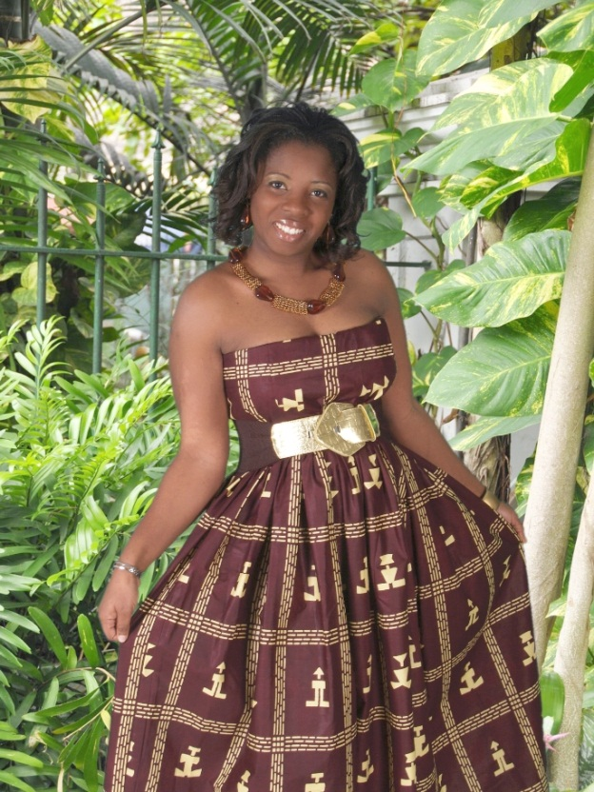
Her work speaks volumes, but one thing one would never imagine is that Season Wesley-Smith never dreamed of becoming a jewelry designer until despair led her to find solace in the distraction of creating beautiful things. In this exclusive interview, Season tells Afrikan Goddess all about the events that led her to the creation of AdAl Jewelry and what it all means to her now. Read the interview below:
Afrikan Goddess: Please tell us a little bit about yourself. Where are you from, and a little bit about your life growing up.
My name is Season Smith-Wesley; I was born in Liberia, West Africa to middle class parents who provided me with love and the finest things in life. I am the second of six children (two boys and four girls). My father wanted a better life and education for his children, and to escape the uprising and beginning of what would be the devastating destruction of civil war in Liberia. My family moved to the United States in 1986 to where we still live in Virginia. I always had an interest in criminal investigation and the amazing workings of solving crimes. I believe my passion grew for this line of work due to the long years of being a child to a father who worked as a high ranking law enforcement officer. My father was a Sheriff and an investigator for many years starting at the age of 19.
After high school I decided to go to college and obtained a degree in Criminal Justice from Park University in Missouri. I always knew that I wanted to own my own business someday and that it would be wise to educate myself further, so I obtained a second degree in Management at American InterContinental University. Prior to discovering my love for designing jewelry, I had another passion which involved the ability to be creative. I am a certified Meeting and Event Planner and Co-Owner of Events by Us Coordinators. As you can see a big part of my life is keeping busy and doing what I enjoy most.
I feel that I was given the chance that most Liberians may never have; the exposure to life, education providing me with reachable tools to be whatever I want to be, with one requirement, to succeed.

What's the inspiration behind AdAl? What does AdAl stand for?
AdAl stands for Addy (my son) and Alicia (my daughter).
The inspiration behind AdAl has always been my children; mainly my son. When I look at my son who is autistic, I don’t see a child with a disability but a child that expresses himself in different ways learns at a different pace but yet intellectually surpassing our expectations in ways that can’t be explained. I believe it is a given to him by God. His challenge like so many others like him is to also teach us that they have as much rights in society as we all do and should not be looked down upon or locked away. It is through my son’s eyes that I began to understand that we were all never meant to be the same, express ourselves the same, or look the same. It is through this, I began to embrace my designs and exotic creativity not having any worries about if another felt it was not to their liking because I know there are others that would see it through my eyes and embrace the world of expressive designs as I do. It is to him Addy, I say thank you for being my son and teaching me so much in life.
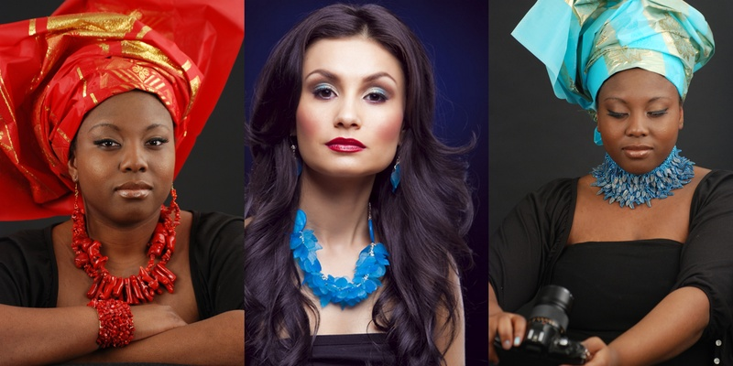
When and how did you start designing jewelry?
Making jewelry was never a part of my desires in life. One thing I have learned about myself and (love) is that I have the ability to adjust to my unexplainable yearnings. I get to try new things “just because”. I have worked in the financial and legal professions for many years and had no experience in the world of arts and handcrafting.
I remember sitting at working one evening and deciding that I would go to the Michaels craft store on my lunch break and look around (until this day I still have no clue what I went to purchase that day). When I got to the store I immediately saw the posting on the door that said “now signing up for our next jewelry-making class”, which happened to be that very evening. A bulb went off in my head and I thought why not? So I did. I called my husband and said I would be late because I was going to take a beginners jewelry making-class. I remember feeling so lost and crazy for taking this class because it was clear that those who were there knew a lot more than I did; but I stuck it out. I made a pair of earrings and a simple bracelet that evening with the assistance of the instructor but I felt pretty good about it. That was the only class I attended. I would say this is where my journey began.
During this time my husband and I were going through a hard time dealing with how to care for our son and pursue the expensive treatments required. With all these thoughts running through my head, I picked up the beading wire and began working, hoping that the outcome would be a necklace since I had no clue what I was doing. All the sudden I experienced calm in my spirit. I had found my new outlet for maneuvering through the hard challenges in life. 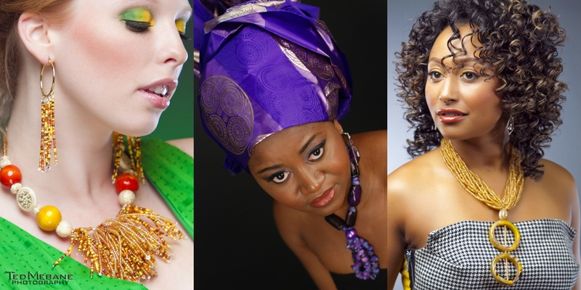
Describe the typical process of making a single piece of AdAl jewelry. Which pieces do you tend to make the most of (bracelet v. necklaces etc), and which ones sell the most?
There is no single process. I design as the ideas come to me. Because of this, duplication becomes a way to maintain the true meaning of our one-of-a-kind pieces for our clients.
The typical process for creating a single piece is this: I place all supplies of beads we have in stock on the workroom floor (if I haven’t already envisioned the design in my head), coordinate colors I think the design would look good in, and once the design is constructed, my assistant designer and I will brainstorm on names for the new piece. We take into consideration the time it takes to construct the pieces in order to determine a fair retail price, and then the piece is copyrighted for design protection and the ability to maintain its uniqueness.
I tend to make more necklace pieces than anything else because they sell the most. However, for my more formal and unusual pieces, I would often design a bracelet simply because I know that if one is attending a formal event they would like to accessorize from neck, ear, and wrist. I sometimes hold off on making the earring for certain sets, only because earrings tend to vary with each customer, some like it big some like it small, some prefer more drama and some prefer simple. Whatever the case, they decide and I create, but each and every set sold comes with a set of earrings.
On your website for AdAl Jewelry, you describe Adal Jewelry Designs as a place where you “provide an eclectic collection of fashion accessories that include natural and traditional African garb.” Explain what this means, and what are African garbs? When you say you offer “custom designed jewelry to suit every taste”, do you mean clients have the option of providing their own designs for creation?
The statement for me means, that our clients will get to view and experience all of the following which I find to be an inspiration through my work because of my native background; an expression through the bright colors used in my pieces (African traditional wear are designed with the most vibrant combination of colors), get to experience the world of creative expression as I see it, and be influenced by tasteful culture.
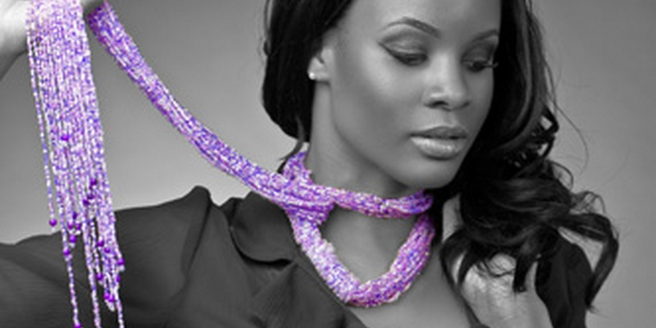
Regarding your second question, yes, you are absolutely correct. Aside from the pre-created pieces I design, we also offer more involvement with the client by constructing their ideal pieces, according to their specifications – whether it’s a request for a copy of a previous design or a request that it be reconstructed in a different color, size modification etc..
Clients bring pictures of what they want and we design the piece they present tweaking little details here and there to keep the AdAl uniqueness.
Clients sometimes bring in their attires for special functions and ask us to come-up with a unique design based on the cut and colors in their garments. This costs a little extra.
Most of all, clients attending a function and who want to standout trust us to create that breath-taking piece within their budget.
We also design for runway looks. Designers can rent pieces for their fashion shows or photo shoots.
AdAl also, often, donates pieces as prize winnings to certain organizations.
Do you design jewelry with a certain type of clientele in mind?
Currently AdAl designs solely for women, but has began receiving requests form men who admire my creative work. There have been some requests to design a men’s line. I am strongly considering this and plan to add a collection for men in upcoming months.
Tell us a little bit about the inside of AdAl. Do you design the pieces yourself or do you have a team of designers? What are some of the challenges you face within the jewelry making industry?
All AdAl pieces are designed by me with the assistance of my assistant designer.
I would have to say that the biggest and most concerning challenge for me is always making sure that I stay one step ahead of the game by protecting my work through copyrights. I copyright all of my most unique pieces. I can create 15-20 different designs in a given week but will not release them for purchase to my clients until they have been copyrighted.
What, if any, are your future goals for AdAl Jewelry? And do you have anything else you'd like to add to this interview that hasn't already been asked?
One of my goals as a designer is to continue to give my clients what they want and to share my work with those who appreciate its uniqueness. I also have the desire to give back, sharing what I have learned with other young Liberian women who may have the very same passion to do what they love. Letting them know that if they can push themselves and make it through that door, the door of fear, unexpected hardship, fear of rejection or not succeeding but have the drive, they can make it. I also hope to give back through non-profit and charity work raising money for food, clothes, education, and recreational actives, for the young and disabled youth of Liberia.
Also, I would like to say thanks to those who have (and continue to) assist me in making AdAl Jewelry Designs what it is today. At the end of the day when I reflect on how far AdAl has come and the opportunity to share my work with the word, I have to always remember to say thank you to those important people behind the scene who have been my number one supporters from day one (my loving husband and children, my parents, my sisters, my best and lifelong friend Isha Yilla, and my Assistant Designer Mrs. Eva Oberly Sahr.
Where is AdAl currently based, and how can potential clients reach you for purchases and requests?
AdAl Jewelry: AdAl Jewelry is currently base in Virginia. We recently closed our showroom located in Old Town Alexandria because the property owner was going into foreclosure. We are now re-evaluating the best and most suitable location to move the show room to.
We also have an international location in Liberia in West Africa. Our showroom is located on Comp Johnson Road, directly opposite the SDA church in Monrovia. Clients can purchase designer pieces off the shelves there, or put in a custom order in the store.
Clients in the United States and Liberia can view our website and place orders there. The website is www.adaljdesigns.com. Clients can also view designs for purchase at http://www.senseofashion.com/ by searching AdAl in the search box.
Clients can get additional information about our services or order questions by sending an email to info@adaljdesigns.com or cs@adaljdesigns.com.

