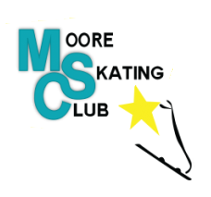
The Nominating Committee invites you to submit nominations for the Board of Directors. We will be accepting nominations for 5 positions (there are 2 one year positions and 3 two year positions available) on the Board of Directors. Nominations will be accepted from now until midnight (12:00 am) on April 4, 2021. Voting will take place at the Annual General Meeting on May 4, 2021 which will be held virtually. Voting will be completed using an online voting tool, similar to last year’s AGM.
Who is eligible?
All active members of the Moore Skating Club who are in good standing are eligible to serve.

How to recommend nominees.
You may nominate yourself or another member using the following form. Please send completed forms (or an email stating your intent to run or nomination) to MacKenzie Kada at mooreskateclub@gmail.com by midnight (12:00 am) on April 4, 2021.

The Nominations Process
The Nominations Committee will submit a single slate of candidates at the AGM. Nominations from the floor are not permitted.

Moore Skating Club Board of Directors Nomination Form
Date: ______________________________________
Name of Nominee: _____________________________________
Address: ______________________________________________________________________
Phone:______________________________ Email: _________________________________
Nominator Name: _____________________________________________

Thank you for your interest! We look forward to working with you to govern the Moore Skating Club.

Please send completed form to:
MacKenzie Kada
mooreskateclub@gmail.com
Chair of the Nominating Committee.

