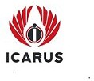
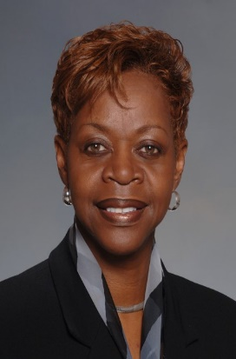

Marilyn S. Abney

Executive VP and Chief Operating Officer
Icarus Consulting

Marilyn Abney is Executive Vice President and Chief Operating Officer. She is a nationally recognized expert in helping organizations create inclusive cultures that leverage diversity and inclusion for a competitive advantage. Her superpower is developing strategies that enable their clients to attract, develop, and retain highly skilled talent from an emerging diverse workforce and, at the same time, enhance the engagement, knowledge, and skill of current employees.

Marilyn is a successful business leader with experience working with global corporate clients across a wide range of markets and industries. She is a dynamic speaker with an engaging personality who has a genuine passion for helping business leaders achieve their goals.

Her style is results-oriented, and she has the unique ability to tailor solutions to meet each client’s needs. Open, honest communications are at the heart of all her engagements. She uses a straightforward approach to help executives set realistic and achievable change management and growth initiatives. Icarus clients consider her a true partner in their success. Marilyn has earned a reputation for implementing visionary, long-lasting changes to create a healthier culture and improve an organization’s overall performance.

Once she retired from the United States Air Force her corporate career began as the Manager of Customer Training at Cummins Fleetguard Inc, where she supported the Sales and Marketing Division Worldwide using technology to educate customers on product knowledge and use. Before joining Southern Company, Marilyn worked for Mayer Electric Supply Company as Manager of IT Training where she led the enterprise Change and training implementation of the JD Edwards OneWorld ERP operating system. She worked at Southern Company where she managed the enterprise DEI, Talent Management, leadership development, employee learning, and succession planning efforts.

Marilyn is a highly decorated Air Force Veteran who has served the country in times of peace and war. She is also a leader in her community and she has dedicated hundreds of hours to help make her community an inclusive place where residents could live, work, and play.

As the Chief Operating Officer for one of the top DEI firms in the country, Marilyn is responsible for business development, project management, and overseeing client needs fulfillment. She oversees the firm’s organizational assessments and workforce strategy advisory services.

Marilyn earned a Bachelor of Science degree from Wayland Baptist University. She is a certified Master Facilitator and received a certification in Instructional System Methodology. A native of Anniston Alabama, Marilyn enjoys reading, skeet shooting, and the periodic home improvement project.

