

Call: Allan - 0873172519, Ana - 0861902966
Or e-mail to: ajecksfoodandcatering99@yahoo.com

MENU

Pork
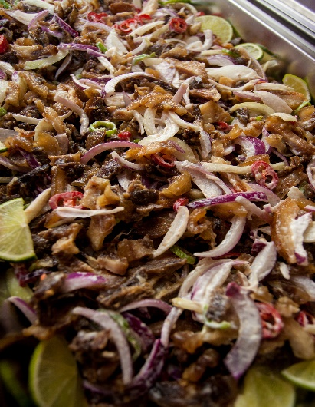
- Menudo
- Letchon Paksiw
- Afritada
- Asado
- Lechon Kawali
- Pork Humba
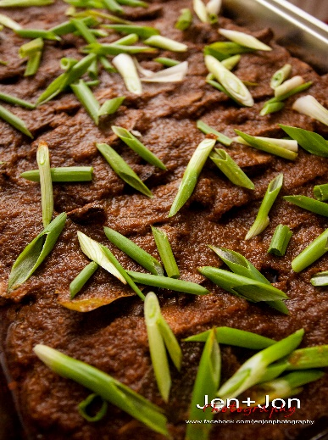
- Sweet and Sour
Dinakdakan
- BBQ Spare Ribs
- Adobo
- Dinakdakan
- Dinuguan
- Binagoongang Baboy
- Lumpia Shanghai
Pork Asado
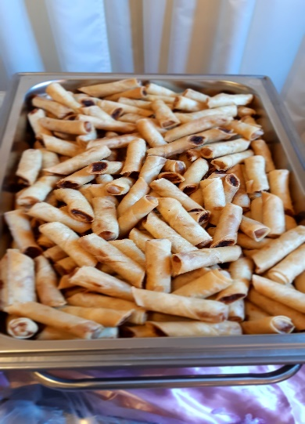
- Bopis
- Embutido
- Siomai
- Bicol Express
- Special Sweet Ham
- LECHON
Lumpia Shanghai

Beef
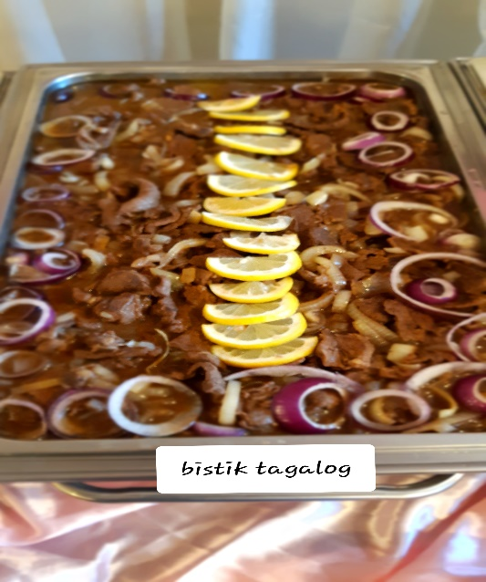
- Kaldereta
- Bistik Tagalog
- Asado
- Kare-kare
- Mechado
- Beef Curry
- Beef Stew
- In Black Bean Sauce
- Teriyaki
- Roast Beef with Gravy
- Bicol Express
- Stroganoff
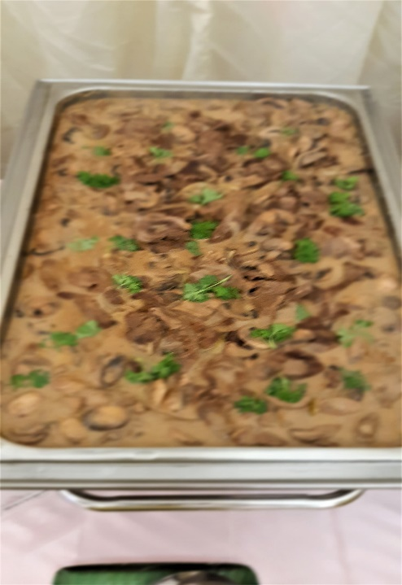
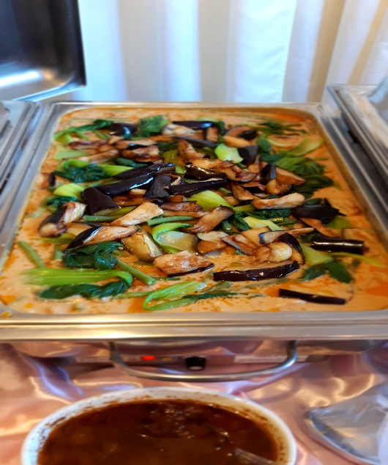
Beef Stroganoff
Kare-kare

Vegetables

- Chopsuey
- Laing
- Stir Fried Vegetable with Japanese To-fu
- Pinakbet
- Ginataang Gulay
- Beef with Broccoli
- Beef with Mushroom
- Lumpiang Gulay
- French Beans with Pork
- Fresh Lumpia
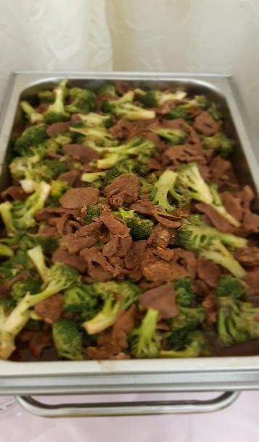
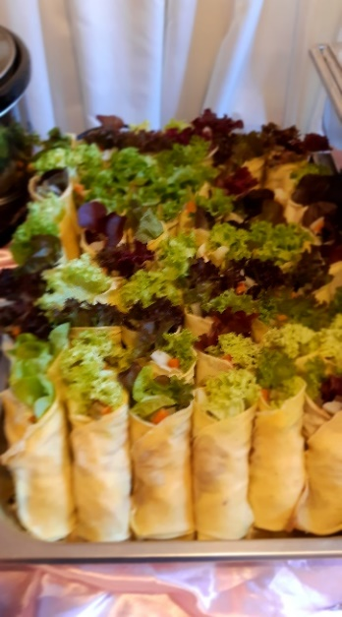
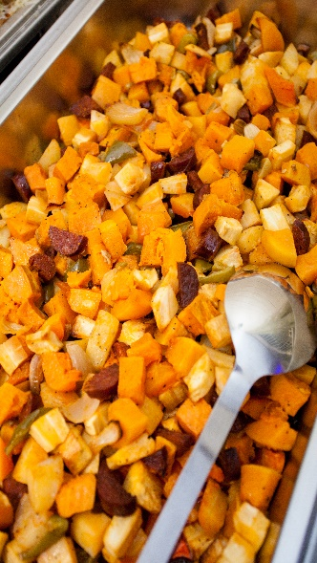
Fresh Lumpia
Bake Vege
Beef Broccoli

Seafood

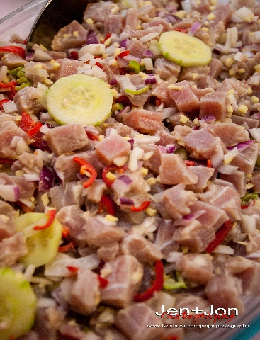
- Sweet and Sour Fish Fillet
- Orange Creamed fish
- Mix Seafood
- Ginataang Pusit
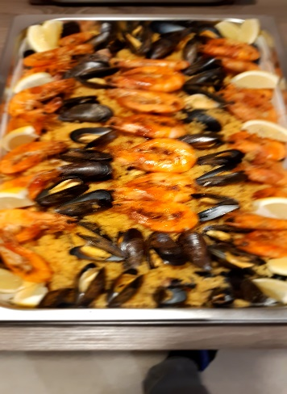
- Camaron Rebosado
- Calamari
Kinilaw
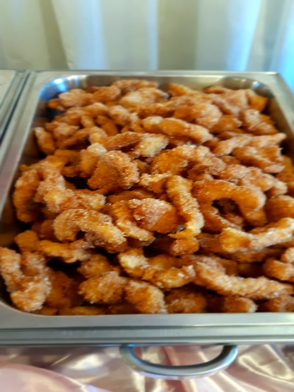
- Adobong Pusit
- Escabeche
- Paella
- Bake Fish
- Kinilaw
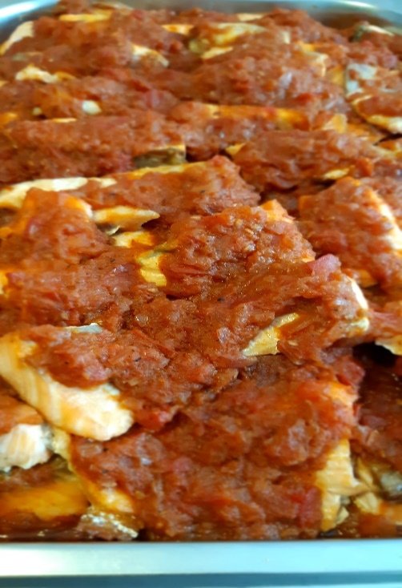
Seafood Paella
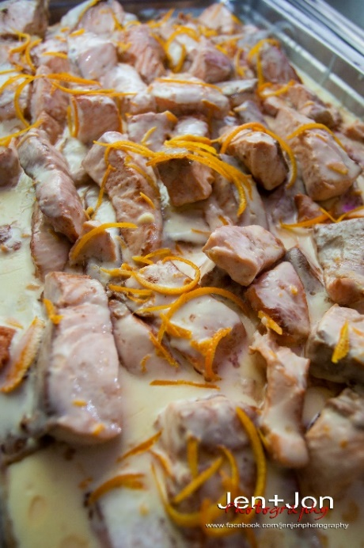
Fish fillet

Orange creamed fish
Fish in tomato salsa

Noodle / Pasta

- Malabon
- Pancit Canton
- Spaghetti
- Pancit Bihon
- Lasagne
- Carbonara
- Sotanghoon
- Bam-i
- Fried Keow Teow
- Chow Mien (pork/chicken)

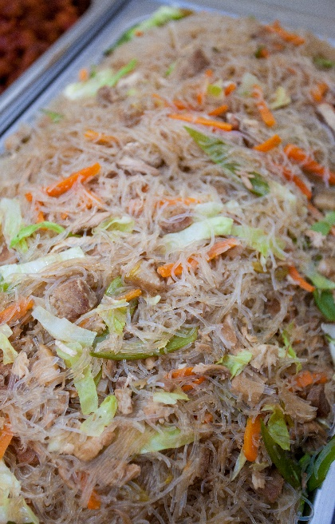
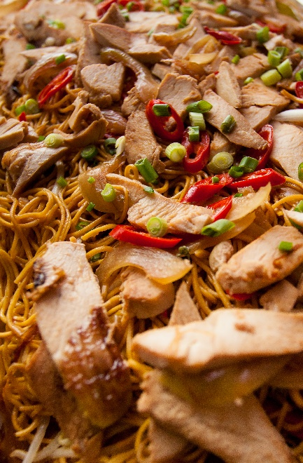
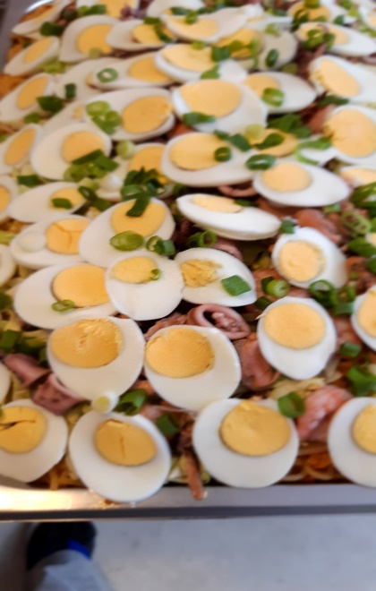

Malabon
Chow Mien MienMien
Pansit Bihon

Chicken

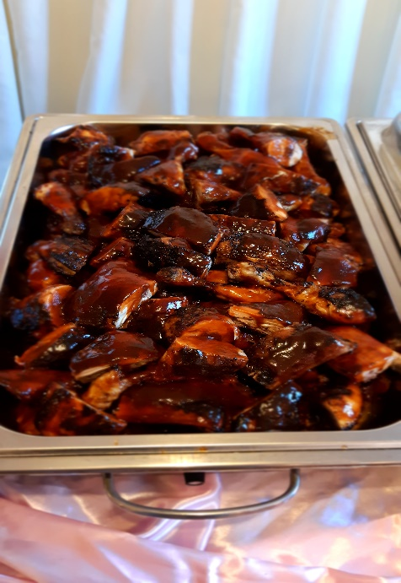
- Sweet and Sour
- Afritada
- BBQ Chicken
- Lemon Chicken
- Apricot
- Chicken Satay
- Orange Chicken
- Chicken with Pineapple
- Curry
Chicken BBQ

Lamb/Goat
- Kaldereta
- Mint Lamb
- Curry

Dessert / Kakanin

- Leche Flan
- Fruit Salad
- Buko Pandan
- Kutsinta
- Bico
- Sapin-sapin
- Puto
- Pichi-pichi
- Maja
- Bibingka
- Palitaw
- Puto Bong-bong
- Halayang Ube
- Suman
- Cassava cake

