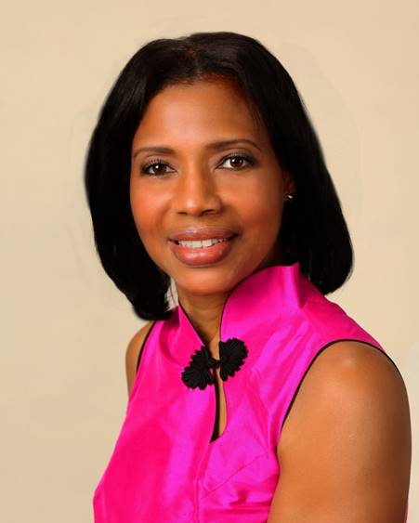
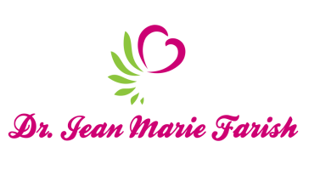

LOVE LIGHT NewsLetter

I am excited to host my VoiceAmerica Empowerment Show-LOVE LIGHT with amazing Guests to cultivate a lifestyle of love and wholehearted connections through worthiness. My show is aligned with my mission to live an altruistic and heart centered life.

MEET GUEST AUTHOR

Meena Menezes

February 14, 2020

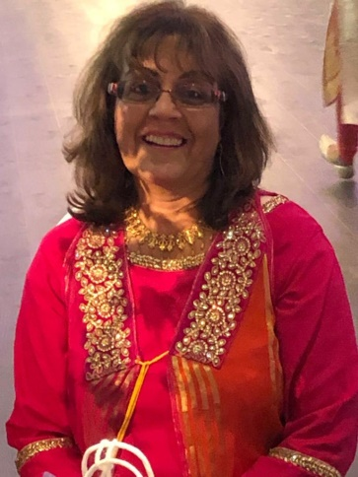

“Building Resilience Through Self-Love”

ABOUT Meena Menezes

Author and Speaker

“I worked as a journalist for one year in the Middle East (Bahrain) and also as a freelance writer/ghost writer. As an active blogger on social media, I truly believe in the power of positive thinking. I hope that such thoughts will inspire and motivate others to never give up but choose to believe in themselves and draw on their inner strength to reach their goals and make their dreams a living reality.”

Meena gave up a full time job to follow her dream and indulge in her passion for writing. With two e-books, “Dream Home Believe” and “Thoughts for the Soul”, she recently published a book entitled, “Life is Beautiful, which is a compilation of thoughts, quotes and personal stories of courage and perseverance. Her books are based on inspirational thoughts on life, love, relationships and most importantly, living with an attitude of gratitude. She is currently working on her next project which is a book of short stories inspired by the lives of women who overcame their challenges and proved that they are women of substance.

Her conversation on “Building Resilience Through Self-Love” highlights the importance of loving and respecting yourself before expecting it from others, because we are worthy and we deserve to be happy. “Your self-worth is determined by how much time and effort you invest in yourself, doing what makes you happy – Life is Beautiful. -Meena

Meena’s Empowering Message

“Resilience is your new reality”

Meet Meena on Facebook -Meena’s Thought of The Day

“An empowered self is a loving self and keep your love light shining”

