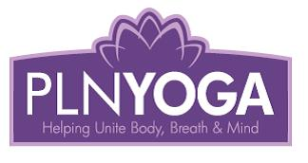 | PLN Yoga  Pamela Nelson  Box 393  Christopher Lake, Sk.  S0J 0N0  www.plnyogastudio.com

Registration Form for Online and In-person Classes

Class Date:

Class Time:

Class Location:
(If online please just put online)

Class fee:

-----------------------------------------------------------------------------------------------------------

Name:_________________________________________________________________

Address:________________________________________________________________

Telephone: (hm.)_____________________ (work) ______________________________

E-mail:__________________________________________________________________

I understand that while many of the techniques may be therapeutic in nature, they are in no way prescriptive. I have been advised to see my health care practitioner if I have any medical concerns.

Signature___________________________________________Date:_________________

Fee payment requested to confirm your registration. Thank you.

Pamela reserves the right to cancel any classes if necessary due to illness, road conditions, etc.
Money for that class will be reimbursed or class will be rescheduled.

