Scoil Bhríde

Important Information for Parents and Schools about the School Playground – Expert Insight and Advice from some of the World’s Leading Child Educationalists and Child Psychologists

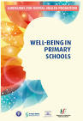
Introduction:
This section has been compiled to address the growing number of calls being made to Schools in relation to alleged incidents on the School Playground. This booklet aims to (i) cut down on the loss of teaching and learning time being used to address these issues (ii) show the wealth and value of life learning experiences available to children on a school yard and (iii) provide practical guidance on promoting positive mental health and well-being (in line with the Department of Education publication “Well-Being in Primary Schools - Guidelines for Mental Health Promotion”)

This booklet should also be read in conjunction with Scoil Bhríde’s Anti-Bullying Policy, Child Protection Policy and Code of Behaviour.

Scoil Bhríde’s Philosophy of Education:
- We support the philosophy of education basic to the three main aims of primary education as stated in the Primary Curriculum

- To enable the child to live a full life as a child and to realise his or her potential as a unique individual

- To enable the child to develop as a social being through living and co-operating with others and so contribute to the good of society

- To prepare the child for further education and lifelong learning

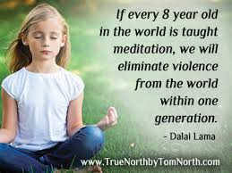
- It is our wish that the school’s total curriculum acknowledges the variety of needs and learning abilities among the pupils and endeavours to strike a balance between an emphasis on an academic core and on the provision of a wide range of other important life learning experiences

- We recognise how important it is for each child to develop the oral, comprehension, reading and written skills of the English language which are so necessary when working in other subject areas and when interacting with others in life. We recognise that it is extremely difficult for any child to reach his/her full potential if he/she has not mastered the basic skills of the language while in primary school

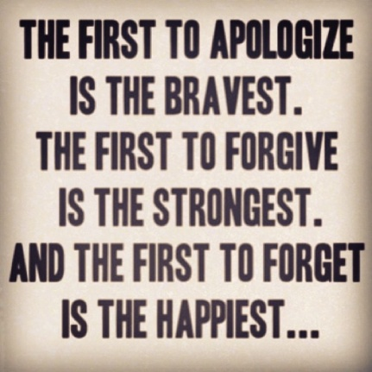
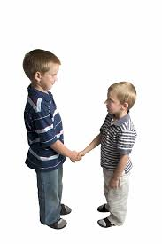
- We recognise that individual growth best takes place in an atmosphere of openness and friendliness. Accordingly we strive, in each class and throughout the school, to create a strong sense of community so that no child will feel alienated or marginalised at school. We aim to help the children feel that their teachers are people they can trust and on whom they can depend. In a school, our size it is possible for all the teachers to get to know each child from their induction into the school.
- We acknowledge that our school is a Catholic school and therefore we strive to create a school community where Gospel values of hope, justice, fair play, compassion, love and reconciliation are fostered. The whole school co-operates when we perform our ‘Nativity Play’ at Christmas and the school choir performs at First Confession and First Holy Communion ceremonies

- The parents are the primary educators of their children and the school is where the professional educators complement the work of the home. In recognition of this fact the school seeks to maintain friendly collaboration and a good working rapport with all parents. The child’s balanced growth and development – not just academic progress is the focus of such collaboration

- We believe that all children are equal regardless of gender, ability, creed or social background

A Summary of Scoil Bhríde’s Philosophy of Education

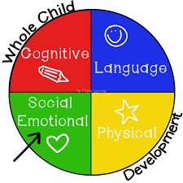
We have adopted the seanfhocal “Mol an Óige” (Encourage the young) as our school motto. Our philosophy is to know each child, to lead them with affection and fairness and to prepare them for life by developing them socially and personally into a fully rounded individual.

We aim for high academic standards and we will demand that each child does his/her best. We believe that this demand will be met by a child who is secure and happy in school and who feels his/her efforts are appreciated.

Section Content:
This Booklet is broken into 4 key sections:

- FIVE IMPORTANT AND ESSENTIAL LIFE SKILLS A CHILD LEARNS IN THE SCHOOL PLAYGROUND

- TOP TIPS FOR PARENTS “WHEN YOUR CHILD FALLS OUT WITH A FRIEND ON THE SCHOOL PLAYGROUND”

- TOP TIPS FOR PARENTS “IF YOU FEEL YOUR CHILD IS GETTING A HARD TIME ON THE SCHOOL PLAYGROUND”

- TOP TIPS FOR PARENTS “WHAT TO DO IF YOU FEEL YOUR CHILD IS BEING EXCLUDED ON THE SCHOOL PLAYGROUND”

- HELICOPTER PARENTING
- FIVE IMPORTANT AND ESSENTIAL LIFE SKILLS A CHILD LEARNS IN THE SCHOOL PLAYGROUND

One would normally think that a child only develops their movement skills in the playground. Aside from the development of movement skills, certain life skills or socio-emotional skills are learned in the playground. A child needs to learn to cope with their feelings and they also need to learn how to respect the feelings of others. The school playground is THE place to cultivate such skills. Why? The school playground represents the world for a child. How the child relates with other children in the playground reflects how the child relates with people in general.

- Building Self-Esteem.
The best way to build self-esteem is to give opportunities for the child to succeed...and yet to fail. Yes, you read it right – to fail.
For example, when Daniel faces the monkey bars for the first time, fear settles in. He tells himself, “How can I possibly swing from those?” He tries it and falls on the first bar. He avoids the monkey bars but is faced with it everyday during Outdoor Play Time. And so he tries again and falls again. He then decides to swing in it everyday until he swings on every bar and jumps from it like a gymnast. This is a great teaching moment for the teacher too. Whenever this child faces difficulty in any other school activity, the teacher can always encourage him by saying “Remember the time when you couldn’t swing in the monkey bars?” The child remembers and has more confidence in taking risks, failing, practicing and eventually succeeding. As the song goes, “But I got to pick myself up, dust myself off, start all over again...”

- Connecting with others.
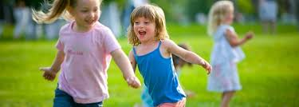
Toddlers usually engage in parallel play or playing side by side but not with each other. As they grow, they learn to interactively play with other children. They learn to come up to their classmates and ask them to play or join a group in a game of tag. The playground gives such opportunities. Games usually played in playgrounds require more than 2 children – whether it be tag, hide and seek or just simply making imaginary games.

- Resolving Conflict
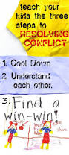
As in any life situation, conflict can be present in the school playground. This is normal and unavoidable. It is simply a fact of life. This conflict is usually brought about by different behaviours, attitudes and upbringing. Creating the conflict is easy. Resolving it takes skill. And this essential skill for the real world can be learned in the school playground.
What child psychologist experts love about conflict is that it is the ultimate teaching moment. The goal for conflict resolution is peace. When a child is in conflict with another child in the school playground, this can result in the game ending abruptly or the creation of enemies – things that a child does not like to happen. And so to avoid these effects, a child learns to temper down and get along with others. Now how, say the experts, can we teach adults the same thing?

- Taking Turns
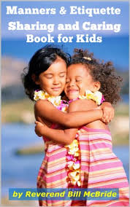
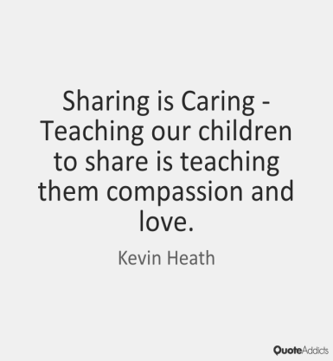
Oh how the world would change if everyone knew how to wait their turn! This skill should be developed early on. A child comes from a self-centred stage before entering school. They think that everything is theirs and they can use anything they like at any given time. When they play in the school playground with other children they realise that there are others who also want to play with the ball, the goals, the skipping rope, the hula hoop and their friends etc. And so the battle begins!
The teacher then sets the rules of taking turns. “What?!” The child exclaims. “I have to wait?!” The teacher then asks them “What if your classmates used it the whole time without giving you your turn? What would you feel?” The child thinks, “I wouldn’t want THAT to happen?” A great teaching moment.

- Standing Ground
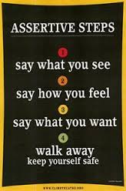
A child needs to reinforce the above 4 life skills by standing their ground. Learning to defend one’s self is a skill that every child should strengthen. This prepares them not only for self-preservation but also as an early defensive skill. This also shows how they value themselves, their identity and their territory.

- TOP TIPS FOR PARENTS “WHEN YOUR CHILD FALLS OUT WITH A FRIEND ON THE SCHOOL PLAYGROUND”

It is distressing enough when you experience your own adult ‘bust-ups’ – so what’s the best way to deal with the upset of your child when a playground spat goes too far?
Your reaction to the problem depends very much on the age of your child – with pre-schoolers, rows are usually easily forgotten and soon blow over. However, once children reach infants age and above, friendships become more complicated. With your support, your child can learn the courage and confidence to tackle life’s many relationship challenges.

Here are ten tips to help maintain social harmony for your little ones:

- Arguing is not all bad
Realise that children use arguing to work out all manner of issues, and that learning how to express one’s disagreement is an important social skill. If the dispute veers out of control it may be time to examine the root cause – perhaps it’s a simple case of incompatibility, or maybe there are underlying anxieties, jealousies or control issues which could be nipped in the bud.
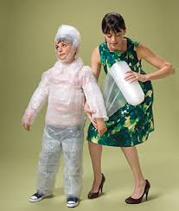
- Keep it in perspective
Yes, it will always be painful to watch your child being rejected by another, but unfortunately squabbles, reconciliation and/or moving on are all parts of growing-up. It would be prohibitive for a mother or father to protect their child from every little tiff, so step back. It may surprise you how quickly your child can forget about things if you don’t make too big a deal of it.

- Listen
Like adults, children often just need a sounding board, so be careful not to always push a ready-made solution. By allowing your child to talk things through in their own time and neither judging them nor treating them as a victim, you will help your child to resolve their problems by allowing them to make observations and decisions by themselves.

- Offer support
Instil self-confidence in your child by telling them you have faith that they will deal with the situation. If appropriate, offer suggestions, but never force your opinion. If you feel it might help, tell them about some of your own childhood fights; children often gain comfort from knowing they aren’t alone.

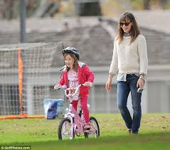
- Leave them to it
Know when to intervene and when to steer clear. As long as no one is getting physically hurt or overly upset, the best lessons can be learned from letting our children work out their own differences. Settling arguments (like cycling a bike) is an essential life skill that can only be acquired through experience, so only step in if absolutely necessary. You may hinder your child’s developing independence if you are forever their rescuer!

- Avoid potentially explosive situations
If a particular friend seems to be causing ructions, you should limit the situations that can lead to further distress outside of school. Within in a school setting this is near impossible to do as they may be in the same class or the same play yard. Within a busy school yard it would very difficult for a school to micro-manage such a situation. Bear in mind also that school playground time in an Irish Primary school is also only 40 minutes, so it is only a small portion of the school day.

- Respect your child’s decision
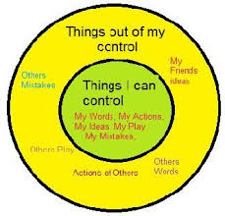
If your child decides they no longer want to play with a friend, it’s your job to support them in that decision. They may well have a very good reason that you might never find out – but it is their right as an individual to choose their playmates, so never enforce a friendship against their wishes.

- Encourage your child to take responsibility for their actions
Once the initial storm has blown over, offer to talk through the whole thing without attaching blame. This gives your child the opportunity to realise their mistakes and take responsibility for their part in the problem. From this they can choose to apologise and/or make changes to their future behaviour.
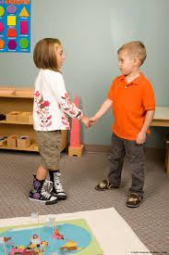

- Don’t make it personal
Accept that fights among friends are normal and view them as a necessary part of your child’s development. It is nothing to do with you and you shouldn’t attach your own feelings to those of your children. Appreciate that kids’ friendships typically change with the weather – what lasts a lifetime as an adult may stretch only a fortnight with a seven-year-old.

- Broaden their horizons
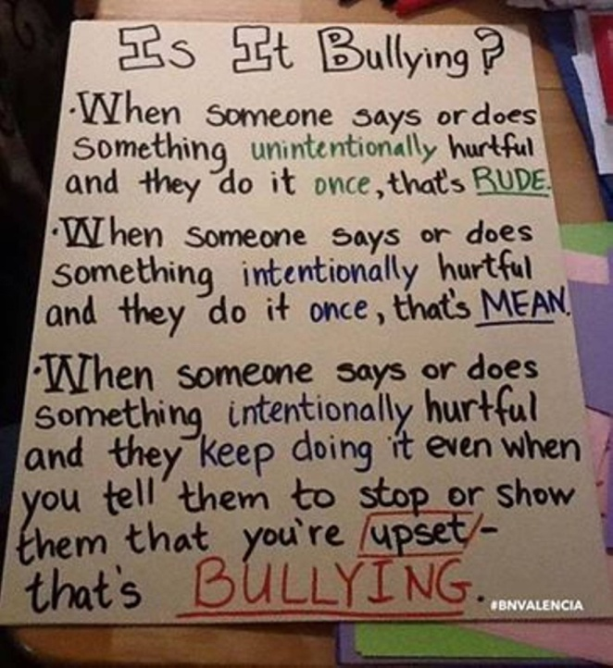
At school help your child to have a wide social group so that if friendships do go awry, they have others to fall back on. This can be encouraged by involving them in different afterschool clubs and activities, and inviting more than just one best friend home to play.
Important note:
While childhood disputes are a normal part of growing up, always bear in mind the difference between regular arguments and issues involving bullying (‘Unwanted negative behaviour, verbal, psychological or physical conducted, by an individual or group against another person (or persons) and which is repeated over time’), violence or racism, and adjust your role accordingly.
Please refer to the schools (i) Anti-Bullying Policy (ii) Child Protection Policy and (iii) Child Protection Policy for further information.

- TOP TIPS FOR PARENTS “IF YOU FEEL YOUR CHILD IS GETTING A HARD TIME ON THE SCHOOL PLAYGROUND”

Letting your kids fight their own battles
Say your child was called a nasty name on the playground or didn’t get invited to a classmate’s birthday party. Say they feel jealous because another child is smart and well-liked. Or they desperately desire something another child has. Or their close friend is moving away, and they’re fretting about their friendship.
Would you intervene by talking to their parents?
Some parents do pick up the phone. But they shouldn’t, according to Joyce Marter, LCPC, psychotherapist and owner of Urban Balance LLC, a multi-site counseling practice.

In these cases, the parents no doubt mean well. They love their kids and want to protect them, Marter says.

But intervening in your child’s battles can actually backfire – and affect their development. “If we fight our kids’ battles we are unintentionally communicating that we do not believe they are capable themselves,” Marter says. Through these battles, kids learn how to communicate effectively and resolve conflicts, she said. This not only improves their self-esteem, but also helps them feel empowered, she adds.
Of course, this is very different from stepping in when your child is getting bullied. (See more on the definition of bullying in the school’s Anti-Bullying Policy)
If you fell your child is getting a hard time in the school playground, don’t despair. Here are some ways to help conquer the conflict and build their self-esteem at the same time.

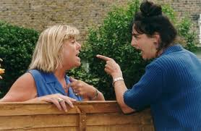
While we know that school playgrounds can sometimes be uneasy places (we’ve all been there, after all), there’s something that strikes at your heart when it’s your child who’s been involved in any schoolyard squabble.

Some parents try stepping in to help diffuse the situation: surely two rational adults can help their kids work it out, right?

Wrong. Experts say this often blows up in your face, which is why experts really discourage parents from confronting other parents.

Lessons for life

“Conflicts occur every day and can be a source of frustration for children and adults alike”, says John Cooper, senior clinical psychologist and author of ‘Getting On With Others’.
“Children who can stay calm, think of different solutions and think ahead are likely to get on better with other children and adults”.

Counselling psychologist Evelyn Field, who has written ‘Bullybusting’ and the more recent ‘Bully Blocking’ says that teaching a child to develop social and emotional resilience will help him-or-herself “deal with difficult, stressful encounters: managing pushy friends, aggressive bosses, controlling partners and others”.

Where to start
John Cooper suggests you start coaching your children in problem-solving skills from the age of four, and then right through to their teen years. He says it’s important not to jump in when our kids are having a problem (unless of course the playground conflict puts them in danger i.e. is your child in immediate danger? which is when you need to work with the school to get it sorted out). Instead of intervening in your child’s social dilemmas, help them solve the dilemma by following these five steps:

Step 1: What is the problem?
Ask your child to describe the problem. “Listen carefully, then summarise the main points,” suggests John.

Step 2: How do you feel?
Get the child to “recognise their own feelings”. Then ask them to think how the other child involved in the conflict is feeling.
“Doing this helps them learn that it is not just them who feel(s) aggrieved,” adds John.

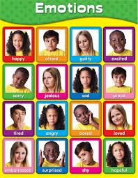
Empathise with your child and offer emotional support advises psychotherapist, Joyce Marter. Show your child that you understand how they’re feeling. For instance, you might say, “I can see that you are feeling very sad and frustrated”.

“This will help your child gain insight into their feelings as well as help them know you understand, which promotes trust and intimacy,” Marter says. Plus, it helps to diffuse emotions. “Sometimes kids – and adults – keep expressing their emotions and up the ante until they feel heard”.

Also, even if your kid’s emotions seem disproportionate to the situation, let them know that their feelings are still a normal response. “A child’s ability to understand and cope with feelings is less sophisticated than ours as adults and things that may seem little to us may in fact be very big to them,” Marter says. So you might say, she says: “It is understandable that you’re feeling sad that you couldn’t play with the others.”

Showing physical and verbal affection also helps kids feel safe and loved and reminds them that they’re not alone.

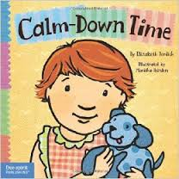
Step 3: Calming down
“When we get angry, instead of looking for solutions, we often spend our time going over and over why we are right and the other person is wrong,” writes John Cooper. Instead, encourage your child to “take three deep breaths and calm down” and count to three.

Help your child learn how to process emotions. For instance, guide them in using deep breathing to soothe their brain and body, Marter says. This involves breathing in through your nose, down to the stomach and then out through the mouth.

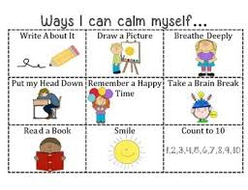
Teach them to release their emotions by talking about them, writing, creating art, exercising and playing, she said. Help them practice mindfulness by bringing attention to the present and away from the issue, she said. You can even have them take a sip of water or take a walk together.

Also, help them avoid creating a monster of negative thoughts by focusing on the positive. “This promotes gratitude and positive thinking and reduces negative thinking patterns that can contribute to depression, anxiety and relationship problems,” Marter says.

Coach them to put things into perspective, and see the bigger picture, she says. “Coach them to put things into perspective, and see the bigger picture, she said. “Coach them to ‘be a duck’ and let issues roll of their backs”.

Finally, humour is a huge help. “After you’ve validated your kid’s feelings and they have calmed down, you can use humour to help them learn to laugh it off.”

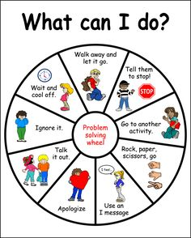
Step 4: Alternative solutions
“Children are more likely to accept a solution if they – not you – suggested it,” says John Cooper. “Stay quiet for a while and see what they come up with. Then you can make suggestions”.

Explain to them how assertive communication works. For instance, have them use “I” statements rather than “you” statements. According to Marter, instead of saying “You left me out,” they can say “I am upset because I wasn’t included in the game.”
Teach them to empathize with other kids. For instance, you might ask, “How do you think that made Mary feel?” Marter says. Encourage them to take responsibility for their actions. “Expect them to own up to any of their own negative behaviors and coach them on how to apologize through role-play,” she says.
Role-play other situations, too, and remind your child that they can only control their own actions and responses – not anyone else’s
Step 5: The best solution
Don’t pass judgement, adds John Cooper, but try to get your child to “think ahead...and judge which solution will bring about the best results for everybody.
- TOP TIPS FOR PARENTS “WHAT TO DO IF YOU FEEL YOUR CHILD IS BEING EXCLUDED ON THE SCHOOL PLAYGROUND”

When your child says she’s being excluded by peers at school, it’s important to understand the difference between friends and a clique, says Jennifer Ryan, a psychologist with a special interest in bullying.
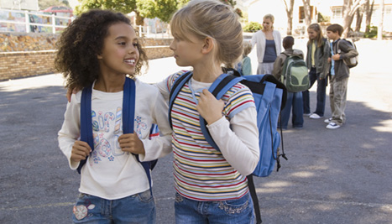
A group of friends hang out together, have common interests, like each other’s company, and there’s no power issue going on, explains Ryan. Whereas in a clique, there’s a power or dominance issue occurring.

“Somebody’s trying to assert themselves as queen bee, someone’s calling the shots – usually one person, sometimes two – about who you can’t play with, who you can’t let in”.
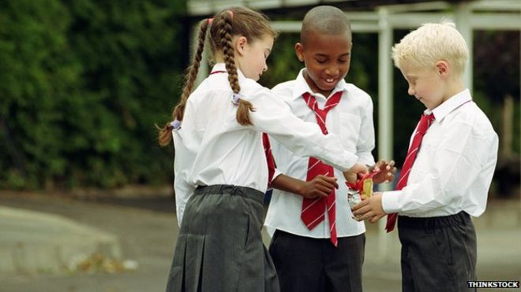
Many children, especially aged 10 to 12, strive to be part of a group for ranking purposes, says Ryan. “At this stage, there’s a shift away from what parents think. It becomes more about what peers think, about how they’re ranked.”
Parents needs to establish with the child what a friend is – how a friend makes you feel, how to behave towards a friend, how they don’t make you do things you’re uncomfortable with.
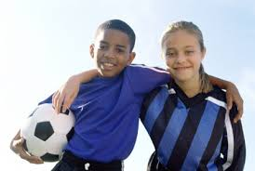
“The child then knows someone who’s excluding them isn’t a friend – so we’re not going to work on that relationship. Instead we’re going to move towards somebody who makes us feel good.”
Connect your child with those who have similar interests – through play dates and after school time activities. “This is where healthy friendships can form”, says Ryan.

- “HELICOPTER PARENTING”

Taken from www.psych4schools.com.au

Parents who are overprotective are sometimes referred to as ‘helicopter parents’ as they relentlessly hover over their children, trying to micro-manage their affairs.

The term "helicopter parent" was first used in Dr. Haim Ginott's 1969 book Parents & Teenagers by teens who said their parents would hover over them like a helicopter; the term became popular enough to become a dictionary entry in 2011.
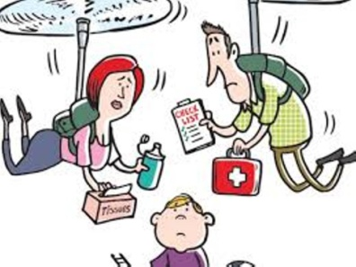
Parents who are overprotective want their children to have a ‘good start in life’ and every opportunity to succeed. They want to protect their children from life’s harsh realities and ensure their children’s happiness. While appearing on the surface to be reasonable aims, constant striving to achieve these types of goals can contribute to increased levels of anxiety for children and their parents.

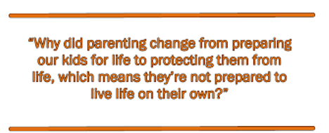
In order to become well adjusted, children need to experience the full range of emotions. Parents who want their children to always be happy are doing their children a disservice. Children need the freedom to make mistakes and experience boredom, sadness, frustration, anger, disappointment and hurt. Children need opportunities to learn to cope with life’s minor challenges. Children who ‘have a go’ at sorting out most of their own issues develop a strong internal locus of control, that is they believe they are able to cope with stress and solve their own problems.

The ‘helicopter’ parent however, rushes in to help, rather than allowing their child to have a go at managing a challenging situation themselves. This can lead to children who are unable to cope with even minor issues, as they are never given the opportunity to fail and then learn from their mistakes.

Why are some parents over protective?

Societal changes over recent decades, such as smaller sized families, older and more affluent parents and two-income families are linked with many parents making huge ‘emotional investments’ in their children and having greater and for some, unrealistic expectations of them. Parents also tend to become overprotective when they are going through a difficult time themselves.
In addition, parental fear for their children’s safety has increased despite the fact that fatal injury and death rates for Irish children have reduced dramatically each decade since the 1900s. The increase in fear is linked to the increase in our repeated exposure to stories of violence and disasters through 24-hour news channels and the Internet. Seeing and hearing the same stories time after time, increases our perception that it is a very dangerous world. Advertisers and marketers also continue to ‘frighten’ parents with the need to buy products and devices to keep children ‘safe’.

The impact of over protective parenting on children:

(1) Poorly developed problem solving skills. Parents who are constantly intervening to sort out their children’s issues are not allowing their children to take safe risks and learn from their mistakes. As a result these children may not believe they can solve problems independently, reinforcing their inability to face their own issues without help.

(2) Learn avoidance as a way of coping. Parental micromanaging means that children do not get to practice solving their own problems, as a result these children are at risk of never learning to cope effectively with minor or major life challenges without parental support. This has serious implications for children as they learn from their parents that the world is a scary place that they have no control over. Furthermore their reliance on others to solve even minor issues leads to low self-esteem, anxiety and depression and other mental health problems.

(3) Have difficulty dealing with friendship issues independently. Children’s opportunities to sort out their own friendship issues are greatly reduced by this parenting style. Primary-aged children, who have their friendship issues constantly ‘managed’ by an overprotective parent, are less likely to cope in adolescence and at risk of developing mental health issues.

(4) Less chance to develop important social skills through unstructured play. These parents are less likely to allow their children opportunities for unstructured play, preferring to involve their children in ‘safer’ organized play activities such as sporting groups, music lessons, and other organized activities. Unstructured play time is important in developing child’s self-esteem, as well as important social skills such as turn taking, sharing, co-operation and coping with frustration. Engaging mainly in structured play activities means that adults are constantly mediating, further reducing the child’s opportunity to independently practice and develop these life skills.

What does the ‘helicopter’ parent look like?
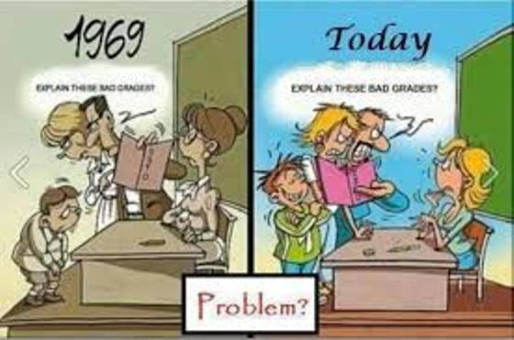
Some parents can have unrealistic or irrational beliefs about what the school can do for their child, and expect school staff to assist them in protecting their child against both minor and major challenges. Parents who are overprotective are likely to approach the school each time a minor incident occurs. They may seem pushy and often want an immediate solution to their problem, even when there isn’t an easy answer, or they may offer a solution that is irrational, such as banning running at school due to safety concerns.

Overprotective ‘helicopter’ parents may display some of the following mannerisms or behaviours:

- frequently initiate approaches to the school
- manage or oversee most of their children's activities
- believe everything their child tells them without further clarification
- readily blame, find fault with a teacher, other school staff or other children
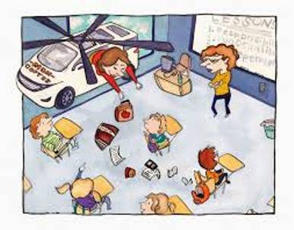
- display general disappointment in what has been decided or offered following a school meeting or conversation with the teacher
- have a stiff facial expression or body posture
- are tearful
- become defensive or use attacking language
- want an answer to what they perceive as ‘the issue’
- have a limited attention span
- repeat questions or statements
- use a high-pitched voice or rapid speech
- confront another child or parent on the school grounds
- make demands or threats to the teacher or the school
- engage other parents by developing their own issues-based parent ‘support’ group through oral communication, email, notes or handouts to parents.

It may be difficult to convince some overprotective parents that their child’s problems do not always need to be addressed or solved by an adult. At times, it may be necessary to point out to some parents that minor childhood disagreements are simply that and ‘tagging’ these disagreements as something major, such as bullying or an assault requiring Gardaí follow-up, is inappropriate

Caution regarding a genuine concern by a parent

All valid parent concerns should be addressed. Such concerns include, but are not limited to, their child’s medical condition, safety, other wellbeing issues, learning difficulties, disorders, family stress or major loss, or parental diagnosis of anxiety or a medical condition.

It is reasonable for parents to expect that perceived learning difficulties and social competency issues such as bullying and other genuine concerns with the child’s safety are followed up and investigated by the school. Schools that have clear discipline and student management, welfare, or special education provision and parenting resources in place are usually well placed to assist.

Conclusion of this Section

Be a good role model.
“Modelling…healthy emotional expression, coping skills and conflict resolution is the best way to help your kids develop these life tools,” Marter says. In other words, “Monkey see, monkey do,” she says or as the saying goes “Trot mother…trot foal”

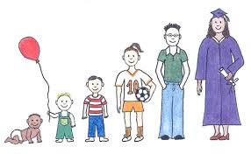
“There is a healthy balance between being a neglectful or absent parent and being an intrusive, helicopter parent. We need to give our children roots — education, values, support — and wings — let them grow to become their own people,” Marter says.

