PSA- (Prostate Specific Antigen)
… a Blood Tumor Marker Test
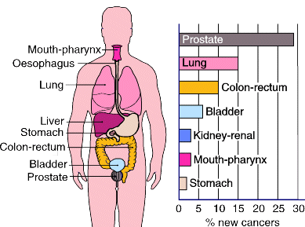
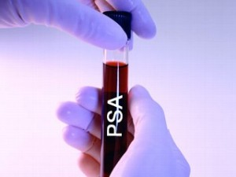

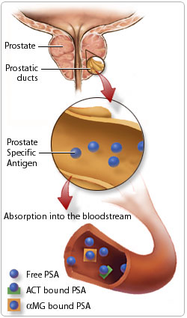
EARLY DETECTION is the key to keeping cancer cells from taking hold in
the body.
- Modern advances in immune chemistry have identified blood tumor
markers.
- Each type of cancer has a unique blood tumor marker (chemical “scent”)
which can be measured in blood with great precision.

Just as the smoke detector in your home predicts the presence of a fire, so do
the blood tumor markers announce the development of a tumor! These tumor
markers show if cancer is present long before several other conventional
methods will show anything.

Research shows that by the time a tumor is large enough to show up on an x-ray,
it has been growing for 10 years. You cannot afford to wait until a tumor grows
this large … it must be identified earlier than that.

Early Detection tests are available through your local laboratory. All health
conscious people are encouraged to take advantage of these non-invasive early
warning tests. You must have an authorized requisition from your doctor in
order to request these tests at the lab.

Antigen testing provides early cancer warning through highly sensitive blood
tumor markers … an antigen test will show up in cancer’s early development
years (1-5) when there is rarely any other physical evidence in the body.
- Antigen tests are not considered a 100% diagnostic test due to the other
influences such as drugs, etc.
- Abnormal testing is reason for concern & suspicion

What is the PSA … it is the blood tumor marker for that can be an early indicator of prostate cancer
  - PSA results should be: less than 4
  - Recommended every 2 years for men 35-45 … Recommended annually for men over 45 and above

PSA Results:
- Total PSA test results can be interpreted a number of different ways and there may be differences in cutoff values between different laboratories.
- The normal value for total PSA is considered to be less than 4.0 ng/ml (nanograms per milliliter of blood). There are some that feel that this level should be lowered to 2.5 ng/ml in order to detect more cases of prostate cancer. Holistic health care provides like to see the following scores met: 40’s = <0.7 ng/ml … 50’s = 0.9 ng/ml … 60’s = 1.3 ng/ml … 70’s = 1.7 ng/ml … and anything above 2.5 ng/ml should be closely investigated.
- Men with a total PSA level greater than 10.0 ng/ml are at an increased risk for prostate cancer (more than a 67% chance, according to the American Cancer Society).
- Concentrations of total PSA between 4.0 ng/ml and 10.0 ng/ml are often referred to as the "gray zone." It is in this range that the free PSA is the most useful.
√ When men in the gray zone have decreased levels of free PSA, they have a higher probability of prostate
cancer;
√ When they have elevated levels of free PSA, the risk is diminished. The ratio of free to total PSA can help the
doctor decide whether or not a prostate biopsy should be performed.

More information about understanding your PSA Results:
- The main differance between the PSA test readings of prostatitis and enlarged prostate, compared to prostate cancer, is the ratio of free vs bound PSA within your test sample.
- Prostate Cancer will have a higher bound PSA ratio.
- An enlarged prostate and prostatitis will have a higher free PSA ratio.
- If your free PSA test results are less than 25%, your risk for developing prostate cancer is between 10% to 20%.
- If your free PSA test levels are less than 10%, your risk for developing prostate cancer jumps to around 50%.
