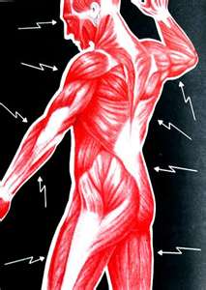
Polymyalgia Rheumatica (PMR)

Polymalgia rheumatica is an auto-immune disorder.

Polymyalgia rheumatica means "pain in many muscles", and is a syndrome with pain or stiffness, usually in the neck, shoulders, and hips. The pain can be very sudden, or can occur gradually over a period of time. It may be caused by an inflammatory condition of blood vessels, but muscle biopsies usually show normal.

Symptoms:
- Most PMR sufferers wake up in the morning with moderate to severe pain in their muscles, usually the neck, shoulders, and hips, which inhibits activity (especially in the morning). However, there certainly are cases in which the patient has developed the pain during the evening.
- Patients who have polymyalgia rheumatica may also have temporal arteritis, a potentially dangerous inflammation of blood vessels. Studies have shown that about 15% of people who are diagnosed with polymyalgia rheumatica also have temporal arteritis, and about 50% of people with temporal arteritis have polymyalgia rhemuatia. Symptoms of temporal arteritis include:
  - Severe headaches
  - Scalp tenderness
  - Jaw or facial soreness
  - Distored vision
  - Aching in the limbs caused by decreased blood flow
  - Fatigue
- Fatigue and lack of appetite (possibly leading to weight loss) are common
- Anemia
- An overall feeling of illness
- Sometimes, mild fever
Traditional Medical Treatment
- Prednisone ... oral corticosteriods

Natural Health Suggestions: (these two steps are the BEGINNING STEPS to wellness ... additional supplements may also be very beneficial
STEP 1:
- Alfalfa (1 or 2 for every 10 pounds of body weight)
- Vitalizer
- Vivix
- 1 teaspoon of cinnamon and 1 teaspoon of turmeric every day
- 3 tablespoons of fresh ground flaxseed
STEP 2:
- Additional OmegaGuard (3 to 6 daily)
- Soy Protein or Shaklee 180 Smoothees
- NutriFeron

