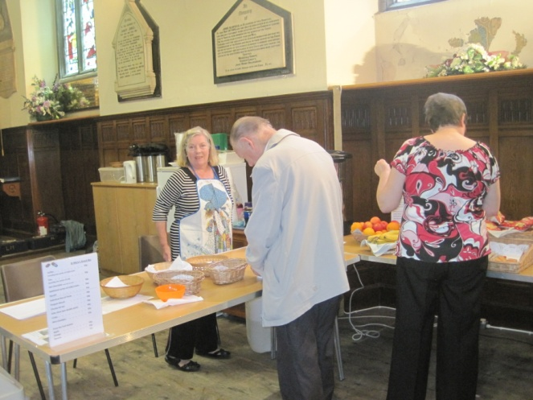
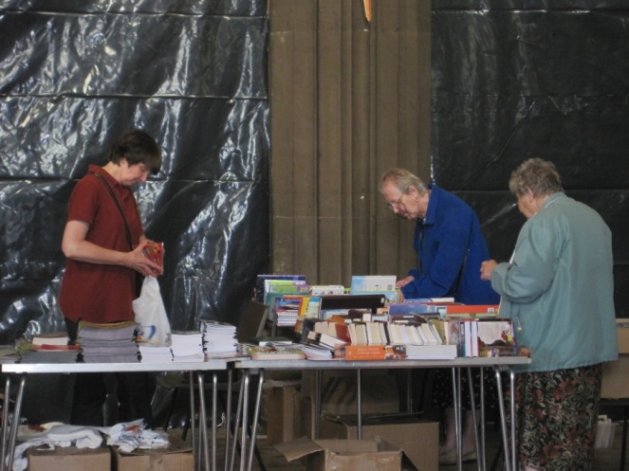
It has been another busy week at St Mary’s, and wonderful to have back with us the CLC Bookshop. They are awaiting the signing of legal documents before moving into new premises, but we hope that they will continue to work with us in the future holding events at St Mary’s. For the present however, they will be in the Nave on Tuesday, Friday and Saturday. We were so pleased to be able to help them out after the fire, and delighted to be able to help them back on their feet.

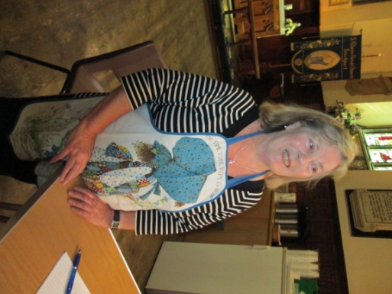
Our “snack bar” is operational with takings of £123 on week one. Clearly there is some expenditure to come from that – but a great start to our new enterprise. Thanks to our volunteers for keeping us open in not ideal working conditions.

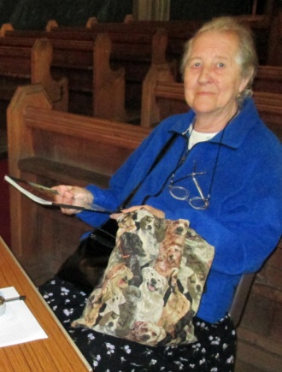
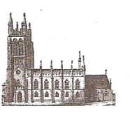
St Mary’s in the Marketplace
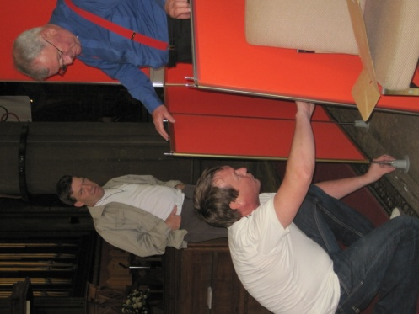
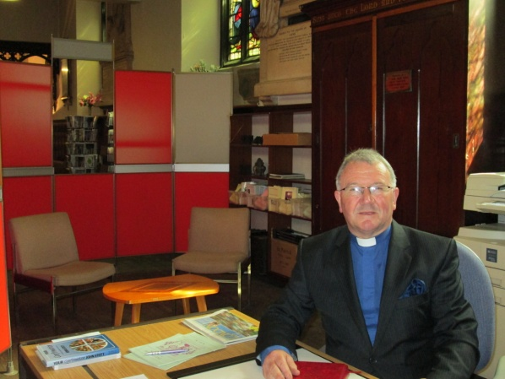
No 5 [19th August 2012] Ready to welcome our visitors
at the welcome desk. .
The temporary church office is now looking more the part thanks to the screens provided by Displex Display and Exhibition Ltd. This is not the first time that they have helped us out providing us with display equipment and we thank them for bringing down these particularly colourful ones to provide some privacy for Roger, yet allowing the viewing “window” through to the Snack Bar.

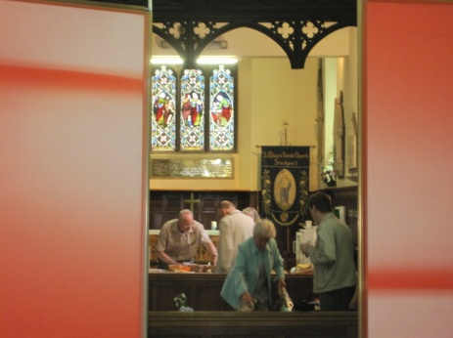
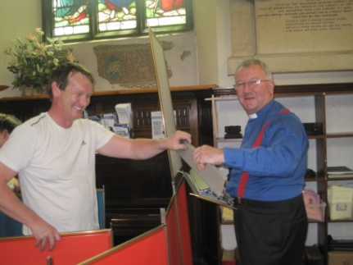

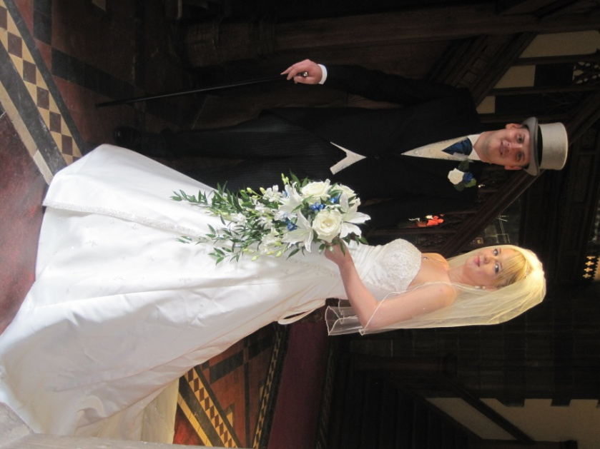
Church life goes on, with the wedding of David and Adele. A most enjoyable occasion with the service held in the Chancel and the signing of the register in the Rector’s Vestry. A happy time was had by all, and it was lovely to see so many children in Church. There may be screening against the north aisle and scaffolding around the west doors, but what a lovely venue St Mary’s is and how wonderful it will be when the work is completed and we have that “longed-for” flexibility within the Nave of the Church.
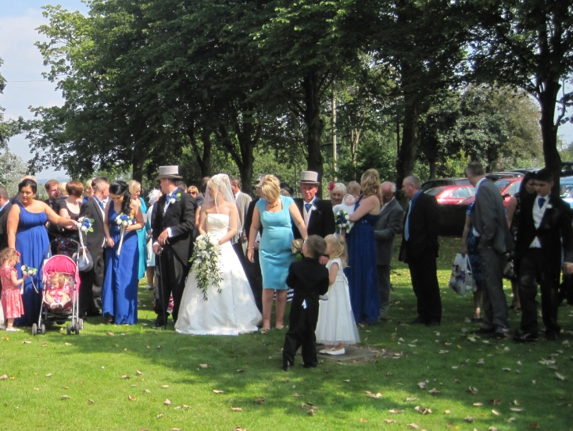
What a wonderful backdrop the outside of the Church makes for photographs on a lovely sunny day.

Meanwhile behind the screens and outside Lambert Walker Conservation Restoration Ltd are busy at work preparing the foundations of the new extension for the toilets, clearing out the old and preparing for the new.
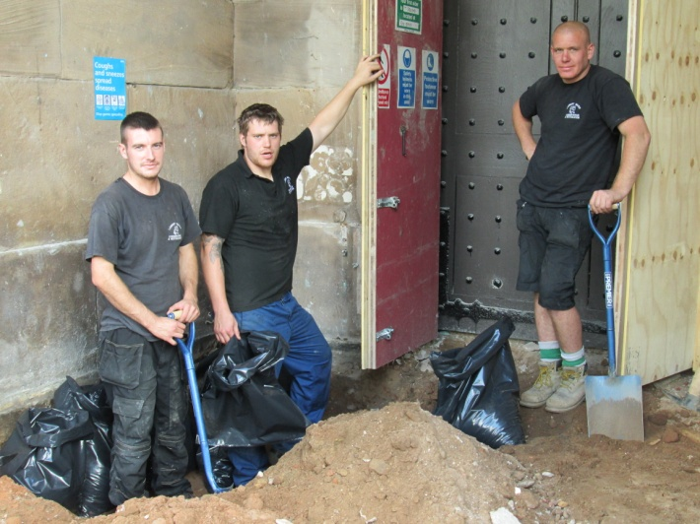
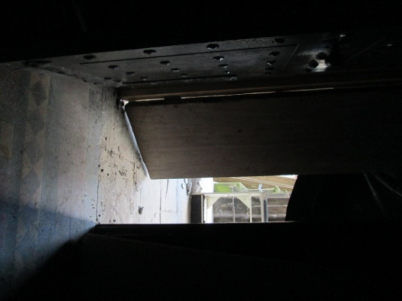

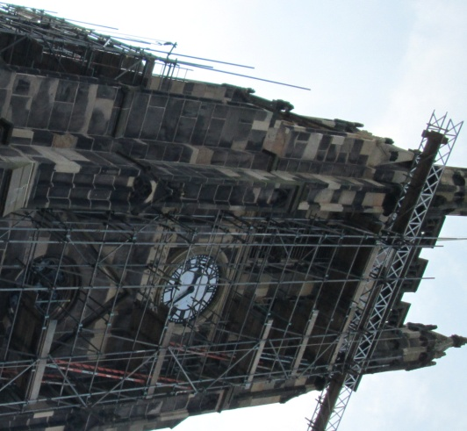
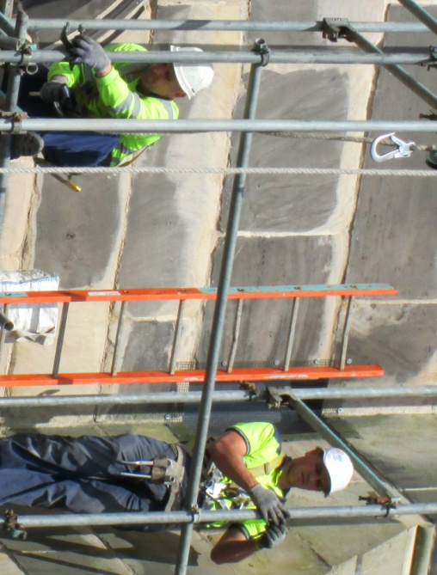
High above our heads, the team from Kirk Scaffolding Ltd are just about at the top of the tower. You have to admire them working at such great heights, but Kirk Scaffolding Ltd is a leading scaffolding contractor operating throughout the North of England. They are a family owned and run company now entering a third generation with over 40 years' experience in the industry.

