Time Value of Money
One of the most fundamental concepts in finance is that money has a “time value.” That is to say that money in hand today is worth more than money that is expected to be received in the future.
1. Time Value of Money for Even Cash flows
Future Value (FV)
This term refers to the value of a present cash flow (or series of cash flows) at a future date. Any cash flow that is scheduled to occur sometime later than today is referred to as a “future value.” For example, if an investment promises to pay 100 one year from now, then the 100 is the future value of the investment.
Present Value (PV)
This term refers to the current (today’s) value of a single or series of future cash flows. In other words, it is the amount that you would be willing to pay today in order to receive a cash flow (or a series of them) in the future. For example, if you invest 50,000 and get 100,000 after 5 years, then 50,000 is the present value of the investment.
Number of Periods (NPER)
The total number of periods is a key variable in all time value of money questions. It is important to distinguish between the number of periods and the number of years. For example, when we refer to a “30-year Home Loan” we are talking of 360 months or periods of repayment and not 30 years.
Payment (PMT)
The payment is a series of cash flows. For example, if you deposit 500 every year for next 10 years to get 20, 000. Then, 500 is the payment (PMT).
Rate
This is the rate that is used for compounding or discounting the future values or present values. For example, if you deposit 10, 000 and earn 12% pa on your deposit, then 12% pa is the Rate.

Purpose | Calculator Key | Excel Function
Solve for Number of Periods | N | NPer(rate, pmt, pv, fv, type)
Solve for periodic interest rate | I/Yr | Rate(nper,pmt,pv,fv,type,guess)
Solve for present value | PV | PV(rate,nper,pmt,fv,type)
Solve for annuity payment | PMT | PMT(rate,nper,pv,fv,type)
Solve for future value | FV | FV(rate,nper,pmt,pv,type)

Note that in the table, the bold function arguments are required while those in italics are optional.

Example 1 - Future Value of Lump Sums
Suppose that you have $100 to invest for a period of 5 years at an interest rate of 10% per year. How much will you have accumulated at the end of this time period?
In this problem, the $100 is the present value (PV), NPer is 5, and Rate is 10%. Open a new workbook and enter the data as shown below, but leave B5 blank for now.
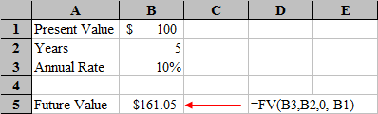
To find the future value of this lump sum investment we will use the FV function, which is defined as:
FV(rate,nper,pmt,pv,type)
Select cell B5 and then type: =FV(B3,B2,0,-B1) and then press Enter. The answer that you get should be 161.05.

Notes
- Note that we left out the optional Type argument. In all of these functions, the Type argument tells Excel when the first cash flow occurs (0 if at the end of the period, 1 if at the beginning). This argument is identical to setting your financial calculator to End Mode or Begin Mode, and only affects the answer when there is an annuity payment. When solving lump sum problems such as this, the argument has no effect. If you had typed =FV(B3,B2,0,-B1,1) you would have gotten the same answer.
- In Excel functions, you must set NPer to be the total number of periods, Rate to be the interest rate per period, and PMT to be the annuity payment per period. So, if this problem had said that the compounding was monthly (annual was implied), then we would have typed =FV(B3/12,B2*12,0,-B1). You divide the rate by 12 to show rate per month and you multiply the years by 12 to show months.
- Notice that we entered -B1 (-100) for the PV argument in the function. Cash inflows are entered as positive numbers and cash outflows are entered as negative numbers. In this problem, the $100 was an investment (i.e., a cash outflow) and the future value of $161.05 would be a cash inflow in five years.

Example 1.1 — Present Value of Lump Sums
Solving for the present value of a lump sum is nearly identical to solving for the future value, except that we use the PV function.
Suppose that you are planning to send your daughter to college in 18 years. Furthermore, assume that you have determined that you will need $100,000 at that time in order to pay for tuition. If you believe that you can earn an average annual rate of return of 8% per year, how much money would you need to invest today as a lump sum to achieve your goal?
In this case, we already know the future value ($100,000), the number of periods (18 years), and the per period interest rate (8% per year). We want to find the present value. Create a worksheet like the one below:
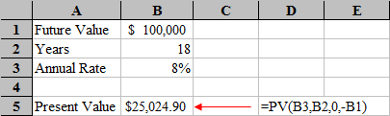
We need to use the PV function, which is defined as:
PV(rate,nper,pmt,fv,type)
So, select B5 and enter the formula: =PV(B3,B2,0,-B1) and see that you would need to invest $25,025 today to fund your daughter's future education.

Example 2 — Present Value of Annuities
Suppose that you are offered an investment that will pay you $1,000 per year for 10 years. If you can earn a rate of 9% per year on similar investments, how much should you be willing to pay for this annuity?
In this case we need to solve for the present value of this annuity since that is the amount that you would be willing to pay today.
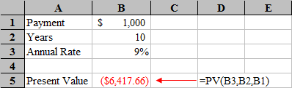
Recreate the spreadsheet pictured above, but leave B5 empty for now. To calculate the present value of an annuity (or lump sum) we will use the PV function. Select B5 and type: =PV(B3,B2,B1). The answer is -6,417.66. Again, this is negative because it represents the amount you would have to pay (cash outflow) today to purchase this annuity.

Example 2.1 — Future Value of Annuities
Now, suppose that you will be borrowing $1000 each year for 10 years at a rate of 9%, and then paying back the loan immediate after receiving the last payment. How much would you have to repay?
In this case, we want to find the future value of the annuity. In your worksheet, change the label in A5 to Future Value and then in B5 enter: =FV(B3,B2,B1).
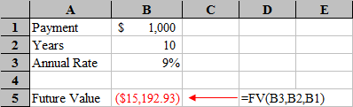

Example 3 — Present Value of Uneven Cash Flows
To find the present value of an uneven stream of cash flows, we need to use the NPV (net present value) function. This function is defined as:
NPV(Rate,Cash Flow 1,Cash Flow 2,Cash Flow 3, ...)

Suppose that you are offered an investment that will pay the following cash flows at the end of each of the next five years:

Period | Cash Flow
0 | 0
1 | 100
2 | 200
3 | 300
4 | 400
5 | 500
How much would you be willing to pay for this investment if your required rate of return is 12% per year?
Use the NPV function. Set up a worksheet as shown below:
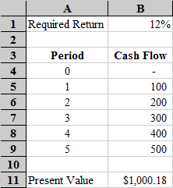
Now, select B11 and type: =NPV(B1,B5:B9) and you will see that the answer is $1,000.18. Make a special note of the fact that we did not include the period 0 cash flow in the function. The NPV function has no way of knowing when a cash flow occurs, so it assumes that the first cash flow in the range occurs one period in the future.

