Wellness Balance Wheel

TOTAL WELLNESS is dependent on many factors
and each one plays an important role in health.

Don’t look for the “magic bullet” to make you well. Get SERIOUS about “TOTAL WELLNESS”
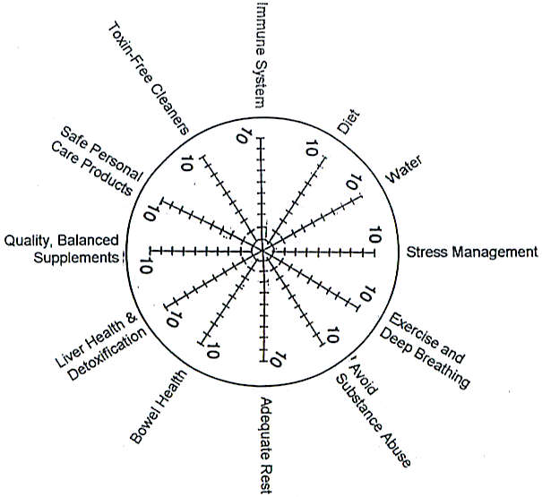

Rate yourself on a scale of 1 to 10. Where do you need to improve?

- Diet: 51% raw; variety; close to nature; adequate protein; avoid allergic foods
- Water: purified water – ½ ounce per pound of body weight
- Stress management and positive attitude
- Exercise and deep breathing
- Avoid substance abuse: smoke, alcohol, drugs, etc.
- Adequate rest
- Bowel health: frequency – bulk-in should equal bulk-out; adequate microflora
- Liver health and detoxification
- Quality, balanced supplements
- Toxin-free cleaners
- Safe personal care products
- Immune system: extra antioxidants? parasites?

