FibroSupport-Wales  Charitable Aims | 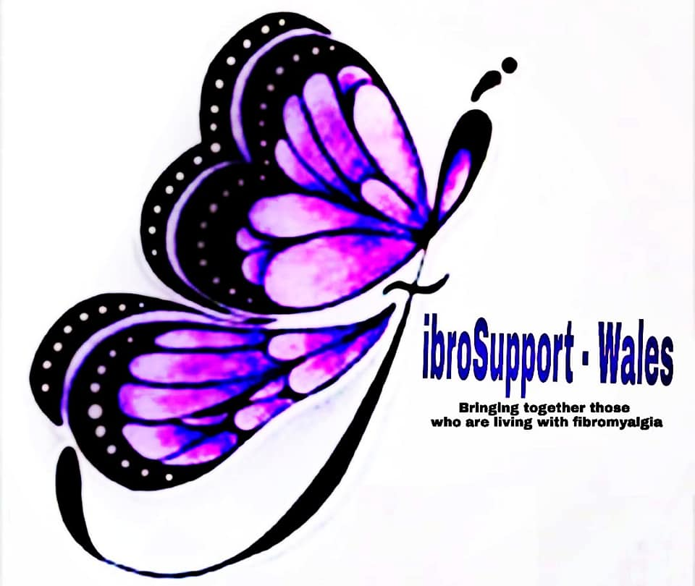
- to relieve the suffering of people with Fibromyalgia in Wales through the provision of information and support to individuals suffering from Fibromyalgia and their families and carers

- bringing together persons suffering from Fibromyalgia and persons interested in Fibromyalgia

- to cultivate a greater public understanding of Fibromyalgia and its effects on sufferers and their families

- to promote the advancement of medical research for the public benefit into the cause, cure, prevention and relief of Fibromyalgia

- to promote a greater understanding and awareness amongst health professionals

- to reach as many public resources as possible to raise awareness and reach our target audience

The team can be contacted via 0333 3355 241 or admin@fswales.org

FibroSupport-Wales Team

