On 19 September 1846, two cowherders, Maximin Giraud (11) and Mélanie Calvat (15), reported seeing a 'beautiful lady' in the mountains, wearing a pearl-studded white robe and a gold apron. Her face buried in her hands, she was weeping bitterly. She spoke to them, first in French, then in the local language, Occitan.
The apparition urged people to respect the seventh day and the name of God, sorrowfully threatening punishment (including a scarcity of potatoes). She asked that her message be spread to the world. Each child received a secret, after which the lady vanished.
Some observers at the time considered the apparition at La Salette a 'pious fraud'. Two priests specifically accused Constance Saint-Ferréol de La Merlière, a former nun, of having 'dressed up' as the Mother of God, inculcating the two credulous teenagers with her own religious agenda. Mademoiselle de La Merlière sued the priests for defamation – and lost, twice.
In 1852, the Missionaries of Our Lady of La Salette were founded. The order still has missionaries serving in many countries. The shrine remains popular with traditionalist believers and the Charismatic Movement within the Catholic church.
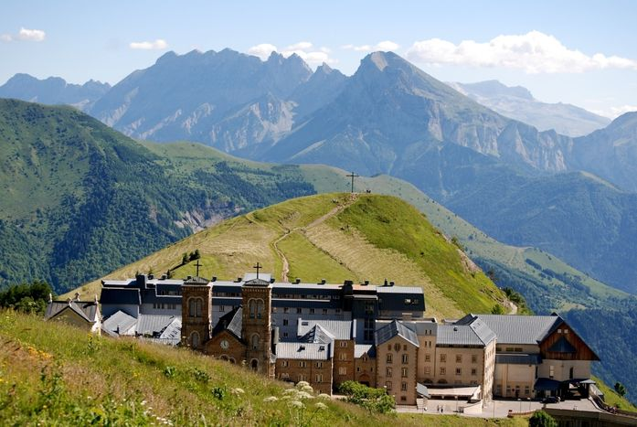

Sanctuary of Notre-Dame de la Salette.
Image: Fphoto, CC BY-SA 4.0

