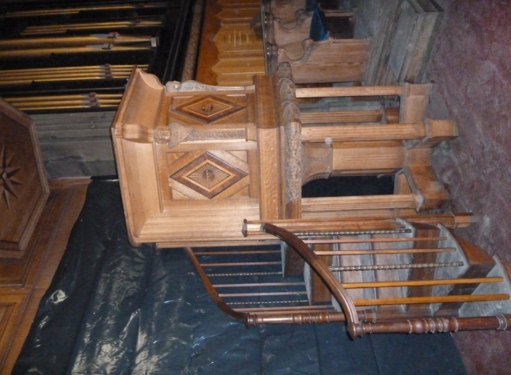
September will continue to be a busy month at St Mary’s. In addition to normal services we have TWO special concerts which we hope you will come and support. Both are excellent, professional groups and come highly recommended.

We are delighted to welcome The Australian Voices with singers selected from all over Australia – a gold-medal winning choir and in contrast, Malted Light - a British duo playing guitar and cello.

THE AUSTRALIAN VOICES IN CONCERT - UK TOUR
Come and experience the sublime sounds of members of The Australian Voices singing beautiful choral classics.
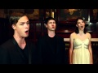
Tuesday, 11th September
7.30pm

MALTED LIGHT
TOur the united kingdom
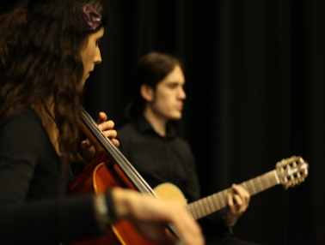
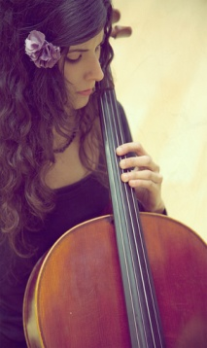
Playing with beautiful sensitivity and exquisite harmonies, their uplifting performances transport you to another world
Cellist Marta Tobar and guitar player Elliot Coombs
Tuesday, 25th September 7.30pm
Malted Light present delicious arrangements of the best classical and popular tunes of the last 300 years from Bach to the Beetles and beyond. The sweet sounds of cello and acoustic guitar create a deliciously mellow, malted blend.​

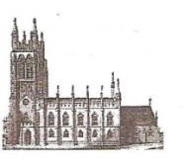
St Mary’s in the Marketplace.

No 7 (2nd September 2012)

A simple turn of the pulpit – and what a dramatic difference that will make to its future use - for services held both in the Nave and the Chancel (or a combination of both). We certainly had a very excited Rector when he walked up the steps for the first time after the move!

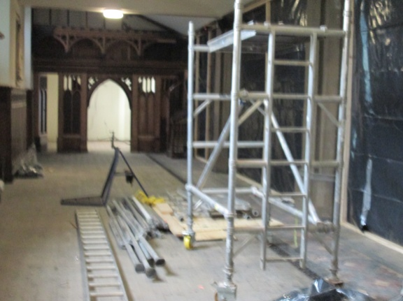
Meanwhile behind the sheeting work continues to prepare the area for the new kitchen and the partition from the old office has now been moved forward to create the new space intended for use by Stockport Heritage Trust and to accommodate the new shop area.
The preparation for the external
foundations have been completed
and the scaffolding continues to be
put in place.
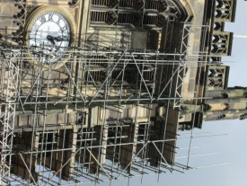
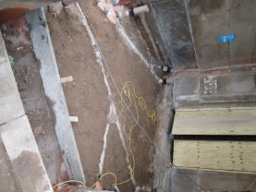

For the Project Team it has been the first site-meeting since works commenced and of course the expected “paper-chase” of contracts and other legal documents that need to be put in place with our architect and contractors.
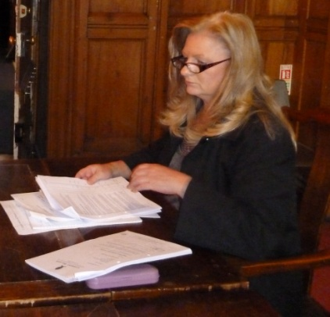
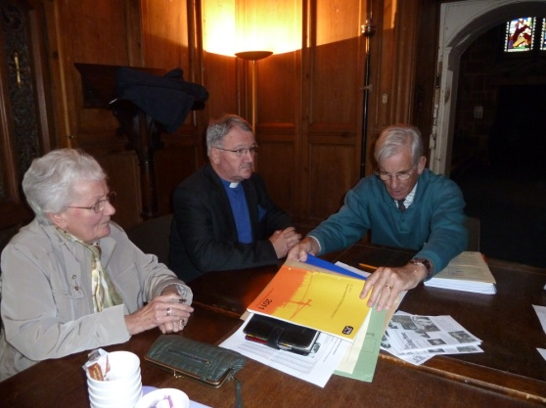

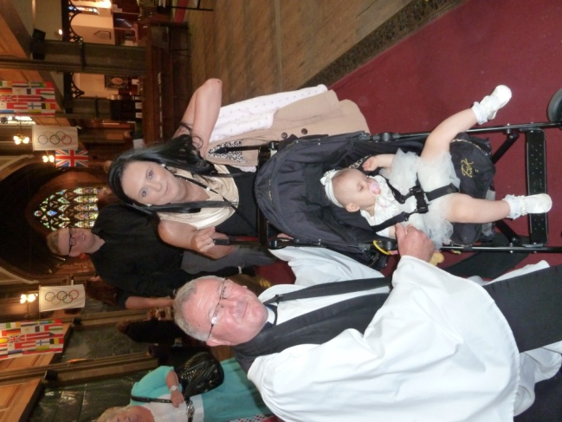
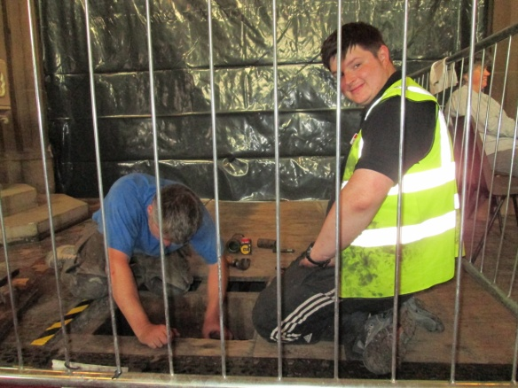
Work also continues within the
Church to prepare the pipework
for the new radiators and to
ensure we have adequate water
supply to the new kitchen and
toilets. Quite a lot of activity
under the floor!

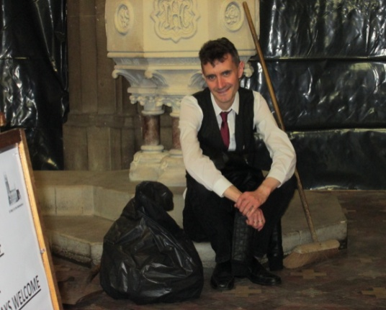
The effort it takes to keep St Mary’s neat and tidy is a little endless at the present time, but it’s alright really, as Allan shows us . .
whilst taking a quick . .
break sat on the steps. .
of the font, as wee .
prepare for the .
arrival of the bride and groom.

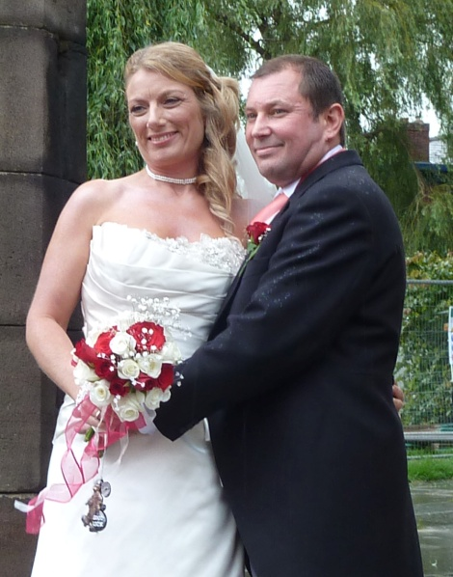
It’s been quite a busy time for us too…

Congratulations to Andrew & Dawn, married at St Mary’s on Saturday, 25th August 2012.

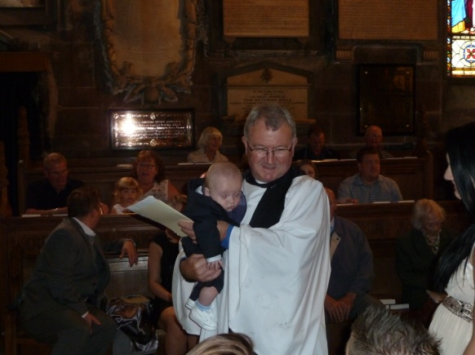

Sunday, 26th August was a special day
for sisters Gemma and Karlie as their
children Harley James and Leyla May
were baptised.

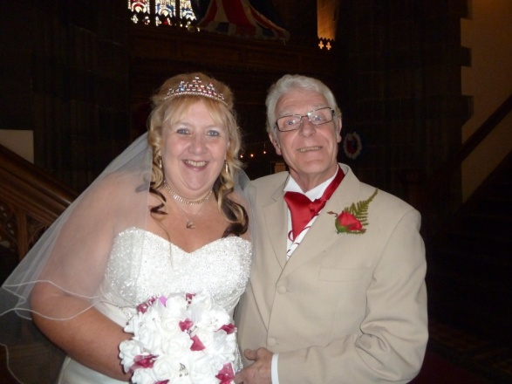
Congratulations also are given to Christopher and Lorraine as they attended St Mary’s on the 31st August for a Service of Prayer and Dedication after a Civil Marriage.

