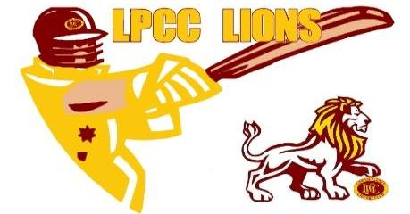
Lower Plenty Cricket Club Inc

Sponsorship Packages
Sponsors are crucial to community-based sporting clubs, and we are always looking for ways to improve our marketing and promotion of sponsors.
Commencing Season 2022/23, we have appointed a Social Media Manager who will be posting on our Instagram and Facebook pages most days.
We value our sponsors and will ensure you are welcomed, and your sponsorship is acknowledged to our members and community. Your sponsorship will help support community participation in sport at senior and junior levels.
Our club has a range of senior, veterans and junior teams so your support will be on display to a wide cross section of our members and community.
Our club was originally established in1934 and is well known and regarded in our local area. We are a family club that is open to all, and we are proud to be a Level 3 “Good Sports Club”.
If you wish to discuss a partnership with Lower Plenty Cricket Club, please contact us via our contacts below or feel free to contact LPCC President Len Dogger on 0420 225506.

Player Sponsorship $100.00
- Sponsors Name on the Players Photo exhibited on the wall looking from top deck down to lower room.
- Sponsors Name in social media when talking about the sponsored player.

Premium Player Sponsor $250.00
- Sponsors Name on the Players Photo exhibited on the wall looking from top deck down to lower room.
- Sponsors Name in social media when talking about the sponsored player.
- 2 x tickets to Sponsors Day
- Social Membership to the Club including hat and stubby holder
- Free welcome drink when attending on a match day

Bronze Sponsor $500.00
- 400mm x 300mm Corflute Sign on Sponsors Wall
- Sponsors name in social media through Season
- 4 x invites to Sponsors Day at Club
- Business name on front page of website
- Paragraph on website sponsors page
- Social Membership to the Club including hat
- Free welcome drink when attending on a match day

Silver Sponsor $1000.00
- 500mm x 500mm corflute sign on Sponsors Wall
- Sponsors name in Social Media weekly through season
- 2 x ticket to 3k Draw
- 4 x invites to Sponsors Day at Club
- Large logo on front page of website
- Fence banner
- Paragraph on website sponsors page
- Logo on Frogbox Stream on Saturday
- 2 x Social Membership to the Club including hat and stubby holder
- Free welcome drink when attending on a match day

Gold Sponsor $5000.00
- 500mm x 500mm corflute sign on Sponsors Wall
- Sponsors name in Social Media twice weekly through season
- 3 x tickets to 3k Draw
- 8 x invites to Sponsors Day at Club
- Large logo on front page of website
- Fence banner
- Paragraph on website sponsors page
- Paragraph on front page of website
- Option for naming rights on playing shirt, social shirt and hoodies
- Logo on Frogbox stream on Saturday
- 4 x Social Memberships to the Club including hat and stubby holder
- 1 x club social polo
- Free welcome drink when attending on a match day

Platinum Sponsor Negotiable
If you are interested in a higher level of sponsorship, we would be pleased to meet with you and tailor a package to suit your needs.

Club on Social Media
Website: www.lowerplentycricketclub.com
Facebook: https://www.facebook.com/LowerPlentyCricketClubPublicPage
Instagram: https://www.instagram.com/lowerplenty_cc/
Email: operations@lowerplentycricketclub.com
President: Len Dogger on 0420 225506.

