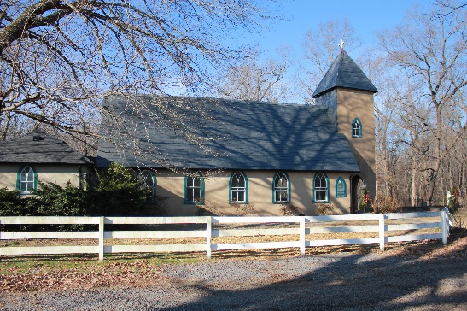

**Grace Episcopal Church**

**Grace Church Lane**

**Casanova, Virginia 22728**

**e-mail: gracechurchcasanova@gmail.com website: www.gracechurchcasanova.org**



**🙠** **Food for Thought 🙣**

*An excerpt from* ***Forward Day by Day***

**Psalm 12:8. *The wicked prowl on every side, and that which is worthless is highly prized by everyone.***

Many of us live surrounded by stuff. Our shelves are lined with trophies, photos, books, and treasures. They remind us of lessons, accomplishments, and relationships. We call them “keepsakes.”

My best friend has experienced burglary several times. He doesn’t call the experiences burglaries, though. He says he was “given gifts.” As more and more of his keepsakes disappeared, he felt more and more free. He experienced less fear. He travels lightly these days, lovingly detached.

I doubt he was burglarized in an attempt to harm him. I imagine the motivations were not centered around my friend at all. The burglars had their own reasons, their own backstory. They felt the prize worth the risk. I believe my friend walked away the winner, though, with an understanding of gifts that can’t be shelved or taken.





*Psalm 136:1*

**AN UPDATE FROM YOUR DISCERNMENT COMMITTEE**

As explained in our monthly update, we’d like to keep you informed as we continue to work toward the goal of finding a new “sheepdog.” The normative process for transition is:

1. Vestry converse with Diocese Transition Ministry Office
2. All say goodbye to departing priest
3. Vestry call an interim priest (see Senior Warden’s Report)

✓

1. Vestry call a Search Committee (referred to by the Diocese as a Discernment Committee (DC))
2. DC perform self-study of the seeking church with input from all
3. Publish a Vestry- and Bishop-approved Community Ministry Portfolio (overview of Grace church) *[published for 8 weeks]*
4. Improve church website, where needed, and keep updated for the benefit of potential candidates
5. DC receive names and select a finalist, based on Office of Transition Ministry vetting *[posting will remain open for 8 weeks]*
6. Vestry vote on finalist and, if affirmed, Vestry extends a call
7. Vestry and candidate negotiate terms and set out in a letter of agreement
8. Senior Warden and Bishop sign letter of agreement
9. Vestry and new priest conduct Mutual Ministry Review after first year of service



We are currently playing the waiting game. The Portfolios for our churches are in the process of being posted on the Diocese website for potential candidates to view and while we were told this would be accomplished within the seven-day period after our meeting with them, it still has not been posted. The posting will remain open for 8 weeks and after that point, open until filled. Thank you for your patience and prayers.

Sincere love and blessings,

Judy Ball, Pat Williams, **Kathlene Bilger,** Linda Winslow**, Tom Bilger,** & Mary Neal

Your Discernment Committee (DC) aka Search Committee

**SR WARDEN’S NOTES**

Well, we’re now into autumn and moving forward with worship on the grounds. The application checklist has been submitted to the diocese for review and hopefully, approval. If approved we will be worshipping in the Parish Hall to begin with as it’s a larger space and can accommodate distancing better, for a larger number of people, than the church building. Bishop Ted and I have positioned chairs and laid out the room to accommodate 30 people at one time. If we have more than that we will need to look into having more than one service and requiring a sign-up process.

With the possibility of moving inside, we also need readers, acolytes and altar guild volunteers. Due to some folks leaving since the first of the year, we’ve lost some from each. We will also be needing folks to volunteer to clean/disinfect after each service, ushers to direct folks to seats and exits and a health/safety officer to over-see the implementation of our safety protocols.

November is also our traditional time for pledges so, please think about your pledge for the upcoming year. A strong financial base is an important consideration to a prospective new priest.

Take care and be safe.

Peace

**Bryan**

**TREASURER’S REPORT – SEPTEMBER 2020**

Income for the month of September was $8,490.64 (budget $10,423.75). Expenditures totaled $4,889.44 (budget $10,193.42), resulting in income for the month of $3,601.20.

Interest earned on our Raise the Roof Fund during the month of September was $0.10. The balance in the roof fund account at the end of the month was $12,524.59.

The book value of our endowment fund as of July 31 was $57,511.98.

Please continue to pray for Grace Church that it will grow spiritually, financially and numerically. If you have any questions about this report or any financial matter, please contact me.

**Judy Ball**, Treasurer

**FEED MY SHEEP**

We continue to need the funds that our parishioners have been so generous to provide. This gives us the opportunity to provide our families with fresh products i.e.: meats, dairy products. Monies can be mailed directly to: Grace Church, PO Box 18, Casanova, VA 20139 OR put in an envelope and left in the collection plate on Sundays. Please make payable to Grace Church with a notation on checks “for FMS.” Thank you for your continued support.

Carol Grove 😇

**FUN FOR ALL!**

Check out the Grace website at www.gracechurchcasanova.org for some fun with Grace photos! How well do you know Grace Church? Check it out and keep your score.

|  |  |
| --- | --- |
| Paul Dawson | 5-Nov |
| Bryan Jacobs | 7-Nov |
| Sue Payne | 13-Nov |
| Maya Brumfield | 15-Nov |
| Jim Cirillo | 18-Nov |
| Rob Moline | 21-Nov |
| Janice Richards | 26-Nov |

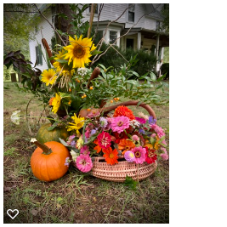

*Arrangement by Mignonne Spellmeyer*

**Birthdays**

|  |  |  |  |
| --- | --- | --- | --- |
| DATE  2020 | DAY | LESSONS | LAY READER |
| November 1st | All Saints Day | Revelation 7:9-17  Psalm 34:1-10, 22  1 John 3:1-3  Matthew 5:1-12 | Mary Neal |
| November  8th | 23 Pentecost | Joshua 24:1-3a, 14-25  Psalm 78:1-7  1 Thessalonians 4:13-18  Matthew 25:1-13 | Judy Ball |
| November  15th | 24 Pentecost | Judges 4:1-7  Psalm 123  1 Thessalonians 5:1-11  Matthew 25:14-30 | Dee Garrett |
| November  22nd | Last Pentecost | Ezekiel 34:11-16, 20-24  Psalm 100  Ephesians 1:15-23  Matthew 25:31-46 | Mary Neal |
| November  29th | 1 Advent | [Isaiah 64:1-9](http://www.lectionarypage.net/YearB_RCL/Advent/BAdv1_RCL.html#ot1)  [Psalm 80:1-7, 16-18](http://www.lectionarypage.net/YearB_RCL/Advent/BAdv1_RCL.html#ps1)  [1 Corinthians 1:3-9](http://www.lectionarypage.net/YearB_RCL/Advent/BAdv1_RCL.html#nt1)  [Mark 13:24-37](http://www.lectionarypage.net/YearB_RCL/Advent/BAdv1_RCL.html#gsp1) | Judy Ball |

**SCHEDULE OF READERS**

Note: Barbara Jacobs will be performing all altar duties for the month of November.

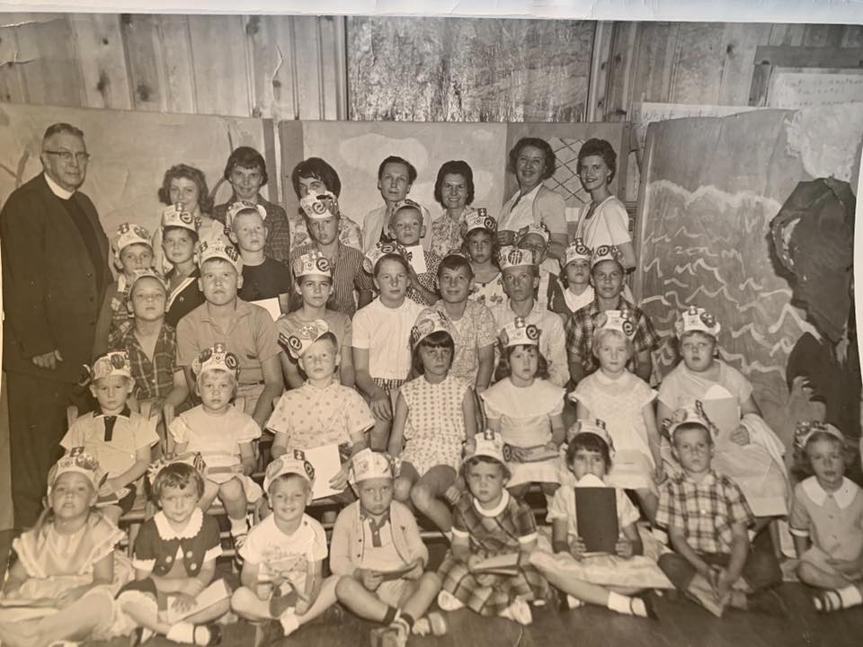

*Photo of Vacation Bible School with yoked churches, Grace and St. Stephens, circa 1961.*

**Do you recognize any of these folks?**



**AMAZON SMILE FOR GRACE CHURCH**

Don’t forget to sign up with Amazon Smile to have 0.5% of the purchase price of eligible items given to Grace Church at no cost to you! You can also go to the Grace Church website home page and click on the link there.

#### *******AmazonSmile Shopping App for Android Users Now Available******

You can now support Grace in the Amazon shopping app on your Android device! Simply follow these instructions to turn on AmazonSmile and start generating donations to Grace from your Android device.

* If you have the latest version of the Amazon Shopping App, open the App on your Android device.
* View Settings and select AmazonSmile.
* Follow the in-App instructions to complete the process.

AmazonSmile is not currently available for IOS users – we’ll let you know when it becomes available.