14 and Under Bracket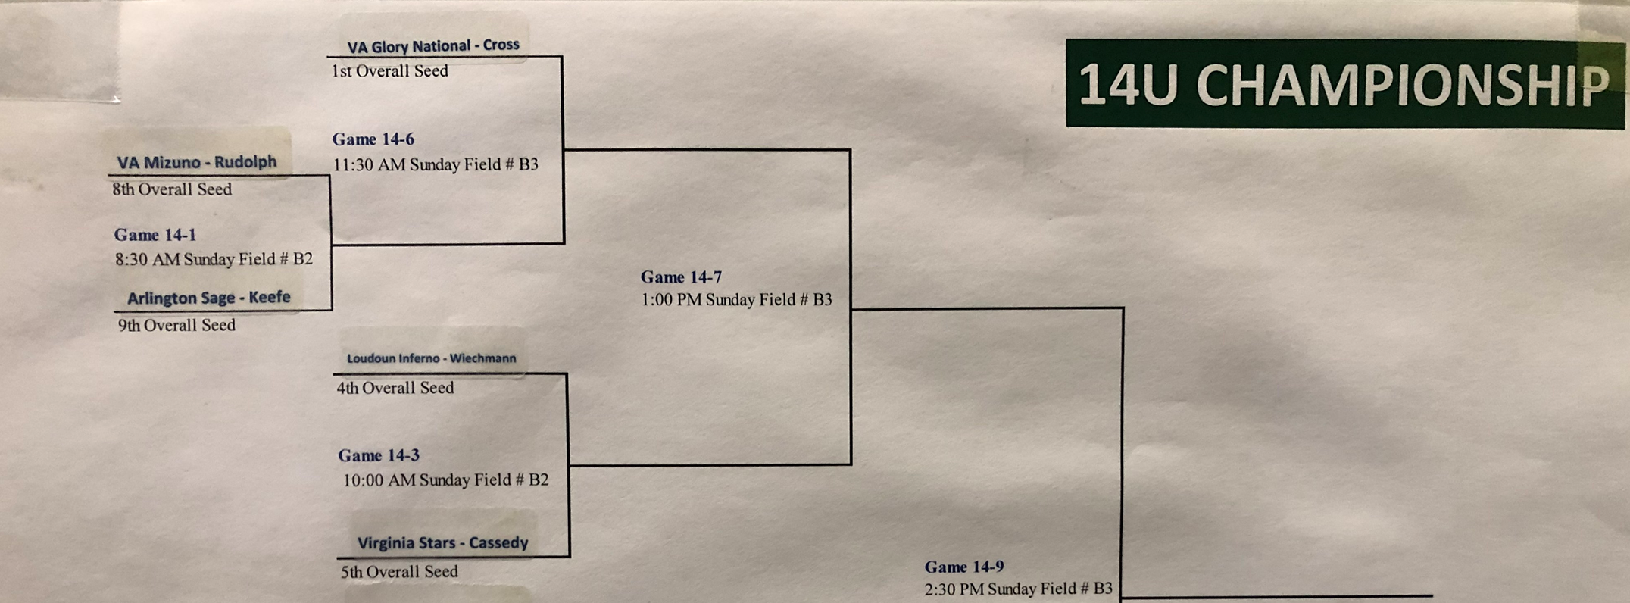
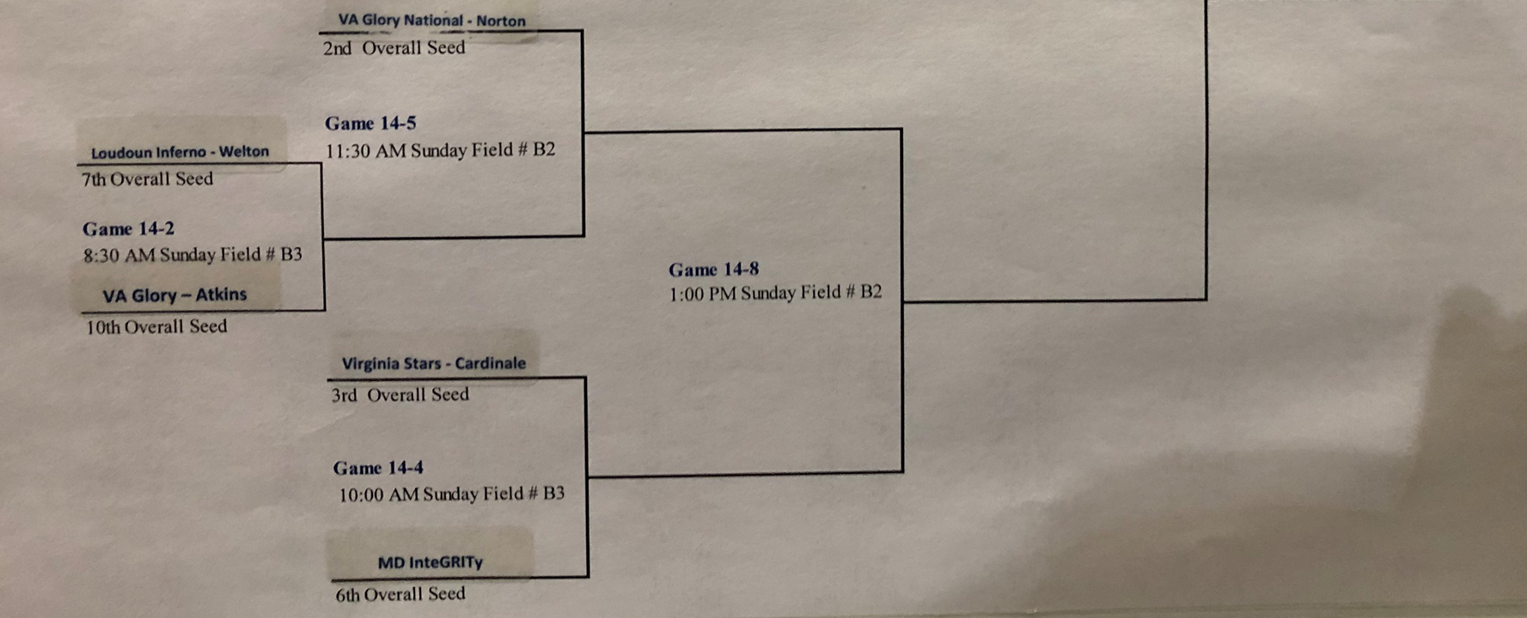

Seeds:
1 VA Glory National – Cross
2 VaGlory National- Norton
3 Virginia Stars – Cardinale
4 Loudoun Inferno Wiechmann
5 Virginia Stars Cassedy
6 MD InteGRITY
7 Loudoun Inferno - Welton
8 VA Mizuno – Rudolph
9 Arlington SAGE - Keefe
10 VA Glory - Atkins

