Peak Performers choose Shaklee Sports Nutrition Products
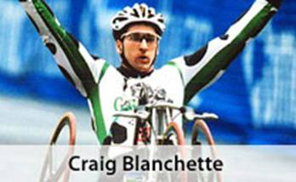
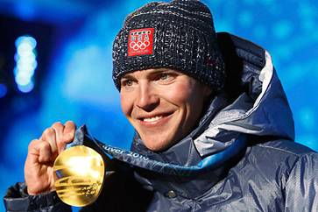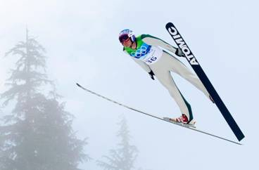
Craig Blanchette – 21 world records in elite wheelchair racing

“After taking Shaklee Physique, my recovery time went from 96 hours down to 12 hours ... after a full effort.”
Hear Craig on this clip: Click here

Bill Demong: “I use Shaklee products EXCLUSIVELY as part of my daily routine.”

29 year old, Bill Demong, lives to compete and win! He has earned two World Championship medals and 11 World Cup podiums in 2009 alone.

To achieve that, Bill, an outdoor enthusiast, spends hours on intense training. In the summer, he bikes for up to seven hours a day, relying heavily on Shaklee Performance® and other Shaklee products. “I like Shaklee Vitalizer™ because it’s in one easy packet. I also take Shaklee DR (Defend & Resist Complex) to help keep my immune system up.” He adds, “I trust Shaklee to help supplement my nutrition. It’s an integral part of how I not only maximize my training, but also how I recover.”
- Gold Medalist in the Vancouver Olympic Games (Individual): 2010
- Silver Medalist in the Vancouver Olympic Games (Team): 2010
- Competitor in the Torino Olympic Games: 2006; Salt Lake City Olympic Games: 2002; Nagano Olympic Games 1998
- First place in the World Cup (Val di Fiemme, Italy): 2010
- First place in the World Cup (Vikersund, Norway): 2009
- First place in the World Cup (Lahti, Finland): 2007, 2009
- First place in the World Cup (Klingenthal, Germany): 2009
- First place in the World Cup (Vancouver-Whistler Olympic Park, CA): 2009
- First place - World Ski Championship (Gundersen LH; Liberec, Czech ): 2009
- Third place - World Ski Championship (Gundersen NH; Liberec, Czech): 2009
- First place in the World Cup (Ramsau am Dachstein, Austria): 2008
- Second place in the World Cup (Val di Fiemme, Italy): 2008
- World Championship Team Member: 1999, 2001, 2005, 2007, 2009
- Second place in the World Cup (Oberhof, Germany): 2007
- First place - FIS Junior World Ski Championship (Saalfelden, Austria): 1999

Bill uses the following Shaklee Products:
- Shaklee Physique
- Shaklee Performance
- Energy Chews
- Shaklee Vitalizer

- Shaklee DR

Kent Bostick: 56-year-old Cyclist … “I believe in Shaklee … I use all the Shaklee Products I can get my hands on. I have been able to stay healthy and pursue my sporting career for a LONG TIME due to Shaklee Products.” Click here

Kent took up cycling in his mid 20s. More than 30 years later, he’s still pedaling strong. When asked, “What’s it like to beat someone who’s almost half your age?”, Kent responds … “It’s about staying healthy and having a good workout, and Shaklee products help me achieve both.”
- First place in the BMW Masters Omnium Individual Time Trial: 2009
- Second place in the BMW Masters Omnium Criterium:2009
- First place: Masters Tennessee State Individual Time Trial Championship: 2009
- First place in the USA Cycling Masters Road National Championship, Time Trial: 2008, 2009
- Recipient of the Best All-Around Rider Award, 55–59 age group: 2008, 2009
- First place in the USA Cycling Masters Road National Championship, Road Race: 2008
- First place in the USA Cycling Masters Track National Championship, Individual Pursuit and Madison: 2008
- Second place in the Tennessee State Individual Time Trial Championship: 2008
- Second place in the USA Cycling National Festival: 2006
- First place in the Masters World Individual Pursuit Championship: 2000, 2002
- Ninth place and personal-best in the Atlanta Olympic Games: 1996
- First place in the Pan-American Games, Individual Pursuit:1995
- First place in the Pan-American Games, Team Time Trial:1987

Shaklee … Providing Nutritional Expertise and Products to the U.S. Ski Team for 31 Years!

In 1980, Shaklee became the Nutritional Consultant to the U.S. Ski Team, and now provides the same for the U.S. Snowboarding Team as well. Troy Flanagan, who is the Director of Sports Science of the U.S. Ski & Snowboard Association, and oversees the science, preparations, and nutrition of both teams says …

“We trust Shaklee products because of their integrity and manufacturing process, and would recommend them for use by any other athlete.”

Eli Bremer: “My favourite product is Shaklee Performance … the fluid & electrolyte balance I need as a Pentathlete.”
Pentathletes demonstrate the ultimate test of the ultimate Olympian, by mastering 5 sports that are unrelated to one another (shooting, fencing, horseback riding, swimming and running). To keep in shape, Eli runs approximately 65 miles a week, and swims 25 miles per week.
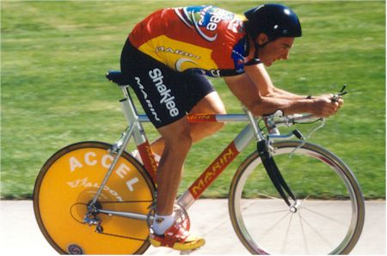

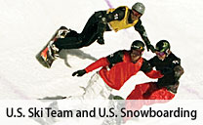

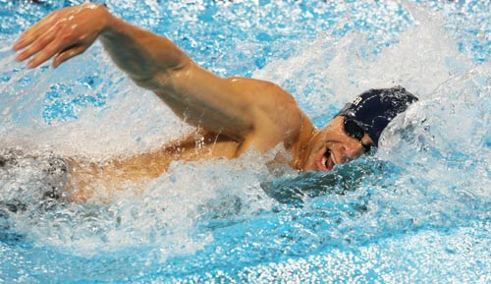

Annika Sorenstam, #1 Player in Women’s Golf: “My favourite product for RECOVERY is
Shaklee Physique.”

Annika set a world record in female golf, winning:
- 8 Player of the Year Awards
- 90 International Tournaments
- 72 Official LPGA Tournaments

“Shaklee Products give you the Winning Edge” ... Darin Shapiro, Water Skiier and Wakeboarder

Darin was inducted into the Water Ski Hall of Fame with the highest winnings in the history of the sport of wakeboarding, some of which include:
- 6 Pro Tour Championships
- 4 Masters Championships
- Multiple Gold & Silver Medals @ the X Games

Powered by Shaklee ...
the Most Trusted Name in Clinical Science!

- Shaklee products powered the FIRST MOUTAIN CLIMBER to reach the top of Mount Everest in 1980 – Sir Edmund Hilary

- Shaklee products powered the FRIST RECORDED EXPEDITION BY DOGSLED to the North Pole, led by Will Steger ... 1986

- Shaklee products powered the FIRST WOMAN TO RUN ACROSS CANADA ... Jo Wells, 44 year old woman from Burlington, ON (May to September, 1994)
