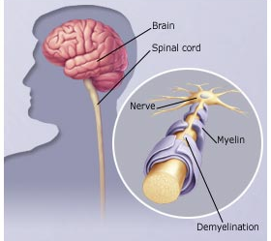
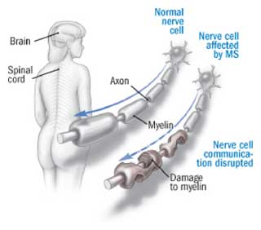
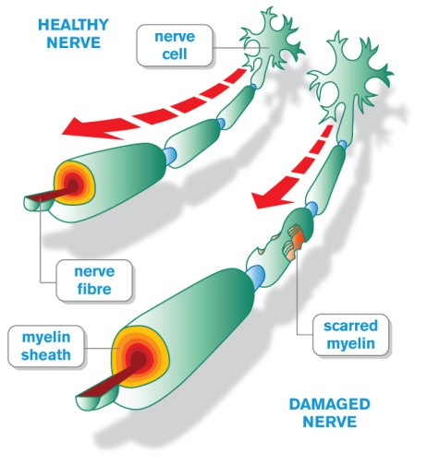

Multiple Sclerosis

What is Multiple Sclerosis?
- An auto-immune chronic degenerative disease
- A condition that degenerates the central nervous system, particularly the nerves that control motor skill function
- Affects the brain & spinal cord
- Called MULTIPLE because the damage of the nerve bundles are multiple (not just one)
- Called SCLEROSIS because sclerosis means scars, & scars are formed on the nerve bundles where damage occurs
- Caused by the degeneration of the “Schwann” cells that manufacture the myelin sheath that insulates the nerve axon

Symptoms of M.S.
- Sudden loss of motor function (examples: when navigating stairs)
- Extreme fatigue in mildly warm weather
- Sudden visual disturbances which may cause partial or total blindness in as little as two days or two weeks
- Pains and/or numbness in extremities (legs, feet, hands)

Multiple Sclerosis is TWO Diseases
- Rapid DEmyelination
- Slow REmyelination

Causes of Multiple Sclerosis
- Can be related to a dormant virus that activates the immune system. (Therefore, diet & lifestyle are a critical issue.) Can be triggered by an insult to the immune system.
- Immunizations can trigger it
- Toxicity (lack of detoxification) can trigger it
- Over-exposure to substances that cause allergic reactions can trigger it
- Inadequate nutrition can trigger it, because the immune system does not have the nutrients to cause it to behave properly
- Deficiency in essential fatty acids allows a breakdown in the myelin sheath
- Stimulants can trigger it (coffee, drugs, certain herbs)
- Pharmaceutical Hormone Replacement Therapy can trigger it
- Can be a genetic weakness, but balancing the immune system can keep it in check
- Continued study may reveal other factors

Areas to Address when dealing with M.S.
- It is very wise to get an Eliza Allergy Test done to determine if allergies are triggering a stimulatory response in the immune system ... (call Martha Willmore @ 905-871-4281 to order a kit)
- Avoid foods to which you are allergic
- Avoid environmental allergens to the best of your ability
- Use toxin-free cleaners and personal care products
- Deep breathing (for oxygen delivery to cells)
- Hormonal imbalances (have a saliva hormone test done ... this will show if DHEA or other hormones are deficient)
- Detoxify: Have a hair analysis done to check for heavy metal toxicity (lead, mercury, cadmium, etc.) ... cal 905-871-4281 to order your test kit
- Suggested Supplements: Acquire a Personal Health Assessment to determine individual needs ...
- NutriFeron ... to increase interferon levels
- Raw soy protein and/or Shaklee 180 Smoothees
- Vitalizer
- Vivix to repair cellular tissue and initiate detoxification
- Lecithin, GLA, OmegaGuard, Flax Oil Capsules to build new myelin
- Vitamin C in generous amounts
- B Complex
- Vitamin E + Selenium (therapeutic amounts to dissolve scar tissue)
- CarotoMax & FlavoMax to balance the immune system
- Super Calcium/Magnesium
- Garlic
- Food choices (see M.S. Diet below)
- Avoid foods containing animal fats
- Absolutely avoid: pork, butter, cream, milk, cheese, marbled meats, sausage, bacon, cooked vegetable oils, fried foods, margarine
- You should also avoid: coffee, black tea, alcohol, cigarettes, pastry, pies, cakes, desserts containing any butter or cooked oil
- You may have small quantities of low-fat yogurt, low fat cottage cheese, buttermilk, or avocados
- Fish & chicken are allowable. Be sure to remove the skin. Broiling, boiling, or roasting are the preferred way to cook fish or chicken. You can have boiled or poached eggs.
- You may have as much fresh fruit & fresh vegetables as you wish. Steamed vegetables & fruits are allowable too. Fruit & vegetable juices from a juicer are wonderful
- You may have whole grain breads & rolls & cereals, but no more than four servings per day of this combined group
- You will require 8-10 hours of sleep per night to allow cells around your nerves to slowly regenerate. Two hours of sleep should be before midnight.

Other Suggested Tips:
- Daily exercise is of utmost importance. Find the type of exercise that suits you. Swimming, walking, passive range-of-motion exercises to your limbs are good for most people. If you are able, jogging, tennis, racquetball or volleyball are helpful. (You should NOT push yourself to exercise when you feel exhausted. Rather, exercise during the times of the day when you feel better. Exercise helps to keep muscles in good tone.)
- During times of exhaustion, a cool shower often gives a boost of fresh energy. This results in the stimulation of the adrenal glands.
- Home enemas help expel wastes & toxic materials & increases bowel muscle tone.
- A seven day liver & gall bladder cleanse aids in removing toxic wastes from the body. This usually helps decrease some of the symptoms of the M.S.

