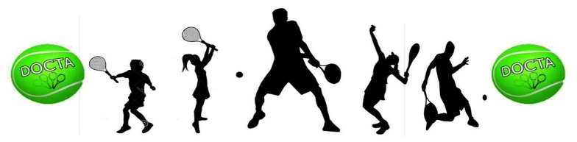
DURHAM-ORANGE COMMUNITY TENNIS ASSOCIATION (DOCTA)
USTA-JUNIOR TEAM TENNIS SPRING LEAGUE 2019
ENO AREA
CAPTAIN’S INCENTIVE

For 2019, the Durham-Orange Community Tennis Association (DOCTA) manages the USTA Junior Team Tennis League for the Eno Area. LeeAnn Rose is the DOCTA-JTT League Coordinator. Her contact information is leerus@icloud.com for questions.

Our Junior Team Tennis goals for 2019 is to:
- encourage active and fun play in tennis for youth ages 8-18
- increase youth league participation and USTA membership in the Eno Area
- increase parent engagement and volunteer participation
- increase youth league captain participation and
- provide a monetary incentive for captains of youth league teams to encourage ongoing volunteer participation with youth league programming.

Incentives
Each captain of a DOCTA-JTT Team in 2019 will receive an opportunity for several incentives totaling up to $250 for the Spring League and paid by May 18. A captain must complete the season without defaults to receive this award.

- Captain’s Incentive – One-time $100.00 monetary incentive in appreciation for
participation as a 2019 Spring League Captain.
- Team Incentive: Captains of more than 1 team, will receive an extra $10 for each team. Incentive is limited to maximum 5 total teams ($50).
- Player Incentive: Captains of teams with 5 or more new first-time USTA youth memberships will receive $20 for each team. Incentive is limited to maximum 5 total teams ($100).
- Maximum incentive is $250.

An example of this award – 1 captain with 3 teams and 2 teams have 5 or more new first-time players. Incentive amount is $100 for being a DOCTA-JTT Captain, $30 ($10 for each team that you are serving as captain); and $40 ($20 each for 2 teams with 5 or more new players). Total Captain Incentive: $170 to be awarded by May 18, 2019.

Each captain must submit the attached verification form to the JTT league Coordinator to document number of teams and new first-time players by April 22, 2019 to receive your Spring DOCTA JTT Incentive for 2019. The JTT Coordinator will send out reminders of this incentive.

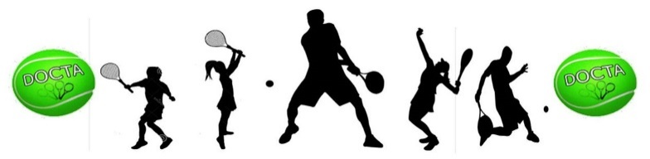

DURHAM-ORANGE COMMUNITY TENNIS ASSOCIATION
JUNIOR TEAM TENNIS SPRING LEAGUE 2019 – ENO AREA

JTT CAPTAIN’S INCENTIVE VERIFICATION FORM

Captain’s Name_________________________________________________________________

Address_______________________________________________________________________

City_____________________________________________State_________Zip______________

Cell Phone________________________Email_________________________________________

Number of League Teams Captaining for Spring 2019: _____________

Name of League Team | Age Group  8U-18U | # of First-Time New USTA Players
1)
2)
3)
4)
5)
6)
7)
8)

Captain’s Signature_________________________________________Date_________________

------------------------------------------------------------------------------------------------------------------------------
For Official DOCTA Use Only

Incentive Breakdown:

Captain Incentive | Team Incentive | Player Incentive | Total Incentive

Approved ______________________Checked #______________ Date Mailed______________

