TRINITY UNITED METHODIST CHURCH
Pastor Doug Benton ___ Minister
September 26, 2021 Greeter: John Pollard Color: Green
EIGHTEENTH SUNDAY AFTER PENTECOST
"We welcome you to our service this morning and pray that your time with us will be a blessing to you"
THE ORDER FOR WORSHIP
Prelude Eddie Welborn
Let us silently prepare our hearts and minds for worship.
Welcome and Announcements Grady Senn
Chiming of the Hour Eddie Welborn
Candle Lighting and Processional
Call to Worship Grady Senn
Opening Prayer Grady Senn
Children’s Time Grady Senn
Hymn of Adoration: “Jesus Loves Me” Page 191
*Apostles Creed Page 881
*Gloria Patri: “Glory Be to the Father”
Praises, Concerns and Prayers Grady Senn
Pastoral Prayer/Lord’s Prayer Grady Senn
Tithes and Offering Ushers / Grady Senn
*Doxology: “Praise God From Whom All Blessings Flow”
*Hymn of Preparation: “Make Me a Captive, Lord” Page 421
First Reading: Psalm 126 Crystal Waldrop
Sermon Scripture: John 16:16-24 Grady Senn
Sermon: From Sorrow to Joy Grady Senn
*Hymn of Service: “Are Ye Able” Page 530
*Returning of the Light

*The Benediction Grady Senn

*Three-Fold Amen and Going Forth: Eddie Welborn
*Stand if able. God’s altar is open to you following the sermon.
Technician: Foster Senn

The Altar Flowers are to the Glory of God.

Next Sunday – October 3

Altar Flowers: Open ; Greeter: Linda Lominack;
Scripture Reader: Frieda Kesler; Technician: Josh Pitts

Our Faithfulness

Worship Attendance for September 19, 2021 40
Total Budget for 2021: $ 149,647.00
Weekly Offering Needed: $ 2,877.83
Offering Received September 19, 2021: $ 5,216.00
2021 Average Weekly Offering YTD: $ 2,207.00

The Concerns of Trinity

Our Known Hospitalized:
Recent Hospitalizations and/or Surgeries: Jeannette Poag
Nursing Home: Gloria Brehmer (Springfield Place), James Poag (White Oak)
Continued Prayers: Shirley Berry, Robert Pollard
Family and Friends of Trinity: Blake Hendrix, Wilson Bowles, Neil Thomas, Francis Leopard, Kinsley Bouknight, Candice Nelson, Janna Longshore, Susan Ward Smith

Please pray for safe travels for Pastor Doug and Carrie during the next few weeks as they enjoy their honeymoon.
Pastor Doug will return to the pulpit on October 17.

Upcoming Events at Trinity

Sept. 26: MYF Spaghetti Fundraiser – takeout plates available afterchurch
Oct. 3 – Trinity Hymn Sing during the 11:00 a.m. service
Oct. 4: Women’s Club – 6:00 p.m.
Oct. 6: Men’s Club – 7:30 p.m.
Oct. 10 – Laity Sunday
Oct. 11: Admin. Council at 6:30 p.m.
Nov. 7: Charge Conference at New Chapel at 5:00 p.m.

WELCOME!
Thank you for coming today! We are delighted you are here! We hope you will join us again as we continue to discover the difference God’s love makes in our lives. If you have questions or desire to become a member of Trinity UMC, please speak to pastor. We are blessed because you’re here.

Trinity United Methodist Church Please visit our website for bulletins & newsletters:
1160 Trinity Church Road www.trinityumcnewberry.net
Newberry, SC 29108 Facebook: trinityumcnewberry
doug benton, Pastor
803-276-1245 (Church Office)
803-768-7687 (Church’s cellphone)
803-543-0082 (Pastor’s Cell)
dobenton@umcsc.net

Thank You for all the cards, calls and memorials sent
with love and concern. Trinity is a wonderful family that has helped us at this dark time.
Ronny Davenport Family

Trinity
United
Methodist
Church

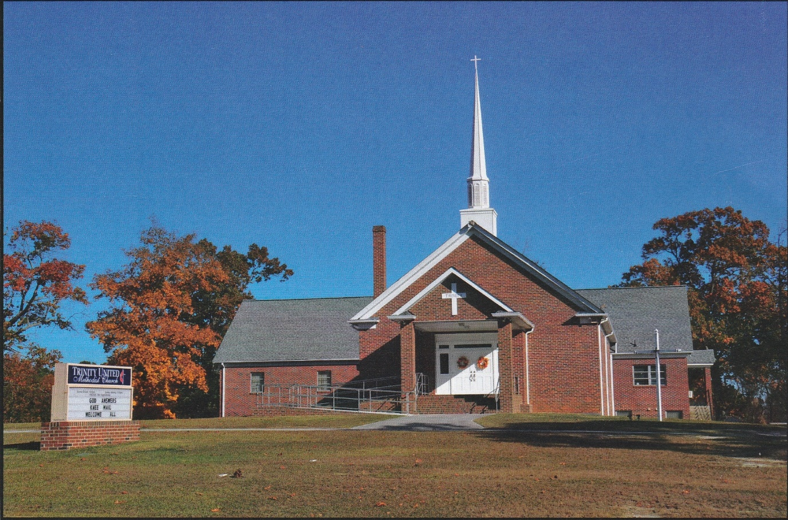

1160 Trinity Church Road
Newberry, SC 29108
trinityumcnewberry@gmail.com

