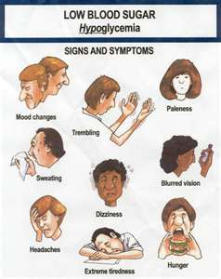
Hypoglycemia

Hypoglycemia means low blood sugar. When you eat, carbohydrates turn into glucose which are released into the blood and the blood sugar goes up. The pancreas responds by making insulin which escorts the glucose into the cells for energy and the blood sugar goes down. It drops to slightly below normal and the adrenal glands are supposed to make a hormone that throws it back up to normal … at this point your body will tell you that you are hungry. With hypoglycemia, The adrenal glands are not producing adequate hormones to stop the blood sugar from dropping too low. Therefore, hypoglycemia always requires a focus on strengthening the adrenal glands.

Symptoms when the blood sugar is dropping too low include:
… fatigue, dizziness, lightheadedness, headache, irritability, fainting spells, depression, anxiety, cravings for sweets, confusion, night sweats, weakness in the legs, swollen feet, a feeling of tightness in chest, constant hunger, pain in various parts of the body, nervous habits, mental disturbances, insomnia, etc.

Suggestions for helping the adrenals:
- Stress management & adequate rest … Shaklee’s Stress Management is helpful for stress management

- Nutritional support:
  - Optimal protein (Shaklee 180 Smoothees, which contain leucine, are wonderful to help repair & restore the adrenal glands)

  - Optimize the following nutrients
    - B Complex
    - Vitamin C
    - Zinc
Some people have benefited from taking 1 B Complex and 1 Vitamin C every hour from waking until 6 p.m. in the evening for a 4 to 6 week period. This therapeutic approach significantly supports the adrenal glands (actually all glands of the body).

  - Have small meals frequently (include protein with each … this can be nuts, yogurt, tuna, cheese, etc., and of course, Shaklee Protein)

