THIEN PHUOC CHARITY
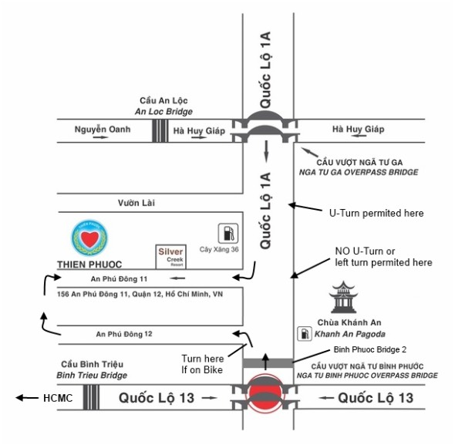
- Address:
156 An Phu Dong 11 Street, An Phu Dong Ward District 12, HCM City
Sister Kim Chi
Telephone: (+84 8) 3719 7343
Mobile: (+84 ) 907 254 0822.
- Introduction:
Thien Phuoc is a non-government organization, acting under the Catholic Committee of Ho Chi Minh City. It was established in 2001 to care for disabled children and disabled orphans. This residential center provides healthcare, rehabilitation, and education for children with Epilepsy, Cerebral Palsy, and Down Syndrome. The center also creates a loving home that gives hope to orphans with special needs.
- Activities at Thien Phuoc charity
- Provide daily physiotherapy sessions to improve the children’s muscular functions and flexibility.
- Teach children how to care for themselves and others.
- Provide a range of activities to educate and entertain children, including play sessions, singing, and dancing.
- Organize day-trips to give the children access to a wide range of interesting and stimulating activities.
- Provide training for staff by inviting training experts.
- Have many visits from local International Schools and Church groups.
- Welcome volunteers and visitors to come and meet children and learn about living with a disability.

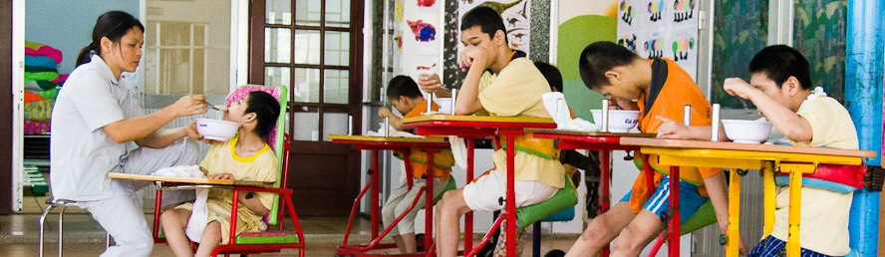

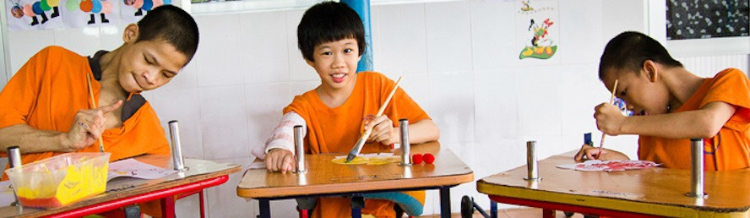

CENTER FOR SPONSORING - VOCATIONAL TRAINING AND JOB CREATION FOR PEOPLE WITH DISABILITIES
OF HO CHI MINH CITY

1/ Contact information: The center is under the Ho Chi Minh City Department of Labour, War Invalids and Social Affairs.
The Center's headquarter is located at 215 Vo Thi Sau, Ward 7, District 3, Ho Chi Minh City.
2/ Formation process:
- On August 7, 1998, the Ho Chi Minh City Center for Sponsoring - Vocational Training and Employment Introduction for disabled people was established under the decision No. 4060/QD-UB-VX of the Ho Chi Minh City People's Committee which belonged to the Ho Chi Minh City Department of Labour, War Invalids and Social Affairs
- On August 23, 2019, the Center for Sponsoring - Vocational Training and Employment Introduction of Ho Chi Minh City was established under the Ho Chi Minh City Department of Labour, War Invalids, and Social Affairs. The establishment was based on the reorganization of the City Restaurant Professional School and the Center for Sponsoring - Vocational Training and Employment Introduction for disabled people.
3/ Functions and duties:
The center organizes vocational training and career counseling for students with disabilities and street children in the city.
Organize production labor associated with vocational training to create jobs for people with disabilities. Coordinate with departments, districts, businesses, production facilities, and employment service centers in the city to introduce and create jobs for people with disabilities.
Support groups and production facilities for people with disabilities in applying for the establishment, creating financial sources, making sources of processed goods, and finding places to sell products according to Vietnamese regulations.
Provide accommodation and food support for disabled people with difficult family circumstances (certified and recommended by local authorities) during their apprenticeship at the Center.
Organize the literacy program, primary school supplement program, secondary school supplement program, and high school supplement program for people with disabilities in the city. These programs are based on the program promulgated by the Ministry of Education and Training and the professional guidance of the Department of Education and Training.
4/ Some jobs are taught:
- Consumer electronics
- Civil electricity – Industrial electricity,
- Tailors
- Cosmetic makeup
- Cut - perm female hair
- Facial skin care
- Manicure technique
