Geographic Tongue
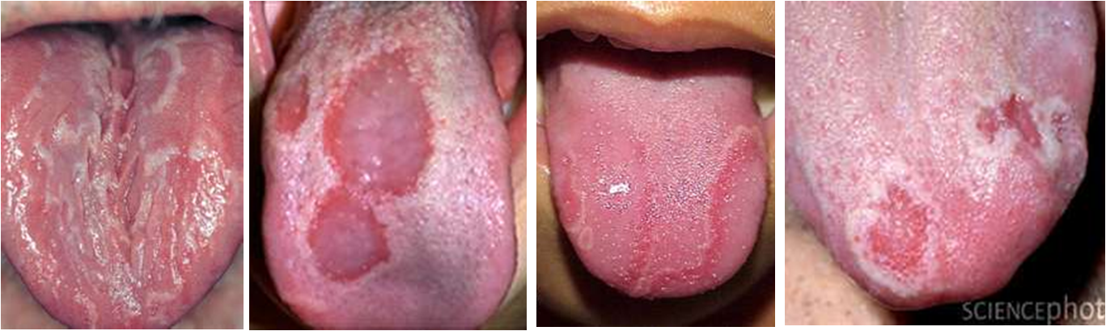

- Also called benign migratory glossitis
- A burning sensation can be experienced on the tongue
- Tongue tissue may be sensitive to hot or spicy food, and alcohol
- Irregular denuded patches appear on the tongue’s surface which give a map-like or mountain ridge appearance (therefore, the name geographic tongue)
- The pattern results from the loss of papillae (tiny, finger-like projections) on the surface of the tongue. This gives the tongue flat spots which are referred to as “denuded areas”.

Causes:
- Allergies may be a factor
- Systemic candida
- Low-grade viral condition
- Deficiency of nutrients, Vitamin C, iron, and B Complex being the most common
- Low levels of DHEA hormone, or other hormonal imbalances
- Inadequate essential fatty acids, especially Omega 3
- Accumulation of internal toxins which weaken the immune system

Treatment:
- Eat an excellent diet, including lots of raw vegetables & fruit
- Get rid of all toxins in your environment (cleaners / personal care products)
- Supplement with Shaklee Vitalizer …
- Optimize Vitamin D3
- Supplement with higher amounts of Vitamin C and B Complex. If anemic, supplement with Iron + C
- Provide essential fatty acids daily by eating raw nuts and seeds and/or supplementing with OmegaGuard
- Supplement with Garlic daily as an anti-fungal/anti-bacterial protector
- Investigate possible allergy factor by having an Elisa Allergy Test (you can order your kit from Second Chance (905-871-4281 … ask for Martha Willmore)
- If you have systemic candida, it is imperative to do follow a “yeast buster program”
- Investigate your hormone levels (saliva testing recommended). For a saliva test kit, call Second Chance @ 905-871-4281 and ask for Martha Willmore.
- Get serious about detoxification …
Alfalfa purifies the blood (it is a good daily choice)
DTX encourages liver cleansing (another good choice)

