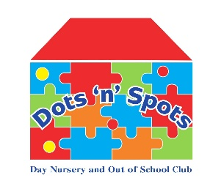

DOTS N SPOTS SELF EVALUATION FORM
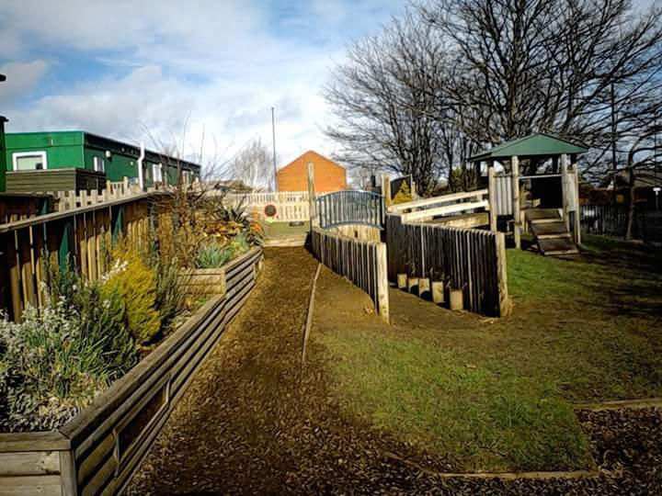Our Setting
Dots n Spots Day Nursery and Out of School Club was opened and initially funded by lottery funding in 2003. We are a registered charity and not for profit organisation, with all fees and funding going back into the nursery to provide high quality care and education, and flexible childcare for the local areas. A voluntary Board of Directors are responsible for the overall management of the setting; However, the day-to-day responsibility of the nursery is the nursery manager, and team. Dots n Spots is self-contained within Skelton Primary School’s site. We have excellent links with the school. Dots n Spots is made up of 4 pre-Fab buildings, The main building with reception office’s, kitchen, staff room, utility room Baby room and Tweenie room which provides a staff/child ratio of 1-3. The dining room, where Pre School children eat their meals. The 2–4-year building with our Toddler room with 1 staff – 4 children ratio and Pre School rooms 1 staff to 8 children ratio, and the Out of School Club is 1 staff to 8 children as good practice. Our Play School room provides one to one support from an assigned key worker.
We are quite high to capacity in some of our play rooms depending on the day, or session as this frequently changes especially as we provide flexible sessions that may change weekly.
We currently have 79 children registered in our nursery, and 64 registered in our Out of School Club.
Dots n Spots also have an extensive outdoor space with age-appropriate areas for children to access throughout the day. We have recently applied to the Tees Valley Community Foundation for a grant towards our outdoor improvement project. From a recent parent/carer questionnaire, an improvement to our outdoor space was suggested. We are also in the process of making plans to improve the cosmetic appearance of the buildings, rendering and replacing the wooden panels around the buildings.
Dots n Spots has a SEND provision called the Play School room, which provides specialist care and support for children with additional needs. The team work closely with other lead professionals within the local authority SEN team to work on specific strategies and targets with the children. As an inclusive setting we also support children within the other rooms of the nursery who require one to one care.
Dots n Spots provide flexible 2-, 3- and 4-year-old funded places for the local area and beyond.
Our Out of School Club runs a breakfast session, and an after-school session during term time. We also provide a holiday club to our families who require out of school term care. These offer exiting activities and trips to local attractions.

Quality of Education
At Dots n Spots we assess the learning and environment by how the children engage, access the resources and areas. The children are calm and enjoy their time here. The staff are happy, smiley and well engaged with the children.
We use themes and topics to plan activities and make changes to the environment, this is alongside the children’s interests, and is very much open to change in the light of where the children take the activity or a topic. Children are encouraged to take activities and to play further, steps are taken to ensure the children are prepared for their next stage, this may be a transition to another room, a next step towards learning a new skill or going over to school.

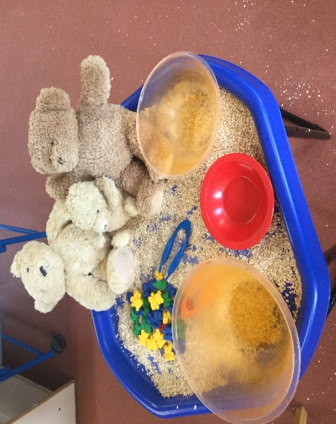
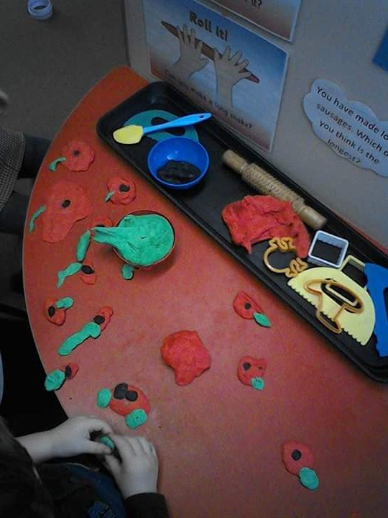
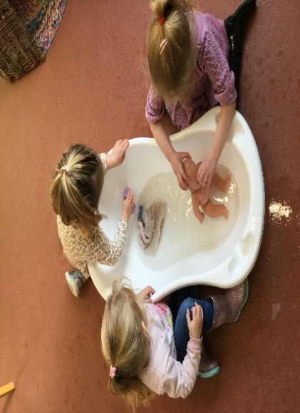
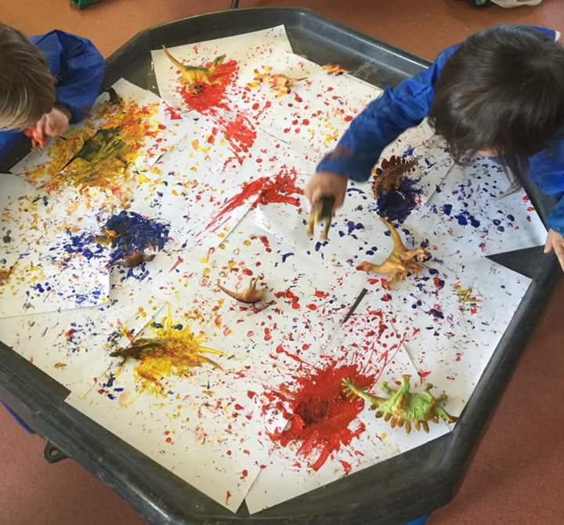
At Dots n Spots we clearly plan for what we intend the children to learn, and set out a curriculum that can be adapted to meet the needs and abilities of all the children, giving them skills and knowledge, they need to succeed in life.
To implement the learning, practitioners understand and have a good knowledge of the Early Years Foundation Stage, and developmental stages across all ages. The practitioners also recognise that all children learn in different ways and at different paces.
Staff support and guide less experienced staff within the rooms.
Practitioners are able to adapt language and communicate well to check a child’s level of understanding, giving explanations and answering questions they may have. Discussions are encouraged within the groups, and children are given time to think, and to respond. Practitioners speak clearly and will use reduced language, when necessary, this is to enable the children to hear and to extend and develop their language and vocabulary.
We assess the impact of the learning, and the environment the children explore. Our aim is for children to develop skills and knowledge across the 7 areas of learning so they can settle, feel safe and secure and are ready to extend their learning when transitions take place.
When given the skills to listen and communicate the children are able to listen attentively to stories, songs and discussions. Some of the children need more support and encouragement, this can be done by sitting them close to you during circle times, using their names and adapting your language to maintain their attention. We also change our tone of voice and use visual prompts.
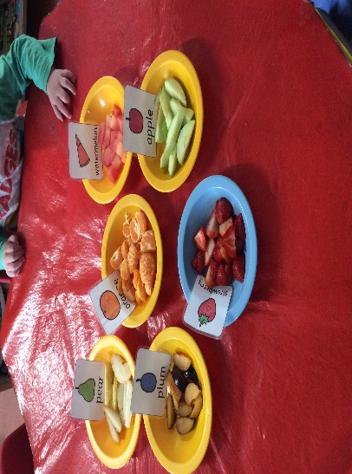
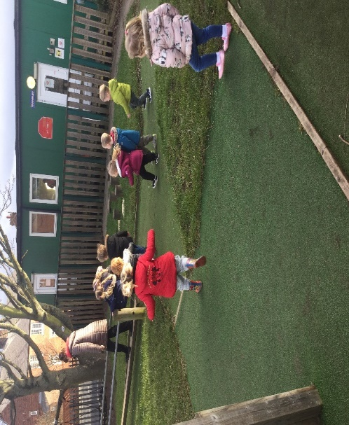
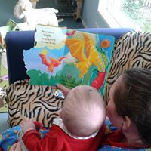
Physical development is also encouraged and focussed on to promote physical and mental health, this also supports co-ordination and develops motor skills.

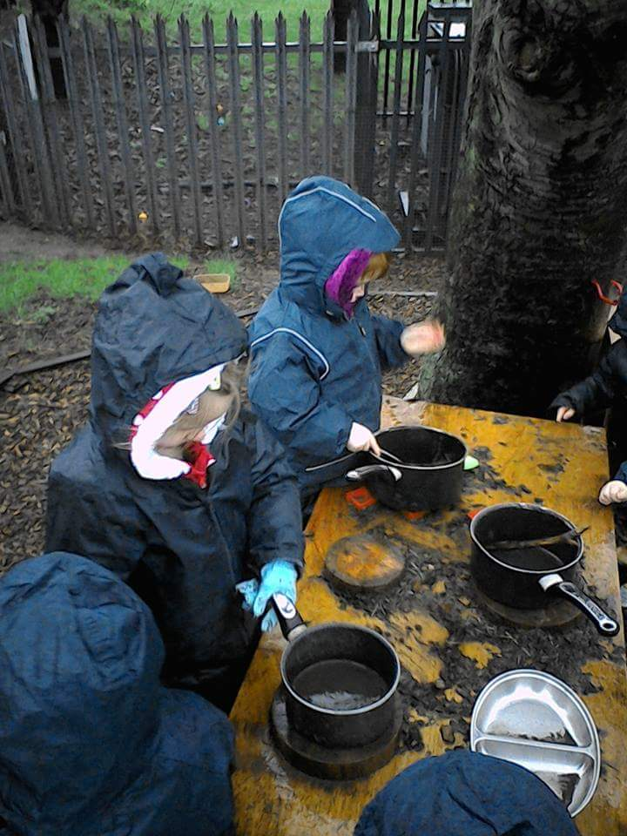

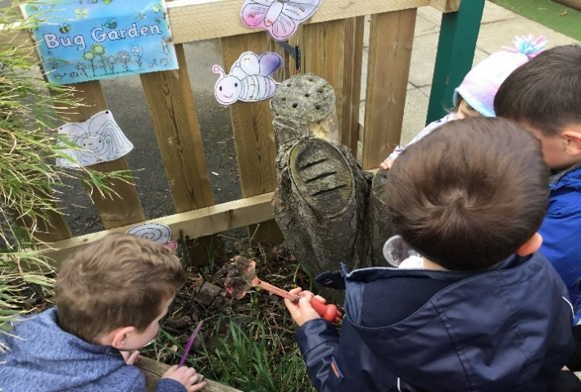

In our Out of School Club the older children are included in evaluating the environment and activities they would like to be involved in, what they like about coming to Dots, or if there are any aspects they would like to see more of.
Staff and parents/carers are given regular questionnaires to find out their views and opinions, our partnership with parents/carers is extremely important to us. The questionnaires are used to give not only positive feedback to the staff, but to reflect on current practice to make us even better. This also helps us to identify what is important for them, and how to keep them informed and involved.
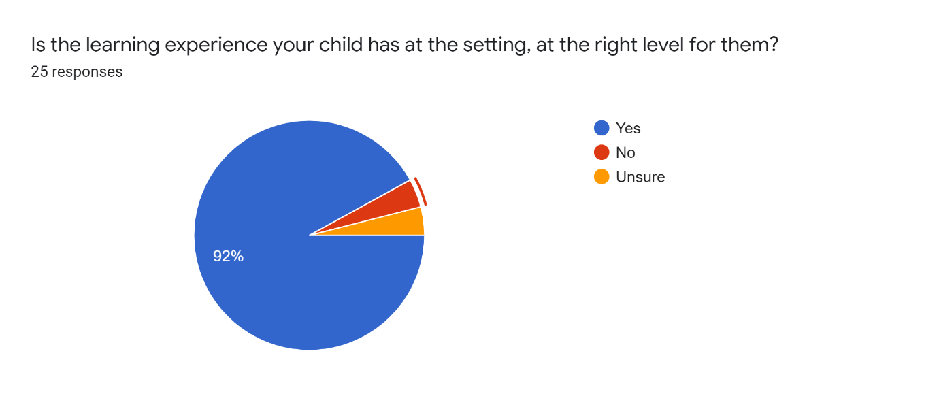

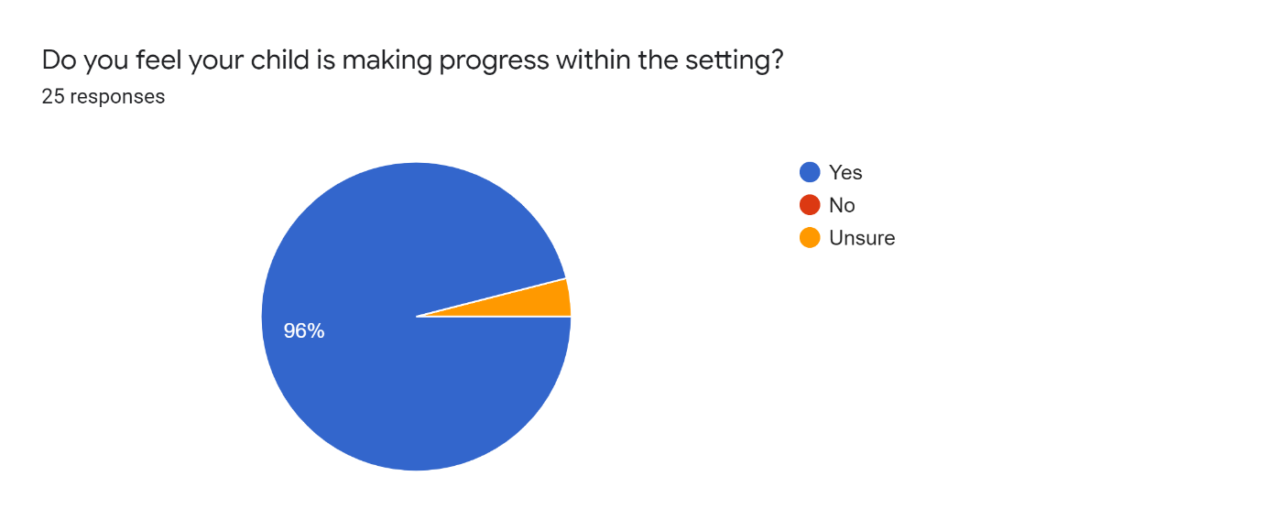

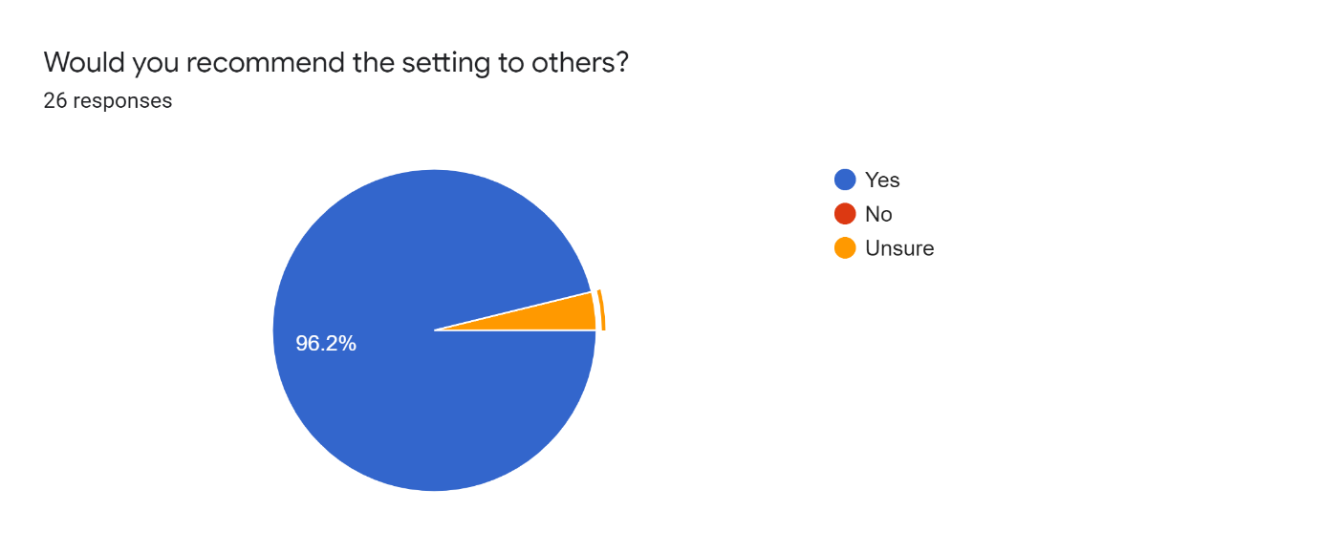

Dots n Spots has an excellent website with details of our opening times, prices, rooms, the environment, funding, staffing structure, meals and much more. We also have a busy bee’s section with activities and resources for parents/carers to access and use. This was particularly put in place during the pandemic to support families who were isolating, or not attending the setting at the time. We also have a selection of busy bee activity packs with resources for parents/carers to take home and use to support learning. Parents/carers are encouraged to provide feedback forms when bringing the resource packs back to us, and can access our interactive ParentZone app to keep those important forms of communication open. Families can also access resources on our ParentZone app such as EYFS activities, mental health, nutrition and sleep advice. This is provided and maintained by our software provider Connect Childcare.
Dots n Spots send out a “Playground Press” newsletter each month with details of what each room has been working on, achievements, notices, and any other information we need to share with our parents/carers.
We use Connect Childcare software to send notifications to parents/carers throughout the day, this also enables them to write a comment in response. We communicate most information through the software, parents/carers can also download the “ParentZone” app which enables them to access invoices, letters, and attendance. We send observations throughout the week which will identify what we are working towards with the children, this identifies next steps as well as ‘magic moments’ they have with us.
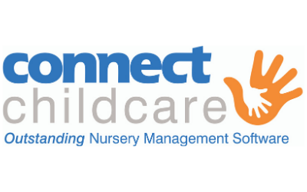
Summative assessments are completed within 6 weeks of the child starting, or moving rooms to identify a starting point. Progress is shared with parents/carers and strategies for supporting development at home are suggested. We also encourage parents/carers to phone during the day if they are concerned about their child.
Parents/carers complete an “All about me” form on registration, and when moving rooms so we have information regarding their development, specific interests, likes/dislikes, family members etc. Our Baby room has an extensive routine form that the parents/carers complete throughout their time in that room, as the babies’ routines change more regularly. Advice and support are offered to parents/carers to establish a compatible routine with home and nursery.
In Pre School we ask the children to draw a picture of themselves to show progress when they leave to go to full time school. Key workers are assigned to each child before starting; however, this may change if a child forms a close relationship with another member of staff. This is to build strong key relationships with our children and their family as we recognise the importance of forming strong attachments in early years.
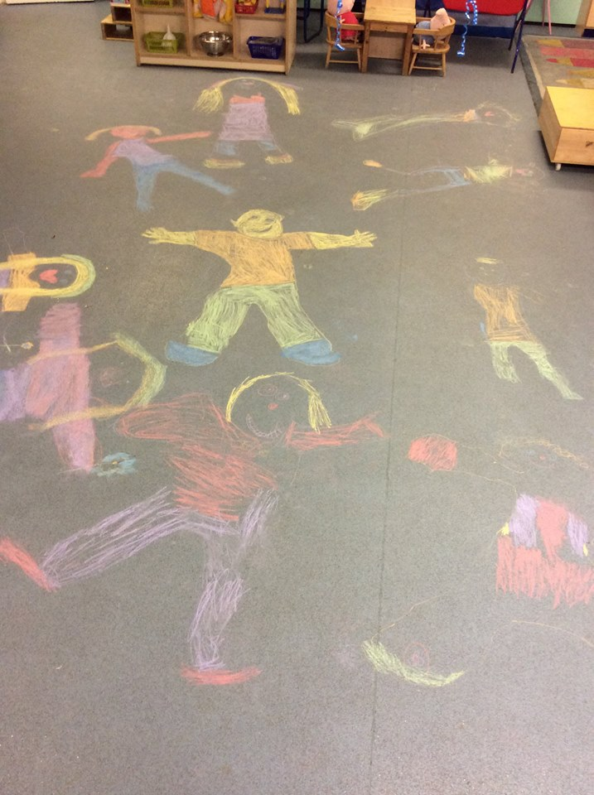

Dots n Spots receives excellent feedback from other professionals within the local authority, we have a good reputation within the extended community and receive a large number of enquiries from recommendations from other families who have attended the setting.
Dots n Spots recognises that establishing strong learning in the 3 key areas of learning, communication and language, Personal Social and Emotional, and physical are key to then progress on to learning more in specific areas such as, mathematics, expressive art and design, the world around us and literacy. Under 3’s concentrate on the 3 main areas of learning, but over 3’s covers all areas within planning.
At Dots n Spots we provide activities and learning that offer experiences to all children so that they all have the same learning opportunities, no matter what their family circumstances are, and the best possible start to their early education. Teaching them about different cultures, religions, and the natural world around us. We teach the children the importance of mutual respect, manners, being kind to each other, establishing firm boundaries so they know what is expected of them, and being considerate of others. Children are encouraged and supported to be independent and take managed risks, and to take pride in their achievements given praise and rewards. We believe these skills are important and can then be transferred throughout their school life. Negative behaviours are dealt with sensitively, collectively, and consistently by all staff, plans are used if needed to assess and put firm strategies in place. During circle time, and throughout the day the children are encouraged to talk about their feelings and thoughts, and let them know who they can talk to.
We have well defined areas within the rooms with accessible resources for the children to explore and use. We have quiet areas to provide an area to rest and relax, recently updating the quiet areas within the Toddler room and Pre School room as we identified that the children were not accessing the area as much as they used to.

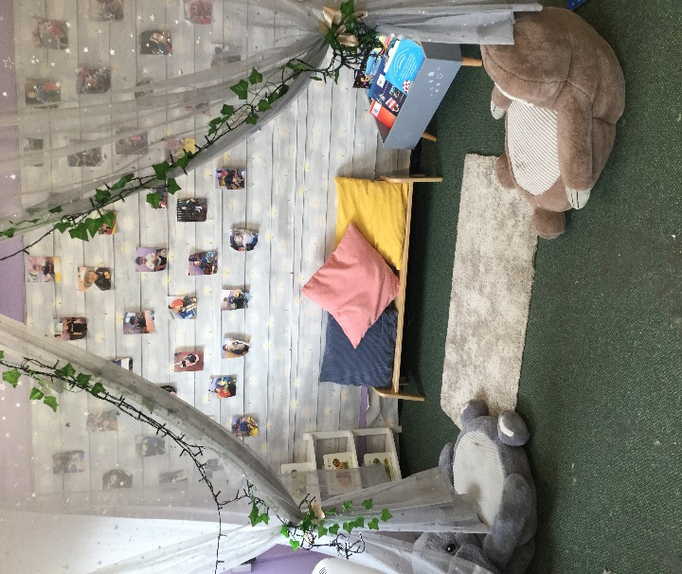
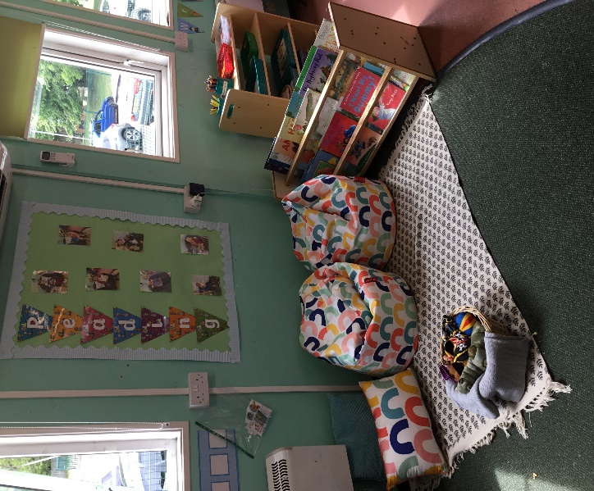

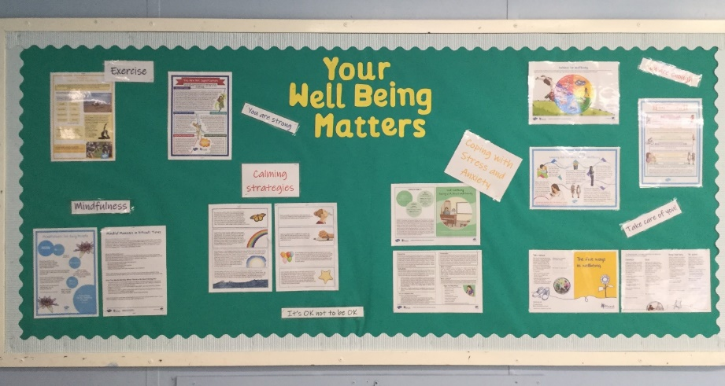
We have also recently started to adapt a space within the nursery as a well-being room for the children and staff to access a quiet space to promote emotional well-being, mindfulness and support. We would like to have the room ready to use in July 2021. The deprivation funding that we have been awarded this year has helped to fund the resources and cost of the room. We recognise that good mental health and well being is such an important part of promoting a healthy, happy workplace.

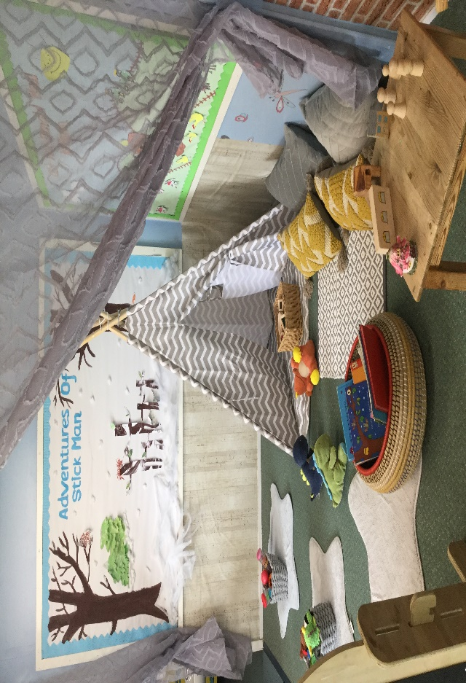

We would like all of our children and staff to be able to access this facility throughout their time at Dots n Spots. The staff are able to take in different resources, activities, music, and even take part in calming exercises such as yoga!
Dots n Spots have a mixture of natural materials and resources to extend imaginative play, but also recognise that the children enjoy familiar toys and resources from home.
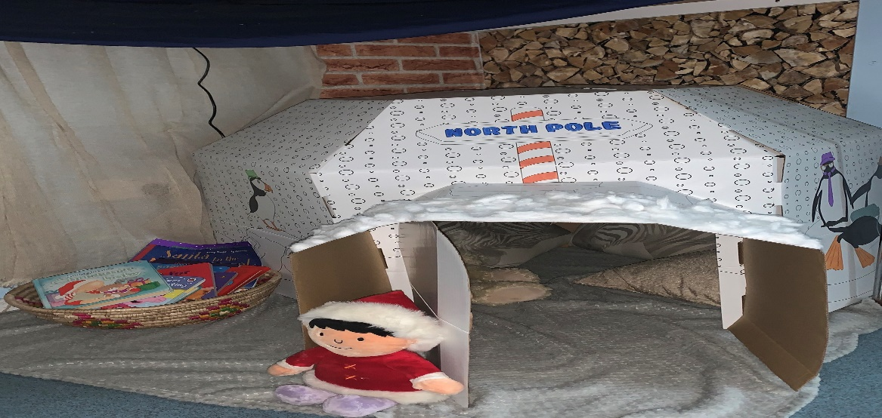
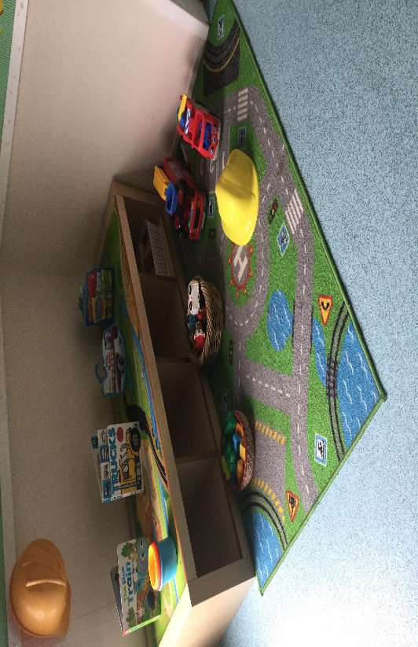
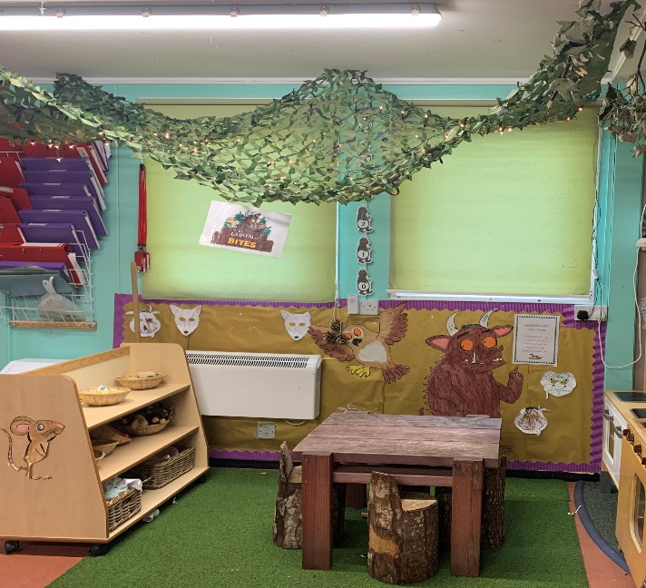
A strong key worker system is in place to encourage confidence, and inner strength to form secure attachments. We also recognise the importance of building a strong relationship with the other practitioners within the room to provide consistency when staff are absent through holidays, or sickness.

With consent we share information with local schools and settings to support transitions, we have also worked closely with the local SEND team to contribute to a generic transition document that can be used by all providers that offers information, and details regarding to the child’s specific needs and development.

Behaviours and attitudes
Emotional well-being is very much focused on within the setting, including the staff. We also recognise that being outdoors has a huge positive impact on mental health, and wellbeing.
We love to be outdoors in all weather and have a wide range of diverse resources and equipment that support learning and gives lots of opportunity to explore their natural environment.
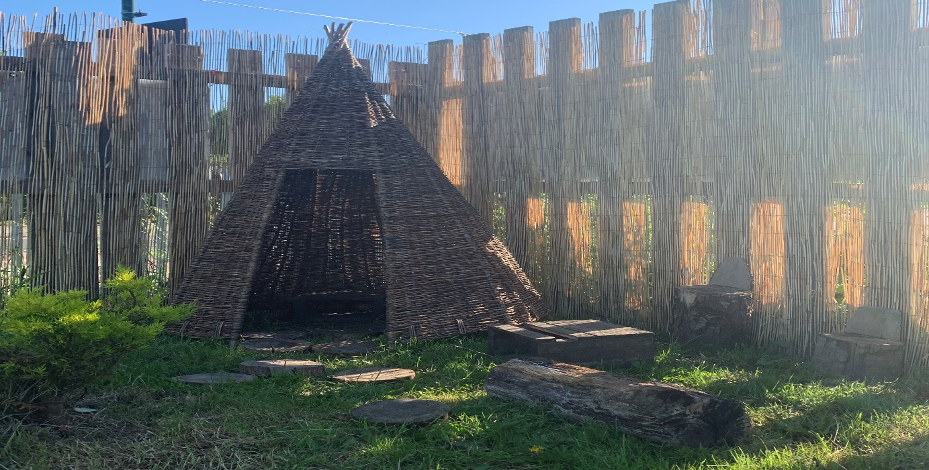
The practitioners are aware of how the children learn, and observe how the children learn in their environment showing curiosity, engaging in open ended activities, showing a particular interest, role playing, and acting out experiences from home, seeking challenges, having a positive attitude, taking managed risks, maintaining focus, having lots of energy, keeping on trying, enjoying achieving, being proud and motivated, having ideas, and finding out new ways to do things, making links and noticing patterns, testing ideas and thoughts, grouping and sequencing, also being able to plan and choosing how to approach a task or an activity. This also develops positive relationships in which children can feel supported, encouraged and guided by the adults.
Practitioners enable environments by providing stimulating resources that are open ended and easy to access. This gives choices, comfort and limits noise providing quiet spaces for children to rest and relax. This also ensures the children have uninterrupted time to play, explore, notice and expand on interests.
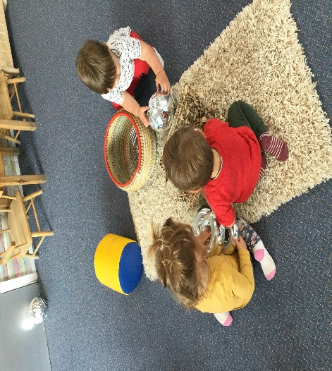
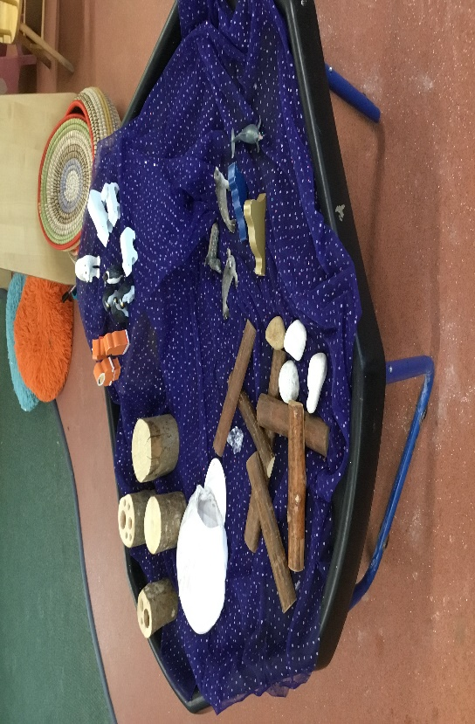
Structure is provided to our nursery day by following routines which can be flexible and support “in the moment” learning.
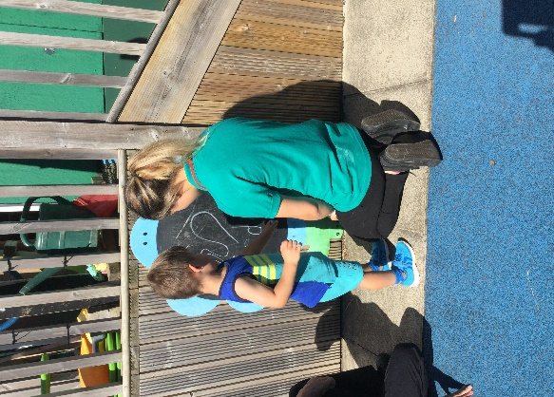
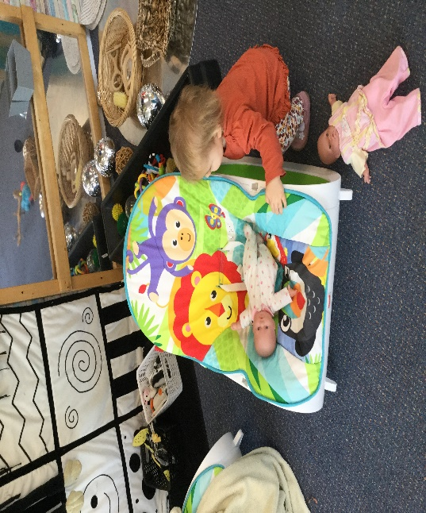
Time outdoors hugely benefits children by offering unique opportunities, exploring the fantastic world around them.
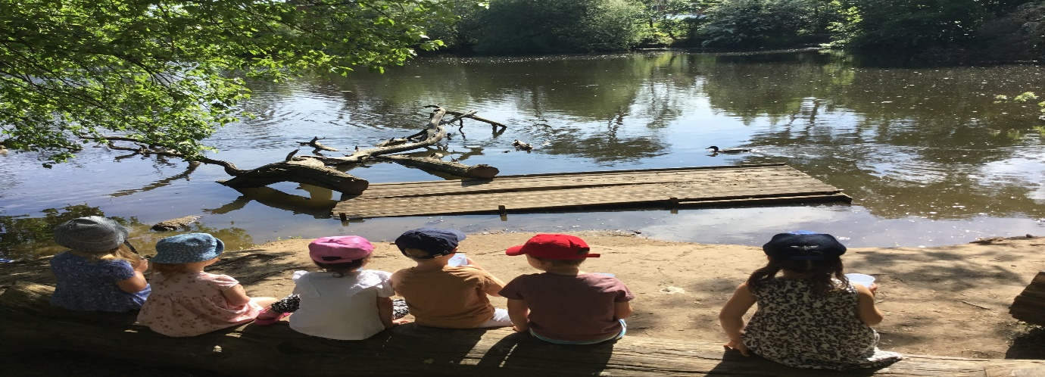
The children are made aware of why we have rules and boundaries in place, and how their behaviour can affect others around them. We discuss this in an age-appropriate way that the children understand and can transfer to their home environment. The children build strong friendships, they are encouraged to share and respect each other, motivate each other to join in and interact in a positive way, demonstrating kind, friendly behaviour. The more confident children will encourage others to engage in their play.
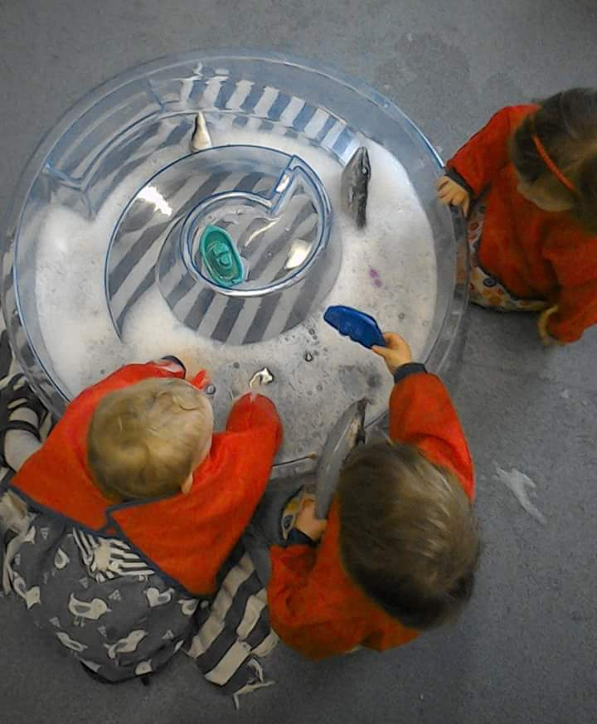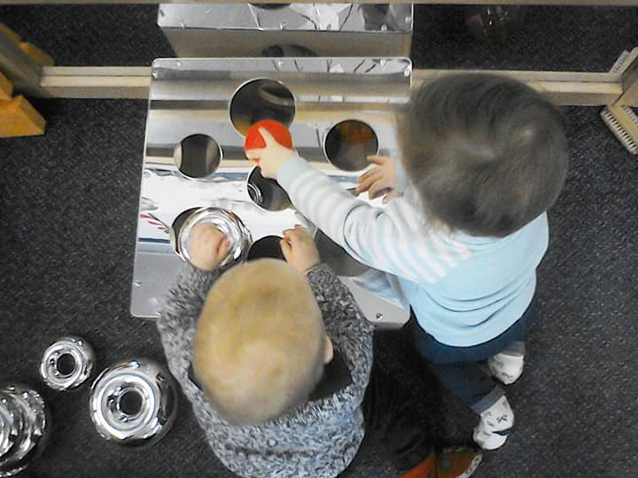
Dots n Spots has high expectations of the children, this is consistently supported throughout the nursery with specific strategies put in place which are supported by the nursery SENCO. This reduces negative behaviours and enables the children to feel safe and secure.

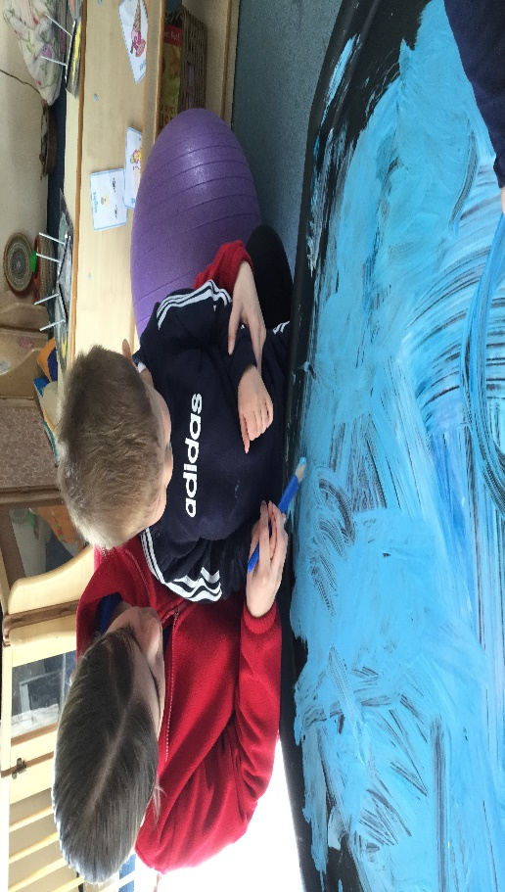

Personal Development
At Dots n Spots we have a holistic approach to children’s learning and development. The children are treated as individuals, recognising that each child learns and develops in different ways, and at different paces. The learning is very much child lead, using their interests and abilities to plan and support progress. We focus on what the children can do and build on that.
We provide experiences that promote each child’s achievements, by displaying their art work, encourage reward charts, and award star of the week. Praise is constantly given throughout the day. We also celebrate their differences from others and the wider community, and world around them. They also recognise that we are all unique as individuals.

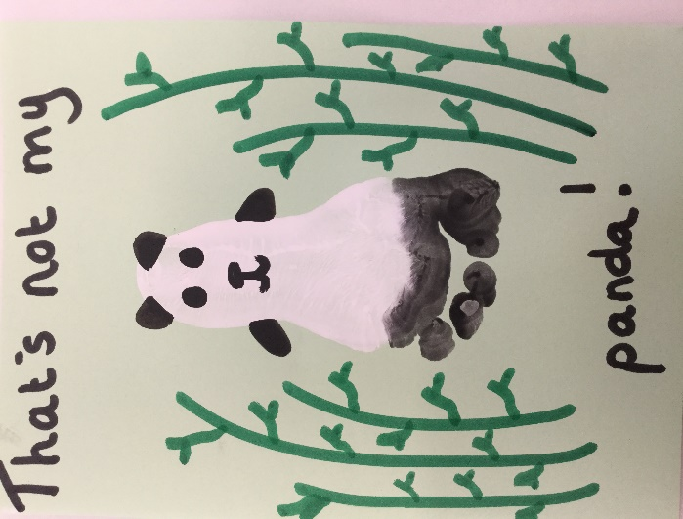
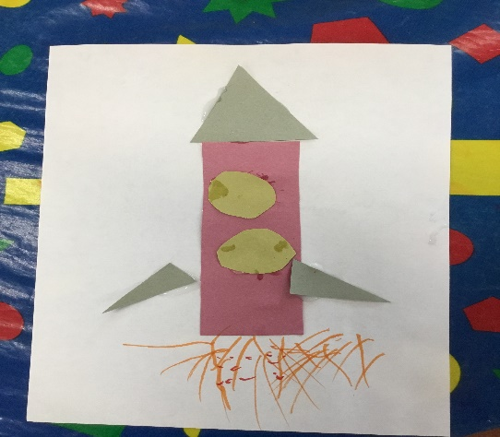
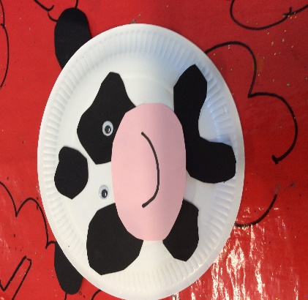
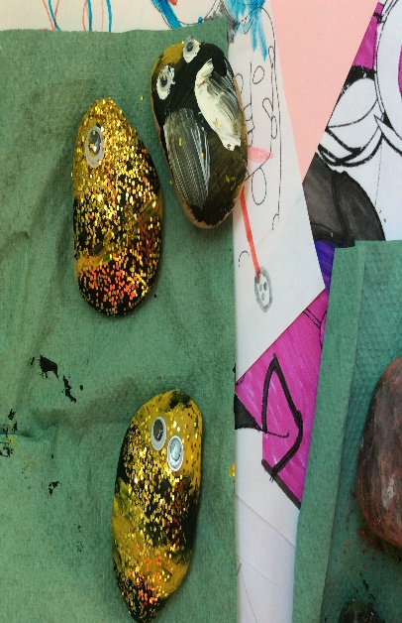
The children are encouraged to talk openly about how they feel, and encouraged to show their emotions at nursery and at home. We talk about what makes us feel happy, sad, angry, exited and how our behaviour can contribute to other people’s feelings and emotions.
All resources are carefully chosen to ensure it can be accessed by all children promoting equality and diversity.
Children are supported and encouraged to gain confidence, and approach tasks independently, but are also taught to take appropriate risks and challenge themselves, especially outdoors.
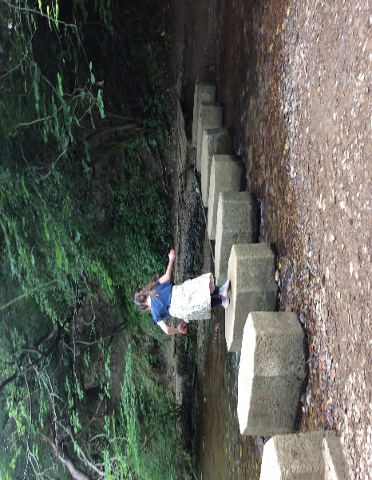
We provide activities to teach the children the importance of a healthy diet, healthy/unhealthy food choices, being active and moving in different ways, but also the importance of rest to recharge our batteries.
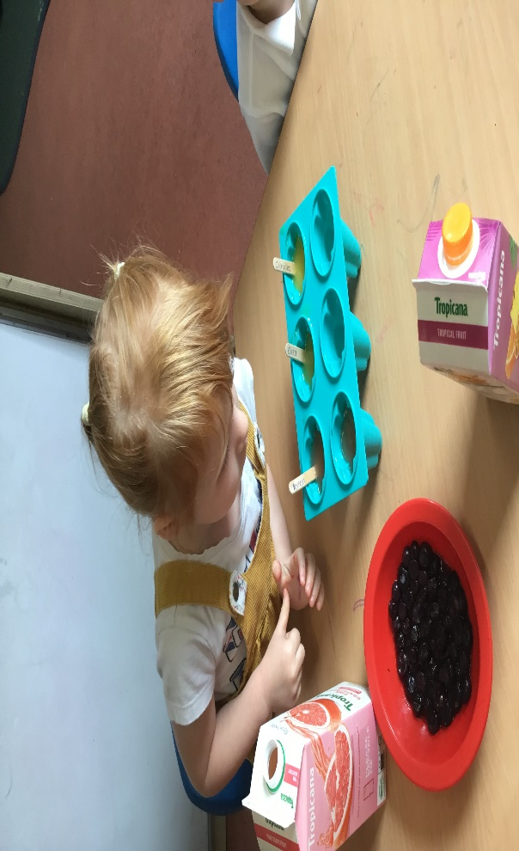
Dots n Spots has a nursery chef on site who provides nutritious meals, ensuring fruit and vegetables are offered to the children as part of a balanced meal.
Staff are trained regularly in dental hygiene, and follow a tooth brushing scheme within the nursery to encourage children to brush, and get extra fluoride on their teeth. The children have their own tooth brush and learn to recognise its specific picture which is assigned to them each term. The scheme is done in a fun way with a “tooth brushing song” that the children clearly recognise as tooth brushing time.
We encourage age-appropriate independence when managing their own personnel hygiene needs, and work that into our routines, toileting and hand washing etc.
The children are also encouraged to recognise their own risks in regards to technology, and keeping safe online. All online learning is assessed by the practitioners before use, songs, clips and games and software to check it is appropriate, and supports learning. These are used alongside other learning resources not to replace it.

Leadership and Management
Dots n Spots Day nursery has an effective, strong management team consisting of a Business Development Manager, Co Deputy Manager/SENCo/Deputy Safeguarding Lead, Co Deputy Manager/Baby Room Leader/Health and Safety Officer/Staff Relations Lead, and Office Manager. This structure works well with each leader having key responsibilities and roles. The Business Development Manager is the Safeguarding Lead and oversees the day to day running of the nursery as a charity and business.
Each room has a room leader that manages the day to running of the room and the staff.
Regular staff/team meetings are held to go over any training, and discuss any information that needs to be shared as a group. The staff are involved in decision making, their views and opinions are valued and always appreciated. Memos and notices are sent or displayed to give information. We try to provide opportunities for staff development whether that be online training or local authority funded training. At Dots we grow leaders, and develop staff expertise. We like to have a good mix of personalities within the room.
The leadership team have attended EYFS training to be able to cascade this to other practitioners to enforce the new reforms to the framework in September 2021. The management team are present within the rooms to offer support and guidance, observe to reflect and evaluate positive practice within the setting.
Dots n Spots SENCO is also undertaking the “Communication Friendly” communication counts, language and literacy 2-4 years training which is delivered by the local authority. This will enable us to work closely with the children to bridge communication delays. After each training session is completed by the designated person, it is then delivered throughout the setting to other practitioners who provide feedback about our environment, curriculum and strategies we use to enhance learning, and improve our practice. This has been a hugely reflective task and has given us the opportunity to evaluate the way we communicate and interact with the children.
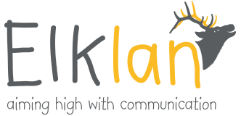
Leaders are very much present and work within the rooms in the nursery to be able to see practice, and engage with the staff and the children. It is important to us that the staff feel supported, valued and appreciated. Any performance concerns are then dealt with effectively with any extra support is identified and given, this is also effective to manage workload.
At Dots n Spots we recognise how important it is to support staff with wellbeing and good mental health, and take steps to promote a positive working atmosphere throughout the nursery. We have an open-door policy; this encourages staff to talk about their mental health and are signposted to other people that may help too. Staff are given clear job descriptions with their roles and responsibilities. Appraisals are given by the line manager in their birthday month, and supervisions are completed by the manager 6 months after to address any issues and chat about any training they would like to do, or anything else in an informal way. The appraisal forms and how we deliver these has been adapted recently to make them more about staff’s achievement’s, what they would like to do in the future, and how we can support them to do this. The appraisal form has outcomes relating to the job description, that was graded on performance in each area. We found this to be a negative experience for the staff and wasn’t consistent throughout the nursery. We recognise that any performance concerns need to be addressed quickly.
Staff are encouraged to be supportive and work as a team with colleagues, and address any issues sensitively and appropriately to reduce negativity.
As manager I have recently sent out a questionnaire to the staff to see what they value, and how they feel about the nursery. It is important for us to be able to share the same values and ethos for the nursery, with us all working towards the same goal. Each week a member of staff takes it in turn to write inspirational quotes on the staff room chalk board to motivate and inspire, but we are always looking for new ideas to promote well-being and good mental health.
Dots n Spots has a strong relationship with local primary schools, we feel communication is key to building relationships. This also supports transitions with teachers often attending the setting to meet and observe the children. The children will participate in local trips to the shops, library and park. We also have a good relationship with the local SEND team, who support and advise us on different matters relating to SEND and behaviours.

Safeguarding
At Dots n Spots we have an effective method of reporting and addressing any safeguarding concerns that arise. The staff are aware of what to do if they have a concern, and who to report it to, understanding that when making decisions on what action to take the child is the main focus, and working in partnership with them and their families. Safeguarding training is completed regularly with in house training also given to refresh knowledge and policies and procedures. Staff recognise that safeguarding children is everyone’s responsibility. All records are kept confidential and stored securely, however still recognising the importance of sharing information.
If possible, we can assist with early intervention to reduce the need for more intervention, working closely with other local organisations and agencies.
Any incidents/concerns are recorded with necessary action also recorded and then shared with the relevant staff and professionals to ensure good communication is maintained.
We have a robust recruitment procedure to ensure the relevant checks are carried out, with a strong application process, induction and probation period.
All visitors and volunteers sign in and out with an identification badge worn within the setting. Child and staff registers are kept up to date throughout the day.
Areas we wish to develop further.
- Increase opportunities for physical play by improving/adapting the outdoor area.
- Improvements to the cosmetics of the nursery buildings, replace wooden skirts and render the outside walls on the units.
- Develop mathematics and numeracy within Pre School.
- Quality of interactions, continue to improve the practice of all staff following the Communication friendly training delivered by Anita. Integrate this into our planning and areas within the rooms.
- Provision to ensure we have effective continuous professional development, and staff mentoring for staff and trainees.
- Transform a space within the setting to support mental health, and wellbeing.

Policies and procedures are updated annually, with any legislation added when necessary and shared with staff.

