ONE STEP VIBRIO CHOLERA O1 TEST
* Please carefully read the instructions before use

Intended Use
One Step Vibrio Cholera O1 (VC O1) Test is a rapid and convenient immunochromatographic in vitro assay. It is used for detection of vibrio cholera O1 Inaba and vibrio cholera O1 ogawa in the specimens of feces or environment water. Vibrio cholera O1 is widely acknowledged as one of the most important pathogen causing gastrointestinal disorders. This assay provides a visual, qualitative result. Clinical expertise and professional judgment should be sought to further evaluate the results of the test. It is intended for professional use.

SUMMARY AND PRINCIPLE OF THE ASSAY
V. cholera O1 is a gram-negative pathogen to cause cholera epidemics, a devastating disease of immense global significance in many developing countries. It is generally transmitted to human via contaminated water and food. Vibrio Cholera O1 is divided into 2 biotypes, E1 Tor and classical. Each of the biotypes contains 3 serotypes named Ogawa, Inaba and Hikojima. The differentiation of the 3 forms of VC O1 has only limited epidemiological value. Clinically, cholera may range from asymptomatic colonization to severe diarrhea with massive fluid loss, leading to dehydration, electrolyte disturbances, acidosis, circulation disorders and death. V. cholera O1 causes this secretory diarrhea by colonization of the small intestine and production of a potent cholera toxin. Because of the clinical and epidemiological severity, it is critical to determine as quickly as possible the presence of v. cholerae in clinical specimens, water and food so that appropriate monitoring and effective preventive measures can be undertaken by public health authorities.
Nova One step V. Cholera O1 Test is a chromatographic immunoassay for the qualitative detection of V. cholera O1 (vibrio cholera O1 Inaba and vibrio cholera O1 ogawa) in human feces, rectal swab specimens or water. The test is very sensitive to detect as little as 10⁴ CFU/ml of V. cholera O1 in specimen solution.
The test device has test line “T” and control line “C” on the membrane. The control line is used for procedural control. Control line should always appear if the test procedure is performed properly and the test reagents of control are working. A pink T line will be visible in the result window if enough V. cholerae O1 antigen is present in the sample. The special V. cholerae O1 antibody are used in the test device as both capture and detector materials.

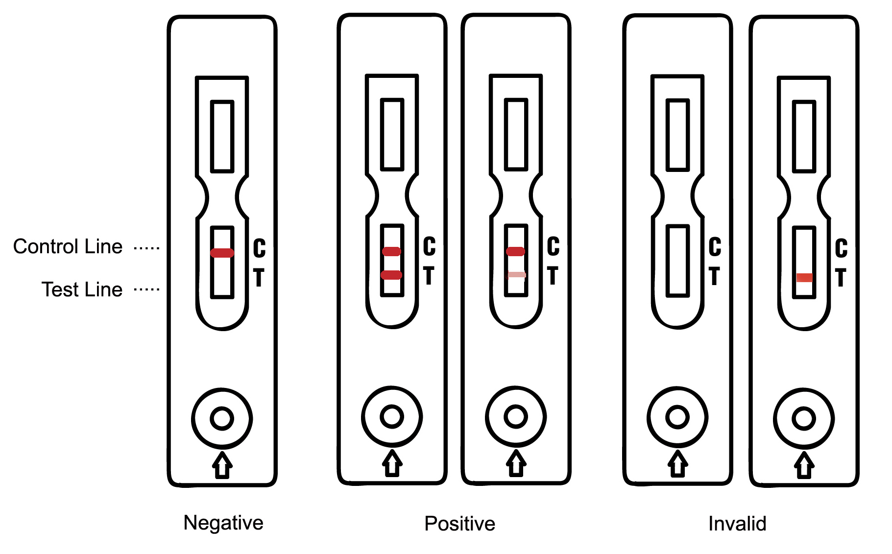
PACKAGE CONTENTS
- Pouch contents: Cassette, sample dropper, desiccant, Sample Buffer A (1 ml/vial).
- Test instruction
- Assay diluent (sample buffer A)

MATERIALS REQUIRED BUT NOT PROVIDED
- Clean, dry specimen collection container (plastic or glass)
- Specimen collection stick or dropper
- Clock or timer

Precautions
- For environmental screening use only.
- Treat all samples as EXTREMELY POISONOUS and as potentially infectious.
- Do not eat or smoke while handling specimens.
- Wear protective gloves while handling specimens. Wash hands thoroughly afterwards.
- Clean up spills thoroughly using an appropriate disinfectant.
- Decontaminate and dispose of all specimens, reaction kits and potentially contaminated
materials, as if they were infectious waste, in a biohazard container.

SPECIMEN PREPARATION
- For feces sample:
- Collect a random feces sample in a clean, dry container.
- Insert the stick or dropper into the feces to get about 0.5g or 0.3ml feces sample.
- Add feces sample to the vial of Sample Buffer A, and mix the feces sample with Sample Buffer A. The supernatant will be used for the test.
- For water sample:
- Collect water sample with a clean and dry container and test directly.
- Note: Save the specimens at –20ºC if the specimens cannot be tested in 3 days.

TEST PROCEDURES


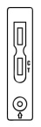
1.
Remove the testing device from the sealed pouch by tearing at the notch. Then place the testing device on a leveled surface.

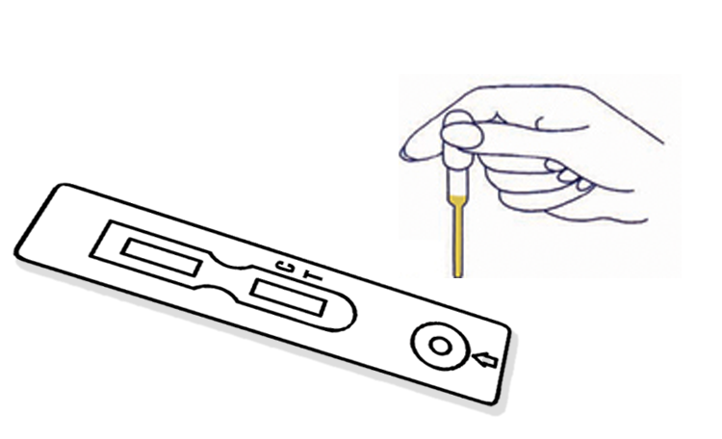
Holding the Sample dropper vertically, adds four full drops (0.2ml) of specimen without air bubbles into the sample well that is marked with an arrow on the testing device.
2

Read the result in 15 minutes. Ensure that the background of the test area is white before interpreting the results.


3
DO NOT INTERPRET RESULTS AFTER 30 MINUTES

RESULT INTERPRETATIONS
Negative
A pink colored band appears only at the control region.

Positive
A clear pink control band and a detectable test band appear.

Invalid
No visible band at the control region. Repeat with a new test device. If test still fails, please contact the distributor with the lot number.

Quality control
Although the testing device contains an internal quality control (pink colored band in the control region), good laboratory practice recommends the daily use of an outside control to ensure proper testing device performance. Quality control samples should be tested according to the standard quality control requirements established by your laboratory.

STORAGE AND STABILITY
- Test device in the sealed pouch can be stored at 2-30ºC up to the expiration date. Do not freeze the test device.
- The test device should be kept away from direct sunlight, moisture and heat.

LIMITATIONS
- This product is designed for in vitro diagnostic use only.
- There is always a possibility that false results will occur due to the presence of interfering substances in the specimen beyond the control of the manufacturer, such as technical or procedural errors associated with the testing.
- As with all diagnostic tests, a definitive clinical diagnosis should not be based on the results of a single test, but should only be made by the physician after all clinical and laboratory findings have been evaluated.

ATLAS LINK, INC
No. 811 Zeyang Plaza, No.166 Fushi Road
Shijingshan Dist., Beijing 100043, China
Tel:86-10-88909112 Fax: 86-10-88909115

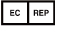
CIRIANO GLOBAL S.L.
(UNILATEX GROUP)
CIF: B50927532 C/Blancas 4-6, 1 B Oficina 1
50001 Zaragoza Spain
Tel: 34-976910399

Latest revision 09.05.2011

USA Headquarters:
10758-A Ambassador Drive
MANASSAS, VA 20109 USA
Tel: 703-3663851

