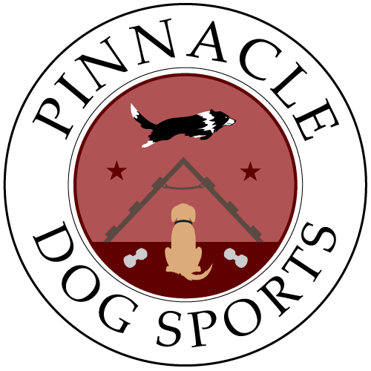  MARCH 5-6, 2022  MARCO GIOVANI  agility seminar  MARCH 5 – AKC MASTERS  MARCH 6 – PREMIER /INTERNATIONAL  WORKING SPOT - $200  AUDTING EACH DAY UNLIMITED $50 | MARCO  GIOVANI  AGILITY SEMINAR  ────  AKC MASTER  AND  PREMIER / INTERNATIONAL  WORKING SPOTS  ────  AUDITING UNLIMITED  ────  REGISTRATION FORM ATTACHED  ────  PRESENTED BY PINNACLE DOG SPORTS  PINNACLE DOG SPORT  1006 Crocker Rd.  Westlake., OH  216-337-5733  www.pinnacledogsports.com  MARCH 5-6, 2022 8-5 PM

