Appendix D
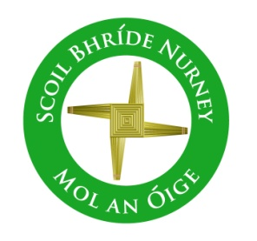
Data Access Request Form
Scoil Bhríde Nurney County Kildare

Date issued to data subject:
Access Request Form: Request for a copy of Personal Data under the Data Protection Act 1988 and Data Protection (Amendment) Act 2003
Important: Proof of Identity must accompany this Access Request Form (eg. official/State photographic identity document such as driver’s licence, passport).
A fee of €6.35 must accompany this Access Request Form if it is a Section 4 Data Access Request together with proof of identity (eg. official/State photographic identity document such as driver’s licence, passport).
Full Name

Maiden Name (if name used during your school duration)

Address

Contact number * | Email addresses *
* We may need to contact you to discuss your access request
Please tick the box which applies to you:
Student | Parent/Guardian of student | Former Student | Current Staff | Former Staff
Age:  Year group/class: | Name of Student: | Insert Year of leaving: |  | Insert Years From/To:

Section 3 Data Access Request:
I, …………………………………………………..[insert name] wish to be informed whether or not Scoil Bhríde holds personal data about me/my child and to be provided with a description of this data and to be informed of the purpose for holding such data. I am making this access request under Section 3 of the Data Protection Acts.
OR
Section 4 Data Access Request:
I, ………………………………………………….. [insert name] wish to make an access request for a copy of any personal data that Scoil Bhríde holds about me/my child. I am making this access request under Section 4 of the Data Protection Acts.
Section 4 Data Access Request only: I attach €6.35
Any other information relevant to your access request (e.g. if requesting images/recordings made by CCTV, please state the date, time and location of the images/recordings (otherwise it may be very difficult or impossible for the school/ETB to locate the data).

Signed ……………………………………… Date ……………........................
Checklist: Have you:
- Completed the Access Request Form in full?
- Included a cheque or postal order made payable to <name of school> in the amount of €6.35 where a Section 4 request is made? (Please do not send us €6.35 if you are making a request under section 3. There is no administration charge for a section 3 request, and if you send us a cheque, it will be returned to you).
- Signed and dated the Access Request Form?
- Included a photocopy of official/State photographic identity document (driver’s licence, passport etc.)*.
*Note to school/ETB: the school/ETB should satisfy itself as to the identity of the individual and make a note in the school/ETB records that identity has been provided, but the school/ETB should not retain a copy of the identity document.

Please return this form to the relevant address:
The Chairperson
Board of Management
Scoil Bhríde
Nurney
County Kildare

