Our Lady of the Miraculous Medal, France
On 19 July 1930, a voice woke up the nun Catherine Labouré calling her to chapel, where the Virgin Mary told her that "times are evil in France and the world" and instructed Catherine to produce medallions that would confer graces on those that wore them.
The medallions proved very popular. Inscribed with the slogan 'Ô Marie conçue sans péché, priez pour nous qui avons recours à vous' ('O Mary, conceived without sin, pray for us who have recourse to thee'), they were influential in the Vatican's promulgation, in 1854, of the dogma of the Immaculate Conception.
Sister Catherine spent the rest of her life caring for the sick and elderly. Her body, now encased in glass in Paris, was discovered to be incorrupt. She was canonized in 1947. Pope John Paul II used a variation of the medallion's image as his coat of arms.
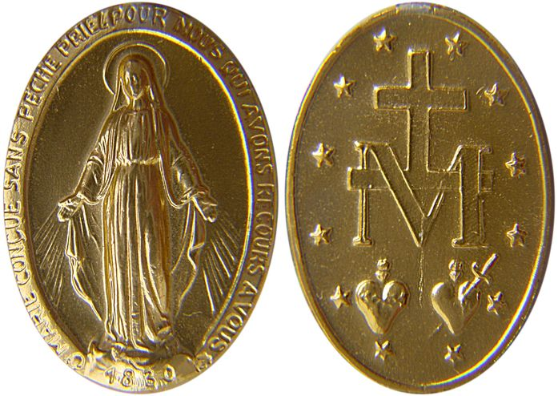

Medal of the Immaculate Conception (a.k.a. 'Miraculous Medal'), created by Saint Catherine Labouré in response to a request from the Blessed Virgin Mary.
Image: Xhienne, CC BY-SA 3.0

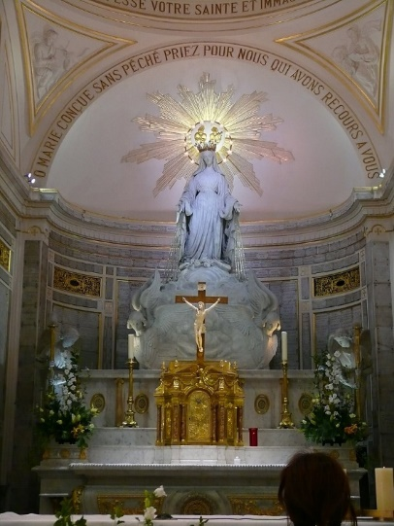

Chapel of Our Lady Of the Miraculous Medal, Paris.

