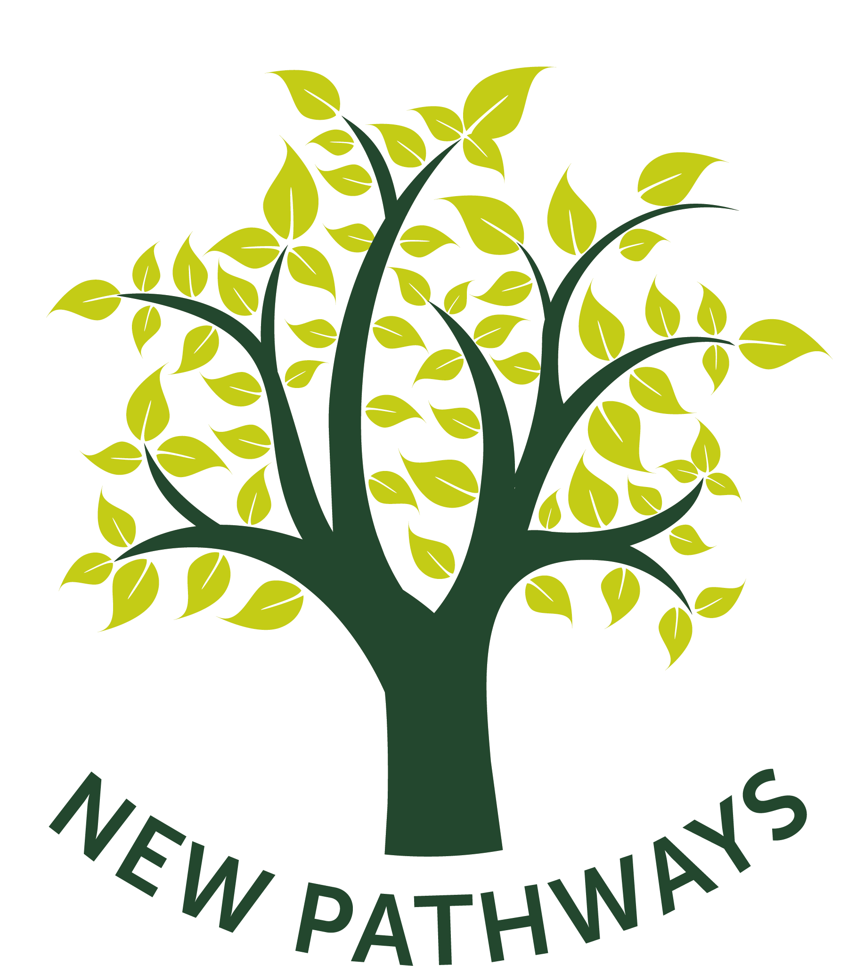 Adult Counselling Referral Form

This referral is for: | New Pathways Counselling (face to face)
This referral is for: | Outlook Project (at risk of offending / ex offenders)
This referral is for: | Telephone Counselling

Date of referral
Client Surname: |  | Client First Name:
Date of Birth: |  | Gender: | Male | Female | Other

Client Address: |  |  |  |  | Is it safe to write to this address? | Y | N
Home # |  | Is it safe to call? | Y | N | Is it safe to leave a message? | Y | N
Mobile # |  | Is it safe to call? | Y | N | Is it safe to leave a message? | Y | N
Work # |  | Is it safe to call? | Y | N | Is it safe to leave a message? | Y | N
Email: |  |  |  |  | Is it safe to email? | Y | N

Referrer Details:
Agency |  | Name of organisation:
Agency |  | Name / Position of referrer:
Agency |  | Address:
Agency |  | Contact phone number/s:
Agency |  | Email:

Is the client experiencing any of these issues | Mental Health Issues |  |  | Y | N
Is the client experiencing any of these issues | Domestic Abuse |  |  | Y | N
Is the client experiencing any of these issues | Drug Abuse |  |  | Y | N
Is the client experiencing any of these issues | Alcohol Abuse |  |  | Y | N
Is the client experiencing any of these issues | Behavioural Problems |  |  | Y | N
Any other issues?

Please give details.
Is the client aware of the referral? | Y | N | If ‘no’, why not?
Are any other agencies involved with the client?

Please provide details
Has a report been made to the police about the referring issue?
Or, does the client intend to report to the police?

Please provide details
Does this client have any additional requirements regarding access, or other support, in order to use our services?

Please provide details

Please explain the reason for referral:

Please continue on a separate sheet if necessary.
Any other relevant information:

Please indicate where the client would prefer to have appointments:

Merthyr Tydfil
Swansea
Cardiff
Carmarthen
Newport
Bridgend
Aberystwyth
Newtown

Please email to counsellingreferrals@newpathways.org.uk
Or return to:

For counselling in: | Please return to:
Newport, Carmarthen, Aberystwyth, Bridgend, Telephone | New Pathways, 20-21 High Street, Newport, NP20 1FW
Merthyr, Swansea, Newtown, Cardiff, Outlook | New Pathways, 19 St Andrews Crescent, Cardiff, CF10 3DB

New Pathways – Monitoring Form

Client Reference number ____________________________

Client Gender M ______ F ______

Are you married or in a civil partnership?
I am married
I am in a registered same-sex civil partnership
I am single / separated / divorced
I prefer not to say

Please tell us about your children and caring responsibilities
I am pregnant
I am caring for a child who is less than 6 months old
I am caring for older children
I have other caring responsibilities
I do not have children or caring responsibilities
I have other caring responsibilities
I prefer not to say

How old are you? (please tick one category)
Aged 10 or under
11-15
16-17
18-24
25-34
35-44
45-54
55-64
65-74
75 or older

What is your ethnicity? (please tick one category)
White British
White European
Mixed / Multiple ethnic groups
Asian / Asian British
Black / African / Caribbean / Black British
Other Ethnic Group
I prefer not to say

What is your religion?
No religion |  | Hindu |  | Sikh
Christian |  | Jewish |  | Any other religion
Buddhist |  | Muslim |  | Prefer not to answer

Do you have a disability?
Yes, I have a disability |  | I do not have a disability |  | I prefer not to answer

How would you describe your sexual orientation?
Heterosexual / Straight
Gay / Lesbian
Bisexual
Other
I prefer not to say

How would you describe your gender identity?
Male
Female
Androgynous
Transgender
I prefer not to say

