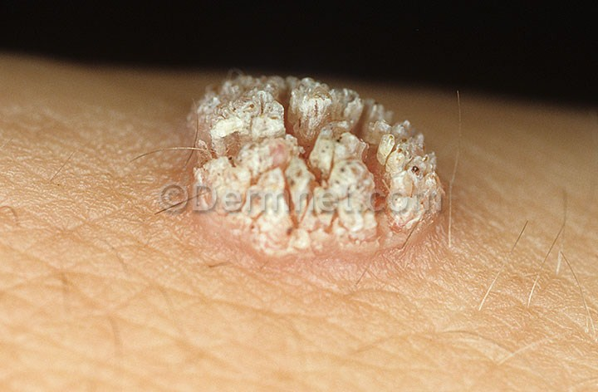
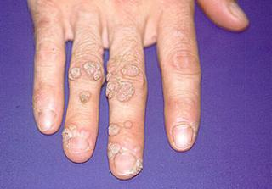
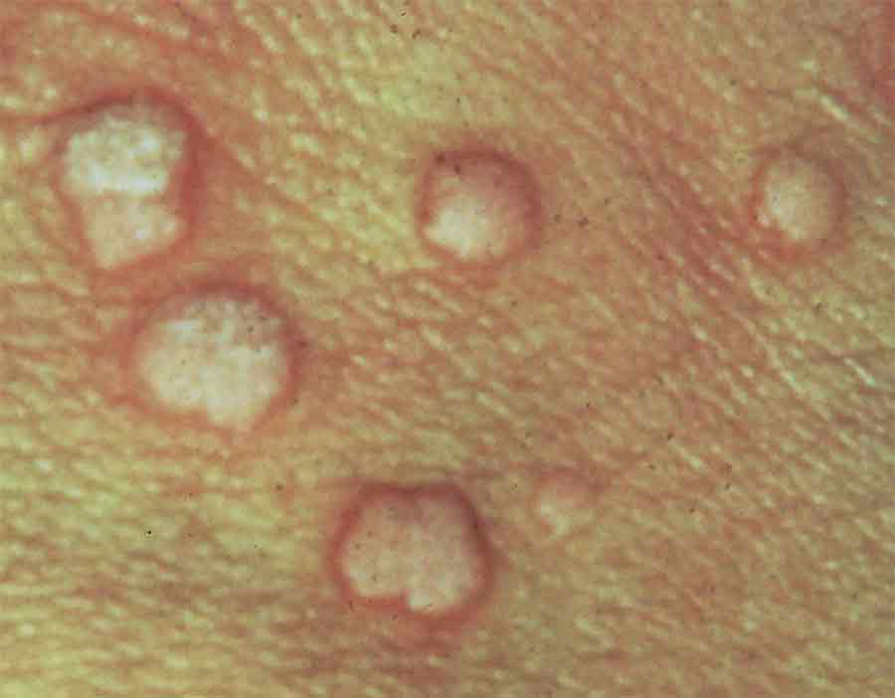
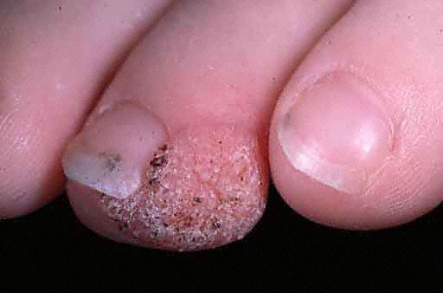
Warts

A wart is generally a small, rough growth, typically on a human’s hands or feet but often other locations
- that can resemble a cauliflower or a solid blister.
- They are caused by a viral infection, specifically by one of the many types of HPV (human papillomavirus).
- There are as many as 10 varieties of warts, the most common considered to be mostly harmless.
- It is possible to get warts from others; they are contagious and usually enter the body in an area of broken skin.
- They can disappear after a few months but can last for years and can recur.
Since they are caused by a virus, if they do not disappear, then it means the immune system needs some support to overcome the virus.
Natural Health Support:
Step 1:
- Optiflora: Since optimal levels of Probiotics represent 70% of the power of the immune system, it is essential to optimize and maintain the level of “good bacteria” in the intestinal tract. Optiflora Pre-biotic is also recommended (1/8th teaspoon per day)
- Garlic: is anti-viral, anti-bacteria, and anti-fungal. It is a wise herb/food to include in your diet regularly, and really supports overcoming the virus that is causing the warts. Children can be given Shaklee Garlic. Simply crush the tablet and mix it in mashed potato, hummus, or applesauce. It is a wise daily choice 1 to 3 daily. (Note: if you can smell garlic leeching out of your skin, then your body is throwing it away, so reduce slightly).
- Shaklee Vita-Lea: The nutrients Vitamin B, C, A, E, D, and Zinc, are all important support for the immune system. Therefore, it is always wise to support the body with a quality multi-vitamin/mineral.
Step 2:
- Vitamin D3: Vitamin D3 is very important to support an optimal immune system. Make sure your personal levels are maintained at the optimal range based on the results of your own personal bloodwork
Step 3:
- Additional Antioxidants: are always beneficial for the immune system. That is why many people optimize their levels by taking additional Vitamin C, E, etc. along with their multiple vitamin.
Diet:
- Include the following foods in your diet choices: good quality yogurts, sauerkraut, garlic, onions, asparagus.
- Shaklee Soy Protein/Cinch Smoothies: which provide a guaranteed supply of the 9 essential amino acids, which are critical in the production of antibodies, a very important part of immune health

