Solar Energy’s Scream
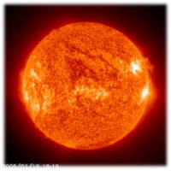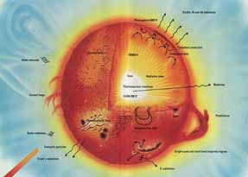
Presented by: Dr. Eng. Wafik Noseir

Date: I have started this research since 1984, when I was working in the Solar Energy Corporation for the memory of my grand father & Past Family. G-D helps me.

Abstract
In this paper I will try to summarize the solar energy, how it is very essential to use from now on and not just to wait for the fossil fuel to run out. As we are in a critical period to recover the damages that happened to the environment of our earth, before it is too late to recover.
As well as will show the different ways of using the solar energy, and how historically this was developed, what we are now, and how this can be developed more, towards a sustainable development & cleaner production.
Introduction

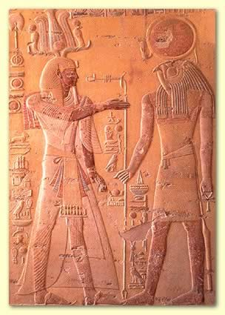
Sun the nearest start to our planet Earth. It is 150 Million Kilometers far from Earth; just the tiny fraction of the Sun's energy that hits the Earth (around a hundredth of a millionth of a percent) is enough to meet all our power needs many times over. In fact, every minute, enough energy arrives at the Earth to meet our demands for a whole year - if only we could harness it properly.
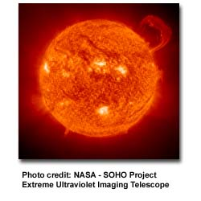
We know today, that the sun is simply our nearest star. Without it, life would not exist on our planet. We use the sun's energy every day in many different ways.
When we hang laundry outside to dry in the sun, we are using the sun's heat to do work -- drying our clothes.

Table of Contents
- The historical usage of the Solar Energy
- What are we using nowadays to produce power using the Solar Energy?
- Advantages & disadvantages of each method.
- What are the new discoveries to produce power using the Solar Energy?
- Conclusion.
Discussion
- The historical usage of the Solar Energy.

We have always used the energy of the sun as far back as humans have existed on this planet. As far back as 5,000 years ago, people "worshipped" the sun. Ra, the sun-god, who was considered the first king of Egypt. In Mesopotamia, the sun-god Shamash was a major deity and was equated with justice. In Greece there were two sun deities, Apollo and Helios. The influence of the sun also appears in other religions - Zoroastrianism, Mithraism, Roman religion, Hinduism, Buddhism, the Druids of England, the Aztecs of Mexico, the Incas of Peru, and many Native American tribes.
We've used the Sun for drying clothes and food for thousands of years, but only recently have we been able to use it for generating power.
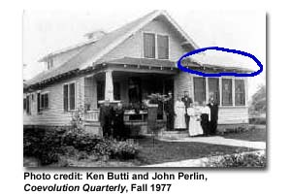

In the 1890s solar water heaters were being used all over the United States. They proved to be a big improvement over wood and coal-burning stoves. Artificial gas made from coal was available too to heat water, but it cost 10 times the price we pay for natural gas today. And electricity was even more expensive if you even had any in your town!
Many homes used solar water heaters. In 1897, 30 percent of the homes in Pasadena, just east of Los Angeles, were equipped with solar water heaters. As mechanical improvements were made, solar systems were used in Arizona, Florida and many other sunny parts of the United States. The picture shown here is a solar water heater installed on the front roof of a house in Pomona Valley, California, in 1911 (the panels are circled above the four windows).
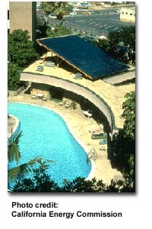
By 1920, ten of thousands of solar water heaters had been sold. By then, however, large deposits of oil and natural gas were discovered in the western United States. As these low cost fuels became available, solar water systems began to be replaced with heaters burning fossil fuels.
Solar water heating, where heat from the Sun is used to heat water in glass panels on your roof.
This means you don't need to use so much gas or electricity to heat your water at home.
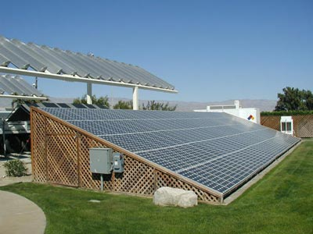

The phenomenon of using solar cells was first discovered in the 18th century. This was originally developed in order to provide electricity for satellites & space technologies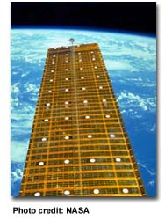, but these days many of us own calculators powered by solar cells. On 1930 a material called Selenium was used to make the photocells, then the silicon was discovered to be more powerful in producing electricity if was exposed to sun light.
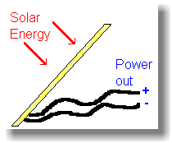
- What are we using nowadays to produce power using the Solar Energy?
1] Direct heat in water solar panels, where the heat can be used directly from sun instead of using it from fossil fuel or use electricity produced again from fossil fuel.
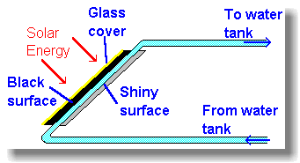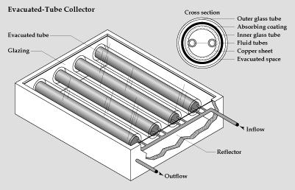
Today, solar water heaters are making a comeback. There are more than half a million of them in California alone and plenty at Israel! They heat water for use inside homes and businesses, also heat swimming pools.
Panels on the roof of a building, contain water pipes. When the sun hits the panels and the pipes (painted black to absorb heat), the sunlight warms them.
This helps out your central heating system, and cuts your fuel bills. However, in places like the UK you must remember to drain the water out to stop the panels freezing in the winter.
Solar heating is worthwhile in places like California and Australia & Middle east, where you get lots of sunshine. Israel was the first country in the Middle East that have used the solar energy, G-D help us too.

2] Direct electricity using photocells (selenium in the past and now silicon & other ways).
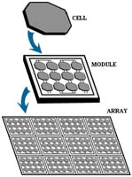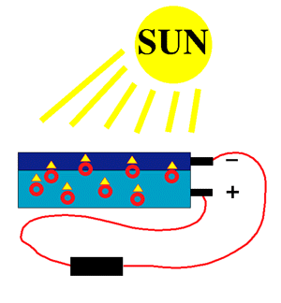

Photovoltaics
Photovoltaic solar cells, which directly convert sunlight into electricity, are made of semiconducting materials. The simplest photovoltaic cells power watches and calculators and the like, while more complex systems can light houses and provide power to the electrical grid.

Technologies
Crystalline Silicon (c-Si)
Crystalline silicon (c-Si) is the leading commercial material for photovoltaic cells, and is used in several forms: single-crystalline or monocrystalline silicon, multicrystalline or polycrystalline silicon, ribbon and sheet silicon and thin-layer silicon.
Common techniques for the production of crystalline silicon include the Czochralski (CZ) method, float-zone (FZ) method, and other methods such as casting and die or wire pulling. The removal of impurities and defects in the silicon is of critical importance, and is addressed with techniques such as surface passivation (reacting the surface with hydrogen) and gettering (a chemical heat treatment that causes impurities to diffuse out of the silicon). Also at issue as the industry grows is the availability and purity of the solar-grade silicon feedstock.
Although crystalline silicon solar cells have been in existence since 1954, new innovations continue to be developed, including the emitter wrap-through (EWT) cell and the self-aligned selective-emitter (SASE) cell.
Thin Films
Thin film photovoltaic cells use layers of semiconductor materials only a few micrometers thick, attached to an inexpensive backing such as glass, flexible plastic, or stainless steel. Semiconductor materials for use in thin films include amorphous silicon (a-Si), copper indium diselenide (CIS), and cadmium telluride (CdTe). Amorphous silicon has no crystal structure and is gradually degraded by exposure to light through the Staebler-Wronski Effect. Hydrogen passivation can reduce this effect. Because the quantity of semiconductor material required for thin films is far smaller than for traditional PV cells, the cost of thin film manufacturing is far less than for crystalline silicon solar cells.
Group III-V Technologies
These photovoltaic technologies, based on Group III and V elements in the Periodic Table, show very high conversion efficiencies under either normal sunlight or sunlight that is concentrated. Single-crystal cells of this type are usually made of gallium arsenide (GaAs). Gallium arsenide can be alloyed with elements such as indium, phosphorus, and aluminum to create semiconductors that respond to different energies of sunlight.
High-Efficiency Multijunction Devices
Multijunction devices stack individual solar cells on top of each other to maximize the capture and conversion of solar energy. The top layer (or junction) captures the highest-energy light and passes the rest on to be absorbed by the lower layers. Much of the work in this area uses gallium arsenide and its alloys, as well as using amorphous silicon, copper indium diselenide, and gallium indium phosphide. Although two-junction cells have been built, most research is focusing on three-junction (thyristor) and four-junction devices, using materials such as germanium (Ge) to capture the lowest-energy light in the lowest layer.
Fabricating Solar Cells and Modules
A variety of technical issues are involved in the fabrication of solar cells. The semiconductor material is often doped with impurities such as boron or phosphorus to tweak the frequencies of light that it responds to. Other treatments include surface passivation of the material and application of antireflection coatings. The encapsulation of the complete PV module in a protective shell is another important step in the fabrication process.
Advanced Solar Cells
A variety of advanced approaches to solar cells are under investigation. Dye-sensitized solar cells use a dye-impregnated layer of titanium dioxide to generate a voltage, rather than the semiconducting materials used in most solar cells. Because titanium dioxide is relatively inexpensive, they offer the potential to significantly cut the cost of solar cells. Other advanced approaches include polymer (or plastic) solar cells (which may include large carbon molecules called fullerenes) and photoelectrochemical cells, which produce hydrogen directly from water in the presence of sunlight.
Balance of System (BOS) Components
The balance of system (BOS) components include everything in a photovoltaic system other than the photovoltaic modules. BOS components may include mounting structures, tracking devices, batteries, power electronics (including an inverter, a charge controller, and a grid interconnection), and other devices.

3] Solar Furnaces use a huge array of mirrors to concentrate the Sun's energy into a small space and produce very high temperatures. There's one at Odellio, in France, used for scientific experiments. It can achieve temperatures up to 33,000 degrees Celsius.
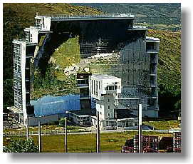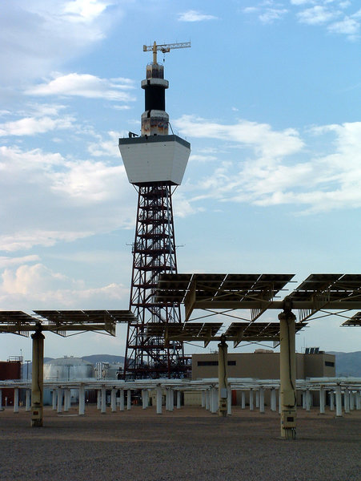
4] Solar towers. The idea is very simple - you build a big greenhouse, which is warmed by the Sun. In the middle of the greenhouse you put a very tall tower. The hot air from the greenhouse will rise up this tower, fast - and can drive turbines along the way. This could generate significant amounts of power, especially in countries where there is a lot of sunshine and a lot of room, such as Australia, or the West & east deserts of Egypt.
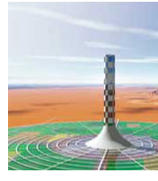
The Advantages & disadvantages
Advantages of Solar Energy in general
- Solar energy is free - it needs no fuel and produces no waste or pollution.
- Cheap In sunny countries, solar power can be used where there is no easy way to get electricity to a remote place.
- Handy for low-power uses such as solar powered garden lights and battery chargers.
- Solar Power is Renewable. The Sun will keep shining, so it makes sense to use it.
Disadvantages of Solar Energy in general
- Doesn't work at night.
- Very expensive to build solar power stations.
Solar cells cost a great deal compared to the amount of electricity they'll produce in their lifetime.
- Can be unreliable unless you're in a very sunny climate. In the United Kingdom, solar power isn't much use except for low-power applications, as you need a very large area of solar panels to get a decent amount of power.
Now what really are our problems?
The use of silicon crystals in the Photovoltaic cells makes it expensive. First of all, silicon crystals are currently assembled manually. Secondly, silicon purification is difficult and a lot of silicon is wasted. In addition, the operation of silicon cells require a cooling system, because performance degrades at high temperatures.
Research is underway for new fabrication techniques, like those used for microchips. Alternative materials like cadmium sulfide and gallium arsenide are at an experimental stage. Reduction of cost will depend on the economies of scale.

- What are the new discoveries to produce power using the Solar Energy?
Scientists have invented a plastic solar cell that can turn the sun's power into electrical energy, even on a cloudy day.
The plastic material uses nanotechnology and contains the first solar cells able to harness the sun's invisible, infrared rays. The breakthrough has led theorists to predict that plastic solar cells could one day become five times more efficient than current solar cell technology.
Like paint, the composite can be sprayed onto other materials and used as portable electricity. A sweater coated in the material could power a cell phone or other wireless devices. A hydrogen-powered car painted with the film could potentially convert enough energy into electricity to continually recharge the car's battery.
The researchers envision that one day "solar farms" consisting of the plastic material could be rolled across deserts to generate enough clean energy to supply the entire planet's power needs.
"The sun that reaches the Earth's surface delivers 10,000 times more energy than we consume," said Ted Sargent, an electrical and computer engineering professor at the University of Toronto. Sargent is one of the inventors of the new plastic material.
"If we could cover 0.1 percent of the Earth's surface with [very efficient] large-area solar cells," he said, "we could in principle replace all of our energy habits with a source of power which is clean and renewable."
Infrared Power
Plastic solar cells are not new. But existing materials are only able to harness the sun's visible light. While half of the sun's power lies in the visible spectrum, the other half lies in the infrared spectrum.
The new material is the first plastic composite that is able to harness the infrared portion.
"Everything that's warm gives off some heat. Even people and animals give off heat," Sargent said. "So there actually is some power remaining in the infrared [spectrum], even when it appears to us to be dark outside."
The researchers combined specially designed nano particles called quantum dots with a polymer to make the plastic that can detect energy in the infrared.
With further advances, the new plastic "could allow up to 30 percent of the sun's radiant energy to be harnessed, compared to 6 percent in today's best plastic solar cells," said Peter Peumans, a Stanford University electrical engineering professor, who studied the work.
Electrical Sweaters
The new material could make technology truly wireless.
"We have this expectation that we don't have to plug into a phone jack anymore to talk on the phone, but we're resigned to the fact that we have to plug into an electrical outlet to recharge the batteries," Sargent said. "That's only communications wireless, not power wireless."
He said the plastic coating could be woven into a shirt or sweater and used to charge an item like a cell phone.
"A sweater is already absorbing all sorts of light both in the infrared and the visible," said Sargent. "Instead of just turning that into heat, as it currently does, imagine if it were to turn that into electricity."
Other possibilities include energy-saving plastic sheeting that could be unfurled onto a rooftop to supply heating needs, or solar cell window coating that could let in enough infrared light to power home appliances.
Cost-Effectiveness
Ultimately, a large amount of the sun's energy could be harnessed through "solar farms" and used to power all our energy needs, the researchers predict.
"This could potentially displace other sources of electrical production that produce greenhouse gases, such as coal," Sargent said.
In Japan, the world's largest solar-power market, the government expects that 50 percent of residential power supply will come from solar power by 2030, up from a fraction of a percent today.
The biggest hurdle facing solar power is cost-effectiveness.
At a current cost of 25 to 50 cents per kilowatt-hour, solar power is significantly more expensive than conventional electrical power for residences. Average U.S. residential power prices are less than ten cents per kilowatt-hour, according to experts.
But that could change with the new material.
Conclusion
We should use the Solar Energy in any way, thanks G-D for the wonderful climate that Egypt is blessed by.
As well as start our own researches on the best ways that we can harness this Solar power in Egypt using the available materials and on the lowest cost, which will prove eventually its economic usages.

On the other side we can export the Oil & Natural gas or other fossil fuel to other countries where they don’t have our climate and can’t use the Solar Energy as we hopefully can, G-D help us.

NO POLLUTION FOR BETTER EVOLUTION

